ALPHABET ART FOUND IN EVERY DAY OBJECTS
David Letterman has spent his entire career in photography including Photojournalism and industrial commercial photography. Over the past few years he has enjoyed compiling a library of to date over two thousand alphabet photographs of everyday objects taken from different angles to capture letters.
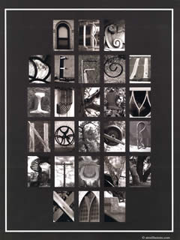
David reflected: “The idea is not an original one, it is something I did thirty odd years ago for fun with family and friends. It was when volunteering at the local school and the literacy programme that I invented a little game to find letters among the desks and chairs of the classroom. That was the aha moment, recalling the past and approaching the subject from a different angle”.
http://atozillusions.com/david-the-letterman-who-is-that-man/

Using a phone, camera or ipad etc look around the house and out in the garden for inspiration to recreate letters from everyday objects. (If you don’t have access to a camera then you could sketch and colour what you find.)
Either find the letters of your name or for a real challenge, find every letter of the alphabet.
Watch the video below for inspiration.
https://www.youtube.com/watch?v=chZoHerp5OU&pbjreload=101

