September 2020

How to get connected
Your child will need to access their own Oakfield Google account in this format:
Pupil Email Addresses: Go to Gmail to login: http://www.google.com/gmail
Years 5, 6, 7, 8 format: for example Cath Bloggs is cath.bloggs@oakfieldacademy.org Password: oakfield
It is advisable that your child changes their password when they login and share this with you!

- The default password is oakfield, which you should change when you log in for the first time.
- To activate your child’s account, go to the normal Google search page on the internet and click on the icon at the top right of the screen. It looks like a person, if you haven’t already got a Google account open, or will simply have a small blue box labelled “sign in”. It will then ask you to log in to your account. Once in, you will find an invitation to join the classrooms that have been set up for you. Accept the invitation and you are away to the delights of an Oakfield virtual classroom!
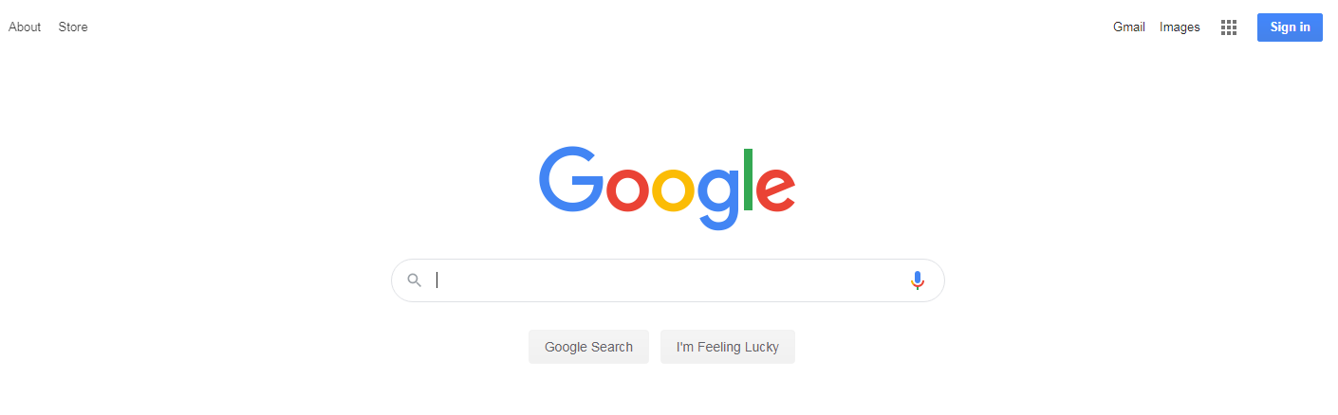
If there is already a Google account associated with the device you are using, you can still use this method to log in – just select “add another account” when you click on the icon and log in as above.
We have also created a video guide for yourselves and pupils to watch that will help them in accessing Gmail and Google Classroom; this can accessed through the link beneath, (be kind as it’s my first instruction video!!)
https://youtu.be/iVPqQaTdJ4Q
How will Google Classrooms operate at Oakfield from September 2020
- Students will be invited to join virtual classrooms for subjects such as English, Maths, Geography, History and Science. They will be set specific lessons by their own teacher or another specialist in that subject area. Students might be asked to read documents, follow a powerpoint or watch videos relating to the lesson. They will then be required to complete a task or series of tasks that will be explained by the teacher, following the same pattern as a classroom-based lesson.
- Students may be expected to submit work and the teacher will indicate when this is required. Google Classroom allows for some assignments to be completed collaboratively and also allows students to ask their teacher any questions they may have. Teachers will provide feedback on work submitted, as well as next step challenges for pupils, before setting new lessons based on the learning completed.

In summary, Google Classroom enables students and teachers to connect with their classes in a safe, virtual way.

This facility is part of our wider Infinity development and will support the teaching and learning at the academy moving forward.

Please do stay safe and take care.

Mr McGrath
Deputy Head teacher

