Mass tourism impacts in Kenya
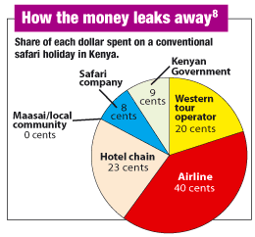
Tourism contributes 15% of the country’s Gross National Product. In 2003, around 219,000 people worked in the tourist industry. Unfortunately, only 15% of the money earned through tourism goes to locals. The rest goes to big companies. This is known as the leakage effect.
The culture and customs of the native Maasai tribe are preserved because things like traditional dancing are often displayed for tourists. However, some Maasai tribe’s people were forced off their land to create National Parks for tourists. Some Muslim people in Kenya are offended by the way female tourists dress.

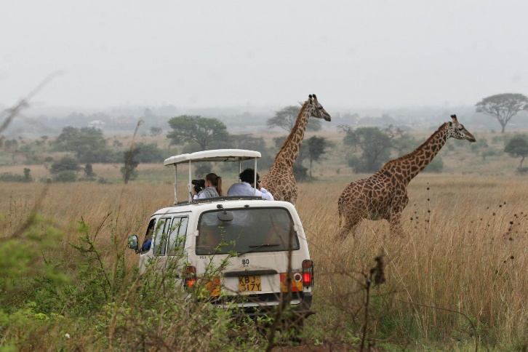
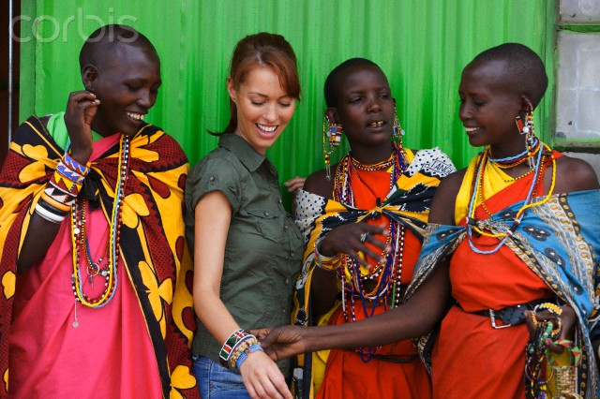
There are 23 National Parks in Kenya E.G. Nairobi National Park. Tourists have to pay entry fees to get in. This money is used to maintain the National Parks, which help protect the environment and wildlife. Sadly, Safari Vehicles have destroyed vegetation and caused soil erosion. Wild animals have been affected, e.g. Cheetahs in the most heavily visited areas have changed their hunting behaviour to avoid the crowds. Coral reefs in the Malindi Marine National Park have been damaged by tourist boats anchoring.

