Message for Y8 students
To all of you keen linguists wishing to prepare for your move to college and wanting more than our Little Lessons, I would like to recommend using these French and Spanish guides for your independent studies:
Each pack is full of crystal-clear notes on all the vocabulary and grammar you need to know.
There are plenty of reading, writing and speaking tasks throughout the book, as well as vocab testers, practice questions (with answers) and listening practice — with online audio.
What's more, there is a free Online Edition that lets you read the entire book on a PC, Mac or tablet — you'll have access via 'My Online Products' on the CGP website from the moment you place your order. When the book arrives, just use the unique code printed inside the cover to gain full access.
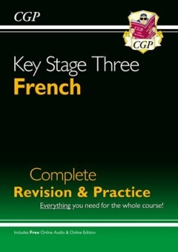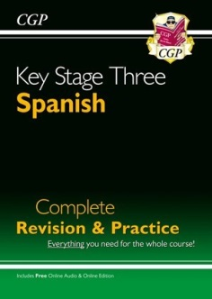
FRENCH: https://www.cgpbooks.co.uk/secondary-books/ks3/languages/french/fhs33-new-ks3-french-complete-revision-practic
SPANISH: https://www.cgpbooks.co.uk/secondary-books/ks3/languages/spanish/sphs32-new-ks3-spanish-complete-revision-pract
I miss you all very much and wish you all the best.
Mrs Hall
Head of Modern Languages

