Movement and Dynamism in Art
How can we depict, or show, movement in our drawings or paintings?
Look carefully at the pictures below: how are the artists showing movement in these pictures? How effective are their methods? Which is your favourite picture?

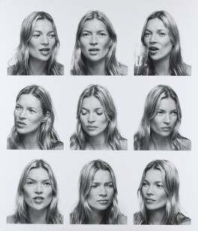
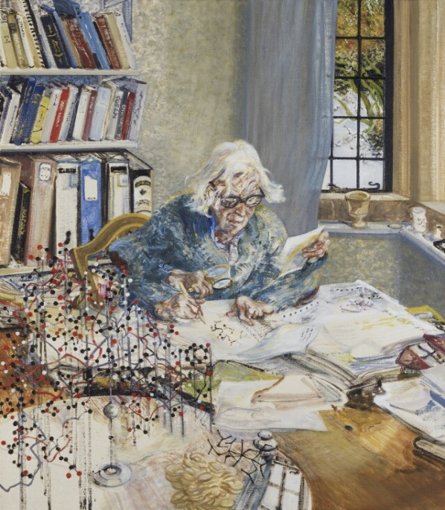
Dorothy Hodgkin, by Maggi Hambling Kate Moss, by Corrine Day

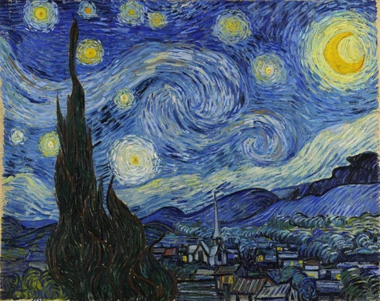

Starry Night, by Vincent Van Gogh Hesitate, by Bridget Riley

Challenge:
We can create movement or dynamism in our art in different ways:
Repetition of part of the picture – did you notice how artist Maggi Hambling shows her subject’s hands moving quickly by giving her four sets of hands in the portrait?
Repeated images or objects– in the portrait of Kate Moss, the artist takes lots of different pictures of her to depict movement. You can ‘read’ this portrait almost like you would a book; for me, it feels a bit like a picture of a conversation.
Brush-strokes or marks – you can depict movement by the speed of a brush stroke or the shape of a pencil mark, or through smudging, blurring or by repeating lines. Look at Vincent Van Gogh’s picture: he uses thick, swirling lines to create a feeling of movement. When I look hard at this painting, I can almost feel the world turning, as the stars twinkle around me.
Organised shapes or lines and marks on the paper. Bridget Riley carefully organises shapes and lines to disorient the viewer and make the picture ‘dance’ in front of you. Can you see the movement?

Challenge: Create your own painting or drawing depicting some form of movement. How will you do this? You might want to follow one of the ideas from the artists above.
Alternative: you might want to choose a different medium: how about creating a dynamic sculpture or photograph?
Visit www.tate.org.uk for more examples of dynamism and movement in art.

When you’ve finished…
Email a photo of your work to: art@oakfieldacademy.org
I can’t wait to see your finished work.

