PE ACTIVITIES
Fantastic sports podcasts
These podcasts could be listened to on your own or together as a family (great for discussion) whilst sitting around the dinner table or whilst out for a run!
Why not have a go at making your own short podcast using your phones as a recording device? Perhaps of your favourite sports person/event or maybe about your own sporting achievements and aspirations.
The P.E department would love to hear them.
Email us at: pe@oakfieldacademy.org

How to be superhuman
Short but inspiring episodes including;
The man who cycled around the world in 78 days.
The lady that saved 20 people from drowning at sea.
The 38 mile wheelie around the Isle of Mann TT circuit.

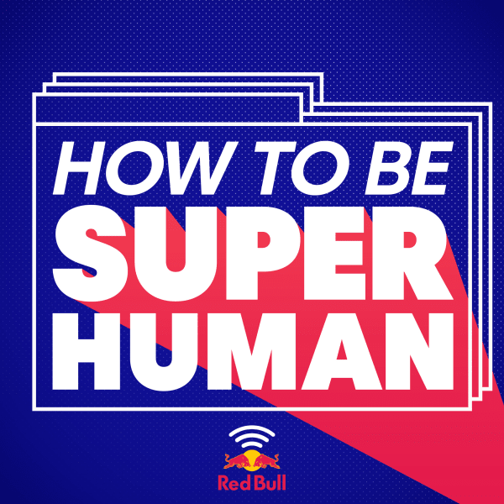

https://www.redbull.com/gb-en/projects/red-bull-how-to-be-superhuman-podcast

The Olympics Podcast
This is the place for inspiration and motivation from the Olympics with interviews from the world's best athletes. Discover the workouts and mentality it takes to succeed in one of the planet's toughest tests: the Olympic Games. Whether it's wrestling, swimming, figure skating, weightlifting, or gymnastics - the Olympic Channel Podcast will have you living your best life in no time.

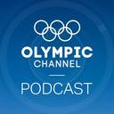

https://www.olympicchannel.com/en/original-series/detail/olympic-channel-podcast/

Costello and Bunce
Two men who have lived a lifetime in the boxing game discuss current and legendary fighters and fights, including Anthony Joshua, Muhamed Ali, Sugar-ray Leonard and the Gypsie king himself, Tyson Fury.
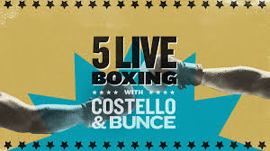

https://www.bbc.co.uk/programmes/p04v5n4p

Sporting Witness
How French teenagers created Parkour, Kenya’s first winter Olympian and how a policeman won the Rugby world cup are just a few of the episodes available in this diverse sports podcast. Some incredible sporting moments and achievements retold. Why not visit the website below and pick your favourite episode to listen to

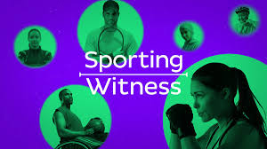
https://www.bbc.co.uk/programmes/p00j2pn5/episodes/downloads

Sports Wars
Epic rivalries including, Kobe Vs Shaq (Basketball), Rafa Nadal Vs Federer (Tennis), Stone Cold Steve Austin Vs The Rock (Wrestling)! Rivalries that must be heard to be believed!

https://wondery.com/shows/sports-wars/

