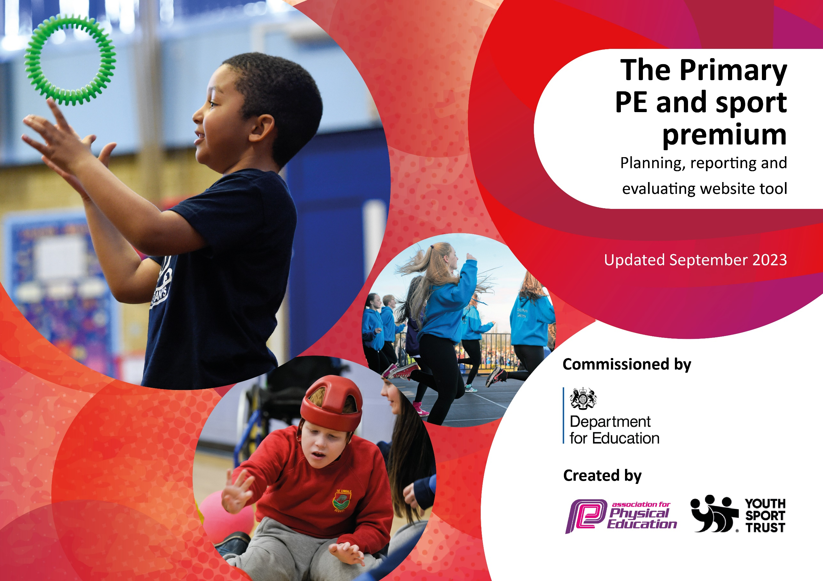

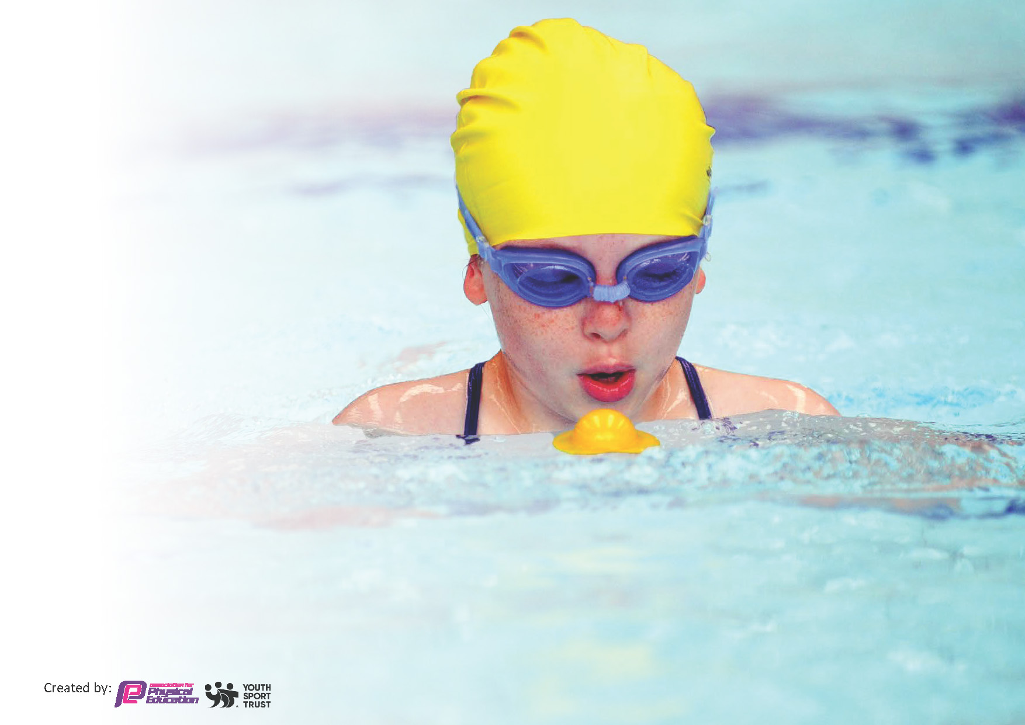
This template can be used for multiple purposes:
by:
- It enables schools to effectively plan their use of the Primary PE and sport premium
- It helps schools to meet the requirements (as set out in guidance) to publish information on their Primary PE and sport premium
- It will be an effective document to support Ofsted inspections enabling schools to evidence progress in Physical Education (PE) and evidence swimming attainment, which forms part of the PE National Curriculum. We would recommend schools consider
the Intent, Implementation and Impact of any spend, as examined within the Education Inspection Framework.

It is important that your grant is used effectively and based on school need.

Schools must use the funding to make additional and sustainable
improvements to the quality of the PE, School Sport and Physical Activity (PESSPA)
they offer. This means that you should use the Primary PE and sport premium to:

- Build capacity and capability within the school to ensure that improvements made now will benefit pupils joining the school in future years
- Develop or add to the PESSPA activities that your school already offers.

The Primary PE and sport premium should not be used to fund capital spend projects; the school’s core budget should fund these. Further detail on capital expenditure can be found in the updated Primary PE and sport premium guidance.

The Primary PE and sport premium guidance, outlines 5 key priorities that funding should be used towards. It is not

necessary that spending has to meet all the key priorities, you should select the priorities that you aim to use any funding towards.

Although completing this template is not a requirement for schools, schools are required to publish details of how they spend this funding. Schools must also outline what the impact this funding has had on pupils’ PE and sport participation and attainment and how any spending will be sustainable in the future. All funding must be spent by 31st July 2023.

The Department for Education has worked closely with the Association for Physical Education (afPE) and the Youth Sport Trust (YST) to develop this template and encourages schools to use it. This template is an effective way of meeting the reporting requirements of the Primary PE and sport premium.
Review of last year’s spend and key achievements (2021/2022)

We recommend you start by reflecting on the impact of current provision and reviewing your previous spend.

Activity/Action | Impact | Comments
Increased physical activity during break and lunchtimes.  Play leaders/IG Sports  Increase in total number of extra-curricular clubs being offered at ks2  Increasing the opportunities for 30 mins physical activity to be achieved | Pupils have the opportunity to engage in a wide range of physical activities from traditional games such as basketball to Frisbee/skipping. More pupils have been active at break and lunchtime.  Additional break and lunchtime activities have taken place. Individual pupils not accessing p.e have been active through this approach.  Increased opportunities provided for Oakfield pupils including football and archery for yr 5 & 6

Key priorities and Planning
This planning template will allow schools to accurately plan their spending.

Action – what are you planning to do | Who does this action impact? | Key indicator to meet | Impacts and how sustainability will be achieved? | Cost linked to the action
- Professional development – Primary p.e conference SASP  AFPE Annual Membership  Soccer Coach Weekly  Rugby Coach Weekly  Increase participation at break and lunchtime through play.  Target non-doers  Additional p.e opportunities  Sharing stories and success in newsletters  Whole-school inter-form games  Additional play equipment for break and lunch  Additional clubs including dodgeball, Basketball and Gymnastics  TOP –UP SWIMMING  Multiple additional fixtures/competitions  Millfield yr 6 Netball  Fairlands yr 5 Football  Millfield Yr 5 Netball  Mini-bus ks2 Girls Football  Samba goals to enable football competitions after school  Footballs for comp | CPD for P.E staff which then benefits pupils  All teachers of p.e including supply and cover staff for whom the resources are accessible  All pupils at ks2 & 3  Pupils that are not fully engaging in p.e  Opportunities are offered to all pupils at ks2  Aim to Motivate and Inspire  All pupils  All ks2 pupils active in additional day of sport  All pupils will have access | - Increased confidence, knowledge and skills of P.E teaching staff  - Engagement of pupils in regular Physical activity  Ig sports to work with pupils reluctant to engage in physical activity  - Raised profile of P.E and sport across the school  - Broader experience of a range of sports  Frisbees/Table tennis equipment/ skipping ropes//Footballs  Catching cups and balls  Hula hoops  Tennis raquets  Uni-hoc  Basketball/Dodgeball  - Increased participation in competitive sport | Sustainability achieved through knowledge documented and shared with departments as well as knowledge used to create schemes of work  Continue to re-integrate inter-form games, back to 1 x games per term  Regular newsletter articles from fixtures, matches and clubs that are run  Train lunchtime supervisors  Train lunchtime supervisors  Introduce and embed both sports into the curriculum within  Support pupils not achieveing the 25m target  Create links with other schools who will return fixtures in the future  Football competitions to run at lunch time (IG SPORT) and after school | £30 Course cost  £200 cost of cover  £180  £144 (annual)  £144 (annual)  £180 cost of supply to free up p.e staff for a day  £1836  £600 NB  Support p.e department to raise profile of p.e  Notice boards, admin etc  Lunchtime equipment  £273.95 equipment  £158.95  £521  £2000  Transport costs  £3500  £668  £245

Key achievements 2023-2024
This template will be completed at the end of the academic year and will showcase the key achievements schools have made with their Primary PE and sport premium spending.

Activity/Action | Impact | Comments

Swimming Data
Meeting National Curriculum requirements for swimming and water safety.
Priority should always be given to ensuring that pupils can perform safe self-rescue even if they do not fully meet the first two requirements of the National Curriculum programme of study

Question | Stats: | Further context  Relative to local challenges
What percentage of your current Year 6 cohort can swim competently, confidently and proficiently over a distance of at least 25 metres? | 86% | Use this text box to give further context behind the pe6 x tutor groups each have 10 swim sessions at Frome Leisure centre as part of their Yr 5 P.e curriculum.  Groups are divided into strong/medium and developing swimmers to aid differentiation and further progression for each child.  Records are kept poolside and calculations made after top-up swims sessions to reflect and review
What percentage of your current Year 6 cohort can use a range of strokes effectively [for example, front crawl, backstroke, and breaststroke]? | 65%

What percentage of your current Year 6 cohort are able to perform safe self-rescue in different water-based situations? | 20  % | 6 x tutor groups each have 10 swim sessions at Frome Leisure centre as part of their Yr 5 P.e curriculum.  Groups are divided into strong/medium and developing swimmers to aid differentiation and further progression for each child.  Records are kept poolside and calculations made after top-up swims sessions to reflect and review.
If your schools swimming data is below national expectation, you can choose to use the Primary PE and sport premium to provide additional top-up sessions for those pupils that did not meet National Curriculum  Requirement’s after the completion of core lessons. Have you done this? | Yes/No | Top-up swims take place during term 6 and target pupils that are unable to swim 25m offering them upto 10 additional sessions to allow them the best chance to achieve the 25m target.
Have you provided CPD to improve the knowledge and confidence of staff to be able to teach swimming and water safety? | Yes/No | Poolside mentoring from experienced swim teachers at Frome Leisure Centre and the offer of external courses.

Signed off by:

Head Teacher: | (Name)
Subject Leader or the individual responsible for the Primary PE and sport premium: | (Name and Job Title)
Governor: | (Name and Role)
Date:

