Was it Wrong to Remove the statue of Edward Colston?
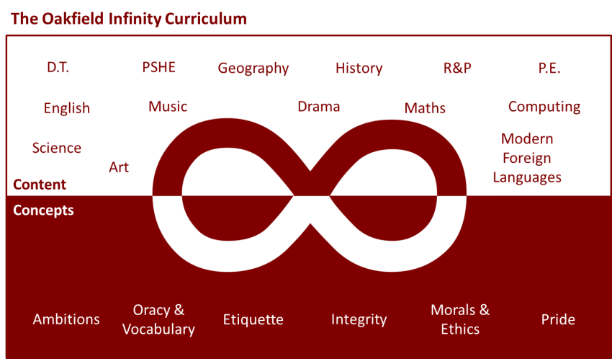

https://www.youtube.com/watch?v=cs36SAytfuE&pbjreload=101
Watch the first 4 minutes of this news report from last week’s anti-racism protests in Bristol. A statue of Edward Colston, a businessman known for bringing wealth and charity to Bristol was pulled down due his involvement in the trading of slaves during the 18th century.
Task 1: Research some key information about Edward Colston using the internet. Try to create answers to the following questions:
- What was his childhood like?

- What did he achieve for the city of Bristol?

- How is he associated with the slave trade?

Task 2: What actions had been taken previously in trying to get the statue removed and why were the people of Bristol becoming more impatient?

Task 3: In your opinion were the protesters right to remove the statue in the way that they did?

https://www.bbc.co.uk/news/uk-england-bristol-53083939?scrlybrkr

After reading the article posted above; how do you feel about other statues of historical figures being vandalised and targeted in illegal ways to protest racist behaviours of the past? Write a statement below as the mayor of Bristol explaining what you would choose to do with the statue if you were given the choice. Would you get rid of it all together? Put it in a slavery museum?
#What might the benefits of the latter option be?
# In Bristol both a school and concert venue named after Colston have said they are going to change their name to remove the association with the actions of Colston. Do you think this is right? Be sure to give reasons for your answer.

