Oakfield Academy Science Department - Home Learning for Year 5
Week beginning: Monday 5th October 2020

Suggested learning activities for this week:

Watch: This video to find out about what we know about how the universe began – The Big Bang: https://www.youtube.com/watch?v=DmUiCweDic4

Main task: Research the ‘Big Bang’ and produce an information poster or fact-page. Try to answer the following questions:
What is the Big Bang?
When did it happen?
What evidence is there to support the theory?
Good luck.

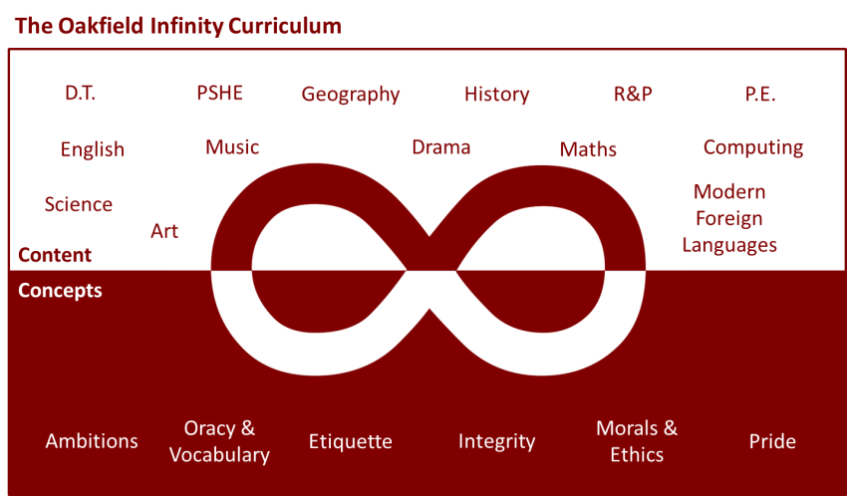

Suggested learning activities you may have missed!
Identify living things: Download and use the Seek app (it’s brilliant!) from inaturalist to find out the plants and animals living near you. Watch this WWF YouTube video clip which shows it being used on a garden safari! (https://www.youtube.com/watch?v=Lp6LL2zOif0)
Earth Squad Go!: Play as Lava, Geo, River or Sky, join the Earth Squad and explore our planet's habitats. Work your way from Rookie to Pro on each of the game's habitats: the vibrant rainforest, the busy city and the wild savannah. Good luck!
(https://www.bbc.co.uk/games/embed/earth-squad-go)

