Oakfield Academy Science Department - Home Learning for Year 5
Week beginning: Monday 12th October 2020

Suggested learning activities for this week:

Watch: These videos all about the phases of the moon:
https://www.youtube.com/watch?v=wz01pTvuMa0&pbjreload=101&scrlybrkr
https://www.youtube.com/watch?v=t6MCtB752AE&pbjreload=101
https://www.youtube.com/watch?v=6AviDjR9mmo&pbjreload=101

Main task: Try to explain why the phases of the moon occur. You could write out your explanation, do a clear labelled diagram, make a poster or, if you have an adult to help you, make your own ‘moon in a box’ (http://www.jodrellbank.net/wp-content/uploads/2014/10/Moon-phase-model.pdf)

Good luck.

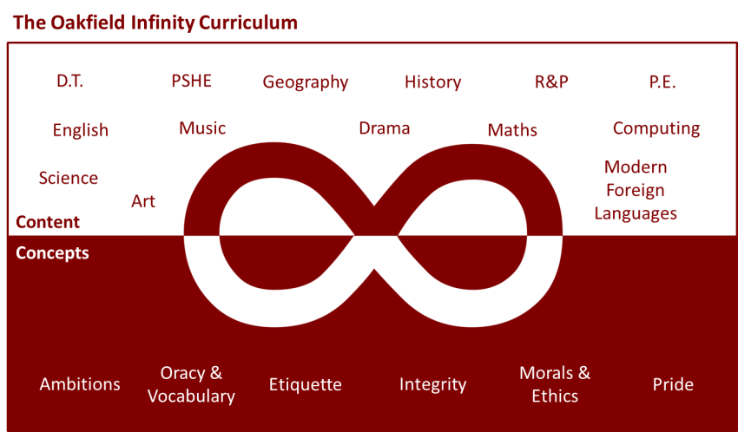

Suggested learning activities you may have missed!
Identify living things: Download and use the Seek app (it’s brilliant!) from inaturalist to find out the plants and animals living near you. Watch this WWF YouTube video clip which shows it being used on a garden safari! (https://www.youtube.com/watch?v=Lp6LL2zOif0)
Earth Squad Go!: Play as Lava, Geo, River or Sky, join the Earth Squad and explore our planet's habitats. Work your way from Rookie to Pro on each of the game's habitats: the vibrant rainforest, the busy city and the wild savannah. Good luck!
(https://www.bbc.co.uk/games/embed/earth-squad-go)

