Oakfield Academy Science Department - Home Learning for Year 5
Week beginning: Monday 15th June 2020

Message from Mr Gough (Head of Science):
I hope you and your family are well. The next set of tasks are below. Why not get involved with the Great Science Share!
Try to show integrity with your home-learning but also remember excellent scientists do not always find out the answers! Just do your best - have ambition and pride - and don’t forget to email any work or achievements you’re proud of to the Academy Office.
Please keep in touch with me (science@oakfieldacademy.org) - ask me any questions, share your learning or make contact with your usual science teacher. Many thanks to those of you who are already doing so. Please be assured the Science Department email is checked and responded to regularly.
Don’t forget, scroll down for details about the Seek App and the Earth Squad Go! educational game. All the best.

Suggested learning activities for this week:
BBC Daily Lessons: The day for Science learning is Wednesday. This week the topic is ‘The circulatory system’. (https://www.bbc.co.uk/bitesize/tags/zhgppg8/year-5-lessons)
Watch: Here are some video clips about the heart and circulatory system: https://www.youtube.com/watch?v=pjOxpLEynIE&pbjreload=101. Warning! The next two show an actual pig heart and pig blood vessels being dissected (cut open): https://www.youtube.com/watch?v=DB5HxSPGVp0&pbjreload=101, https://www.youtube.com/watch?v=ZjT3qjxYTro&pbjreload=101
The Great Science Share: Investigate something of your choice. Be as creative as possible. What question could you answer? Can you link it to sustainability? You need to plan, do and review your investigation. Make sure you take photos and record your findings (here is an example from last year’s blog post). For helpful hints and help getting started look on the website. Share your ideas on Twitter yourself or email them to Mr Gough on the Science email for us to share.

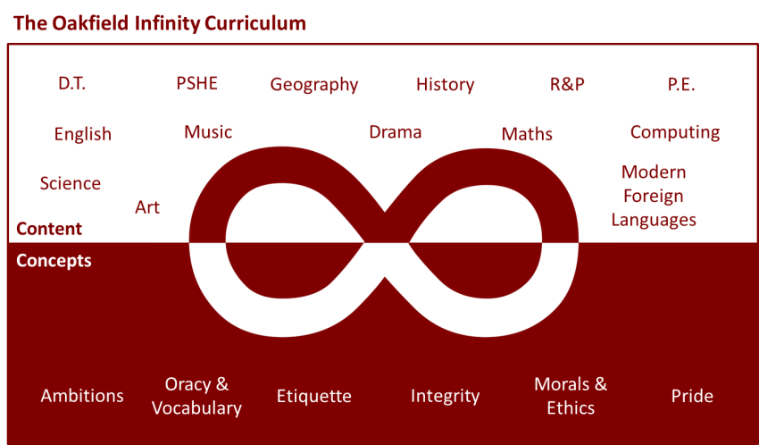

Suggested learning activities you may have missed!
Identify living things: Download and use the Seek app (it’s brilliant!) from inaturalist to find out the plants and animals living near you. Watch this WWF YouTube video clip which shows it being used on a garden safari! (https://www.youtube.com/watch?v=Lp6LL2zOif0)
Earth Squad Go!: Play as Lava, Geo, River or Sky, join the Earth Squad and explore our planet's habitats. Work your way from Rookie to Pro on each of the game's habitats: the vibrant rainforest, the busy city and the wild savannah. Good luck!
(https://www.bbc.co.uk/games/embed/earth-squad-go)

