Oakfield Academy Science Department - Home Learning for Year 6
Week beginning: Monday 5th October 2020

Suggested learning activities for this week:

Watch: This video to remind/teach you about the seven life processes and how we can remember them (MRS GREN): https://www.youtube.com/watch?v=jpO52VTHecQ

Main task: Make a poster which could be used to teach Year 4 children all about the seven life processes. Make sure you explain clearly what each word means. What pictures will you include? How will you make it interesting? Good luck.

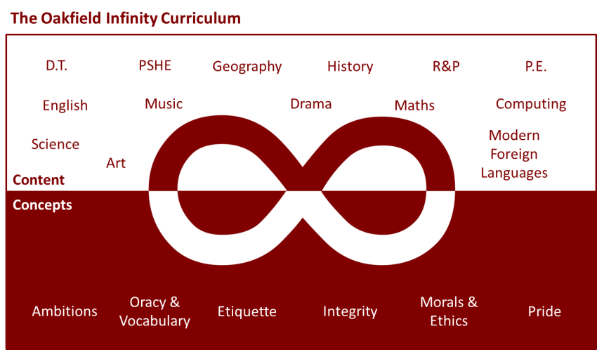

Suggested learning activities you may have missed!
Identify living things: Download and use the Seek app (it’s brilliant!) from inaturalist to find out the plants and animals living near you. Watch this WWF YouTube video clip which shows it being used on a garden safari! (https://www.youtube.com/watch?v=Lp6LL2zOif0)
Earth Squad Go!: Play as Lava, Geo, River or Sky, join the Earth Squad and explore our planet's habitats. Work your way from Rookie to Pro on each of the game's habitats: the vibrant rainforest, the busy city and the wild savannah. Good luck!
(https://www.bbc.co.uk/games/embed/earth-squad-go)

