Oakfield Academy Science Department - Home Learning for Year 6
Week beginning: Monday 12th October 2020

Suggested learning activities for this week:

Task: Have a go at this (recorded) live lesson: https://encounteredu.com/live-lessons/ks2-habitat-exploration-300420
You will need this too so if possible print it off before you start: https://encounteredu.com/uploads/10e-KS2-Habitat-exploration-live-lesson.pdf

Good luck

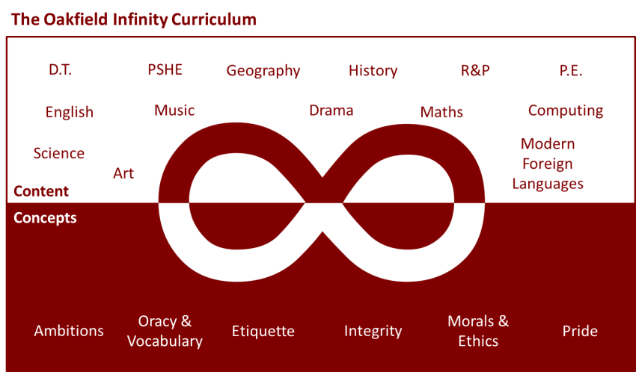

Suggested learning activities you may have missed!
Identify living things: Download and use the Seek app (it’s brilliant!) from inaturalist to find out the plants and animals living near you. Watch this WWF YouTube video clip which shows it being used on a garden safari! (https://www.youtube.com/watch?v=Lp6LL2zOif0)
Earth Squad Go!: Play as Lava, Geo, River or Sky, join the Earth Squad and explore our planet's habitats. Work your way from Rookie to Pro on each of the game's habitats: the vibrant rainforest, the busy city and the wild savannah. Good luck!
(https://www.bbc.co.uk/games/embed/earth-squad-go)

