Oakfield Academy Science Department - Home Learning for Year 6
Week beginning: Monday 22nd June 2020

Message from Mr Gough (Head of Science):
I hope you and your family are well. The next set of home learning tasks are below. As an extra this week I’m suggesting you find out some fascinating facts about animals.

Try to show integrity with your home-learning but also remember excellent scientists do not always find out the answers! Just do your best - have ambition and pride - and don’t forget to email any work or achievements you’re proud of to the Academy Office.

Please keep in touch with me (science@oakfieldacademy.org) - ask me any questions, share your learning or make contact with your usual science teacher. Many thanks to those of you who are already doing so. Please be assured the Science Department email is checked and responded to regularly.
Don’t forget, scroll down for details about the Seek App and the Earth Squad Go! educational game. All the best.

Suggested learning activities for this week:
BBC Daily Lessons: The day for Science learning is Wednesday. This week the topic is ‘Features of sound’. (https://www.bbc.co.uk/bitesize/tags/zncsscw/year-6-and-p7-lessons)
Watch: Here are some video clips about sound: https://www.youtube.com/watch?v=aWieHpsZ7ik&pbjreload=101&scrlybrkr
https://www.youtube.com/watch?v=HblEhc0gses&list=PLQlnTldJs0ZQRzLgW42JXOV_KjtG7TXck&pbjreload=101
https://www.youtube.com/watch?v=NN3x6Fycv98&pbjreload=101
Fascinating facts: Learn incredible facts you'll want to share about some of our planet's most amazing species.
https://www.wwf.org.uk/learn/fascinating-facts

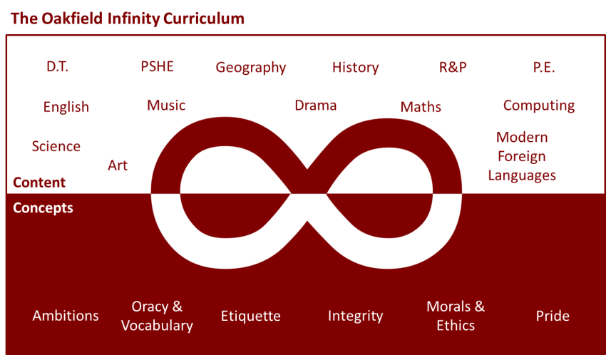

Suggested learning activities you may have missed!
Identify living things: Download and use the Seek app (it’s brilliant!) from inaturalist to find out the plants and animals living near you. Watch this WWF YouTube video clip which shows it being used on a garden safari! (https://www.youtube.com/watch?v=Lp6LL2zOif0)
Earth Squad Go!: Play as Lava, Geo, River or Sky, join the Earth Squad and explore our planet's habitats. Work your way from Rookie to Pro on each of the game's habitats: the vibrant rainforest, the busy city and the wild savannah. Good luck!
(https://www.bbc.co.uk/games/embed/earth-squad-go)

