Oakfield Academy Science Department - Home Learning for Year 7

Week beginning: Monday 5th October 2020

Suggested learning activities for this week:

Explore: ‘What are specialised cells?’ on BBC Bitesize: https://www.bbc.co.uk/bitesize/topics/znyycdm/articles/zfj3rwx?scrlybrkr=4342b790#:~:text=Specialised%20cells%20have%20a%20specific,together%20to%20make%20muscles%20contract.

Main task: Compile a fact-page on one or two specialised cells. Do some extra research if you need to. Make sure you highlight the job that the cell does and the special features (adaptations) the cell has so it can do this job. Don’t forget to do a neat, labelled diagram of the cell. Good luck.

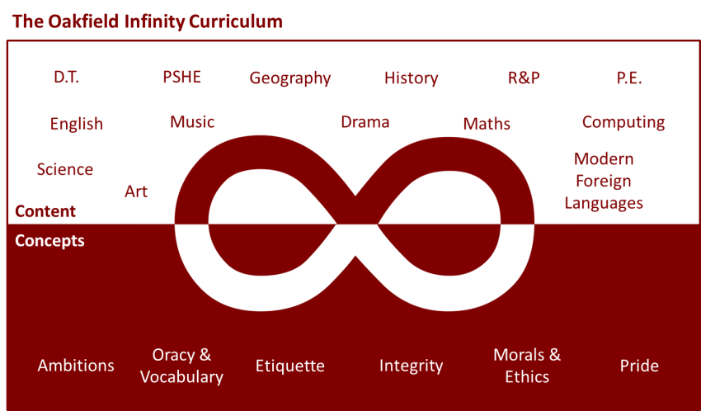

Suggested learning activities you may have missed!
Identify living things: Download and use the Seek app (it’s brilliant!) from inaturalist to find out the plants and animals living near you. Watch this WWF YouTube video clip which shows it being used on a garden safari! (https://www.youtube.com/watch?v=Lp6LL2zOif0)
Earth Squad Go!: Play as Lava, Geo, River or Sky, join the Earth Squad and explore our planet's habitats. Work your way from Rookie to Pro on each of the game's habitats: the vibrant rainforest, the busy city and the wild savannah. Good luck!
(https://www.bbc.co.uk/games/embed/earth-squad-go)

