Oakfield Academy Science Department - Home Learning for Year 8
Week beginning: 8th June 2020

Message from Mr Gough (Head of Science):
I hope you and your family are well. The next set of tasks are below. Monday is World Ocean Day so you have the opportunity to discover what lurks beneath!
Try to show integrity with your home-learning but also remember excellent scientists do not always find out the answers! Just do your best - have ambition and pride - and don’t forget to email any work or achievements you’re proud of to the Academy Office.
Please keep in touch with me (science@oakfieldacademy.org) - ask me any questions, share your learning or make contact with your usual science teacher. Many thanks to those of you who are already doing so. As I am now in the Academy all week the ‘live’ email sessions on Monday and Thursday are not happening but please be assured the Science Department email is checked and responded to regularly.
Don’t forget, scroll down for details about the Seek App and the Bright Ideas competition (Deadline is 19th June). All the best.

Suggested learning activities for this week:
BBC Daily Lessons: (https://www.bbc.co.uk/bitesize/tags/zvdbbdm/year-8-lessons/1) Science learning this week is Tuesday (Biology – Ecosystems and interdependence), Wednesday (Chemistry - Distillation) and Friday (Physics – Features of waves).
WWF Learn to Love Nature - Oceans: To celebrate World Ocean Day discover more about our oceans. Why not join the live broadcast on Monday? (https://www.wwf.org.uk/learn/love-nature/oceans?dm_i=38LF,11M0P,31OXCW,3ZIEA,1)
Doddle: Back due to popular demand! The next set of revisions and quizzes is ready and waiting for you. Don’t forget to repeat the quizzes to improve your scores (until you get 100%!). Deadline is Friday 19th June 2020.
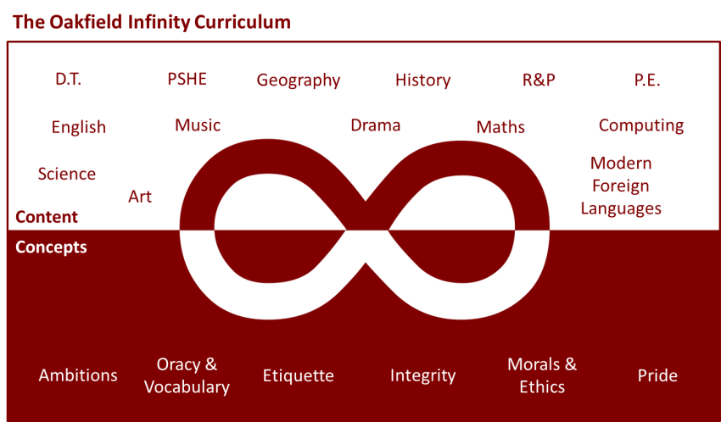

Suggested learning activities you may have missed!
Identify living things: Download and use the Seek app (it’s brilliant!) from inaturalist to find out the plants and animals living near you. Watch this WWF YouTube video clip which shows it being used on a garden safari! (https://www.youtube.com/watch?v=Lp6LL2zOif0)
The Bright Ideas Challenge: What will cities look like in 2050? How will they be powered to be vibrant, healthy and clean places to live? They are the questions you need to answer for this STEM competition. The deadline for entries is Friday 19th June and individual entries are allowed. More information here: Bright Ideas Challenge
Please let me know if you are going to enter.

