Oakfield Academy Science Department - Home Learning for Year 8
Week beginning: 15th June 2020

Message from Mr Gough (Head of Science):
I hope you and your family are well. The next set of tasks are below. Why not get involved with the Great Science Share! This week I have included video clips to supplement the learning – I hope you find them useful.

Try to show integrity with your home-learning but also remember excellent scientists do not always find out the answers! Just do your best - have ambition and pride - and don’t forget to email any work or achievements you’re proud of to the Academy Office.

Please keep in touch with me (science@oakfieldacademy.org) - ask me any questions, share your learning or make contact with your usual science teacher. Many thanks to those of you who are already doing so. Please be assured the Science Department email is checked and responded to regularly.
Don’t forget, scroll down for details about the Seek App and the Bright Ideas competition (Deadline is 19th June – NEXT FRIDAY). All the best.

Suggested learning activities for this week:
BBC Daily Lessons: (https://www.bbc.co.uk/bitesize/tags/zvdbbdm/year-8-and-s2-lessons?scrlybrkr) Science learning this week is Tuesday (Biology – Muscles, tendons and joints), Wednesday (Chemistry – Neutralisation reactions) and Friday (Physics – Density).
Watch: These videos support this week’s learning. Biology: https://www.youtube.com/watch?v=MWdjDv0sf1c&pbjreload=101, https://www.youtube.com/watch?v=hdes6W76OOw&pbjreload=101, https://www.youtube.com/watch?v=3haTJCOkyxA&t=127s&pbjreload=101 Chemistry: https://www.youtube.com/watch?v=-aGRYS7JVd8&pbjreload=101, https://www.youtube.com/watch?v=_cB2vSaalXg&pbjreload=101, https://www.youtube.com/watch?v=xZtqzBgSqnI&pbjreload=101
Physics: https://www.youtube.com/watch?v=MzsORE0ae10&pbjreload=101, https://www.youtube.com/watch?v=fE2KQzLUVA4&pbjreload=101
The Great Science Share: Investigate something of your choice. Be as creative as possible. What question could you answer? Can you link it to sustainability? You need to plan, do and review your investigation. Make sure you take photos and record your findings (here is an example from last year’s blog post). For helpful hints and help getting started look on the website. Share your ideas on Twitter yourself or email them to Mr Gough on the Science email for us to share.
Doddle: Back due to popular demand! The next set of revisions and quizzes is ready and waiting for you. Don’t forget to repeat the quizzes to improve your scores (until you get 100%!). Deadline is Friday 19th June 2020.
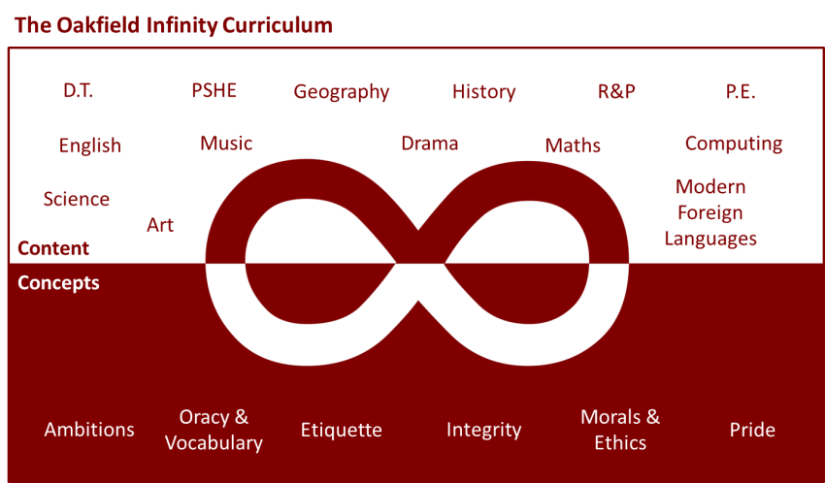
Suggested learning activities you may have missed!
Identify living things: Download and use the Seek app (it’s brilliant!) from inaturalist to find out the plants and animals living near you. Watch this WWF YouTube video clip which shows it being used on a garden safari! (https://www.youtube.com/watch?v=Lp6LL2zOif0)
The Bright Ideas Challenge: What will cities look like in 2050? How will they be powered to be vibrant, healthy and clean places to live? They are the questions you need to answer for this STEM competition. The deadline for entries is Friday 19th June and individual entries are allowed. More information here: Bright Ideas Challenge
Please let me know if you are going to enter.

