Oakfield Academy Science Department - Home Learning for Year 8

Week beginning: Monday 19th October 2020

Suggested learning activities for this week:

Watch: ‘Elements, compounds and mixtures’: https://www.youtube.com/watch?v=nxRGahK7B48

Main task: Make a learning aid to teach KS3 pupils all about elements, compounds and mixtures. You will probably need to do more research before starting.
Make sure you get all spellings correct. Good luck.

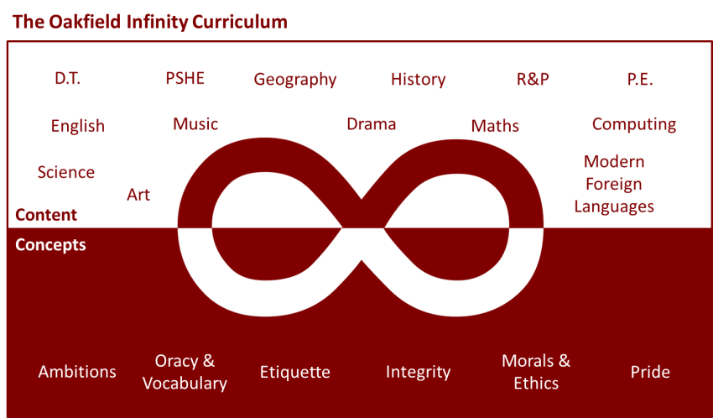

Suggested learning activities you may have missed!
Identify living things: Download and use the Seek app (it’s brilliant!) from inaturalist to find out the plants and animals living near you. Watch this WWF YouTube video clip which shows it being used on a garden safari! (https://www.youtube.com/watch?v=Lp6LL2zOif0)
Earth Squad Go!: Play as Lava, Geo, River or Sky, join the Earth Squad and explore our planet's habitats. Work your way from Rookie to Pro on each of the game's habitats: the vibrant rainforest, the busy city and the wild savannah. Good luck!
(https://www.bbc.co.uk/games/embed/earth-squad-go)

