Oakfield Academy Science Department - Home Learning for Year 8
Week beginning: 29th June 2020

Message from Mr Gough (Head of Science):
Hi, I hope you and your family are well. The next set of home learning tasks are below. There are some more good videos to watch this week. The third biology one is about dinosaurs because they’ve always fascinated me. You may find the first physics one rather challenging but give it a go. I have left the climate change links from last week as I think it is so important that as many of you as possible find out about it.

Try to show integrity with your home-learning but also remember excellent scientists do not always find out the answers! Just do your best - have ambition and pride - and don’t forget to email any work or achievements you’re proud of to the Academy Office.

Please keep in touch with me (science@oakfieldacademy.org) - ask me any questions, share your learning or make contact with your usual science teacher. Many thanks to those of you who are already doing so. Please be assured the Science Department email is checked and responded to regularly.
Don’t forget, scroll down for details about the Seek App. All the best.

Suggested learning activities for this week:
BBC Daily Lessons: (https://www.bbc.co.uk/bitesize/tags/zvdbbdm/year-8-and-s2-lessons?scrlybrkr) Science learning this week is Tuesday (Biology – Evolution – Natural selection), Wednesday (Chemistry – Gases) and Friday (Physics – Orbits, satellites and comets).
Watch: These videos supplement this week’s learning.
Biology: https://www.youtube.com/watch?v=JBEPLuU6q0E&pbjreload=101&scrlybrkr
https://www.youtube.com/watch?v=ehV-MmuvVMU&pbjreload=101&scrlybrkr
https://www.youtube.com/watch?v=e5BFR-E-ae0&pbjreload=101
Chemistry: https://www.youtube.com/watch?v=frFFoiXwqww&pbjreload=101
https://www.youtube.com/watch?v=Wn48reA1vBs&pbjreload=101
Physics: https://www.youtube.com/watch?v=bFdzuTwYo3g&pbjreload=101
https://www.youtube.com/watch?v=Ia1k4Jec1Dc&pbjreload=101
Effects of Climate Change: We’re facing the biggest environmental challenge our species has ever seen. No matter what we’re passionate about, something we care about will be affected by climate change. Find out more here: https://www.wwf.org.uk/learn/effects-of/climate-change
Doddle: The next bumper set of revisions and quizzes is ready and waiting for you. Don’t forget to repeat the quizzes to improve your scores (until you get 100%!). Deadline is Friday 3rd July 2020.

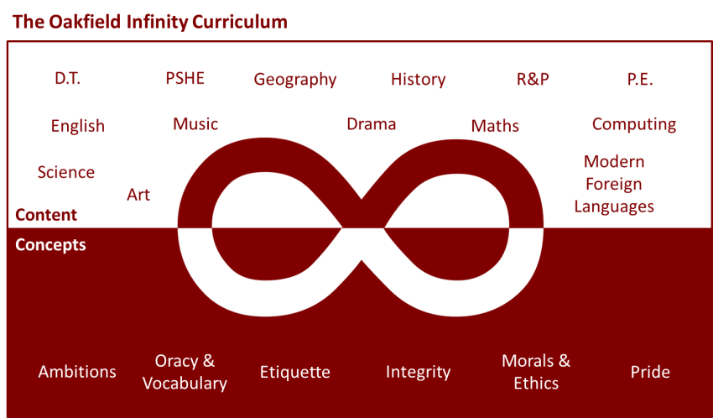

Suggested learning activities you may have missed!
Identify living things: Download and use the Seek app (it’s brilliant!) from inaturalist to find out the plants and animals living near you. Watch this WWF YouTube video clip which shows it being used on a garden safari! (https://www.youtube.com/watch?v=Lp6LL2zOif0)

