4th May 2020

Dear Pupils,
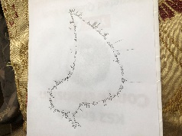
I thought I would be able to sit outside and write this to you as the weather has been fantastic but instead I’m sitting inside looking out at the rain! My children are currently sitting in their pyjamas, writing shape poems and doing some comprehension, but I know that they can’t wait until they can get back on their computers!

I have been amazed and thoroughly impressed with the work you have sent me this week (Year5@oakfieldacademy.org) – Bella has started an Ancient Egyptian project, a story set in the 1800s and some code cracking by another student who has also been gardening, creating a compass, writing about an early morning walk and learning more about Stonehenge; Hugo has been busy helping his sister with her work, playing games, creating fantastic art work, finding out more about nature and baking a fantastic looking cake; Daisy has been baking fabulous puddings!
Please keep sending in examples of what you have been doing – models, baking, gardening, creating new worlds online, walking – anything that you are proud of.
All the teachers are missing you terribly and will be phoning you over the next few weeks.
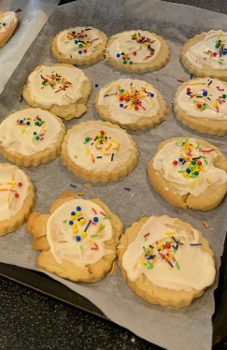
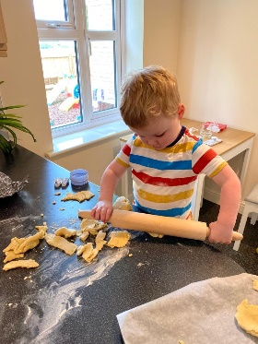
Mrs Roberts and her son Matthew have been busy making rainbow sugar cookies. She says that they didn’t look the prettiest (I think they look lovely!!) but they were delicious and great fun to make!

Here are some of your pictures:
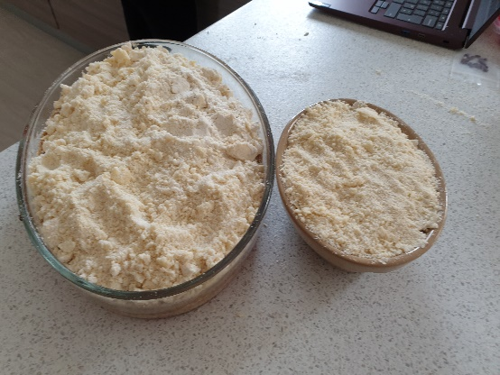
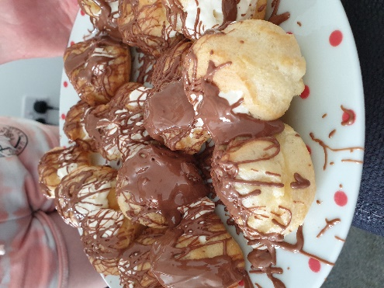
Daisy’s fantastic profiteroles and crumbles!
Creating codes, out in the garden and creating a compass.
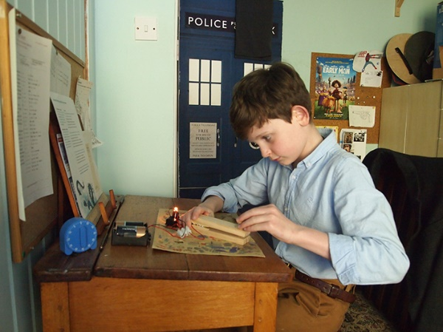
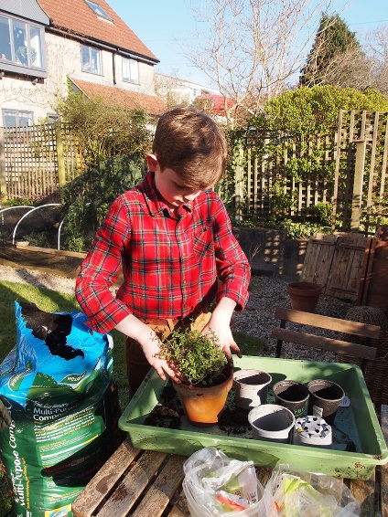
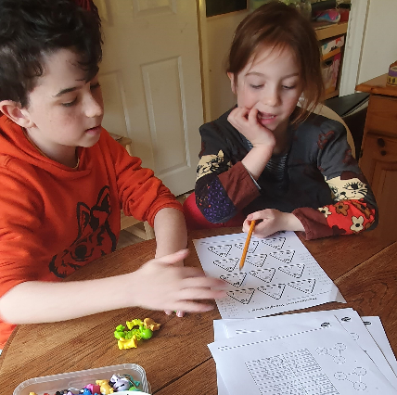
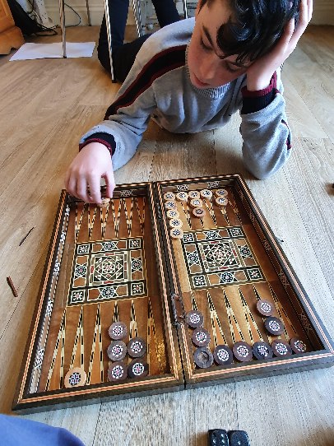
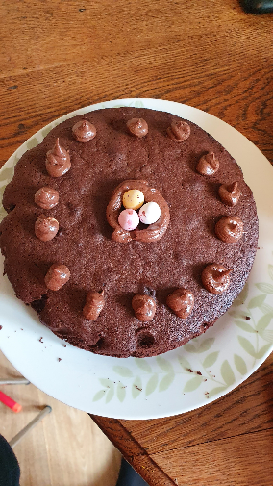
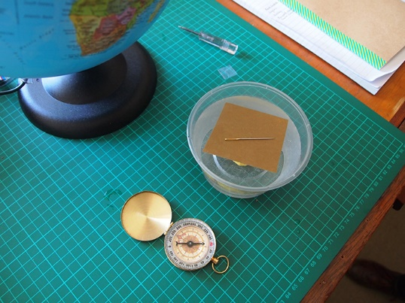
Hopefully the weather will have improved by the time you read this, and I can go back out into the garden and enjoy the sunshine!
I look forward to hearing from you and seeing what you are doing!

If you would like to e-mail Mrs Applegate because you have worries or just to make contact, then please use her new e-mail address support@oakfieldacademy.org.

Take care and stay safe.

E Green
Mrs Green
Head of Year 5
Year5@oakfieldacademy.org
Hugo teaching his sister, playing backgammon and baking – that cake looks amazing!

