4th May 2020

Dear Pupils,

I hope this letter finds you and your families all well and that you are still managing to keep busy.
Your tutors have let me know how you are all getting on after they have called you which is really good to know. If they have not contacted you yet they are working to get to you all over the next few weeks. But don’t forget you can contact us through Year7@oakfieldacademy.org, just get a parent to email in your questions and they will be passed on and replied to as soon as possible.
I have been receiving examples of some brilliant work this week so it is good to know that you are engaging well with the Little Lessons, BBC and Oak Academy work and also being inventive in what you are doing.

As for me I am keeping busy by playing football for my youngest son and sorting out my garden. I have just bought some vegetables and flowers to plant. Let’s hope the good weather continues so that I can get them planted. Yes, I know – Gardner by name and gardener by nature!! I am also spending some time doing work for school every day and teaching my own two children, which is very different to teaching all of you.

The other tutors wanted to show you a little of what they have been up to: Mr Stephenson has been busy with a Star Wars and stadium jigsaw; Miss Sanders has been puppy sitting; and Ms Parsons has been experimenting with her hair, enjoying walks listening to music and cooking scrummy food. I hope you enjoy the photos!

If you would like to e-mail Mrs Applegate because you have worries or just to make contact, then please use her new e-mail address support@oakfieldacademy.org.
Please stay safe and well and make contact via the email addresses you now have if you have questions. Also don’t forget to check out the weekly newsletter to see what others have been doing and get tips and ideas.

R Gardner

Mrs Gardner
Head of Year 7
Year7@oakfieldacademy.org
Mr Stephenson’s jigsaws

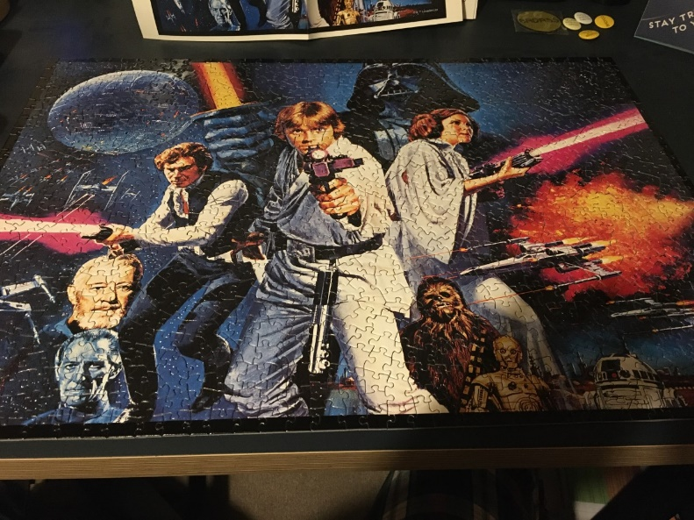

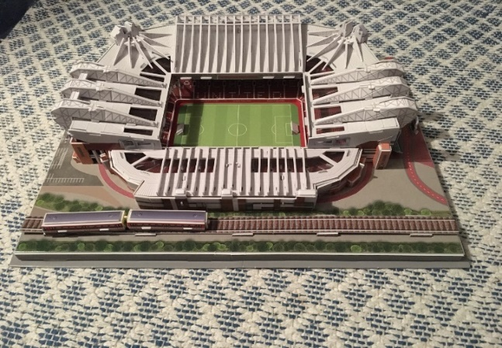

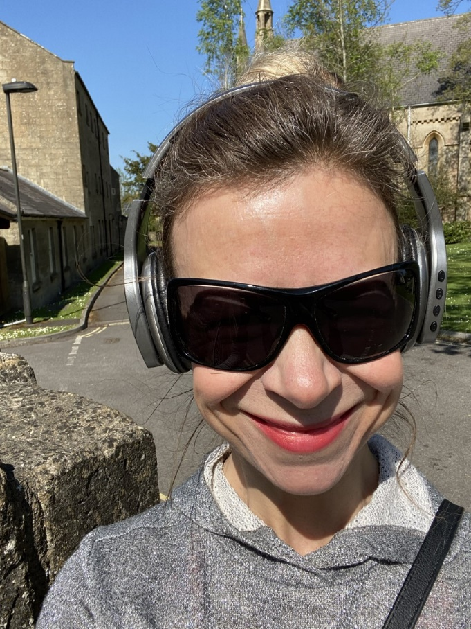
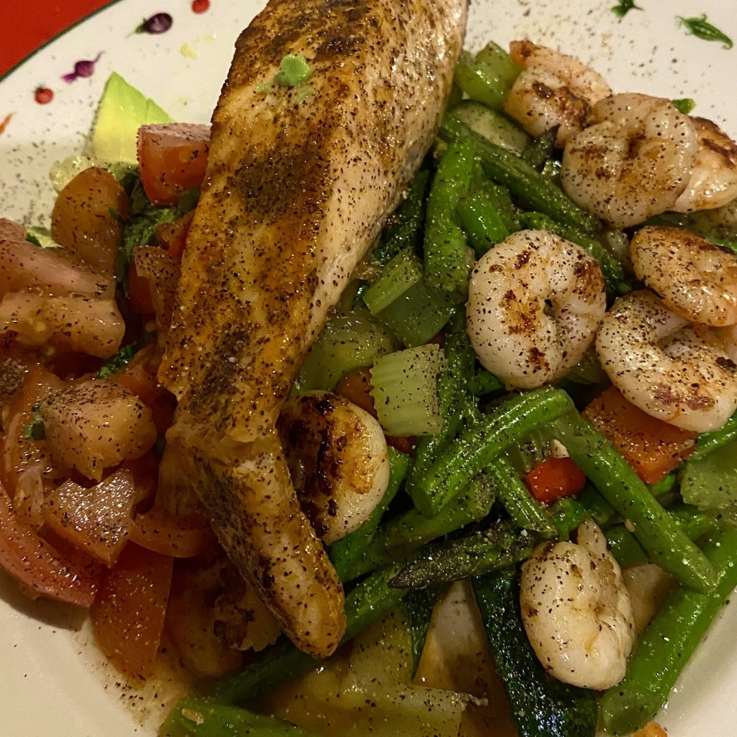
A Day in the life of Ms Parsons!

