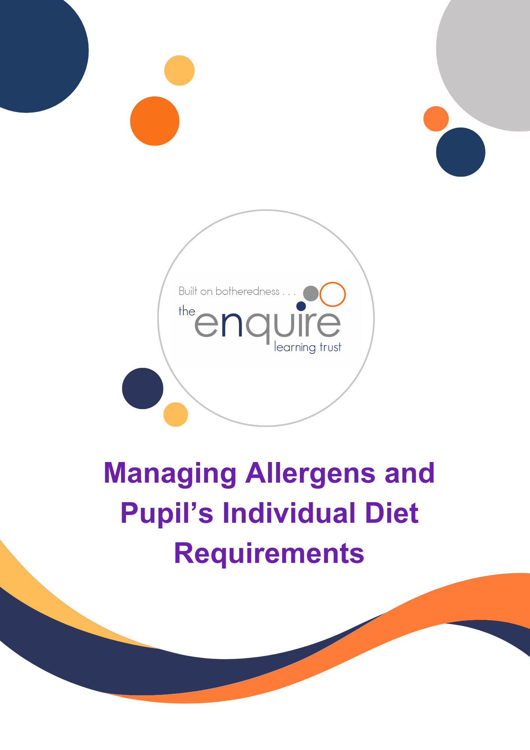

Contents
 | Description | Page
 | Summary  - Arrangements  - EYFS Specific variation | 3
 | Cook / Catering Manager sign off sheet | 5
 | Catering team sign off sheet | 6
 | Allergen breach and near miss reporting procedure and contact numbers | 7
 | Step by step guide | 8
 | Managing allergens and special diet requirements | 9
 | Special diet traffic light colour coding Chart | 12
 | Reporting a near-miss form | 13
 | Reporting an allergen breach form – link to SharePoint | 14

Version History
Approved by: | Trustees
Last reviewed: | July 2026
Next review due by: | July 2027

Date | Author | Version | Comment
Sept 2024
Sept 2025 |  |  | Reviewed and included Allergen Breach reporting form on SharePoint.
Jul 2026 |  |  | Reviewed and updated to reflect Benedict’s Law

Summary
Special diets are a very important part of the ELT catering provision in schools. Allergen procedures are essential in ensuring that the needs of individual pupils can be safely met. The successful implementation of this policy and the allergen management procedure requires the commitment and support from all employees to achieve this.

The following arrangements apply:
It is important for the safety of our pupils the school has accurate and relevant allergen information on the foods that it produces and serves. The information on the 14 allergens will be recorded on the ELT’s recipes/menus and the allergen Matrix.
Working with suppliers, allergen information is uploaded onto our recipe database. All recipes are kept on this database where each ingredient is clearly listed. This is why it is important to follow recipes. All cooks have access to this database and all staff can request access.
It is our legal obligation to provide accurate allergen information about the foods that we produce and serve. To support this process, we need schools to provide us with up to date and accurate information of pupils that have allergies or intolerances.
Where we have been informed of a pupil with severe allergies or who has suffered from anaphylactic symptoms they will be categorised as RED and will be treated in line with the procedures set out. Other pupils with an intolerance will be categorised as AMBER.
Some families and pupils may have a dietary preference based on religious or lifestyle, choosing to exclude or include certain foods. These pupils will be categorised as BLUE.
Working with the academy we will seek to make the relevant information available to parents/carers of pupils who have food allergies.
Photos and allergy requirements of pupils should be supplied by the school/academy to the kitchen, in hard copies.
Pupil images must be on a coloured backing which corresponds to the type of special diet they have (RED, AMBER, BLUE) A copy of these images should be clearly displayed in the kitchen (if space allows) or retained in the ‘purple allergen folder’ along with any medication requirements.
The whole school must be briefed on requirements and made aware of allergies and special dietary requirements.
Pupils with severe allergens (RED) and intolerance (AMBER) will be identified by a lanyard in the corresponding colour.
Lanyards will be issued each lunchtime by a member of the school team, prior to pupils entering the dining room.
The catering team and the dining room staff will then check the corresponding images for the pupil they are serving, to ensure they receive the correct meal.
When pupils have finished their meals, they will hand their lanyards back to a member of the school team, to be returned to the office and redistributed the following day.

EYFS Specific variation
Within EYFS settings, a designated lead will be responsible for overseeing meals for any pupils that have allergens or special dietary requirements. Pupil information will be contained within a ‘purple folder’ specifically for EYFS pupils only. A copy of the information will be maintained within the kitchen allergen folder And also on Brom Com.
Should there be a near miss or allergen breach the catering team must report this immediately to the Principal. For a near miss the catering team must complete a near miss form and return it to the catering email the same day. If an allergen breach occurs the academy must report this the same day using SharePoint.

WRAP AROUND
Where food is provided during wrap around care the same processes identified within this document should be followed.

Cook / Catering Manager and Business Manager Sign-off
I confirm that I have read and understood the contents of The Enquire Learning Trust’s managing allergens and individual diet requirements and the allergen management procedure ‘purple folder’.
As cook/catering manager and Business Manager, I am aware that it is my responsibility to ensure that all new and existing team members have read through the ‘purple folder’ and understand the allergen process for the .school
I am responsible for ensuring this document is kept up to date.
Name | Title | Date | Signature

Employee Sign-off – This document is to be uploaded onto Flick training so that it can be tracked that the policy has been read. Hard copy for the catering team to be retained in the Kitchen.
I confirm that I have read and understood the contents of The Enquire Learning Trust’s managing allergens and individual diet requirements and the allergen management procedure ‘purple folder’.
I can confirm that managing food allergies is a team responsibility and I have a part to play in keeping children safe. I should never guess or attempt to answer any questions I am not fully confident in answering.
Name | Title | Date | Signature

ALLERGEN BREACH
Near Miss Reporting Procedure

In the event of ANY allergen or a near miss incident with in the kitchen or dining hall, please follow these steps:
- Report any incident however small to the school’s Principal (if unavailable report to Business Manager).
- Report the incident to your Area Support Manager
- If unable to reach your Area Support Manager. Please contact the central catering team (ELT Central Catering)
- For near miss incidents please complete the appropriate form and share a copy with your business manager and the central catering email.
- For breaches complete the Allergen Breach Reporting form on SharePoint – link below:
ELT Allergen Breach Form

Angie Gilby, Area Manager – NEL Hub
angie.gilby@enquirelearningtrust.org
07542 027 450

Tracey Seddon, Area Manager – West Hub tracey.seddon@enquirelearningtrust.org
07524 027452

Alison Earnshaw-Akers, Area Manager – North Hub
alison.earnshawakers@enquirelearningtrust.org

07542 027453

ELT Central Catering catering@enquirelearningtrust.org

Step by step guide
Parents / Carers to contact school and request a special diet.

Complete and return the medical diet form along with medical evidence where approporiate.

Speak to the business manager and cook to confirm menu if necessary.

School admin to update BromCom and notify the appropriate staff,
including wraparound services.

Information to be reviewed termly.

Cook to communicate this to the kitchen team and the catering area support
and ensure the ‘Purple Folder contains the most up to date information.

Pupil to be allocated either a RED or AMBER lanyard

Preservice brief to take place.

Pupils to be identified by their coloured lanyard and
corresponding photograph when they come to the counter
and the appropriate meal to be served.

EYFS Meal Handover

Meals for EYFS to be handed over to the designated EYFS lead with
Allergen meals clearly identifiable.

Managing allergens and special diets
Please follow the steps below:
Process | Control | Why
The parent /Guardian/Carer will need to:  - Inform the school/academy of their pupil’s allergy as soon as possible.  - Complete the special diets/allergen form and return to the school, providing a medical support for food allergies.  - Where necessary meet with the cook/business manager/allergen lead to discuss any specific requirements relating to their pupil’s allergy. Information from these meetings to be recorded on the special diets form by the business manager and communicated to the cook/catering area support and all school staff.  Designated school allergen lead will need to:  - Give a copy of the special diets/allergen form to the cook.  - Record the information on BromCom (completed by relevant member of the administration team)  - Issue an update for the allergen board/ purple folder to the kitchen.  - Give the pupil an identifiable lanyard.  - Notify appropriate staff including teacher / TA / dining room staff and first aider(s) as required.  - Review all special diet/allergy forms on a termly basis to ensure any changes are documented and communicated to the kitchen teamteacher / TA / dining room staff and first aider(s)  - Ensure special diet / allergy wall information is shared as necessary with breakfast club staff / wrap around staff should food be consumed during these times. | To ensure we have the most up to date information | To enable the school/ catering team to reduce the risk of exposure to allergens.
The Cook will need to:  - Once the cook receives a copy of the medical diet form, they MUST inform their team as soon as possible.  - Ensure that the ELT’s allergen policy and procedures are followed at site level.  - Liaise with the business manager/allergen lead. To identify which pupil has special dietary needs and use the school’s procedures to identify them through appropriately coloured lanyards / special diet or allergen board within kitchen.  - With the business manager/allergen lead meet with any parents to discuss the pupil’s requirements. Agreed outcome from any meeting should be recorded on the special diet form and Brom Com With a copy placed in the ‘purple folder’  - Ensure that ALL staff are aware of all the information relating to pupil’s and their allergies.  - Bespoke Menu – each special dietary requirement should be backed up with a menu for the pupil with the meals required to meet their daily requirements. | All staff have read the ELT’s allergen policy.  Identify the pupil’s dietary requirement, complete the special diets form and purple lanyard given to pupil.  Gaining the most recent / relevant information from parents around their pupil’s allergies | To ensure that all meals are served in accordance with ELT allergen procedures and pupils are served safe food.  To ensure we have the most up to date information and an added layer of control using visual identification for pupils at the service point.  To ensure all catering team have the relevant information

Process | Control | Why
- When allergen board is updated, The Business Manager is to ensure that the information is shared with all staff and the cook is to ensure that information is shared with all catering staff.  - Sharing of information (Termly) regarding special diet / allergies from Cook to midday / lunchtime supervisors to ensure full awareness of any requirements.  - Ensure that when requests are made for trip related packed lunches that dietary / allergy information is taken into consideration and that all pack lunches provided by ELT kitchens contain an allergen matrix form. This is to be added to the front of each bag along with the pupils name  - Follow all recipes to ensure that allergen information is correct and up to date.  - Complete the daily allergen matrix and the pre-service brief, making sure to sign and date when completed.  - Check substitute product packaging before use/consumption as the packaging will carry the manufacturer/suppliers up to date information and updated allergen and MAY CONTAIN information.  - Plate up and cover meals for RED allergen pupils. Labelling them with their names prior to service. | All staff have read the ELT’s allergen policy.  Identify the pupil’s dietary requirement, complete the special diets form and purple lanyard given to pupil.  Gaining the most recent/relevant information from parents around their pupil’s allergies.  Avoids miscommunication and reduces the risk of cross contamination.  To ensure all catering team support and agency staff have the relevant information.  Ensure most recent and relevant information is cascaded to all staff. | Reduces the risk of serving a pupil with the wrong meal.  To ensure that all meals are served in accordance with ELT allergen procedures and pupils are served safe food.  This is vital so that all catering staff are aware of the food allergies contained in the prepared food.  Different brands may have different potentially allergenic ingredients
Complete allergen training on flick learning and ensure all staff have been trained, ask for a copy of their training certificate, and keep this in the ‘staff training folder’ | Staff training | This is vital to ensure staff have the most up to date allergen information
Immediately report any concerns or issues to your business manager/ catering area support. | Review | Reduce the risk of a potential near miss / allergen breach

Special Diets
To ensure the safety of children, ELT use a traffic light colour coding system, the following procedures categorises the child depending upon their needs.

Colour | Severity of a reaction | Control
Red | Severe reaction / anaphylactic symptoms disclosed with Epi-pen | Will have an agreed plated meal prepared covered labelled with pupil’s name and served by an allocated member of the team.
Amber | Food / allergen intolerance non-disclosed medical intervention | Will have a meal prepared and served by an allocated member of the team.
Blue | Excludes foods due to lifestyle preference | Will be a suitable meal served from the counter
The information should be provided using the allergen / special diet form and supported by medical evidence where appropriate. The information on this form will be used to categorise the pupil’s dietary needs. An upto-date photo of the pupil should be supplied, with allergen/medical information and put on the allergen board/wall in the kitchen along with a copy in the purple allergen folder located in the kitchen.
At the beginning of each term the school must confirm all medical diets and photos of pupils are up to date. In addition, the school must provide this information for new pupils or any changes throughout the year.

Once the procedures above have been followed and a menu agreed for the pupil, the following controls MUST be in place at all times:
Red Category controls – The cook must communicate to the kitchen and dining room staff when food for the RED category is being prepared. Where possible this should be in a separate area, if this is not possible then separated by time from other foods containing allergens. Prior to preparation the area and all equipment MUST be thoroughly cleaned using the 2- stage cleaning method and / or dishwasher to prevent cross contamination. When preparing the meal, the Cook must thoroughly wash their hands and wear a disposable plastic apron over their uniform to prevent cross contamination. Care must be taken at all stages to prevent any allergen cross contamination including storage of ingredients, preparation cooking and serving.

Amber Category controls – The cook must communicate to the kitchen and dining room staff when food for the AMBER category is being prepared. Where possible this should be in a separate area, if this is not possible then separated by time from other foods containing allergens. Prior to preparation the area and all equipment MUST be thoroughly cleaned using the 2- stage cleaning method and /or dishwasher to prevent cross contamination. When preparing the meal, the Cook must thoroughly wash their hands and wear a disposable plastic apron over their uniform to prevent cross contamination. Care must be taken at all stages to prevent any allergen cross contamination including storage of ingredients, preparation cooking and serving.

Blue Category controls -Can be served from the counter ensuring that they are served the correct meal, and no cross contamination has taken place. All staff in the kitchen and dining room must be briefed before service by the cook.

A pre-service brief identifying all allergens and which special diet meals are being served and to whom must take place each day.

Allergens, Intolerances and Special Diet Requirements


Traffic light colour chart

Severe Allergies
Anaphylaxis – (anna-fill-axis)
Is an acute, severe allergic reaction needing immediate medical attention. It usually occurs within seconds or minutes of exposure to a certain food or substance but on rare occasions, may happen after a few hours.

Intolerances
Food intolerance is a reaction to food that causes unpleasant symptoms. When someone is sensitive to a food in this way, they will react every time they come into contact with it. There is currently no cure for food intolerance / allergy, so the only way to prevent a reaction is to avoid that particular food.

Religious diets and ethical requirements
Some of these groups follow lacto-vegetarian diets.
(Avoid meat, fish and eggs)

Near Miss Report Form
A near miss is an event that could potentially have resulted in a negative outcome. We want to prevent these happening.
In the event of ANY allergen or a near miss incidents within the kitchen or dining hall please follow these steps
- Report any incident however small to the school’s Principal (if unavailable report to Business Manager).
- Report the incident to your Area Support Manager
- If unavailable contact the central catering team (ELT Central Catering)
- For near miss incidents please complete the below form and share a copy with your business manager and the central catering email. catering@enquirelearningtrust.org

School: | Time: | Date:

Please answer questions below:

What happened?
When did it happen?

Where did it happen?

Who was involved?

What caused it?
Any further comments please state.
Name: | Signature:
Reporting an Allergen Breach
In the event of an allergen breach, please notify the Principal immediately – see procedure on page 7 of this policy.
Once you know the pupil is no longer at risk, complete the Allergen Breach Reporting form on SharePoint – link below:
ELT Allergen Breach Form

