
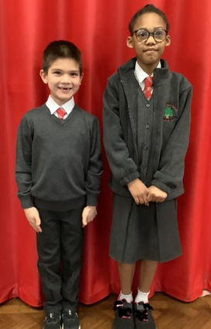

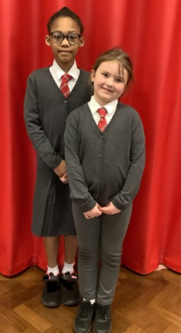
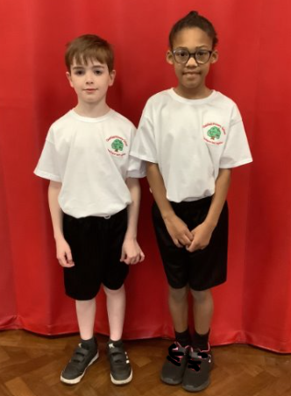
PE KITS
All children should have an indoor PE kit:
- White T -shirt or Polo shirt (with or without Logo)
- Black Shorts
- Black school pumps or black trainers.
Children also need an outdoor PE kit during the colder months (October – March):
- Black leggings/ tracksuit bottoms
- White T Shirt or polo shirt – School Jumper or fleece can be work if needed.
- Outdoor trainers
Children will come to school in their kit on PE days
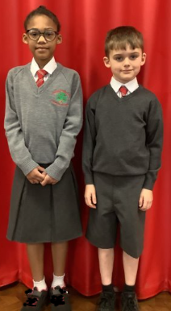

BOYS UNIFORM SEPTEMBER 2025
- Grey trousers/ Shorts
- White shirt with collar
- School Tie (to be issued mid – June)
- Grey V neck jumper - Available at KIDZstop with the school logo. (plain grey V neck can also be worn and are available at ASDA online, Sainsburys, Matalan)
- Grey/black/white socks
- Children should wear ALL black school shoes.

Below are the details about the uniform from September 2025
Children will be expected to wear full uniform from Reception to Y6 – nursery children have the option of wearing a white polo shirt and no tie.
The only jewellery permitted is a small pair of stud earrings (which will need to be covered with plasters from home during PE sessions) and a watch. No false nails are to be worn.
If you would like any more information, please contact school.

GIRLS UNIFORM SEPTEMBER 2025
- Grey skirt/ trousers/ pinafore
- White shirt with collar
- School Tie (available in school on MCAS)
- Grey V neck jumper with logo available at KIDZstop or without the school logo. (plain grey V neck are available at ASDA online, Matalan, Sainsburys)
- Grey, Black or White socks. Black or Grey tights.
- Red School Summer dress – White socks and black shoes/trainers
- Children should wear ALL Black school shoes or trainers.

Uniform News

