Class 1 - Progression in Writing
Early Steps  Making Marks | I explore making marks, but I do not communicate meaning.  Random scribbling.  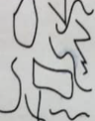 | I draw basic pictures.  I use lines to look like writing. Scribble writing  Left to right direction  I begin to assign meaning.  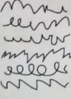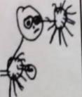 | I write symbols and shapes that look like writing.  I assign meaning to the marks  Attempts to write name  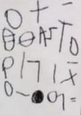 | I write random letters but there is no connection between letters and sounds. I talk about my writing and give meaning.  Writes name from memory  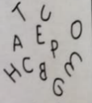 | I use letter strings which travel from left to right and top to bottom.  I attempt to ‘read’ my writing.  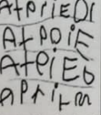 | I write letters with spaces between them to resemble the idea of words. | I copy words that I see in the environment around me.  I often do not know what the words say.  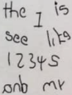
Developing Writing  Words | I am beginning to hear initial sounds and attempt to write these down.  m - mum  letter for name | I can hear initial sounds in words and write the letters down to match.  c - cat  d- dog  p - pig | I can write short strings of letters to represent words. Two or three letters in sequence. Hearing /writing final sounds first and then medial. Left to right.  muy - mummy  pto - potato | I can spell out and write down vc cvc words by matching letters and sounds.  at in up  cat  dog  pig | I can write High Frequency decodable and tricky words from memory.  mum dad. and can  I go to the no into | I can spell out words with consonant clusters, vowel digraphs and trigraphs.  buzz fill. mess  ship. chip thing rush  boat sheep now soil  chair night. Pure. | I write more challenging words with a sound knowledge of Phase 2, 3 and 4 phonics Plausible attempts  Phase 2, 3 and 4 HF words  Adjacent consonants
Developing Writing  Sentences | I can formulate and say a simple sentence for writing. | I can orally compose a sentence and hold it in my memory before I start to write it.  Repeats & recalls | I can write a series of beginning letters and sounds for my phrase. There may be no spaces between words.  Begins to be readable to others.  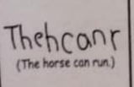 | I can recall the order of words in my sentence. I start to put finger spaces between my words and to use known words. Writing is readable. I start to read my sentence. | I am beginning to write a sentence with a full stop and capital letter. I can re-read it and check that it makes sense. Others can read my sentence.  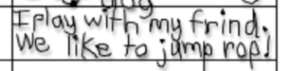 | I can write spaces between most of the words in my sentences. Some punctuation may be used. | I can write two or more sentences. Most sentences have the correct beginning and end punctuation.
Text forms and purposes | I attempt to write simple labels. | I can write simple labels | I can write simple lists. | I can write short captions and messages.  I can write lists and cards | I can write captions | I can write simple sentences. | I can write sentences.

