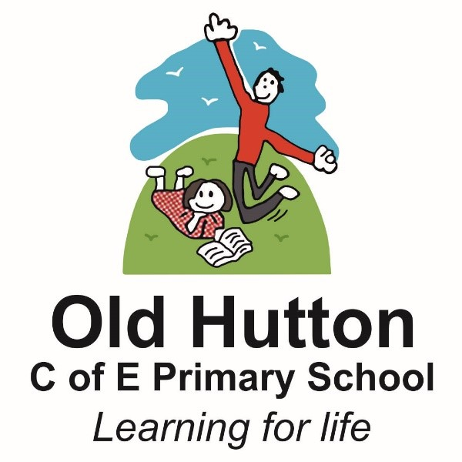

Old Hutton C of E Primary School
Music Strategy 2025
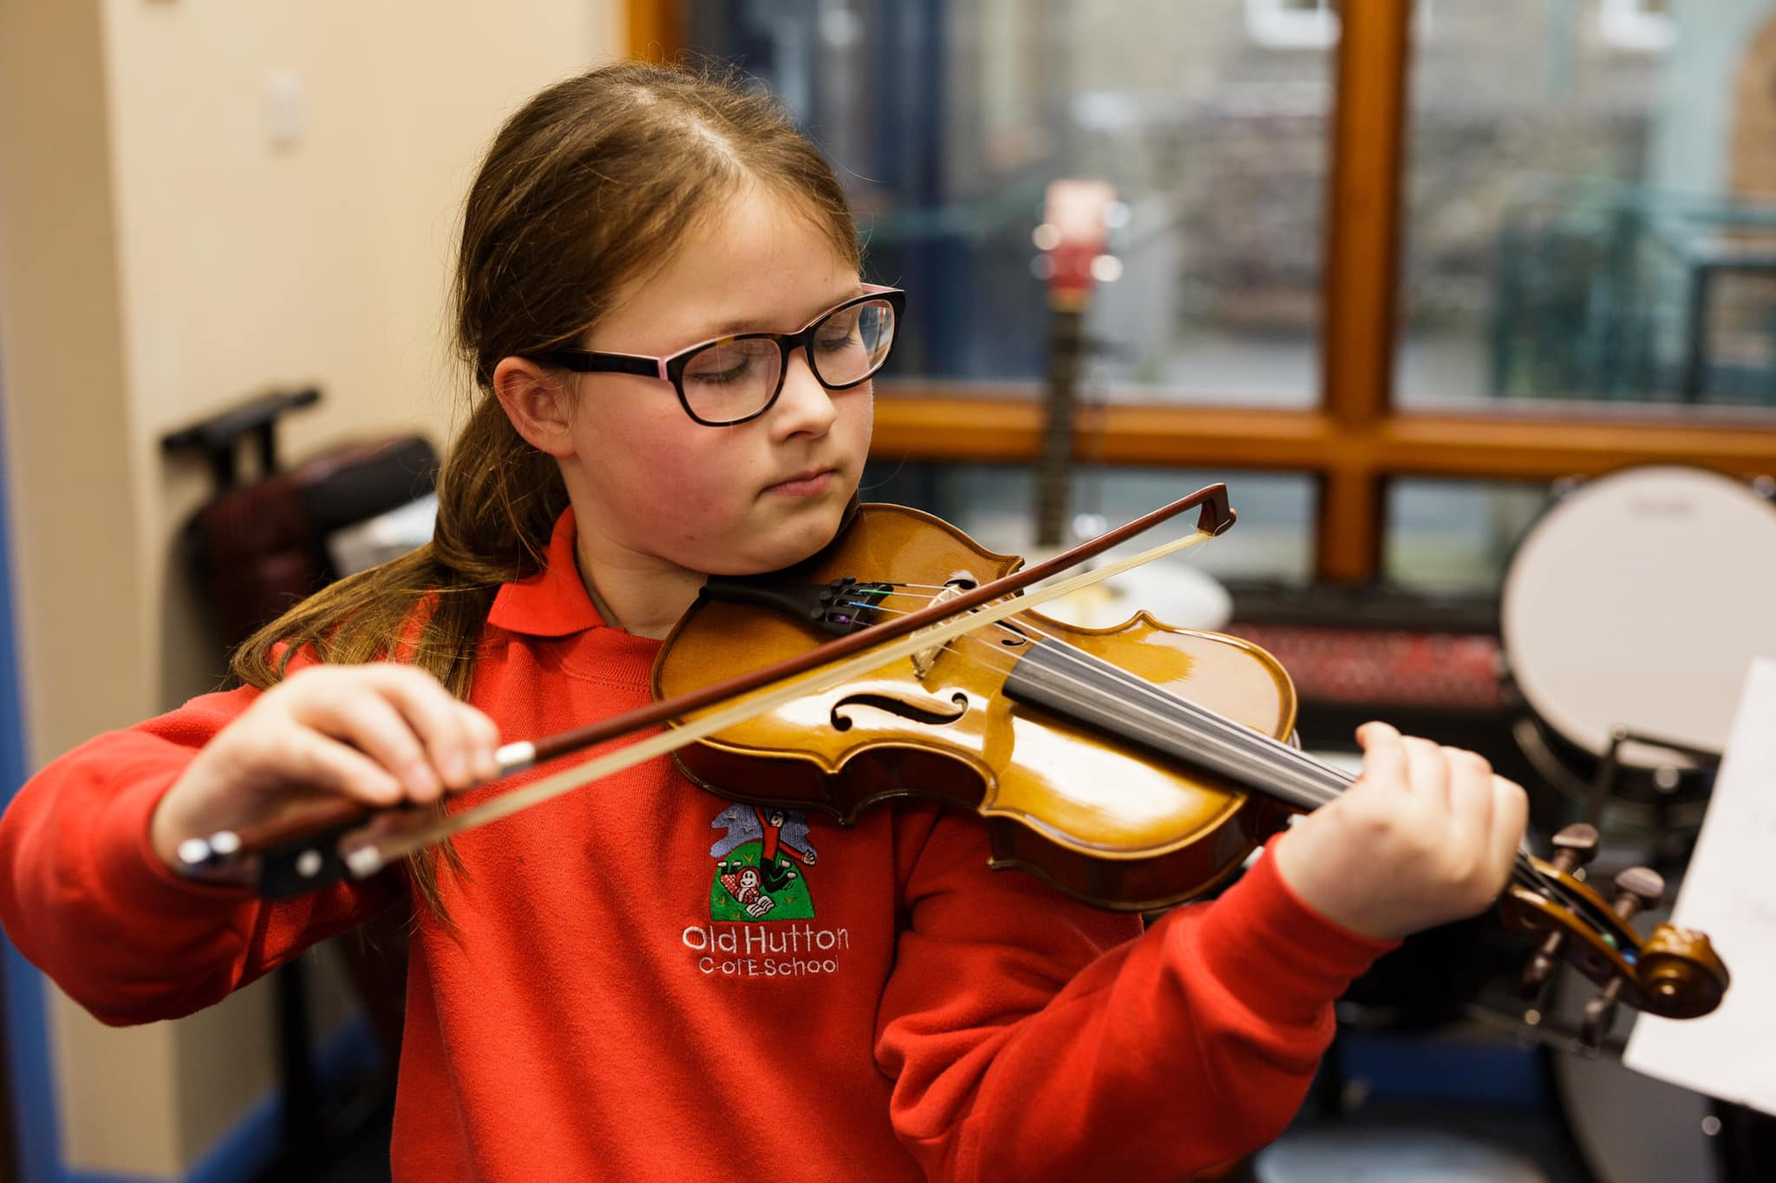

Music development plan summary:
Old Hutton C of E Primary School
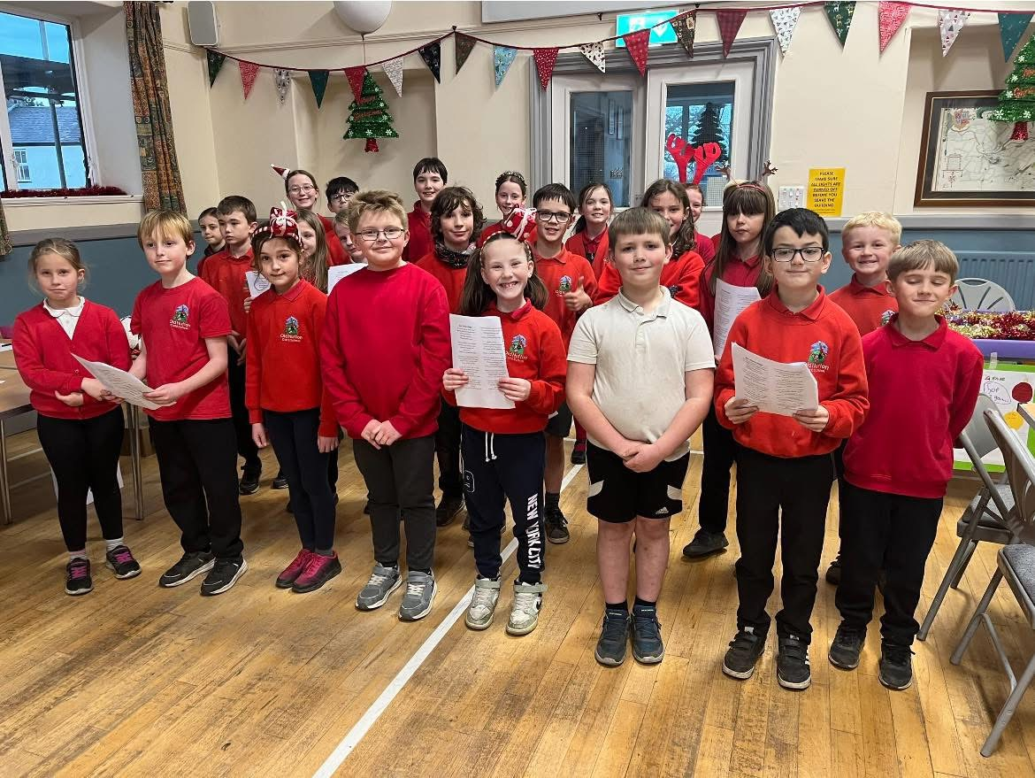

Overview
Detail | Information
Academic year that this summary covers | 2025 -2026
Date this summary was published | September 2025
Date this summary will be reviewed | September 2026
Name of the school music lead | Katie Brown
Head teacher | Nick Turley
Name of local music hub | Cumbria Music Hub
Name of other music education organisation(s) (if partnership in place)

This is a summary of how our school delivers music education to all our pupils across three areas – curriculum music, co-curricular provision and musical experiences – and what changes we are planning in future years. This information is to help pupils and parents or carers understand what our school offers and who we work with to support our pupils’ music education.

Curriculum music
This is about what we teach in lesson time, how much time is spent teaching music and any music qualifications or awards that pupils can achieve.
Our Curriculum is based on National Curriculum https://assets.publishing.service.gov.uk/media/6061f6a3e90e072d94e6f920/Model_Mu sic_Curriculum_Key_Stage_1__2_FINAL.pdf
https://assets.publishing.service.gov.uk/media/6061f6a3e90e072d94e6f920/Model_Music_Curriculum_Key_Stage_1__2_FINAL.pdf
https://assets.publishing.service.gov.uk/media/6061f6d4d3bf7f5cdf624d3a/Model_Music_Curriculum_Appendices.pdf

Music Strategy Summary
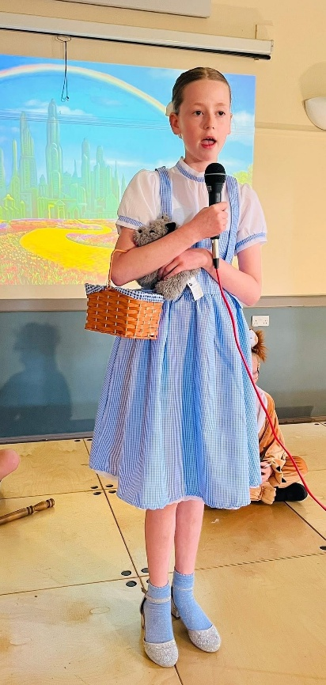
Our music education program is deeply embedded within the curriculum, providing a rich and progressive musical journey for all pupils from Early Years Foundation Stage to Year 6. Using Charanga and Purple Mash as a framework, we deliver engaging and structured lessons that develop musical skills and understanding. Our well-resourced approach ensures a clear progression of instrumental learning, supported by inspiring performances, expert visitors, and strong partnerships with Cumbria Music Hub. These elements collectively create a vibrant musical environment where pupils are inspired to explore and develop their musical talents.
Participation in events like Young Voices and the Brewery Arts events enriches pupils’ musical experiences and aspirations. Through these strategic partnerships and a commitment to excellence, we aim to equip our pupils with the skills, knowledge, and confidence to become lifelong music enthusiasts.

Co-curricular music
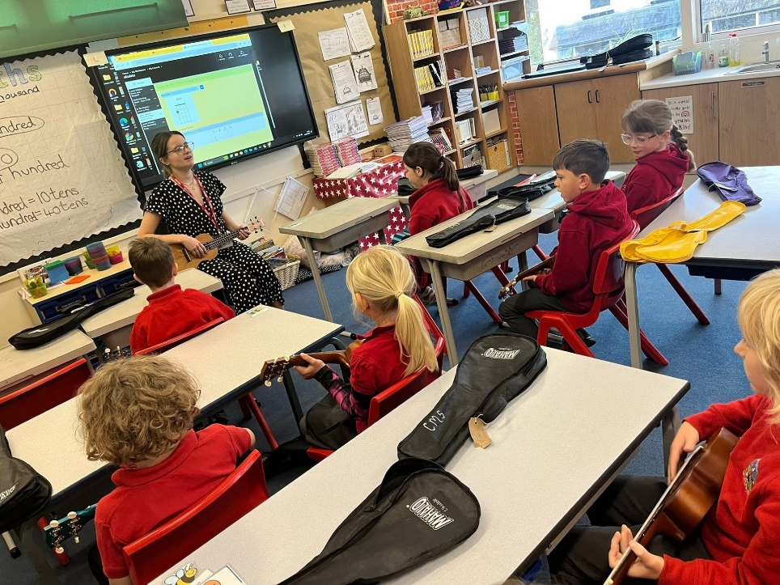
This is about opportunities for pupils to sing and play music, outside of lesson time, including choirs, ensembles and bands, and how pupils can make progress in music beyond the core curriculum.
Children in KS2 have the opportunity to sing in the Young Voices school choir and take part in performances out of school e.g. carol singing in town. Children who learn an instrument with a Cumbria Music Service tutor take part in a performance for parents either on-site or as part of the Cumbria-wide Big Play initiative.
KS1 children often take part in the Big Sing annual event where they learn songs and sing together with other local schools at a nearby venue.
Peripatetic music teachers come into school every week to teach 1-1 lessons to pupils in keyboard, drums and guitar.

Musical experiences
This is about all the other musical events and opportunities that we organise, such as singing in assembly, concerts and shows, and trips to professional concerts.
• Weekly/Daily singing in worship time
• Weekly singing practice
• Termly music concerts to showcase pupil’s class ensembles and peripatetic
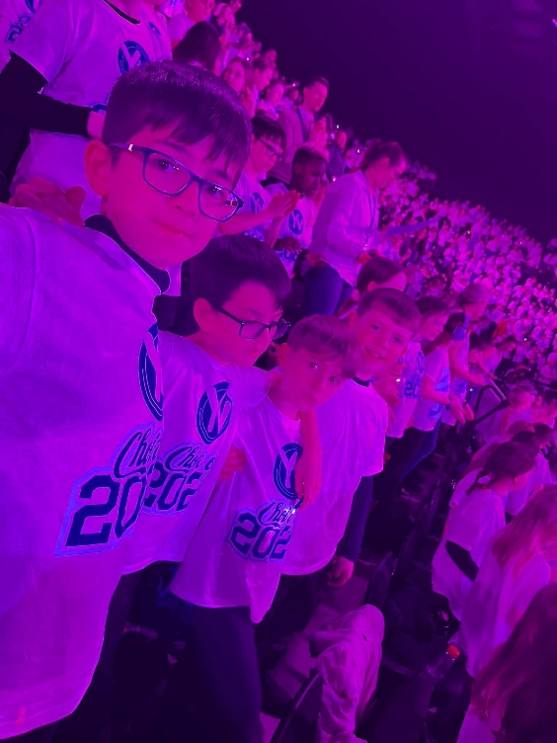
• Young Voices – Feb (30 children)
• Reception/KS1 – Nativity (Dec)
• Key Stage 2 Play – Spring term
• Kendal College production
• Christmas carol service
• Carols in the community – Booths Windermere/Kendal
• Pantomime experiences – EYFS, KEY STAGE 1 and Y6
• Kendal Torchlight
• Drum Nation workshop for Torchlight
• Recording studio opportunities
• Working with Cumbria Music Hub to enrich music opportunities including; Ukulele, Keyboards, Flutes, and drums.

In the future
This is about what the school is planning for subsequent years.
- Music Club
- Local Concert opportunities
- Nursing home choir trips
- Musical theatre trips
