At Ormskirk School, we are extremely lucky to have a brilliant team of highly accomplished musicians who deliver individual music tuition and also contribute to our exciting extra-curricular music programme. We currently offer the following tuition:

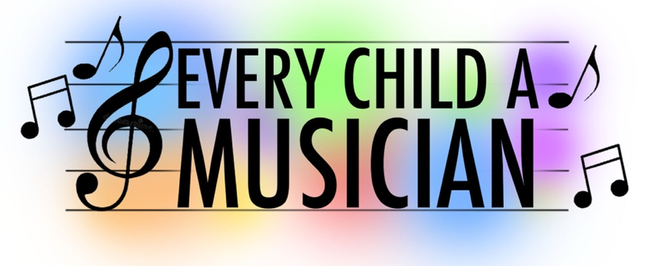
- Singing
- Guitar & Bass Guitar
- Piano/Keyboard
- Drums
- Violin/Viola/Cello/Double Bass
- Clarinet/Saxophone
- Flute
- Brass
For more information on our teachers, please see the ‘Instrumental lessons’ link on the school website.
Lessons take place during the school day and lesson times are rotated to avoid you missing the same academic lesson every week. We also offer a number of ensemble opportunities for Pop & Rock as well as Choirs and Band.
Invoices are sent out before the start of each term and need to be paid in full before lessons commence. Payment should be made directly to instrumental teachers. This will communicated directly by your child’s instrumental teacher prior to commencing lessons.

There may be some financial assistance that the school can offer for students in receipt of free school meals. Please contact the school if you would like to know more. If you have any further questions regarding these extra music lessons, please do not hesitate to contact Mr Ellwood at j.ellwood@ormskirk.lancs.sch.uk

Students’ name: ___________________________________ Tutor group:__________________

I am interested in my son/daughter participating in an additional music lesson.

Please indicate the instrument or voice: _____________________________________________

Parent email address to be forwarded to music tutors:

Signed (Parent/Guardian) ________________________________ Date: ____________________

