

Oswaldtwistle School

Behaviour policy and statement of behaviour principles

Approved by: D. Shaw |  | Date: 30.10.2025
Last reviewed on: | 30.10.2025
Next review due by: | 30.10.2026

Contents

1. Aims 3
2. Legislation, statutory requirements and statutory guidance 3
3. Definitions 4
4. Bullying 4
5. Roles and responsibilities 5
6. School behaviour curriculum 7
7. Responding to behaviour 8
8. Serious sanctions 16
9. Responding to misbehaviour from pupils with SEND 17
10. Supporting pupils following a sanction 18
11. Training 18
12. Monitoring arrangements 18

Appendix 1 - Behaviour Support Team Structure
Appendix 2 - Consequence System
Appendix 3 - Classroom Rules and Routines
Appendix 4 - Behaviour Norms and Vision

1. Aims
This policy aims to:
- Create a positive culture that promotes excellent behaviour, ensuring that all pupils have the opportunity to learn in a calm, safe and supportive environment
- Establish a whole-school approach to maintaining high standards of behaviour that reflect the values of the school
- Outline the expectations and consequences of behaviour
- Provide a consistent approach to behaviour management that is applied equally to all pupils
- Define what we consider to be unacceptable behaviour, including bullying and discrimination

2. Legislation, statutory requirements and statutory guidance
This policy is based on legislation and advice from the Department for Education (DfE) on:
- Behaviour in schools: advice for headteachers and school staff 2024
- Searching, screening and confiscation: advice for schools 2022
- The Equality Act 2010
- Keeping Children Safe in Education
- Suspension and permanent exclusion from maintained schools, academies and pupil referral units in England, including pupil movement
- Use of reasonable force in schools
- Supporting pupils with medical conditions at school
- Special Educational Needs and Disability (SEND) Code of Practice
- Sharing nudes and semi-nudes: advice for education settings working with children and young people
In addition, this policy is based on:
Maintained schools, pupil referral units (PRUs) and non-maintained special schools insert:
- Section 175 of the Education Act 2002, which outlines a school’s duty to safeguard and promote the welfare of its pupils
- Sections 88 to 94 of the Education and Inspections Act 2006, which requires schools to regulate pupils’ behaviour and publish a behaviour policy and written statement of behaviour principles, and gives schools the authority to confiscate pupils’ property
Maintained schools add:
- DfE guidance explaining that maintained schools must publish their behaviour policy online
Academies, including free schools, and independent schools insert:
- Schedule 1 of the Education (Independent School Standards) Regulations 2014; paragraph 7 outlines a school’s duty to safeguard and promote the welfare of children, paragraph 9 requires the school to have a written behaviour policy, and paragraph 10 requires the school to have an anti-bullying strategy
Academies, including free schools, add:
- DfE guidance explaining that academies should publish their behaviour policy and anti-bullying strategy
Academies, including free schools, check and add:
This policy complies with our funding agreement and articles of association.

3. Definitions
Misbehaviour is defined as:
- Disruption in lessons, in corridors between lessons, and at break and lunchtimes
- Non-completion of classwork or homework
- Poor attitude
- Incorrect uniform
Serious misbehaviour is defined as:
- Repeated breaches of the school rules
- Any form of bullying
- Sexual violence, such as rape, assault by penetration, or sexual assault (intentional sexual touching without consent)
- Sexual harassment, meaning unwanted conduct of a sexual nature, such as:
- Sexual comments
- Sexual jokes or taunting
- Physical behaviour such as interfering with clothes
- Online sexual harassment, such as unwanted sexual comments and messages (including on social media), sharing of nude or semi-nude images and/or videos (including pseudo-images, which are computer-generated images that otherwise appear to be a photograph or video), or sharing of unwanted explicit content
- Vandalism
- Theft
- Fighting
- Smoking
- Racist, sexist, homophobic or discriminatory behaviour
- Possession of any prohibited/banned items. These are:
- Knives or weapons
- Alcohol
- Illegal drugs
- Stolen items
- Tobacco and cigarette papers
- E-cigarettes or vapes
- Fireworks
- Pornographic images
- Any article a staff member reasonably suspects has been, or is likely to be, used to commit an offence, or to cause personal injury to, or damage to the property of, any person (including the pupil)

4. Bullying
Bullying is defined as the repetitive, intentional harming of 1 person or group by another person or group, where the relationship involves an imbalance of power.
Bullying is, therefore:
- Deliberately hurtful
- Repeated, often over a period of time
- Difficult to defend against
Bullying can include:
TYPE OF BULLYING | DEFINITION
Emotional | Being unfriendly, excluding, tormenting
Physical | Hitting, kicking, pushing, taking another’s belongings, any use of violence
Prejudice-based and discriminatory, including:  - Racial  - Faith-based  - Gendered (sexist)  - Homophobic/biphobic  - Transphobic  - Disability-based | Taunts, gestures, graffiti or physical abuse focused on a particular characteristic (e.g. gender, race, sexuality)
Sexual | Explicit sexual remarks, display of sexual material, sexual gestures, unwanted physical attention, comments about sexual reputation or performance, sharing of nude or semi-nude images and/or videos (including pseudo-images, which are computer-generated images that otherwise appear to be a photograph or video), or inappropriate touching
Direct or indirect verbal | Name-calling, sarcasm, spreading rumours, teasing
Cyber-bullying | Bullying that takes place online, such as through social networking sites, messaging apps, gaming sites, devices or via images, audio, video, or written content generated by artificial intelligence (AI)

Details of our school’s approach to preventing and addressing bullying are set out in our anti-bullying strategy https://oswaldtwistle.org/about/policies-documents

5. Roles and responsibilities
5.1 The governing board
The management committee is responsible for:
- Reviewing this behaviour policy in conjunction with the headteacher
- Monitoring the policy’s effectiveness
- Holding the headteacher to account for its implementation
5.2 The headteacher
The headteacher is responsible for:
- Reviewing this policy in conjunction with the management committee
- Approving this policy
- Ensuring that the school environment encourages positive behaviour
- Ensuring that staff deal effectively with poor behaviour
- Monitoring that the policy is implemented by staff consistently with all groups of pupils
- Ensuring that all staff understand the behavioural expectations and the importance of maintaining them
- Providing new staff with a clear induction into the school’s behavioural culture to ensure they understand its rules and routines, and how best to support all pupils to participate fully
- Offering appropriate training in behaviour management, and the impact of special educational needs and disabilities (SEND) and mental health needs on behaviour, to any staff who require it, so they can fulfil their duties set out in this policy
- Ensuring this policy works alongside the safeguarding policy to offer pupils both sanctions and support when necessary
- Ensuring that the data from the behaviour log is reviewed regularly, to make sure that no groups of pupils are being disproportionately impacted by this policy (see section 13.1)
5.3 Staff
Staff are responsible for:
- Creating a calm and safe environment for pupils
- Establishing and maintaining clear boundaries of acceptable pupil behaviour
- Implementing the behaviour policy consistently
- Communicating the school’s expectations, routines, values and standards through teaching behaviour and in every interaction with pupils
- Modelling expected behaviour and positive relationships
- Providing a personalised approach to the specific behavioural needs of particular pupils
- Considering the impact of their own behaviour on the school culture and how they can uphold school rules and expectations
- Recording behaviour incidents promptly on Class Charts and CPOMS
- Challenging pupils to meet the school’s expectations
The senior leadership team (SLT) will support staff in responding to behaviour incidents.
5.4 Parents and carers
Parents and carers, where possible, should:
- Get to know the school’s behaviour policy and reinforce it at home where appropriate
- Support their child in adhering to the school’s behaviour policy
- Inform the school of any changes in circumstances that may affect their child’s behaviour
- Discuss any behavioural concerns with school promptly
- Take part in any pastoral work following misbehaviour (for example, attending reviews of specific behaviour interventions)
- Raise any concerns about the management of behaviour with the school directly, while continuing to work in partnership with the school
- Take part in the life of the school and its culture
The school will endeavour to build a positive relationship with parents and carers by keeping them informed about developments in their child's behaviour and the school’s policy, and working in collaboration with them to tackle behavioural issues.
5.5 Pupils
Pupils will be made aware of the following during their induction into the behaviour culture:
- The expected standard of behaviour they should be displaying at school
- That they have a duty to follow the behaviour policy
- The school’s key rules and routines
- The rewards they can earn for meeting the behaviour standards, and the consequences they will face if they don’t meet the standards
- The pastoral support that is available to them to help them meet the behaviour standards
Pupils will be supported to meet the behaviour standards and will be provided with repeated induction sessions wherever appropriate.
Pupils will be supported to develop an understanding of the school’s behaviour policy and wider culture.
Pupils will be asked to give feedback on their experience of the behaviour culture to support the evaluation, improvement and implementation of the behaviour policy.
Extra support and induction will be provided for pupils who are mid-phase arrivals.

6. School behaviour curriculum
In conjunction with the legislation and statutory requirements as outlined in Section 2, this policy uses the research and writing of Tom Bennett as the primary source of principles which underpin the daily management of behaviour of staff and students within Oswaldtwistle School.
Tom Bennett advocates that behaviour should be a taught curriculum in the same way that other subjects are taught in school. He attaches great importance to understanding the psychology and motivation of classroom management and the establishment of school “norms” of behaviour which are reinforced by consistent and frequent use of routines. The overall objective of his work is to allow teachers to establish a safe and cohesive classroom where they are allowed to teach and where students are able to learn and grow as individuals.
In conjunction with the work of Tom Bennett, the policy also recognises the importance of understanding “Emotional Literacy”, as developed by Claud Steiner and interleaving this with the behaviour management structures and routines in everyday use by staff and students.

Adverse childhood experiences (ACES), trauma and attachment theory.
Oswaldtwistle school is committed to becoming a trauma informed and mentally healthy place for all. A trauma informed school is one that is able to support children who suffer with trauma or mental health problems and whose troubled behaviour acts as a barrier to learning. Public health studies have shown that when children have suffered painful life experiences, there is a high chance of them going on to suffer severe mental and physical ill-health, unless they receive help and appropriate interventions.
Working definition of trauma-informed practice - GOV.UK (www.gov.uk)
The school behaviour policy recognises the importance of trauma in young peoples’ lives and commits to ensuring staff receive appropriate training in the issues of adverse childhood experiences (ACES), trauma and attachment theory.

The policy also sits along side the DFE advice on mental health and behaviour in schools (2018) which aims to help schools to support pupils whose mental health problems manifest themselves in behaviour.

- Every pupil understands they have the right to feel safe, valued and respected, and learn free from the disruption of others
- All pupils, staff and visitors are free from any form of discrimination
- Staff and volunteers set an excellent example to pupils at all times
- Rewards, sanctions and reasonable force are used consistently by staff, in line with the behaviour policy
- The behaviour policy is understood by pupils and staff
- The school behaviour procedure is understood by pupils and staff
- Exclusions will only be used as a last resort
- Pupils are helped to take responsibility for their actions
- Families are involved in behaviour incidents to foster good relationships between the school and pupils’ home life
- The Management Committee also emphasises that violence or threatening behaviour will not be tolerated in any circumstances.
Pupils are also expected expected to:
- Behave in an orderly and self-controlled way
- Show respect to members of staff and each other
- In class, make it possible for all pupils to learn
- Move quietly around the school
- Treat the school buildings and school property with respect
- Wear the correct uniform at all times
- Accept sanctions when given
- Refrain from behaving in a way that brings the school into disrepute, including when outside school or online
Where appropriate and reasonable, adjustments may be made to routines within the curriculum to ensure all pupils can meet behavioural expectations in the curriculum.
6.1 Mobile phones
Students are not permitted to use mobile phones while on school grounds. All phones must be handed in upon entry to ensure a focused and distraction-free learning environment. Once collected, the phones will be securely locked away for the duration of the school day. They will then be returned to students only when they are due to leave. This policy helps maintain a safe, respectful, and productive atmosphere for everyone.

7. Responding to behaviour
7.1 Classroom management
Teaching and support staff are responsible for setting the tone and context for positive behaviour within the school.
They will:
- Create and maintain a stimulating environment that encourages pupils to be engaged
- Display the behaviour curriculum or their own classroom rules
- Develop a positive relationship with pupils, which may include:
  - Greeting pupils in the morning/at the start of lessons
  - Establishing clear routines
  - Communicating expectations of behaviour in ways other than verbally
  - Highlighting and promoting good behaviour
  - Concluding the day positively and starting the next day afresh
  - Having a plan for dealing with low-level disruption
  - Using positive reinforcement

7.2 Safeguarding
The school recognises that changes in behaviour may be an indicator that a pupil is in need of help or protection.
We will consider whether a pupil’s misbehaviour may be linked to them suffering, or being likely to suffer, significant harm.
Where this may be the case, we will follow our child protection and safeguarding policy, and consider whether pastoral support, an early help intervention or a referral to children’s social care is appropriate.
Please refer to our child protection and safeguarding policy for more information.
School Policies | Oswaldtwistle School
7.3 Responding to good behaviour
When a pupil’s behaviour meets or goes above and beyond the expected behaviour standard, staff will recognise it with positive recognition and reward. This provides an opportunity for all staff to reinforce the school’s culture and ethos.
Positive reinforcements and rewards will be applied clearly and fairly to reinforce the routines, expectations and norms of the school’s behaviour culture.
Positive behaviour will be rewarded with:
- Positive comments from staff
- Friday Good News assembly
- Pupil of the week
- Form of the week
- 100% weekly attendance
- Best form attendance
- Vouchers
- Tuck shop every Wednesday and Friday for students who do not receive C3s or C4s
- End of term reward trips
- Positive behaviour post cards
- Letters or phone calls home to parents
- Form/House challenge rewards
7.4 Responding to misbehaviour
When a pupil’s behaviour falls below the standard that can reasonably be expected of them, staff will respond in order to restore a calm and safe learning environment, and to prevent recurrence of misbehaviour.
Staff will endeavour to create a predictable environment by always challenging behaviour that falls short of the standards, and by responding in a consistent, fair and proportionate manner, so pupils know with certainty that misbehaviour will always be addressed.
De-escalation techniques, including the use of pre-arranged scripts and phrases, can be used to help prevent further behaviour issues arising.
All pupils will be treated equitably under the policy, with any factors that contributed to the behavioural incident identified and taken into account.
When giving behaviour sanctions, staff will also consider what support could be offered to a pupil to help them to meet behaviour standards in the future.
The school may use 1 or more of the following sanctions in response to unacceptable behaviour:

The school may use one or more of the following sanctions in response to unacceptable behaviour:
- A verbal reprimand
- Sending the pupil out of the class to regulate
- Expecting work to be completed at break or lunchtime
- Detention at break or lunchtime
- After-school detentions (See below for further information on this)
- Referring the pupil to a senior member of staff
- Letters or phone calls home to parents which may include in school meetings
- Agreeing a behaviour contract
- Putting a pupil ‘on report’
- Suspension
- Managed transfer to another PRU
- Permanent Exclusion

After-School Detentions
After-school detentions are issued for breaches of school rules that require immediate consequences (see below) Parents will be notified and pupils will be kept behind until 3.15pm to either complete work missed or to reflect on their actions. Transport will be arranged for those who require it. If a pupil receives two such detentions within the same week, they will be required to stay after school until 3.15pm from Monday to Thursday the following week. This extended detention period serves as a structured opportunity for reflection and reinforces the importance of consistent positive behaviour.
Behaviours that may result in an after-school detention:
- C3 – Refusal to complete work
- C3 – Persistent disruption
- C3 – Unacceptable behaviour
- C4 – Refusal to work
- C4 – Threatening behaviour towards pupils
- C4 – Threatening behaviour towards adults
- C4 – Persistent disruption
- C4 – Refusal to follow instruction
- Persistent swearing
- Persistent uniform issues
- In some cases, smoking, drugs and absconding but these may carry a suspension (see 9.8) as may some of the C4s stated above
All after school detentions will be at the discretion of the Senior Leadership Team
Personal circumstances of the pupil will be taken into account when choosing sanctions, and decisions will be made on a case-by-case basis, but with regard to the impact on perceived fairness.

7.5 Reasonable force
Reasonable force covers a range of interventions that involve physical contact with pupils. All members of staff have a duty to use reasonable force, in the following circumstances, to prevent a pupil from:
- Causing disorder
- Hurting themselves or others
- Damaging property
- Committing an offence
Incidents of reasonable force must:
- Always be used as a last resort
- Be applied using the minimum amount of force and for the minimum amount of time possible
- Be used in a way that maintains the safety and dignity of all concerned
- Never be used as a form of punishment
- Be recorded and reported to parents/carers
When considering using reasonable force, staff should, in considering the risks, carefully recognise any specific vulnerabilities of the pupil, including SEND, mental health needs or medical conditions.
7.6 Searching, screening and confiscation
Searching, screening and confiscation is conducted in line with the DfE’s latest guidance on searching, screening and confiscation.
Confiscation
Any prohibited items (listed in section 3) found in a pupil’s possession as a result of a search will be confiscated. These items will not be returned to the pupil.
We will also confiscate any item that is harmful or detrimental to school discipline. These items will be returned to pupils after discussion with senior leaders and parents/carers, if appropriate.
Searching a pupil
Searches will only be carried out by a member of staff who has been authorised to do so by the headteacher, or by the headteacher themselves.
Subject to the exception below, the authorised member of staff carrying out the search will be of the same sex as the pupil, and there will be another member of staff present as a witness to the search.
An authorised member of staff of a different sex to the pupil can carry out a search without another member of staff as a witness if:
- The authorised member of staff carrying out the search reasonably believes there is risk that serious harm will be caused to a person if the search is not carried out as a matter of urgency; and
- In the time available, it is not reasonably practicable for the search to be carried out by a member of staff who is the same sex as the pupil; or
- It is not reasonably practicable for the search to be carried out in the presence of another member of staff
When an authorised member of staff conducts a search without a witness, they should immediately report this to another member of staff, and make sure a written record of the search is kept.
If the authorised member of staff considers a search to be necessary, but not required urgently, they will seek the advice of the headteacher, designated safeguarding lead (or deputy) or pastoral member of staff who may have more information about the pupil. During this time the pupil will be supervised and kept away from other pupils.
A search can be carried out if the authorised member of staff has reasonable grounds for suspecting that the pupil is in possession of a prohibited item or any item identified in the school rules for which a search can be made, or if the pupil has agreed.
An appropriate location for the search will be found. Where possible, this will be away from other pupils. The search will only take place on the school premises or where the member of staff has lawful control or charge of the pupil, for example on a school trip.
Before carrying out a search the authorised member of staff will:
- Assess whether there is an urgent need for a search
- Assess whether not doing the search would put other pupils or staff at risk
- Consider whether the search would pose a safeguarding risk to the pupil
- Explain to the pupil why they are being searched
- Explain to the pupil what a search entails – e.g. “I will ask you to turn out your pockets and remove your scarf”
- Explain how and where the search will be carried out
- Give the pupil the opportunity to ask questions
- Seek the pupil’s co-operation
If the pupil refuses to agree to a search, the member of staff can give an appropriate behaviour sanction.
If they still refuse to co-operate, the member of staff will contact the headteacher or deputy to try to determine why the pupil is refusing to comply.
The authorised member of staff will then decide whether to use reasonable force to search the pupil. This decision will be made on a case-by-case basis, taking into consideration whether conducting the search will prevent the pupil harming themselves or others, damaging property or causing disorder.
The authorised member of staff can use reasonable force to search for any prohibited items identified in section 3, but not to search for items that are only identified in the school rules.
The authorised member of staff may use a metal detector to assist with the search.
An authorised member of staff may search a pupil’s outer clothing, pockets, possessions, desk or locker.
‘Outer clothing’ includes:
- Any item of clothing that isn't worn wholly next to the skin or immediately over underwear (e.g. a jumper or jacket being worn over a t-shirt)
- Hats, scarves, gloves, shoes or boots
Searching pupils’ possessions
Possessions means any items that the pupil has or appears to have control of, including:
- Desks
- Lockers
- Bags
A pupil’s possessions can be searched for any item if the pupil agrees to the search. If the pupil does not agree to the search, staff can still carry out a search for prohibited items (listed in section 3) and items identified in the school rules.
An authorised member of staff can search a pupil’s possessions when the pupil and another member of staff are present.
If there is a serious risk of harm if the search is not conducted immediately, or it is not reasonably practicable to summon another member of staff, the search can be carried out by a single authorised member of staff.

Informing the designated safeguarding lead (DSL)
The staff member who carried out the search should inform the DSL without delay:
- Of any incidents where the member of staff had reasonable grounds to suspect a pupil was in possession of a prohibited item as listed in section 3
- If they believe that a search has revealed a safeguarding risk
All searches for prohibited items (listed in section 3), including incidents where no items were found, will be recorded in the school’s safeguarding system.
Informing parents/carers
Parents/carers will always be informed of any search for a prohibited item (listed in section 3). A member of staff will tell the parents/carers as soon as is reasonably practicable:
- What happened
- What was found, if anything
- What has been confiscated, if anything
- What action the school has taken, including any sanctions that have been applied to their child
Support after a search
Irrespective of whether any items are found as the result of any search, the school will consider whether the pupil may be suffering or likely to suffer harm and whether any specific support is needed (due to the reasons for the search, the search itself, or the outcome of the search).
If this is the case, staff will follow the school’s safeguarding policy and speak to the designated safeguarding lead (DSL). The DSL will consider whether pastoral support, an early help intervention or a referral to children’s social care is appropriate.
Strip searches
The authorised member of staff’s power to search outlined above does not enable them to conduct a strip search (removing more than the outer clothing) and strip searches on school premises shall only be carried out by police officers in accordance with the Police and Criminal Evidence Act 1984 (PACE) Code C.
Before calling the police into school, staff will assess and balance the risk of a potential strip search on the pupil’s mental and physical wellbeing and the risk of not recovering the suspected item.
Staff will consider whether introducing the potential for a strip search through police involvement is absolutely necessary, and will always ensure that other appropriate, less invasive approaches have been exhausted first.
Once the police are on school premises, the decision on whether to conduct a strip search lies solely with them. The school will advocate for the safety and wellbeing of the pupil(s) involved. Staff retain a duty of care to the pupil involved and should advocate for pupil wellbeing at all times.
Communication and record-keeping
Where reasonably possible and unless there is an immediate risk of harm, before the strip search takes place, staff will contact at least 1 of the pupil’s parents/carers to inform them that the police are going to strip search the pupil, and ask them whether they would like to come into school to act as the pupil’s appropriate adult. If the school can’t get in touch with the parents/carers, or they aren’t able to come into school to act as the appropriate adult, a member of staff can act as the appropriate adult (see below for information about the role of the appropriate adult).
The pupil’s parents/carers will always be informed by a staff member once a strip search has taken place. The school will keep records of strip searches that have been conducted on school premises, and monitor them for any trends that emerge.
Who will be present
For any strip search that involves exposure of intimate body parts, there will be at least 2 people present other than the pupil, except in urgent cases where there is risk of serious harm to the pupil or others.
One of these must be the appropriate adult, except if:
- The pupil explicitly states in the presence of an appropriate adult that they do not want an appropriate adult to be present during the search, and
- The appropriate adult agrees
If this is the case, a record will be made of the pupil’s decision and it will be signed by the appropriate adult.
No more than 2 people other than the pupil and appropriate adult will be present, except in the most exceptional circumstances.
The appropriate adult will:
- Act to safeguard the rights, entitlements and welfare of the pupil
- Not be a police officer or otherwise associated with the police
- Not be the headteacher
- Be of the same sex as the pupil, unless the pupil specifically requests an adult who is not of the same sex
Except for an appropriate adult of a different sex if the pupil specifically requests it, no one of a different sex will be permitted to be present and the search will not be carried out anywhere where the pupil could be seen by anyone else.
Care after a strip search

After any strip search, the pupil will be given appropriate support, irrespective of whether any suspected item is found. The pupil will also be given the opportunity to express their views about the strip search and the events surrounding it.
As with other searches, the school will consider whether the pupil may be suffering or likely to suffer harm and whether any further specific support is needed (due to the reasons for the search, the search itself, or the outcome of the search).
Staff will follow the school’s safeguarding policy and speak to the designated safeguarding lead (DSL). The DSL will consider whether, in addition to pastoral support, an early help intervention or a referral to children’s social care is appropriate.
Any pupil(s) who have been strip searched more than once and/or groups of pupils who may be more likely to be subject to strip searching will be given particular consideration, and staff will consider any preventative approaches that can be taken.
Screening
- On arrival into school, pupils must remove their jackets and empty their pockets placing everything onto the table provided. They will then be asked to walk through the detection arch. As a secondary precaution, pupils will then be wanded with a hand-held device to ensure nothing is concealed about their person.
- Pupils will then collect their belongings from the table, place their coats and bags in a lockable cupboard and put their mobile phones in the phone box. All items will be securely stored and returned at the end of the day or at the end of their personalised provision.
- The use of a mobile phone is not permitted in school, unless special permission is given by a named member of staff and the pupil agrees to be closely monitored by a member of staff.
- On some occasions, wanding may take place at other times during the day at the discretion of school staff. All wanding will take place in the presence of more than 1 member of staff at all times.

7.7 Off-site misbehaviour
Sanctions may be applied where a pupil has misbehaved off-site when representing the school. This means misbehaviour when the pupil is:
- Taking part in any school-organised or school-related activity (e.g. school trips)
- Travelling to or from school
- Wearing school uniform
- In any other way identifiable as a pupil of our school
Sanctions may also be applied where a pupil has misbehaved off-site, at any time, whether or not the conditions above apply, if the misbehaviour:
- Could have repercussions for the orderly running of the school
- Poses a threat to another pupil
- Could adversely affect the reputation of the school
Sanctions will only be given out on school premises or elsewhere when the pupil is under the lawful control of a staff member (e.g. on a school-organised trip).
7.8 Online misbehaviour
The school can issue behaviour sanctions to pupils for online misbehaviour when:
- It poses a threat or causes harm to another pupil
- It could have repercussions for the orderly running of the school
- It adversely affects the reputation of the school
- The pupil is identifiable as a member of the school
Sanctions will only be given out on school premises or elsewhere when the pupil is under the lawful control of a staff member.
7.9 Suspected criminal behaviour
If a pupil is suspected of criminal behaviour, the school will make an initial assessment of whether to report the incident to the police.
When establishing the facts, the school will endeavour to preserve any relevant evidence to hand over to the police.
If a decision is made to report the matter to the police, the headteacher or member of the senior leadership team will make the report.
The school will not interfere with any police action taken. However, the school may continue to follow its own investigation procedure and enforce sanctions, as long as it does not conflict with police action.
If a report to the police is made, the designated safeguarding lead (DSL) will make a tandem report to children’s social care, if appropriate.
7.10 Zero-tolerance approach to sexual harassment and sexual violence
The school will ensure that all incidents of sexual harassment and/or violence are met with a suitable response, and never ignored.
Pupils are encouraged to report anything that makes them uncomfortable, no matter how ‘small’ they feel it might be.
The school’s response will be:
- Proportionate
- Considered
- Supportive
- Decided on a case-by-case basis
The school has procedures in place to respond to any allegations or concerns regarding a child’s safety or wellbeing. These include clear processes for:
- Responding to a report
- Carrying out risk assessments, where appropriate, to help determine whether to:
  - Manage the incident internally
  - Refer to early help
  - Refer to children’s social care
  - Report to the police
Please refer to our child protection and safeguarding policy for more information
School Policies | Oswaldtwistle School
7.11 Malicious allegations
Where a pupil makes an allegation against a member of staff and that allegation is shown to have been deliberately invented or malicious, the school will consider whether to discipline the pupil in accordance with this policy.
Where a pupil makes an allegation of sexual violence or sexual harassment against another pupil and that allegation is shown to have been deliberately invented or malicious, the school will consider whether to discipline the pupil in accordance with this policy.
In all cases where an allegation is determined to be unsubstantiated, unfounded, false or malicious, the school (in collaboration with the local authority designated officer (LADO), where relevant) will consider whether the pupil who made the allegation is in need of help, or the allegation may have been a cry for help. If so, a referral to children’s social care may be appropriate.
The school will also consider the pastoral needs of staff and pupils accused of misconduct.
Please refer to our child protection and safeguarding policy for more information on responding to allegations of abuse against staff or other pupils.

8. Serious sanctions
8.1 Detention
Pupils can be issued with detentions during break, lunch and after school.
The school will decide whether it is necessary to inform the pupil’s parents/carers.
When imposing a detention, the school will consider whether doing so would:
- Compromise the pupil’s safety
- Conflict with a medical appointment
- Prevent the pupil from getting home safely
- Interrupt the pupil’s caring responsibilities

See 7.4 for further information related to after-school detentions
8.2 Removal from classrooms
In response to serious or persistent breaches of this policy, the school may remove the pupil from the classroom for a limited time.
Pupils who have been removed will continue to receive education under the supervision of a member of staff. This education will be meaningful, but it may differ from the mainstream curriculum.
Removal is a serious sanction and will only be used in response to serious misbehaviour. Staff will only remove pupils from the classroom once other behavioural strategies have been attempted, unless the behaviour is so extreme as to warrant immediate removal.
Removal can be used to:
- Restore order if the pupil is being unreasonably disruptive
- Maintain the safety of all pupils
- Allow the disruptive pupil to continue their learning in a managed environment
- Allow the disruptive pupil to regain calm in a safe space
Pupils who have been removed from the classroom are supervised by a member of the behaviour/pastoral team.
Pupils will not be removed from classrooms for prolonged periods of time without the explicit agreement of the headteacher.
Pupils should be reintegrated into the classroom as soon as it is appropriate and safe to do so. The school will consider what support is needed to help a pupil successfully reintegrate into the classroom and meet the expected standards of behaviour.
The school will consider an alternative approach to behaviour management for pupils who are frequently removed from class, such as:
- Meetings with mentors
- Use of teaching assistants
- Short-term behaviour report cards
- Personalised timetables
- Multi-agency assessment
Staff will record all incidents of removal from the classroom in the behaviour log, along with details of the incident that led to the removal, and any protected characteristics of the pupil.
8.3 Suspension and permanent exclusion
The school can use suspension and permanent exclusion in response to serious incidents or in response to persistent poor behaviour which has not improved following in-school sanctions and interventions.
The decision to suspend or exclude will be made by the headteacher and only as a last resort.

9. Responding to misbehaviour from pupils with SEND
9.1 Recognising the impact of SEND on behaviour
The school recognises that pupils’ behaviour may be impacted by a special educational need or disability (SEND).
When incidents of misbehaviour arise, we will consider them in relation to a pupil’s SEND, although we recognise that not every incident of misbehaviour will be connected to their SEND. Decisions on whether a pupil’s SEND had an impact on an incident of misbehaviour will be made on a case-by-case basis.
When dealing with misbehaviour from pupils with SEND, especially where their SEND affects their behaviour, the school will take its legal duties into account when making decisions about enforcing the behaviour policy. The legal duties include:
- Taking reasonable steps to avoid any substantial disadvantage to a disabled pupil being caused by the school’s policies or practices (Equality Act 2010)
- Using our best endeavours to meet the needs of pupils with SEND (Children and Families Act 2014)
- If a pupil has an education, health and care (EHC) plan, the provisions set out in that plan must be secured and the school must co-operate with the local authority and other bodies
As part of meeting these duties, the school will anticipate, as far as possible, all likely triggers of misbehaviour, and put in place support to prevent these from occurring.
Any preventative measures will take into account the specific circumstances and requirements of the pupil concerned.
We will remove triggers of misbehaviour using the following strategies:
- Short planned movement breaks for a pupil with SEND who finds it difficult to sit still for long
- Adjusting seating plans to allow a pupil with visual or hearing impairment to sit in sight of the teacher
- Adjust uniform requirements for a pupil with sensory issues or who has severe eczema
- Training for staff in understanding conditions such as autism
- Use of separation spaces where pupils can regulate their emotions during a moment of sensory overload
9.2 Adapting sanctions for pupils with SEND
When considering a behavioural sanction for a pupil with SEND, the school will consider whether:
- The pupil was unable to understand the rule or instruction
- The pupil was unable to act differently at the time as a result of their SEND
- The pupil was likely to behave aggressively due to their particular SEND
If the answer to any of these is ‘yes’, it may be unlawful for the school to sanction the pupil for the behaviour.
The school will then assess whether it is appropriate to use a sanction and if so, whether any reasonable adjustments need to be made to the sanction.
9.3 Considering whether a pupil displaying challenging behaviour may have unidentified SEND
The school’s special educational needs co-ordinator (SENCO) may evaluate a pupil who exhibits challenging behaviour to determine whether they have any underlying needs that are not currently being met.
Where necessary, support and advice will also be sought from specialist teachers, an educational psychologist, medical practitioners and/or others, to identify or support specific needs.
When acute needs are identified in a pupil, we will liaise with external agencies and plan support programmes for that child. We will work with parents/carers to create the plan and review it on a regular basis.
9.4 Pupils with an education, health and care (EHC) plan
The provisions set out in the EHC plan must be secured and the school will co-operate with the local authority and other bodies.
If the school has a concern about the behaviour of a pupil with an EHC plan, it will make contact with the local authority to discuss the matter. If appropriate, the school may request an emergency review of the EHC plan.

10. Supporting pupils following a sanction
Following a sanction, the school will consider strategies to help the pupil to understand how to improve their behaviour and meet the expectations of the school.
This could include measures such as:
- Reintegration meetings
- Restorative meetings
- Daily contact with mentors/behaviour team/pastoral
- A report card with personalised behaviour goals

11. Training
As part of their induction process, our staff are provided with regular training on managing behaviour, including training on:
- The proper use of restraint
- The needs of the pupils at the school
- How SEND and mental health needs can impact behaviour
Behaviour management will also form part of continuing professional development.

12. Monitoring arrangements
12.1 Monitoring and evaluating behaviour
The school will collect data on the following:
- Behavioural incidents, including removal from the classroom
- Attendance, permanent exclusions and suspensions
- Use of pupil support units, off-site directions and managed moves
- Incidents of searching, screening and confiscation
- Perceptions and experiences of the school behaviour culture for staff, pupils, governons and other stakeholders
The data will be analysed weekly and half termly by Alison Ashton (Deputy Head)
The data will be analysed from a variety of perspectives.
The school will use the results of this analysis to make sure it is meeting its duties under the Equality Act 2010. If any trends or disparities are identified by this analysis, the school will review its policies to tackle them.
12.2 Monitoring this policy
This behaviour policy will be reviewed by the headteacher and full governing body at least annually, or more frequently, if needed, to address findings from the regular monitoring of the behaviour data (as per section 13.1). At each review, the policy will be approved by the chair of governors.

Other Information:
Behaviour Support Team
Appendix 1

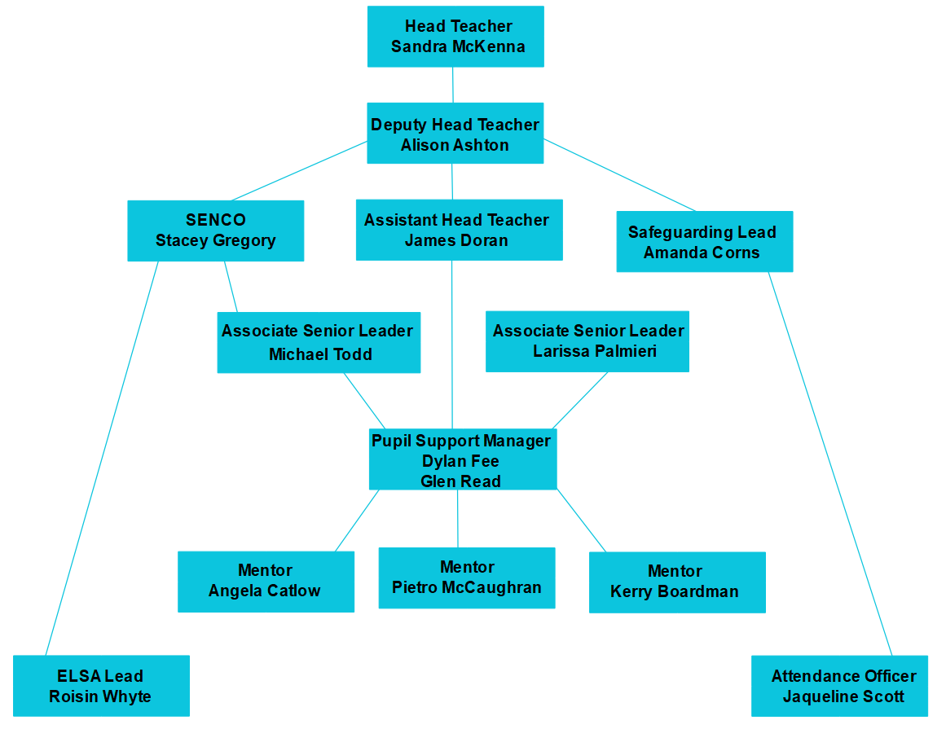
Learning Mentor
(Angela Catlow)

Appendix 2
Classroom
Second Verbal Warning
C1 Consequence slip
First Verbal Warning
No Consequence slip

Forth Verbal Warning

Third Verbal Warning
Pupil offered Time Out
C2 Consequence slip

Forth Verbal Warning
Behaviour Manager called
Pupil removed from room
Pupil attends next lesson
C3 Consequence slip

Forth Verbal Warning
Serious Incidents
Behaviour Manager or SLT called
Pupil Removed to Student Services

C4 Consequence slip

Appendix 3
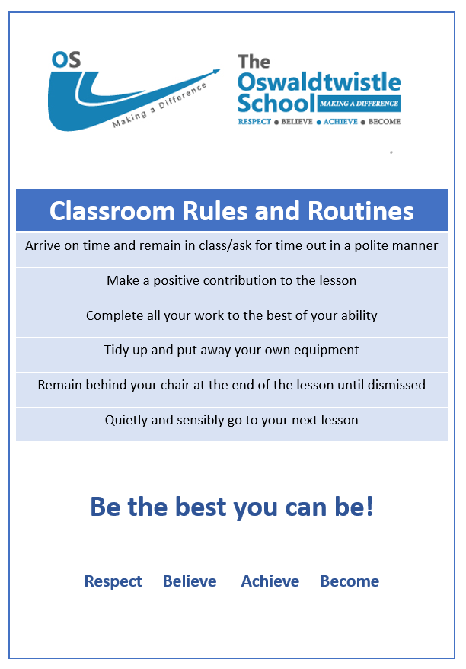

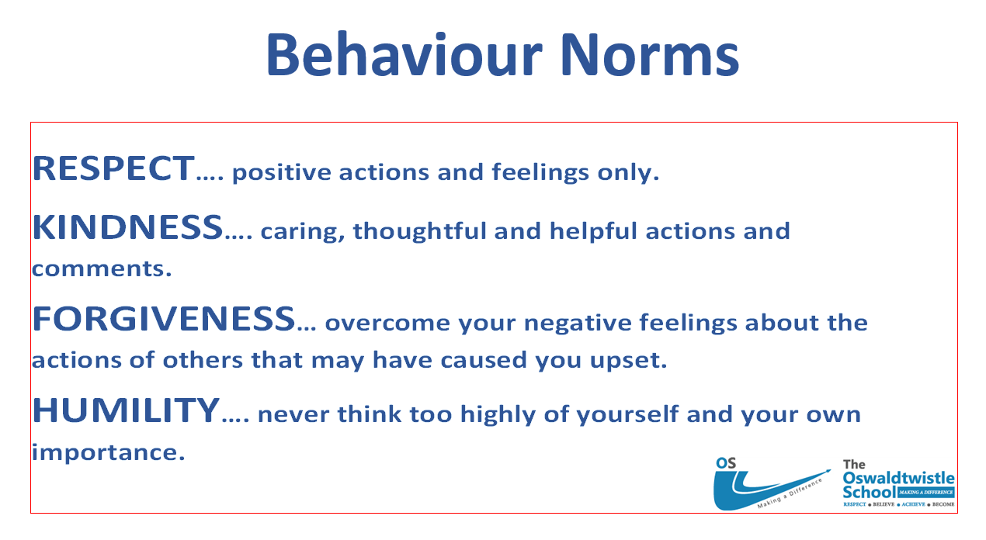
Appendix 4

