The Oswaldtwistle School Marking Policy
'Marking is an important part of the learning process and over time we should be able to see its impact on student progress.'
The primary purpose of marking students work is to determine whether progress has been made. It allows us to clarify what the student has been successful in and offers clear guidance on what should be done to make further progress. It allows us to track academic progress over time and as such should be carried out on a regular basis.

Types of marking and feedback
Staff should use a combination of:
- Formative feedback
- Summative feedback
(Pupil self/peer assessment will also form part of the process)

Formative feedback
Formative feedback is information that allows for improvements in learning to take place. It is task- related and not ego-related feedback. Formative feedback should cause thinking and offer a recipe for further action.

‘Closing the Gap’
This style of marking enables the students to close the gap between the work they have done originally and a higher level as suggested by the feedback they receive.
Students need to be clear about what they are being assessed on so success criteria needs to be clear, shared and measurable.
Students should use the ‘purple progress pen’ to respond to ‘closing the gap’ feedback.

Summative Feedback
Summative assessment usually takes place after pupils have completed units of work or modules at the end of each term. The information it gives indicates progress and achievement. It’s the more formal summing-up of a pupil’s progress. This information can then be provided to parents or used for certification as part of a formal examination course.

Frequency of Summative Feedback
Summative Feedback should take place every 12 lessons or at a minimum, once per half term for subjects that have only 1 lesson a week. The resulting grade should be entered on a Progress Marker and should be followed by formative feedback in the form of a WWW comment followed by an EBI comment. The EBI comment should include at least one improvement activity. The nature of the improvement activity will very much be subject dependent; for example, it may be a straight forward written task, a mathematical equation or involve the annotation of existing work. Whatever is completed by the student at this stage should be carried out with a ‘purple progress pen’.

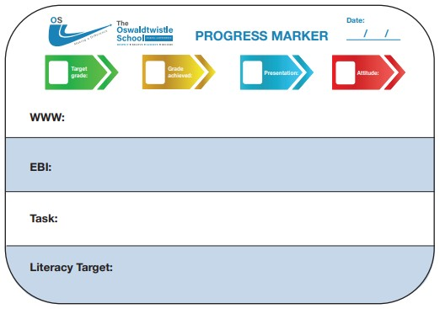

Summative marking should also grade the general attitude displayed by the student to their learning and the quality of their presentation in line with the presentation codes. These should be entered on the Progress Marker and should be informed by the statements below.

Attitude to learning
- Classwork always reflects the student's very best efforts and ability
- Classwork usually reflects the student's very best efforts and ability
- Classwork is inconsistent but sometimes reflects the student's best effort and ability
- The standard of classwork often does not reflect the student's best effort and ability

Presentation of work
- Student’s handwriting is clear and legible. There is no graffiti, titles and dates are clear. Student’s organisation is excellent.
- Student’s handwriting is inconsistent. Graffiti may be evident and dates and titles are not underlined. Little consideration is given to the presentation of work. Student’s organisation of work is not consistent.
- Students handwriting is not clear and it is very difficult to read. Work is randomly attempted and there is evidence of graffiti. Titles and dates are not included. Organisation is poor.

Literacy Marking Policy
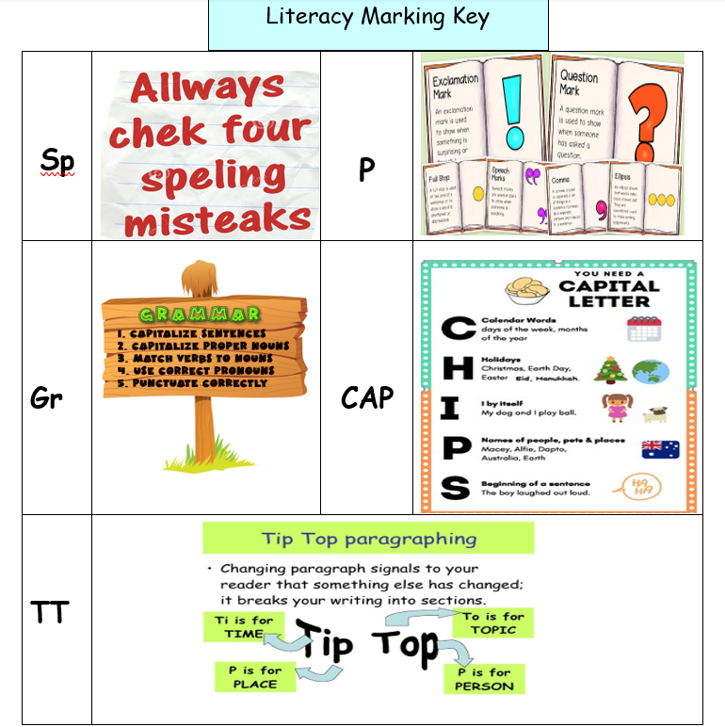
Marking should also be used to correct inaccuracies in spelling, punctuation and grammar (SPaG).

Literacy Marking Codes

Sp Spelling
P Punctuation
Gr Grammar
CAP Capital letter needed
TT Paragraphing

Literacy Marking Expectations
The literacy codes should be used when marking all written work. As a minimum requirement the following actions should be carried out by every member of staff:
All capital letters and full stops must be corrected.
Students need to correct a maximum of 3 misspelled subject specific words/common words and write each one out 3 times in the margin or under the last piece of written work.
In addition to the above, students will be given personalised literacy targets every time a Progress Marker is completed and future work will be assessed against this.

Progress Card
Progress cards, found at the front of student books, are completed at every data capture. These include students working at grades, their attitude to learning grade and a presentation mark. In addition to these, reading ages are identified to allow teachers to plan accordingly.

