The Oswaldtwistle School

Whole School Numeracy Policy
June 2020
To be reviewed June 2022

Whole School Numeracy Policy
Contents:
1. Numeracy
2. Aims
3. Strategies
4. Use of Calculators
5. Vocabulary
6. Possible Cross Curricular Links
7. Maths Vocabulary
8. Maths Yearly Overview
9. Useful Websites
10. Evaluation

1. Numeracy
Numeracy complements literacy and is sometimes called ‘mathematical literacy’. Both skills are needed in order to function fully in modern life. Being numerate means being able to reason with numbers and other mathematical concepts and to apply these in a range of contexts and to solve a variety of problems.

It means being able to:
- Interpret data, charts and diagrams
- Process information
- Solve problems
- Check answers
- Understand and explain solutions
- Make decisions based on logical thinking and reasoning

We use numeracy every day in all areas of our lives. Our confidence and ability with numbers impacts us financially, socially, and professionally. It even affects our health and wellbeing. Poor numeracy can affect people’s confidence and self-esteem. (https://www.nationalnumeracy.org.uk/about-us)

Numeracy is at the heart of all learning and is involved in all aspects of our daily lives. As teachers of all subjects at The Oswaldtwistle School, it is our duty to enable and encourage all learners to develop in all of the above and therefore become young numerate adults. Numeracy skills can be developed across the curriculum, not just what happens in maths lessons, and therefore the development and consolidation of numeracy is a whole school responsibility.

2. Aims
Aims of the Whole School Numeracy Policy
- To develop, maintain and improve standards of Numeracy at KS3 and 4.
- To raise the profile of numeracy across the curriculum.
- To ensure that all teaching and learning is embedded with numeracy that is relevant, meaningful and mathematically accurate.
- To give students of all abilities and backgrounds the opportunity to improve their numeracy skills.
- To raise the awareness of Numeracy amongst staff through training, twilights, departmental and numeracy meetings.
- To encourage staff to share good Numeracy practice and engage in cross curricular Numeracy activities to ensure consistency of practice.
3. Strategies
Develop positivity towards Numeracy
All staff has the responsibility to be Numeracy role models – demonstrating positive attitudes surrounding Numeracy and Maths as well as expressing the importance to students in real life. Staff should encourage students to engage with Numeracy posters, Maths challenges, Maths vocabulary activities, Numeracy Ninja and skills checks to plug gaps in Numeracy knowledge.
Develop a consistent approach to Numeracy
In order to develop a consistent approach to Numeracy across the school, staff should:
- Use agreed approaches to Numeracy
- Ensure any relevant equipment that can be used for Mathematical reasons is available
- Encourage students to estimate an initial answer in order to decide if their answer is realistic
- Follow any mathematical notation and be consistent with this
- Encourage students to show all working out for all numeracy based questions and activities
- Assist in encouraging students to use mental calculations wherever possible
- Use correct mathematical language such as ‘subtract’ rather than ‘take away
Raising the profile of Numeracy
Department of Mathematics
- Create a positive and attractive environment which celebrates numeracy.
- Identify pupils who require additional intervention to plug numeracy gaps.
- Identify pupils who require additional support to learn their times tables effectively.
- Seek opportunities to use topics and examination questions from other subjects in mathematics lessons.
- Be aware of the mathematical techniques used in other subjects and provide guidance and training to other departments so that a sound, coherent and consistent approach is used in all subjects, using preferred methods.
- Provide information about common misconceptions and errors which may occur during teaching of specific topics.
Other subject areas and form time
- Create a positive and attractive environment which celebrates numeracy.
- Ensure that they are familiar with correct mathematical language, notation, conventions and techniques relating to their own subject and encourage pupils to use these correctly
- Be aware of appropriate expectations of pupils and difficulties that might be experienced with numeracy skills.
- Explore possibilities for cross-curricular links with the department of Mathematics
- Run the Numeracy Ninja programme during form time which encourages using basic mental calculation strategies.
- Identify gaps in learning and introduce the skills check sheets appropriated to fill those gaps.
4. Use of Calculators
In deciding when pupils use a calculator in lessons, we should ensure that:
- pupils’ first resort should be mental methods;
- pupils have sufficient understanding of the calculation to decide the most appropriate method: mental, pencil and paper or calculator;
- pupils understand the four arithmetical operations and recognise which to use to solve a particular problem;
- pupils have the technical skills required to use the basic functions of a calculator constructively and efficiently, the order in which to use keys, how to enter numbers as money, measures, fractions, etc;
- when using a calculator, pupils are aware of the processes required and are able to say whether their answer is reasonable;
- pupils can interpret the calculator display in context (e.g. 5.3 is £5.30 in money calculations);
- we help pupils, where necessary, to use the correct order of operations – especially in multi-step calculations, such as (3.2-1.65 x (15.6-5.77).
5. Vocabulary
The following are all important aspects of helping pupils with the technical vocabulary of Mathematics;
- Using a variety of words that have the same meaning e.g. add, plus, sum.
- Encouraging pupils to be less dependent on simple words e.g. exposing them to the word multiply as a replacement for times.
- Discussions about words that have different meanings in mathematics from everyday life e.g. take away, volume, product, etc.
- Highlighting word sources e.g. quad means 4, lateral means side so that pupils can use them to help remember meanings.

All maths key words can be found in section 7 of this policy.

6. Cross Curricular Links
Art | Symmetry  Use of paint mixing as a ratio  Perspectives - Enlargements
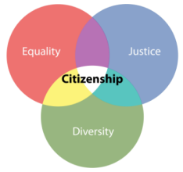  Citizenship | Overseas development budgets  Data analysis
English  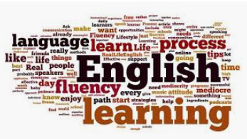 | Comparison of 2 data sets on word and sentence length  Understanding facts and figures in non-fiction texts
Geography | Representing data  Analysing data  Use of Spreadsheets  Distance/Time
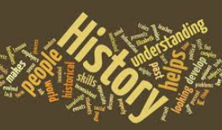  History | Timelines  Sequencing events
PE | Collection of real data  Estimation  Speed, Distance, Time
RE | Interpretation and comparison of data gathered from secondary sources
Science | Calculating with formulae  Graphing skills  Ratio and proportion  Problem solving
DT | Measuring skills  Units of area and volume  Scale drawings

7. Maths Vocabulary
A
Acute angle | An angle less than 90°.
Adjacent | Adjacent sides are next to each other and are joined by a common vertex.
Algebra | Algebra is the branch of mathematics where symbols or letters are used to represent numbers.
Angle | An angle is formed when two straight lines cross or meet each other at a point. The size of an angle is measured by the amount one line has been turned in relation to the other.
Approximate | An approximate value is a value that is close to the actual value of a number.
Arc | Part of a circumference of a circle.
Area | The amount of space a shape takes up. E.g. the area of the lawn is 35 square metres.
Asymmetrical | A shape which has no lines of symmetry.
Average | A value to best represent a set of data. There are three types of average - the mean, the median and the mode.
Axis | An axis is one of the lines used to locate a point in a coordinate system.
B
Bearing | A three digit angle measured from north in a clockwise direction.
BIDMAS | A way of remembering the order in which operations are carried out. It stands for Brackets - Indices - Division - Multiplication - Addition - Subtraction.

Bisect | To divide an angle or shape exactly in half.
Brackets | Used to determine the order in which operations are carried out. For example, 3 + 4 x 2 = 11 but (3 + 4) x 2 = 14.
C
Calculate | To work out the value of something. This does not have to mean you need a calculator!
Centilitre (cl) | A measure of volume. 100 centilitres = 1 litre (100 cl = 1 l). 1 centilitre = 10 millilitres (1 cl = 10 ml).
Centimetre (cm) | A measure of distance. 1 centimetre = 10 millimetres. (1 cm = 10 mm). 100 centimetres = 1 metre. (100 cm = 1 m).
Chord | A straight line drawn from one point on the edge of a circle to another.
Circumference | The perimeter of a circle.
Coefficient | The number in front of an algebraic symbol. For example the coefficient of 5x is 5.
Congruent | If you can place a shape exactly on top of another then they are said to be congruent. You may rotate, reflex or translate the shape.
Constant | A letter or symbol whose value always stays the same. The constant Π is a common example.
Credit | To add money to a bank account. For example, I had £500 credited to my bank account.
Cross section | The end section created when you slice a 3D shape along it's length.
Cube number | The product when an integer is multiplied by itself twice. For example 5 cubed = 5 x 5 x 5 = 125.

Cuboid | A 3D shape with all sides made from rectangles.
Cumulative frequency | A running total of the frequencies, added up as you go along.
D
Day | A time period of 24 hours. There are 7 days in a week.
Debit | To take out money from a bank account. For example, £400 was debited from my account.
Decagon | A ten sided polygon.
Decimal | Not a whole number or integer. For example, 3.6 or 0.235.
Decrease | To make an amount smaller.
Denominator | The bottom part of a fraction.
Diameter | The distance across a circle which passes through the centre.
Difference | Subtract the smaller value from the larger value to find the difference between two numbers.
Distance | How far away an object is. For example, it is a distance of 3 miles to the city centre.
Distribution | How data is shared or spread out.

E
Equal | Used to show two quantities have the same value.
Equation | Two expressions which have the same value, separated by an '=' sign. E.g. 3y = 9 + y
Equilateral triangle | A triangle with all sides and angles the same size.
Estimate | To find an approximate answer to a more difficult problem. E.g. 31.2 x 5.94 is roughly equal to 30 x 6 = 180.
Even number | Any number which is a multiple of 2. Even numbers always end in 2, 4, 6, 8 or 0.
Expand | To multiply out brackets in an expression. For example, 2(3x + 7) = 6x + 14.
Expression | A collection of terms which can contain variables (letters) and numbers. E.g. 4pq - q + 7
F
Factor | A number that divides another number exactly. E.g. 4 is a factor of 12.
Factorise | To put an expression into brackets by taking out a common factor. For example, 20x + 15y = 5(4x + 3y).
Figures | Another name for numbers. For example one thousand and fifty in figures is 1050.
Formula | An equation used to describe a relationship between two or more variables.
Frequency | How many times something happens. Another word for 'total'.
Frequency density | The frequency divided by the class width.

G
Gradient | How steep a line is. Found by dividing the distance up by the distance across.
Gram (g) | A measure of mass. 1 gram = 1000 milligrams. (1 g = 1000 mg)
H
HCF | Stands for 'highest common factor'. It is the largest factor common to a set of numbers. E.g. The HCF of 16 and 24 is 8.
Heptagon | A seven sided polygon.
Hexagon | A six sided polygon.
Histogram | A diagram drawn with rectangles where the area is proportional to the frequency and the width is equal to the class interval.
Hypotenuse | The longest side on a right angled triangle.
I
Increase | To make an amount larger.
Indices | Another name for powers such as ² or ³.
Integer | A whole number.
Inter-quartile range (IQR) | The difference between the upper and lower quartile.
Irrational | A decimal which is never ending. It must also not be a recurring decimal.

J
Justify | Another word for 'explain'. Often crops up on your maths exam. E.g. 'Calculate the mean and range for each player. Who is the better player Justify your answer.'
K
Kilogram (Kg) | A measure of mass. 1 kilogram = 1000 grams. (1 kg = 1000 g)
Kilometre (Km) | A measure of distance. 1 kilometre = 1000 metres. (1 km = 1000 m)
L
LCM | Stands for 'lowest common multiple'. It is the smallest multiple common to a set of numbers. E.g. The LCM of 3 and 4 is 12.
Litre (l) | A measure of volume. 1 litre = 100 centilitres (1 l = 100 cl). 1 litre = 1000 millilitres (1l = 1000 ml).
Loci | The plural of locus.
Locus | A collection of points which are the same distance from another point or line.
Lower range | The smallest value in a set of data.
M
Mean | A type of average found by adding up a list of numbers and dividing by how many numbers are in the list.
Median | The middle value when a list of numbers is put in order from smallest to largest. A type of average.
Metre (m) | A measure of distance. 1 metre = 100 centimetres. (1 m = 1000 cm).

Millilitre (ml) | A measure of volume. 10 millimetres = 1 centilitre (10 ml = 1 cl). 1000 millilitres = 1 litre (1000 ml = 1 l).
Millimetre (mm) | A measure of distance. 10 millimetres = 1 centimetre. (10 mm = 1 cm).
Modal | Another term for mode
Mode | The most common value in a list of numbers. If two values are tied then there is two modes. If more than two values are tied then there is no mode. A type ofaverage.
Month | A time period of either 28, 29, 30 or 31 days. There are 12 months in a year.
Multiple | A number which is part of another number's times table. E.g. 35 is a multiple of 5.
N
Natural number | A positive integer
Negative | A value less than zero
Nonagon | A nine sided polygon.
Numerator | The top part of a fraction.
O
Obtuse angle | An angle between 90°�and 180°.
Octagon | An eight sided polygon.
Odd number | A number that is not a multiple of 2. Odd numbers always end in 1, 3, 5, 7 or 9.
Operation | An action which when applied to one or more values gives an output value. The four most common operations are addition. subtraction, multiplication and division.

P
Parallel | Two or more lines which are always the same distance apart.
Parallelogram | A quadrilateral with two pairs of parallel sides.
Pentagon | A five sided polygon.
Perimeter | The distance around a shape.
Perpendicular | Two or more lines which meet at right angles.
Pi (Π) | An irrational constant used when calculating the area and circumference of circles. It is approximately equal to 3.14.
Polygon | A shape made from straight lines.
Positive number | A number greater than zero.
Prime | A number which has exactly two factors. The number one and itself.
Prism | A 3D shape with the same cross section all along its length.
Probability | A measure of how likely an event is to occur.
Product | The answer when two values are multiplied together.
Q
Quadratic equation | An equation where the highest power is two. For example x² + 4x + 6 = 0 is a quadratic equation.
Quadrilateral | A four sided polygon.

R
Radius | The distance from the centre of a circle to its circumference. The plural of radius is radii.
Random sampling | A method of choosing people at random for a survey.
Range | The largest number take away the smallest value in a set of data.
Rational | A decimal number which ends or is recurring.
Reciprocal | The reciprocal of any number is 1 divided by the number. E.g. the reciprocal of 3 is 1/3., the reciprocal of 3/4 is 4/3.
Recurring | A decimal which never ends but repeats all or parts of the sequence of numbers after the decimal point. E.g 0.333333 or 0.141414.
Reflex angle | An angle greater than 180°.
Regular | A shape with all sides and angles the same size.
Remainder | The amount left over when a number cannot be divided exactly. For example, 21 divided by 4 is 5 remainder 1.
Right angle | An angle of 90°.
Rotation | To turn a shape using an angle, direction and centre of rotation.
Round | To reduce the amount of significant figures or decimal places a number has. For example £178 rounded to the nearest £10 is £180.

S
Scale factor | How many times larger or smaller an enlarged shape will be.
Segment | An area of a circle enclosed by a chord.
Sequence | A list of numbers which follows a pattern. For example 6, 11, 16, 21, ...
Simplify | To write a sum, expression or ratio in its lowest terms. For example 4:10:6 can be simplified to 2:5:3.
Solid | A 3D shape.
Solve | To find the missing value in an equation.
Speed | How fast an object is moving. Average speed = Total distance divided by time taken.
Square number | The product when an integer is multiplied by itself. For example, 1, 4, 9, 16, 25, 36, 49, 64, 81, 100.
Sum | The answer when two or more values are added together.
Surface area | To total area of all sides on a 3D shape.
Symmetrical | A shape which has at least one line of symmetry.
T
Tally | A system of counting where every group of four vertical lines is followed by a horizontal line to easily count in steps of five.
Tangent | A straight line that just touches a point on a curve. A tangent to a circle is perpendicular to the radius which meets the tangent.

Term | A number, variable or combination of both which forms part of an expression.
Transformation | The collective name for reflections, rotations, translations and enlargements.
Translation | To move a shape from one position to another by sliding in the x-axis followed by the y-axis.
Trapezium | A quadrilateral with one pair of parallel sides.
Tree diagram | A method of solving probability questions by listing all the outcomes of an event. Probabilities are calculated by multiplying down the branches.
Triangle | A three sided polygon.
Triangular number | A sequence of numbers generated by adding one more than was added to find the previous term. For example, 1, 3, 6, 10, 15, 21, ...
U
Units | A quantity used to describe a measurement. Examples are kilograms, metres and centilitres.
Upper range | The largest value in a set of data.
V
Value | A numerical amount or quantity.
Variable | A letter which we don't know the value of.
Volume | The amount an object can hold. E.g. a bottle of cola has a volume of 2 litres.

W
Week | A time period of 7 days.
Wide | Used to describe the width of something
Width | The distance from side to side. E.g. 'The swimming pool is 10 metres wide.'
X
X-Axis | The horizontal axis on a graph. The line going across the page.
Y
Y-Axis | The vertical axis on a graph. The line going from top to bottom.
Y-Intercept | The value of the y-coordinate when a graph crosses the y-axis.
Year | A time period of 12 months or 365 days. (366 in a leap year.)
Z
Z-Axis | Represents the depth of an object when working with 3D coordinates.

8. Yearly Overviews
 | Topic 1 | Topic 2 | Topic 3 | Topic 4 | Topic 5 | Topic 6
KS3 | Number and the number system  Properties of numbers  HCF and LCM  Prime factorisation  Indices  Addition/Subtraction  Multiplication/Division  BIDMAS | Rounding/Estimating  Approximation  Ordering integers and decimals  Ordering fractions  Properties of shapes  Constructions | Basic algebra  Collecting like terms  Expanding brackets  Substitution  Function machines  Exploring FDP  Basic ratio | Number sequences  Metric units  Angles  Calculating with FDP | Calculating with FDP  Solving equations  Area and Perimeter | Transformations  Presenting data  Measuring data
KS4 F | Prime factorisation  HCF and LCM  Venn diagrams  Round to DP and SF  Standard form  Directed number  Properties of numbers  BIDMAS | Enlargements  Scale drawings  Bearings  Understanding risks 1  Expand  Factorise  Indices | Exploring FDP  Number sequences  Ratio/Proportion  Speed/Distance/Time | Investigating angles  Calculating with FDP  Solving equations | Area and Perimeter inc circles  Volume and SA  Linear graphs | Understanding risks 2  Measuring data  Presenting data
KS4 H | HCF and LCM  Indices  Standard Form  Error Intervals  Constructions  Loci  Plans and Elevations | Expanding Brackets  Factorising  Equivalent Expressions  Expressions and Formulae  Direct and Inverse Proportion  Compound Measures | Sequences  Fibonacci  Solving Equations  Inequalities | Parts of a Circle  Area and Circumference of a Circle  Cylinders  Pythagoras Theorem  Geometric Proof  Congruent Triangles | Straight Line Graphs  Quadratic Graphs  Cubic Graphs  Reciprocal Functions  Solving Quadratic Equations  Simultaneous Equations | Tree Diagrams  Probability  Relative Frequency  Time Series Graphs  Bar Charts  Frequency Polygons  Stem and Leaf  Scatter Diagrams

Please not this is not set in stone and may alter during the year due to student understanding, prior knowledge and retrieval skills. Please ask the maths department if you want to know where a topic fits in with your subject. We are more than happy to help.

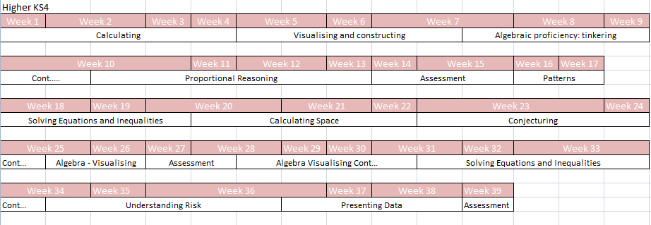
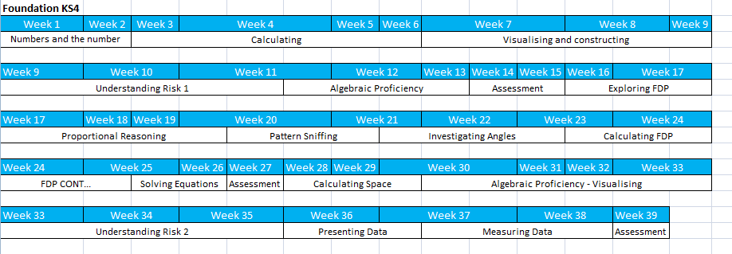
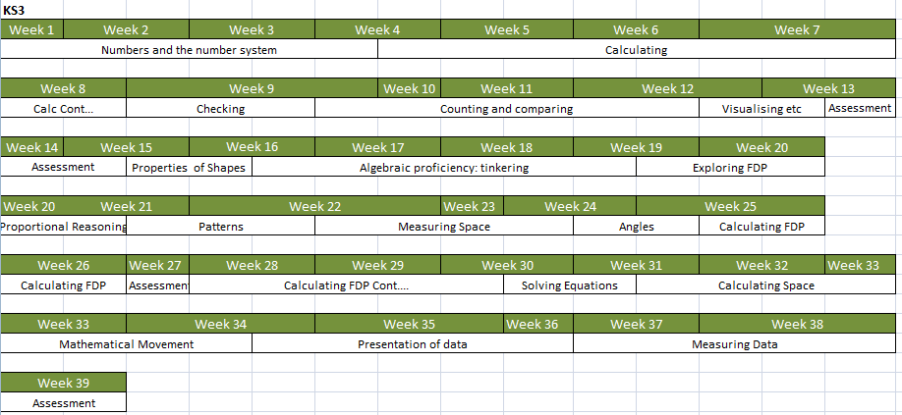

9. Useful Websites

MathsGenie.co.uk (How To Videos)
CorbettMaths.com (How To Videos)
MathsMadeEasy.co.uk (Online Practice Papers)
OnMaths.com (Online Practice Papers)

10. Evaluation
 | ACTION | IMPACT | MEASURE
1 | All year groups to use Numeracy Ninja Booklets 2x per week during form time | Improved numeracy skills, independent learning skills and self-evaluation skills. | Pupil voice  Staff Voice  Data Sheet – Improved pupil outcomes
2 | FT to enter progress data into tracking sheet | Progress data can be tracked by AA  Areas of weakness identified | Data sheets completed  Intervention plan written  Staff Voice
3 | AA to review and appropriate intervention to take place | Analysis of data to identify areas of weakness  Intervention groups highlighted  Intervention plans in place – improved outcomes for pupils | Pupil Voice  Staff Voice  Data sheets - Improved scores
4 | Opportunities for Numeracy highlighted in Schemes of Learning (updated as they go) | Staff are able to plan appropriately for opportunities for numeracy within their day-to-day lessons  Students use standard methods across school | Schemes of Learning  Lesson Observation  Pupil Voice  Pupil workbooks
5 | Mathematical key words displayed and used in lessons where appropriate | Students draw links between Maths and other subjects  Mathematical vocabulary improved | Pupil Voice  Staff Voice  Pupil workbooks
6 | Marking focused on Numeracy – where appropriate | All calculations / working is corrected and appropriately set out | Pupil Voice  Pupil Workbooks

