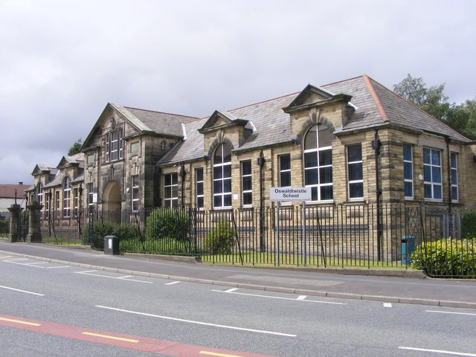

THE OSWALDTWISTLE SCHOOL

Public Sector Equality Duty

Equality Information and Objectives

2023-2027


PUBLIC SECTOR EQUALITY DUTY

EQUALITY OBJECTIVES
2023 - 2027

At The Oswaldtwistle School, we are committed to ensuring equality of education and opportunity for all pupils, staff, parents and carers; irrespective of race, gender, disability, belief, religion or socio-economic background.

In order to further support pupils, raise standards and ensure inclusive teaching, we have set the following equality objectives:

Objective 1:
To promote cultural development and understanding through a rich range of experiences, both in and beyond the school and curriculum.

Objective 2:
Actively close gaps in attainment and achievement between pupils and all groups of pupils; especially students eligible for free-school meals, students with special educational needs and disabilities and looked after children.

Objective 3:
To ensure that all pupils are given the opportunity to make a positive contribution to the life of the school.

Objective 4:
To eradicate the use of homophobic, biphobic, transphobic, sexist, racist and other discriminative language by pupils in and around school.

Objective | Which groups with protected characteristics will  benefit | Actions and who will be involved | Timescale | Which general duty will it address? | How will we measure our success?
- To promote cultural development and understanding through a rich range of experience, both in and beyond the school and curriculum. | Disability Gender Race  Religion or belief Sexual orientation  Age | Programme of visits to include places of worship and larger towns and cities.  Programme of visitors organised for assemblies and Drop Down Days to share different faiths and cultures.  All teachers and support staff. | Yearly Drop Down Day schedule  Termly visitors  Termly visits | Eliminate unlawful discrimination, harassment, victimisation and other conduct prohibited by the Act. | Pupils will have a wider experience of a diverse society.  Pupils understand that they are part of a multi- faith society and learn the values of other religions and faiths.
- A visit to St Annes Hebrew Congregation (synagogue) took place. Pupils were given a tour of the synagogue, took part in a question and answer session with the Rabbi and spoke to synagogue members.
- Mrs McKenna and Miss Amin have delivered numerous assemblies on different faiths and cultures, including on Christianity - Easter and Islam – fasting.
- A successful Chinese New Year drop down day took place on 26th January. This involved looking at human rights in China, Chinese zodiac signs artwork, re-writing the zodiac story, science experiments on making bangers and air dragons, compass work and tangrams linking to the year of the rabbit.
- Muslim pupils who took part in Ramadan spoke to fellow pupils and teachers throughout the month to educate all. School also made reasonable adjustments to allow fasting Muslims a quiet space to sit during break and lunch time.
- Actively close gaps in attainment and achievement between pupils and all groups of pupils; especially students eligible for free-school meals, students with special educational needs and disabilities and looked after children. | Disability Gender Race | Modify provision in order to meet all pupil’s needs and interests.  Introduce interventions for Literacy and Numeracy and subject under performance across the curriculum  All teachers and support staff. | Ongoing | Advance equality of opportunity between people who share protected characteristics and those who do not. | The gap between Pupil Premium pupils and non-Pupil Premium pupils will be narrowed.  The gap between EAL and non EAL pupils and non- disadvantaged pupils will be narrowed.
- Data is reviewed at every data capture. This is done on a departmental basis and pupils are openly discussed during the curriculum meetings.
- Miss Emmett, the Literacy and SEND Support Assistant informs staff of updated reading ages and which pupils are receiving literacy interventions.
- Support staff and the behaviour team are deployed to remove barriers and meet pupil needs.

- To ensure that all pupils are given the opportunity to make a positive contribution to the life of the school. | Disability Gender Race  Religion or belief Sexual orientation  Age | All school initiatives to be open to all pupils and will be promoted throughout school in assemblies, posters, social media and correspondence home. | Ongoing | Eliminate unlawful discrimination, harassment, victimisation and other conduct prohibited by the Act. | All pupils will be given the same opportunities to join the Student Council, Pupil Leadership Team, Anti Bullying Ambassadors and any other school led initiatives.
- All pupils are given the same opportunities, regardless of all their background to partake in making a positive contribution to school life.
- The school council is made up of a diverse group of pupils.
- The Pupil Leadership Team has recently reopened for nominations for the new academic year and currently has three members.

- To eradicate the use of homophobic, biphobic, transphobic, sexist, racist and other discriminative language by pupils in and around school. | Disability Gender Race  Religion or belief Sexual orientation  Age | All discriminative language to be addressed and challenged on a daily basis.  Interventions to be timely and held on the same day or the day after any incident has occurred.  Ongoing pupil and staff training/ education on such matters. | Ongoing | Advance equality of opportunity between people who share protected characteristics and those who do not.  Eliminate unlawful discrimination, harassment, victimisation and other conduct prohibited by the Act. | The number of recorded incidents on CPOMS around homophobic, biphobic, transphobic, sexist, racist and other discriminative language by pupils in and around school will decline.  Incident data will be analysed termly to identify trends and assess impact.
- A zero tolerance approach to homophobic, biphobic, transphobic, sexist, racist and other discriminative language in school has been shared with pupils and staff.
- All discriminative language is addressed and challenged immediately. This involves giving consequences, contacting parents/carers and conducting intervention/educational sessions with pupils. Sessions take place at lunch time and can include support from external agencies, such as Hope Not Hate and the Prevent Educational Officer.
- Curriculum For Life lesson on protected characteristics/Equality Act 2010 to all pupils.
- Assembly on Equality Act 2010.
- Staff CPD on Equality Act 2010/protected characteristics.
- Racism, bullying and sexual harassment data is analysed on a termly and yearly basis to identify trends and assess impact.

PROTECTED CHARACTERISTIC INCIDENTS

NUMBER OF INCIDENTS FROM JANUARY 2023 – APRIL 2023

Type of incident | Number of incidents | Reflection
Disability | 0 | There were no incidents relating to disability. However, upon reflection it is important to note that that there is no sub-category on CPOMS for this protected characteristic and data had to be analysed on an incident by incident basis.
Sex | 0 | There were no incidents relating to sex. Data had to be analysed on an incident by incident basis, as there is no sub-category on CPOMS relating to this characteristic. Instead, incidents can be logged generally under ‘discriminatory’.
Race/ethnicity | 2 | There were two racist incidents logged on CPOMS. One incident was child on child related and the other incident was child on teacher related.
Religion or belief | 0 | There were no incidents relating to religion or belief. Data had to be analysed on an incident by incident basis, as there is no sub-category on CPOMS relating to this characteristic. Instead, incidents can be logged generally under ‘discriminatory’ and other behaviour concerns.
Sexual orientation | 1 | There was one incident logged on CPOMS for sexual orientation. This involved a pupil refusing to enter a Curriculum For Life lesson, as they did not want to learn about homosexuality. Parents were consulted and the pupil took part in a catch up session.
Gender reassignment (transgender identity) | 1 | There was one incident logged on CPOMS for gender reassignment. This incident was logged three times by different members of staff and involved comments made by a pupil to another pupil. The victim and their family have been invited (and kept in contact with) to school for a restorative, as the perpetrator is remorseful and understands the severity of their actions, however the victim does not want a restorative meeting.
Age (other than pupils) | 0 | There were no incidents relating to age. However, upon reflection it is important to note that that there is no sub-category on CPOMS for this protected characteristic and data had to be analysed on an incident by incident basis.
Pregnancy/maternity | 0 | There were no incidents relating to maternity and pregnancy. However, upon reflection it is important to note that that there is no sub-category on CPOMS for this protected characteristic and data had to be analysed on an incident by incident basis.
Marital/civil partnership status | 0 | There were no incidents relating to marital and civil partnership status. However, upon reflection it is important to note that that there is no sub-category on CPOMS for this protected characteristic and data had to be analysed on an incident by incident basis.

Moving forward, the safeguarding team will review the sub-categories for reporting protected characteristic incidents on CPOMS. This will allow data analysis and reporting to be reliable, instead of having most categories presented under ‘discriminatory.’

