

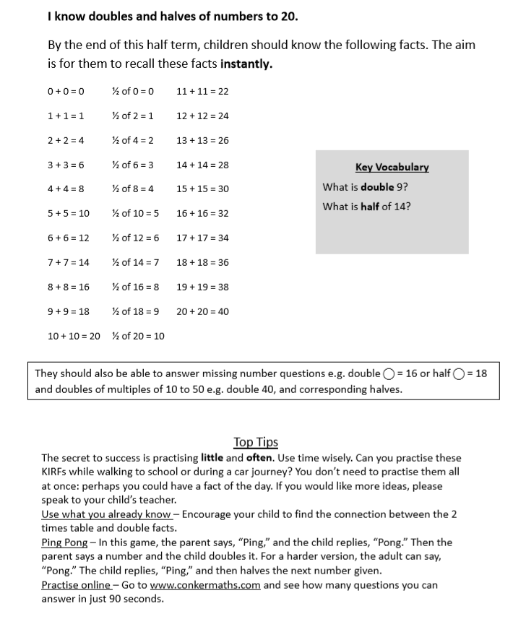**KEY INSTANT RECALL FACTS (KIRFS) YEAR 2 Summer 1 Home Learning**