

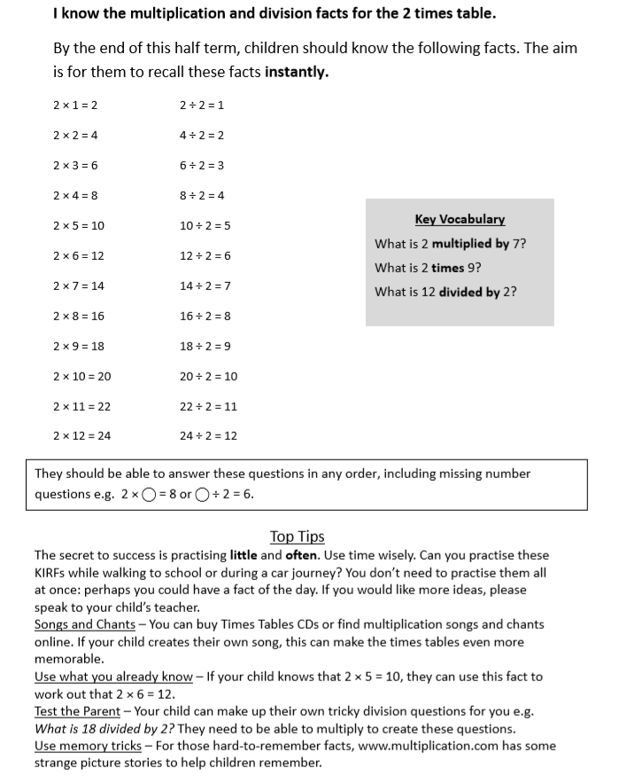**KEY INSTANT RECALL FACTS (KIRFS) YEAR 2 Spring 1 Home Learning**