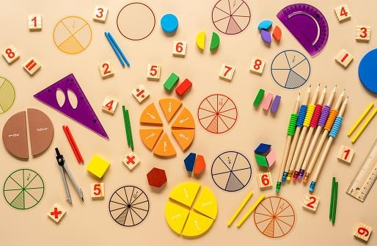

A Parents’ Guide
to Mathematics


This booklet has been written to help you understand how mathematics is taught throughout our school. It is not intended as a list to work through and each stage should only be attempted when your child is ready. It also gives practical ideas, suggestions and vocabulary for helping at home.

We know that parents are keen to help with their child’s education but may feel they do not understand what their child is doing as it is different to the way they were taught or find they confuse their children with their methods.

The days are gone when maths lessons were endless pages of calculations to be done in silence. Today, it is a lot more about collaboration and investigation. Children are taught why the methods work, not just how to perform them. It is the difference between telling someone directions and giving them a map.

So, use this guide to help you and your child gain confidence and remember to make maths fun!

Mastery in Mathematics

At Our Lady of Lourdes we believe all children have the capability to become Masters at Maths. This thinking is called a ‘growth mindset.’ It allows children to understand that they have an unlimited maths potential and that being good at maths is all about working hard and not about being ‘smart.’ We praise their effort and their thinking rather than their achievement e.g. “Well done for your thinking.” Below are the 7 principles of this growth mindset:

- Everyone can learn maths to the highest level.
- Mistakes are valuable.
- Questions are really useful.
- Maths is about creativity and making sense.
- Maths is about connections and communicating.
- Maths is about learning not performing.
- Depth is more important than speed.

With this in mind we encourage our children to develop a greater depth of understanding rather than just working on the next topic. It is important for children to really grasp how to perform a procedure in many different ways and contexts rather than just working with greater numbers. So before exploring numbers to 100, consider the following with numbers to 10:

3 + 2 = = 6 + 2 3 + = 4 + = 8

6 - = 2 5 = - 2 - = 7 5 – = 8 -

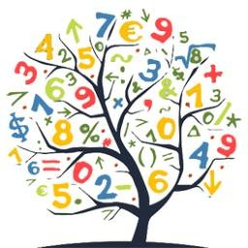

Some Do’s and Don’ts


Do make maths silly, gruesome or funny — get your child excited about maths

questions e.g. I bet you don’t know the answer?
Do recognise there’s more than one way of doing calculations — children’s methods may be long winded or confusing, but you should always let them try their own way of solving a problem. Notice one method does not solve all calculations

e.g. you would use different methods to find 378 + 499 to 378 + 468.

Don’t expect children to ‘get it’ after you’ve explained once — it can take a long time for the ‘penny to drop’. It is perfectly normal for children not to grasp a concept in a new context.
Don’t tell your child you are hopeless at maths — many adults claim that are not good at maths and this can give the message that maths is difficult, not enjoyable and ultimately not important to succeed in life. This just isn’t true, as adults we deal with mathematics every day and cope with it. Just because you don’t remember how to complete long division, doesn’t mean you don’t understand mathematics.
Do encourage your child to be resilient and have a go at challenging themselves to build their learning power.
When a child gets a question wrong, it is tempting to tell them they are wrong and how to correct it. Instead ask them to explain their method and help them spot their mistake.
Similarly, if a child gets a question right, do get them to explain how they reached their answer; perhaps pretending not to understand.
Do play maths with your child — board games or cards are full of maths and are an ideal way to engage mathematical thinking.
Do let your child win, or be ’better than you’ - of course you know your child best, so will know the correct balance of winning and losing, but you can compete against one another within a mathematical context e.g. I bet you can’t get ready for bed in 5 minutes.
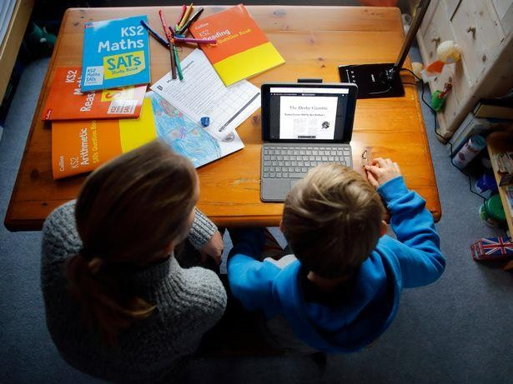
Do make maths a casual part of what you do while you’re doing something else — instead of making maths formal, find ways to sneak it in e.g. How many more plates do I need? Have we got enough money for the bread and milk? Did you see the number 23 bus?

Maths props to have at home


Tape measure and ruler - get your child involved when completing DIY.


Bar of chocolate (with squares) - good for showing multiplication and fractions. Magnet numbers - a great way for impromptu maths in the house.
Dartboard - darts teaches not only addition, subtraction and multiplication but also raises discussions of what is needed to finish the game.
Unusual dice - they don’t have to be 6 sided.
Dominoes - another great game to show combinations of numbers
Guess who - this game shows how to group characters into categories and can be extended to shapes and numbers.
Thermometer - shows both positive and negative numbers to discuss.
A prominent clock - try using both an analogue and digital clock. Can you compare the
two?
A wall calendar - not only good for noticing days and months, but also for finding patterns.
Board games with dice or spinner - why not make your own board game?
Pack of playing cards - not only can you learn about counting but also chance and probability.
Calculator - you can discover so many patterns with calculators, not just basic computation.
Measuring jug - discover both imperial and metric ways of measuring. Scales - traditional balances can show counting as well as measuring.
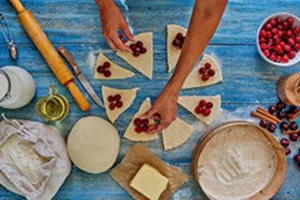

Minimum Expectations for Multiplication Tables
The teaching of times tables in the school is supported by the use of Times Table Rockstars. Mastery of a particular table group is shown by an accurate recall rate of below 3 seconds.

x | 1 | 2 | 3 | 4 | 5 | 6 | 7 | 8 | 9 | 10 | 11 | 12
1 | 1 | 2 | 3 | 4 | 5 | 6 | 7 | 8 | 9 | 10 | 11 | 12 |  | Y2 | master  1x, 2x, 5x, 10x
2 | 2 | 4 | 6 | 8 | 10 | 12 | 14 | 16 | 18 | 20 | 22 | 24 | (Y1 to begin ASAP)
3 | 3 | 6 | 9 | 12 | 15 | 18 | 21 | 24 | 27 | 30 | 33 | 36
4 | 4 | 8 | 12 | 16 | 20 | 24 | 28 | 32 | 36 | 40 | 44 | 48 |  | Y3 | master 3x, 4x,  8x
5 | 5 | 10 | 15 | 20 | 25 | 30 | 35 | 40 | 45 | 50 | 55 | 60
6 | 6 | 12 | 18 | 24 | 30 | 36 | 42 | 48 | 54 | 60 | 66 | 72 |  | Y4 | master 6x, 7x,  9x, 11,  12x
7 | 7 | 14 | 21 | 28 | 35 | 42 | 49 | 56 | 63 | 70 | 77 | 84
8 | 8 | 16 | 24 | 32 | 40 | 48 | 56 | 64 | 72 | 80 | 88 | 96
9 | 9 | 18 | 27 | 36 | 45 | 54 | 63 | 72 | 81 | 90 | 99 | 108
10 | 10 | 20 | 30 | 40 | 50 | 60 | 70 | 80 | 90 | 100 | 110 | 120
11 | 11 | 22 | 33 | 44 | 55 | 66 | 77 | 88 | 99 | 110 | 121 | 132
12 | 12 | 24 | 36 | 48 | 60 | 72 | 84 | 96 | 108 | 120 | 132 | 144

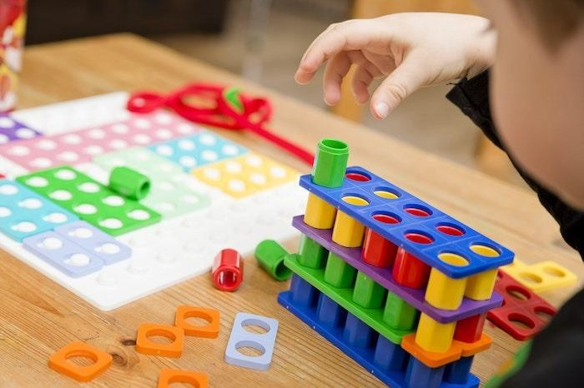

Reception

+ Addition  1 + 2 = 3 |  |  |  |  |  | Allow children to count these objects.  Written  +  1 + 2 = 3 |  |  |  |  |  |  |  | - Use physical objects - toys, counters, cubes, to help children count mentally.  - Encourage children to put  them into rows.  - Build up children counting 2  sets of objects practically.  - Children start with the biggest group first.  - Adding 1 more object.  - From objects move onto  pictures.  - Children can still use  objects when it is written.  - When confident, children  move onto a number line.  - Children move in jumps of  1 using their finger to help.  - Children count the jumps  for the answer.
0 | 1 | 2 | 3 | 4 | 5
- Subtraction  4 - 2 = |  |  |  |  |  | 6  2 | - | 2 | =  3 | 4 | 4 | 5 | 6 | - Explain to children that  subtraction is to take away.  - Use physical objects, games, songs and practical activities to help children gain a good understanding of subtraction and vocabulary  used.
 |  |  |  |  |  |  |  |  |  |  |  |  |  | - Encourage children to physically take objects away. eg: 1 less.
 |  |  |  |  |  |  |  |  |  |  |  |  |  | - Children start with the biggest group first and when recording children can cross out pictures.
 |  |  |  |  |  |  |  |  |  |  |  |  |  | - When children are confident children can use a number line.
 |  |  |  |  |  |  |  |  |  |  |  |  |  | - Children start with the biggest number and count back. e.g.: 9 - 3. Start at 9 on the number line and count back in 1’s 3 jumps.


x Multiplication | 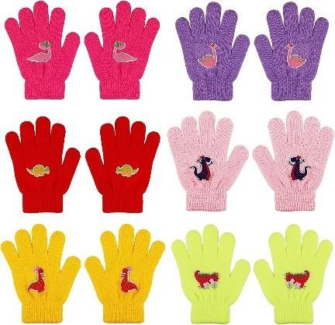  Children will use objects to count. | - Children will count in 2’s, 5’s  and 10’s orally.  - Children will use objects to  help them count.  - Encourage children to learn songs, rhymes and use visual aids.
÷ Division | 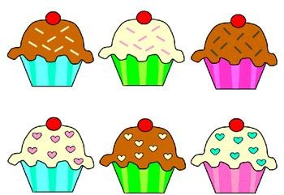  Children cut out 6 cakes and share them equally between two people. | - Children learn songs rhymes  and use visual aids.  - Children will practically group objects. E.g.: Children will cut and stick pictures to share.  - Children will practically  share objects between two.  - Children will gain an understanding of halving when practically sharing objects.

Examples of deeper understanding



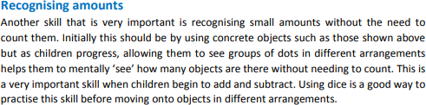

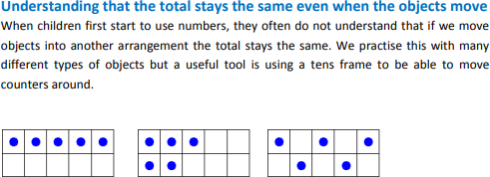

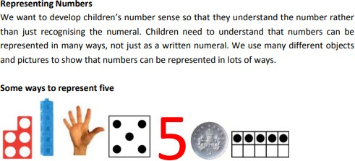

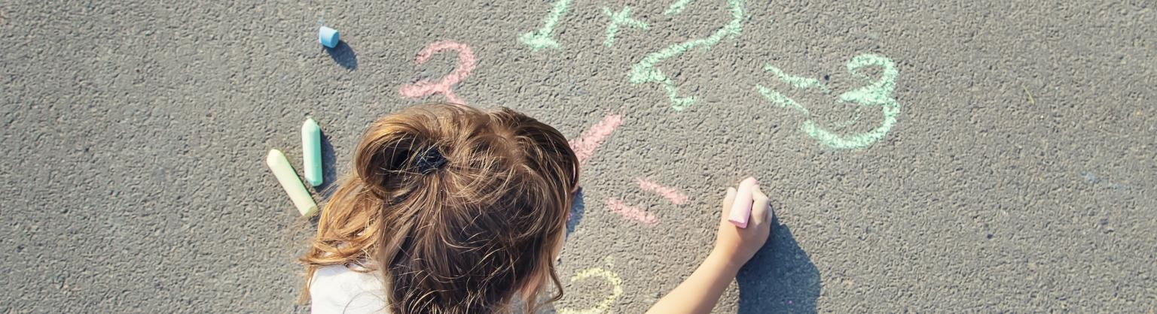

Year One

+ Addition  1st term - Practically.  Spring - number lines drawn. Counting on. | Use objects or counters.  3 + 5 = 8      1 2 3 4 5 6 7 8 9 10 | - In the Autumn term children add numbers using objects or pictures and mentally add together.  - In Spring children use number lines to count on from the first number.  - Start at 3 on the number  line and count in ones - 4, 5, 6, 7, 8.
- Subtraction | 8 - 3 = 5  1 2 3 4 5 6 7 8 9 10  8 - 3 = 5  1 2 3 4 5 6 7 8 | - Start with the lowest  number. E.g.: 4  - Children taught to count  up/find the difference.  - Children count up from 4 in  jumps of 1 to get to 10.  - They then count the jumps  to get the answer.  - Children are taught to  count back.  - Children start with the biggest number and count back e.g: 12-4. Start at 12 on the number line and count back in 1’s 4 jumps.

x Multiplication  2, 5, 10 | 3 x 4 = 12 | - Autumn term children work practically with objects, pictures or mentally.  - Spring term children record  arrays e.g.: 2 x 4 = 8  - 2 rows of 4 or 4 columns of  2. This gives children an image of the answer.  - It also helps develop the understanding that 2 x 4 is equivalent to 4 x 2.
÷ Division | 8 ÷ 2 = 4  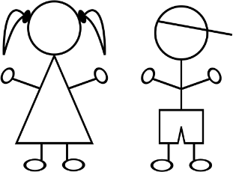     | •Children work practically with objects, pictures and arrays! In Spring children start to record.  - Children should solve a division problem within context.  - Children should use equipment to share objects and separate them into groups.  - E.g.: 6 sweets are shared between 2 people, how many do they each get?  - Children may solve by using ‘one for me’, “one for you’ strategy until all the sweets have been given out.  - Children should answer by counting how many sweets 1 person has got.  - 8 ÷ 2 = 5 how many groups of 2 are there in 8?  - Children draw 2 circles and share 10 between the 2 circles by drawing dots.  - Children count how many in each group.

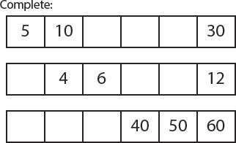
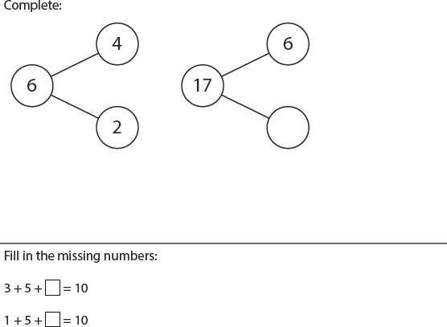




Examples of deeper understanding
Place
Value
Addition and
Subtraction

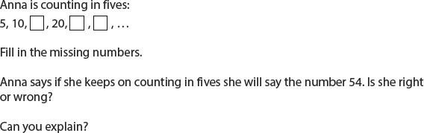


Multiplication and Division

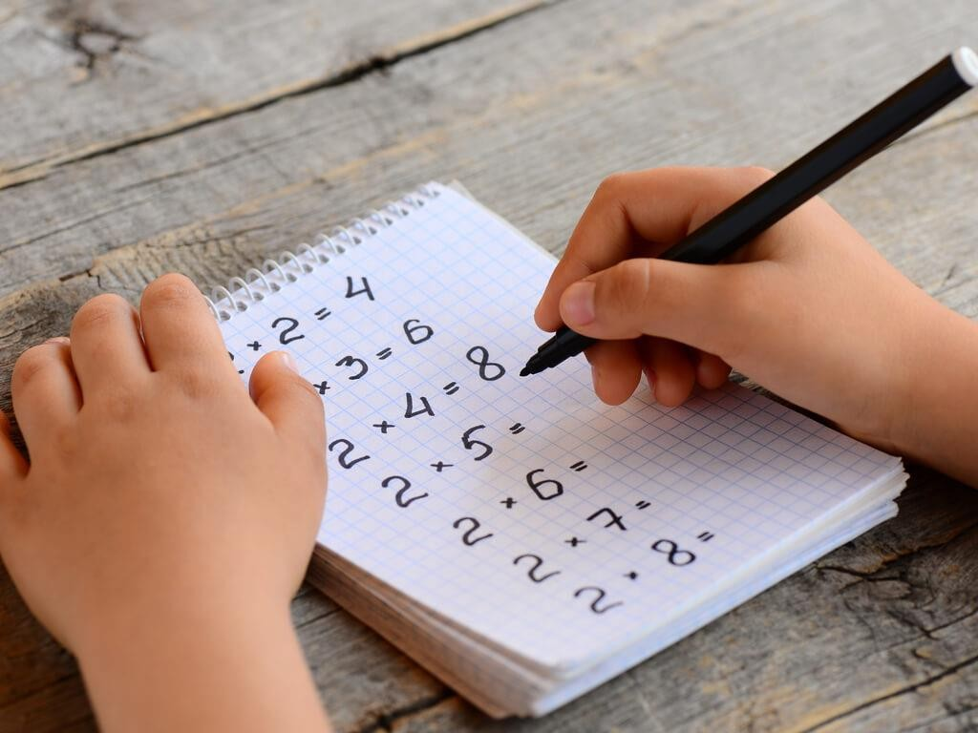

Year Two

+ Addition | 43 + 35 =  40 + 30 = 70  3 + 5 = 8  40 + 30 + 8 = 78 | - Children partition (split)  number  into tens and ones. E.G.: 32 30 + 2  - Tens numbers are added.  - Ones numbers added.  - Totals are then recombined.
- Subtraction  Counting On. | 35 - 18 = 17  +3 +10 +5  17 20 30 35  3 + 10 + 5 = 18 | - Start with the lowest  number.  - Children count on to the next multiple of ten and record number in the jump.  - Count in tens to the final multiple of ten, then add ones.  - Numbers in jumps are added together to find the difference.

x Multiplication | 3 x 5 =  13 x 5 =  10 x 5 = 50  3 x 5 = 15  50 + 10 + 5 = 65 | - Children continue to record  in arrays. E.g.: 3 x 5 = 15  - Children draw 3 rows of 5 or 5 columns of 3.  - Children then use the partitioning method to multiply when multiplying by a single digit.  - Partition 15 (10 and 5) and use known facts to multiply by 5.  - 10 x 5 = 50  - 3 x 5 = 15  - Add the answers together  by recombining.  - 50 + 10 + 5 = 65
÷ Division | 12 ÷ 4 =  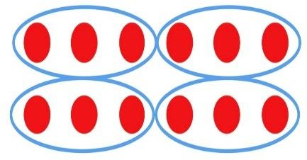  Towards Summer Term  2 1  3 ) 6 3 | - Children will continue to use practical equipment to represent division calculation.  - Children need to understand that 18÷3 reads as ‘How many groups of 3 are there in 18?’ or 18 divided into groups of 3.  - Children will draw 3 circles and share by drawing 18 dots between the 3 circles.  - Children will then count how many dots are in the circle to give them the answer.  Towards Summer Term:  - Simple divisions linked to tables without remainders should be carried out.  - 63 ÷ 3 = 21  - How many groups of 3 are there in 6? 2 Write 2 above the 6 on the line.  - How many groups of 3 are there in 3? 1. Write 1 above the 3 on the line.  - Answer is 31.

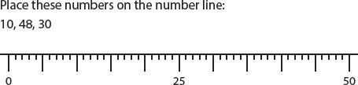


Examples of deeper understanding
Place
Value

What do I need to add or subtract from each of these numbers to total 60?

40, 44, 66, 69, 76, 86, 99, 89, 79.
Addition and
Subtraction

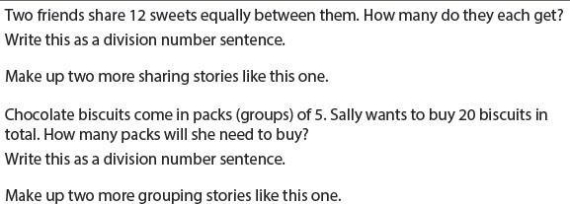

Multiplication and Division

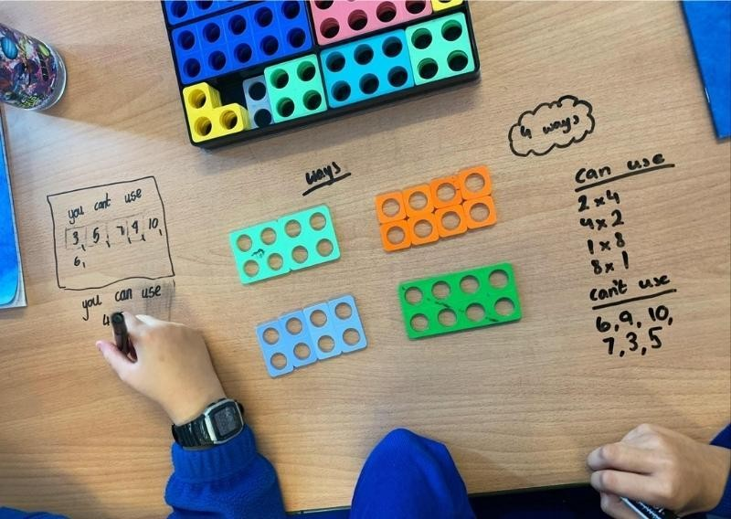

Year Three

+ Addition  Children should add numbers with  up to 3 digits.  T O  + H T O  H T O  + H T O | 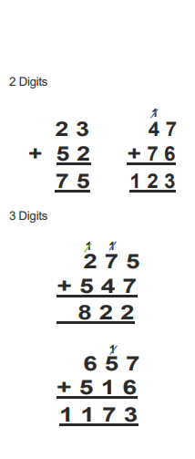  - Digits  1  2 3 4 7  + 5 2 + 7 6  7 5 1 2 3  - Digits  1 1  2 7 5  + 5 4 7  8 2 2  1  6 5 7  + 5 1 6  1 1 7 3 | • + on the left.  - Lined up accordingly to place value (tens above tens.)  - Carry above the top  numbers.  - Cross out the carrying number when added on (so we don’t forget.)  - Reinforce the importance of 0 as a place holder 1st on the left.
- Subtraction  Children should subtract numbers  up to 3 digits.  T O  - H T O  H T O  - H T O | 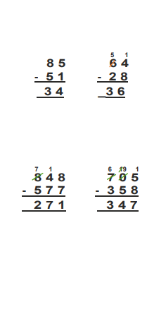  5 1  8 5 6 4  - 5 1 - 2 8  3 4 _3 6  7 1 6 19 1  8 4 8 7 0 5  - 5 7 7 - 3 5 8  2 7 1 3 4 7 | - Lined up according to place  value (tens above tens)  - When borrowing, cross the original number out and write the new number above.  - For example: 8 is larger than 4 so you can’t take it away from 4. There are 6 tens in the 64, change one of the tens into ten ones. Now you have 14-8. You still have 64 in total but instead of being 60+4 it is now 50+14.  - Reinforce the importance of  0 as a place holder.  - Remember sometimes both tens and ones need to borrow.  - Sometimes you may carry  numbers greater than 1.

x Multiplication  O x O  T O  x O  _ | 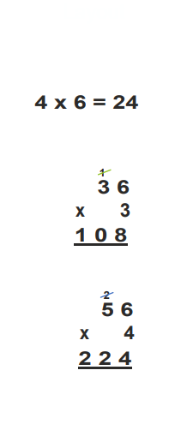  4 x 6 = 24  1  3 6  x 3  1 0 8  2  5 6  x 4  2 2 4 | - x on the left.  - All multiplication tables  should be done mentally.  - Multiply the ones first, then  the tens number.  - Carry above the number and remember to cross out when we have added it.
÷ Division  Children  T O ÷ O | Children  15 ÷ 3 = 5  3 2  2)64  2 1 r2  3)6 5 | - Simple division linked to tables without remainders should be carried out mentally  - ‘Short division’.  For example: 65÷3=  - How many groups of 3 are there in 6? 2. Write the 2 above  the 6 on the line.  - How many groups of 3 are there in 5? 1 group of 3 and there are 2 more to reach 5. Write 1 above the 5 on the line. There is 2 remainder so place an r 2.  Answer is 21 r 2.

Examples of deeper understanding
Addition and
Subtraction
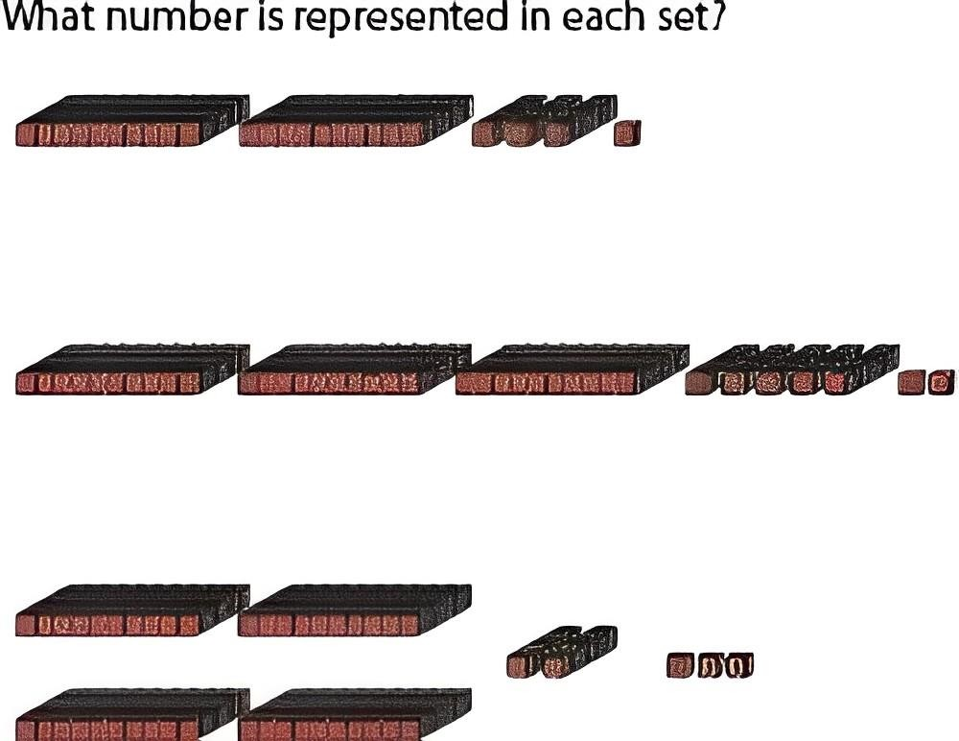
Place
Value

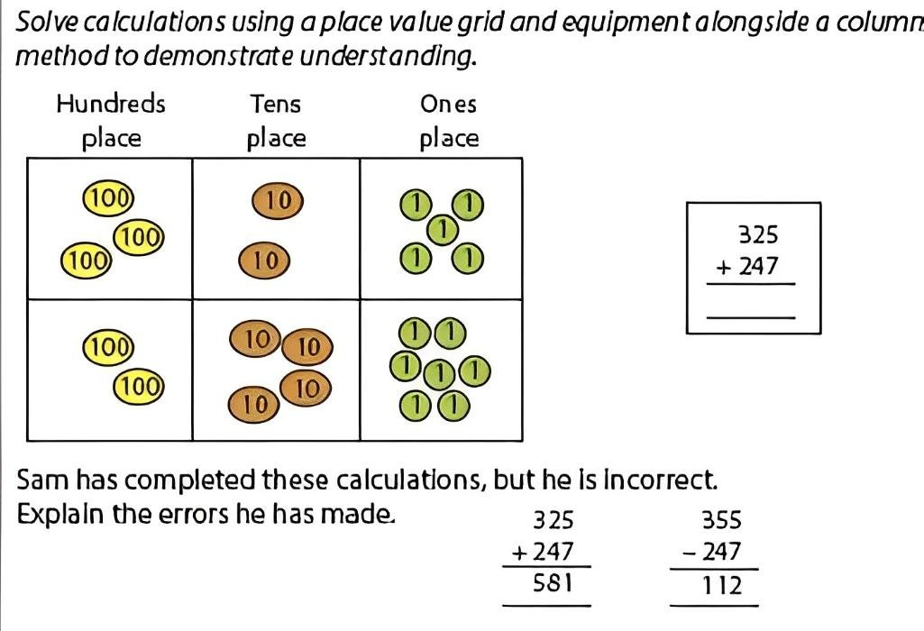
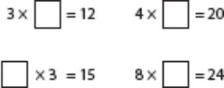
Complete the following:



Multiplication and
Division

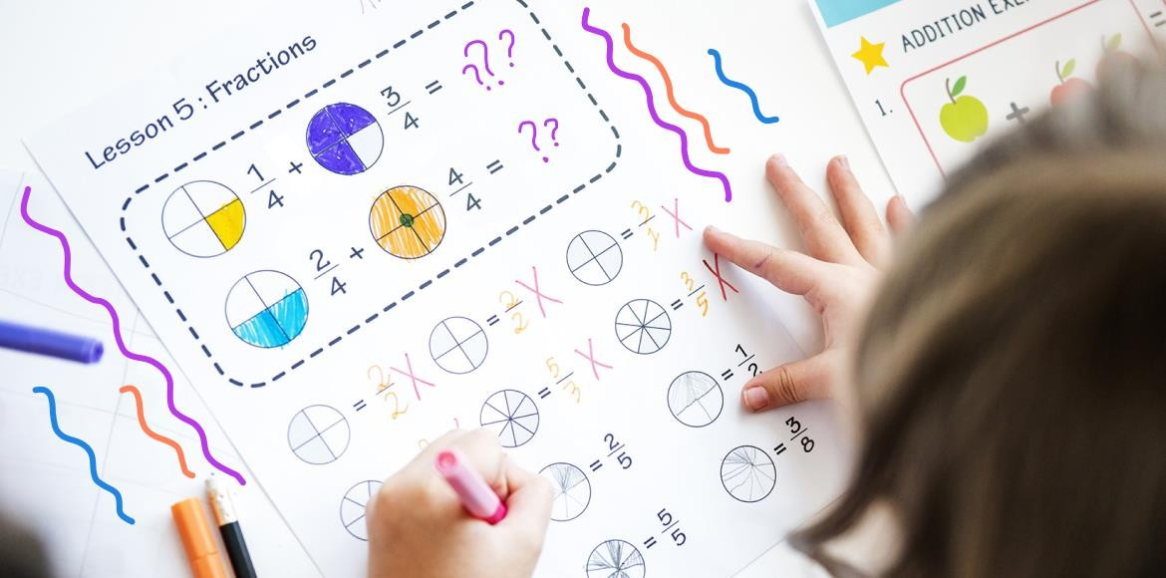

Year Four

+ Addition  Children should add numbers up  to 4 digits. | 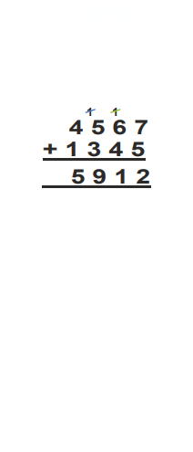  1 1  4 5 6 7  + 1 3 4 5  5 9 1 2 | • + on the left.  - Lined up according to place  value (tens above tens).  - Carry above the top  number.  - Cross out the carrying number when added on (so we don’t forget).
- Subtraction  Children should subtract digits up  to 4 digits | 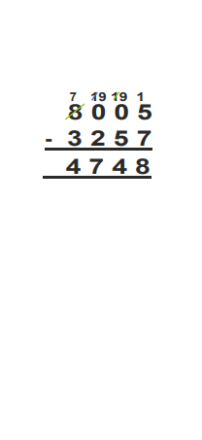  7 19 19 1  8 0 0 5  - 3 2 5 7  4 7 4 8 | - - on the left.  - Lined up according to place  value (tens above tens).  - When ‘borrowing’ cross the original number out and write the new number above.  - E.g.: 7 is larger than 5 so  you can’t take it away from  5. Move along the digits  turning the 0’s into 10’s.  - Ask the tens to borrow  which turns into 9’s  15 - 7 = 8

x Multiplication H T O x O | 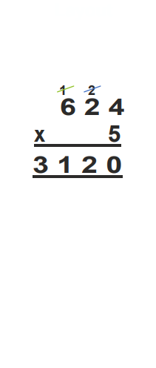  1 2  6 2 4  x 5 3 1 2 0 | - X on the left.  - Multiply the units first, then by the tens numbers and then by the hundreds.  - Carry the number.  - Remember to cross out numbers you ‘carry’ when you add them on.
÷ Division H T O ÷ O | 1 2 4 r1  3)3 7 3 | - Short division.  - For example: 373 ÷ 3  - How many groups of 3 are there in 3? 1. Write the line.  - How many groups of 3 are there in 7? 2 groups and there is 1 more to reach 7 write the 2 above the 7 on the line.  - How many are left over? 1. Write the 1 next to the 3.  - How many groups of 3 are there in 13? 4 groups and there is 1 more to reach 13. Write 4 above the 3 on the line. There is 1 remainder, so place an r1.

Examples of deeper understanding
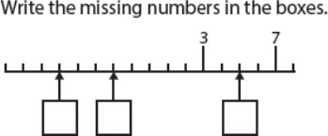
Place
Value

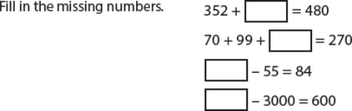



Addition and Subtraction

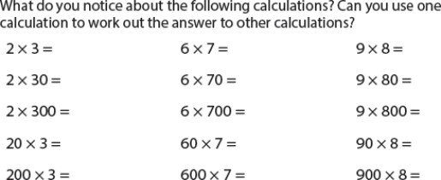
Multiplication and
Division

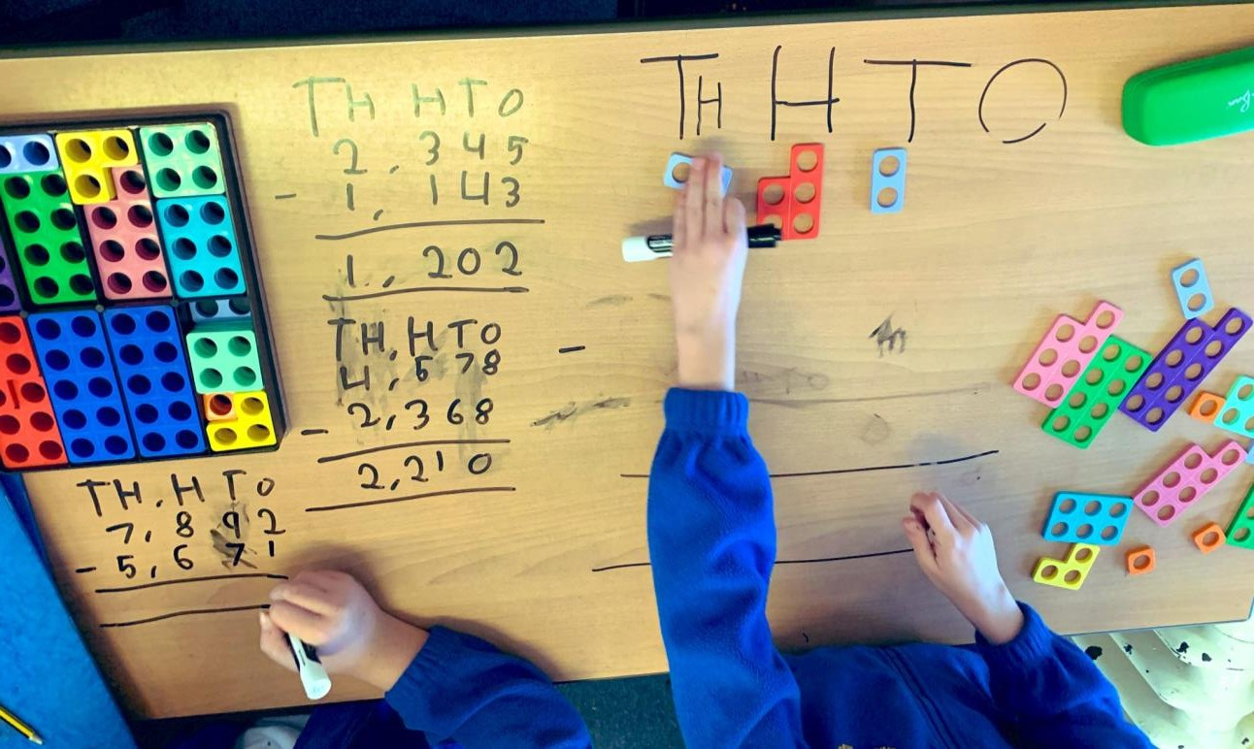

Year Five

+ Addition  Children should add whole numbers with more than 4 digits.  - Decimals | 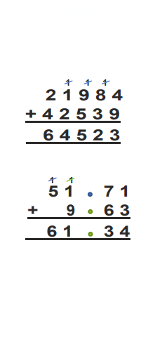  1 1 1  2 1 9 8 4  + 4 2 5 3 9  6 4 5 2 3  1 1  5 1 7 1  + 9 6 3  6 1 3 4 | • + on the left.  - Lined up according to place  value (tens above tens)  - Carry above the top  numbers.  - Cross out the carrying numbers when added on (so we don’t forget).  - Adding decimals.  • + on the left.  - Lined up according to place value. Make sure decimal points are lined up.  - Add a 0 in to fill the gaps.
- Subtraction  Children should subtract whole numbers with more than 4 digits.  - Decimals | 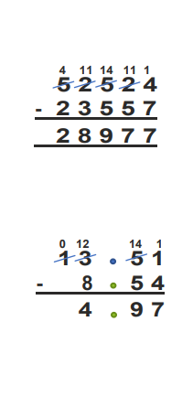  4 11 14 11 1  5 2 5 2 4  - 2 3 5 5 7  2 8 9 7 7  0 12 14 1  1 3 5 1  - 8 5 4  4 9 7 | - - on the left.  - Lined up according to place value (tens above tens). Decimal numbers – arrange numbers around decimal point.  - Decimal subtraction - add a 0 to fill in the gaps.  - When ‘borrowing’ cross the original number out and write the new number above. E.g.: 1 - 4 you can’t, so borrow from the 5 making it 4 tenths and place 1 above the 1.  11 - 4 = 5. Remember you may need to borrow from the number to the left, that is fine.

x Multiplication  T O x O  H T O x T O H T O | 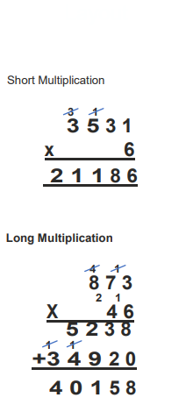  Short Multiplication  3 1  3 5 3 1  x 6  2 1 1 8 6  Long Multiplication  4 1  8 7 3  2 1  X 4 6  5 2 3 8  1 1  +3 4 9 2 0  4 0 1 5 8 | - x on the left.  - Multiply the ones / units first, then tens, then hundreds and then thousands.  - Carry above the number and cross out the numbers you carry when you add them on.  Long Multiplication  - x on the left  - Multiply the unit of the bottom number by the units, tens and hundreds of the top number. When carrying place on top unit, cross out when added.  - Add a 0 on the second line  and multiply the tens digits  (4) by the units, tens and hundreds of the top line.  - When carrying place on the  line.  - Adding the two rows of answers carry above the answer.
÷ Division  Th H T O ÷ O  Th H T O ÷ T O with remainder | 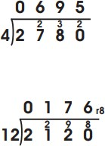 | Short Division  2780 ÷ 4  2 ÷ 4 = 0 remainder 2 put 2 next to the 7.  27 ÷ 4 = 6 remainder 3. Put the 6 above the 7 on the line. Put the 3 next to the 8.  38 ÷ 4 = 9 remainder 2. Put the 9 above the 8 on the line. Put the 2 next to the 0.  - ÷ 4 = 5. Put the 5 above  the 0 on the line. 2 ÷ 12 = 0  remainder 2.  Put a 0 above the 2 on the line and 2 next to the 1.  - ÷ 12 = 1 remainder 9. Put  1 on the line and 9 next to 2.  92 ÷ 12 = 7 remainder 8. 7  above 2 and put 8 next to 0.  80 ÷ 12 = 6 remainder 8. Place remainder on the line with an 8 beside it.

Examples of deeper understanding

What can we say about 48,000?

It is less than 50,000.


It is made if 40,000 and together. It is made of thousands.
Place
Value
It is made of hundreds. It is made of tens.

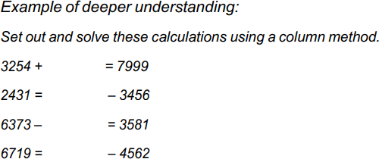

Addition and
Subtraction

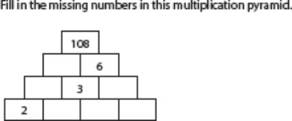

Multiplication and
Division

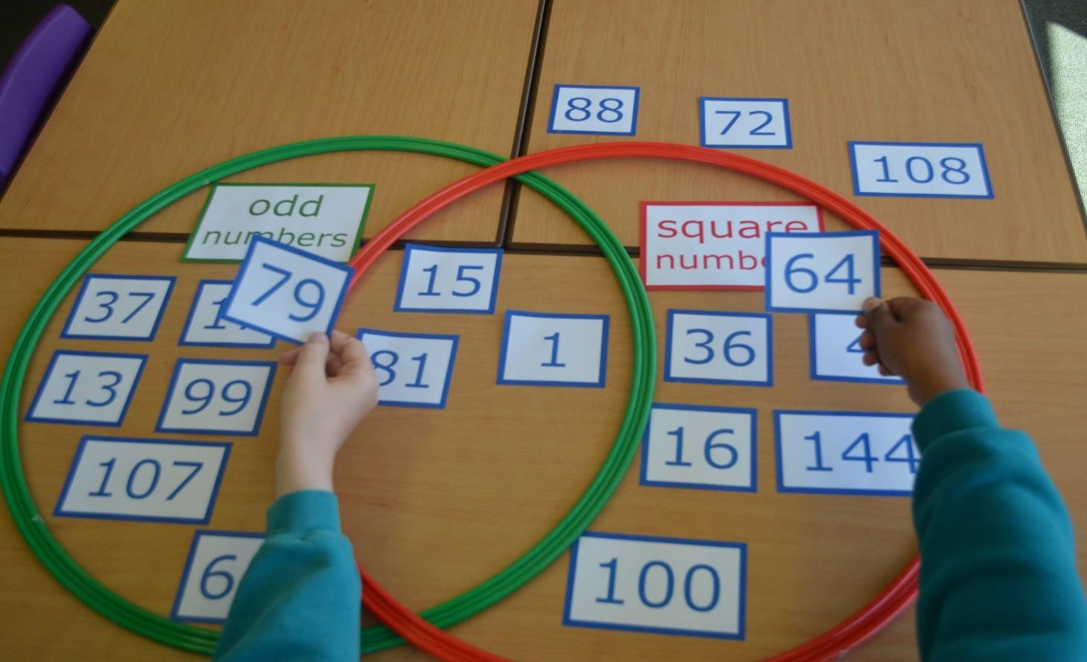

Year Six

+ Addition | 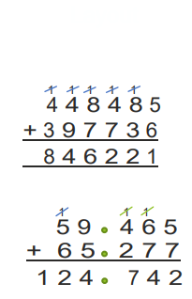  1 1 1 1 1  4 4 8 4 8 5  + 3 9 7 7 3 6  8 4 6 2 2 1  1 1 1  5 9 4 6 5  + 6 5 2 7 7  1 2 4 7 4 2 | • + on the left.  - Lined up according to place value  - Carry above the top numbers.  - Cross out the carrying numbers when added on (so we don’t forget).  - Adding decimals.  • + on the left.  - Write the calculation using place value to line up the digits.  - Make sure decimal points are lined  up.  - Work from thousandth column and  carry above the top number.
- Subtraction | 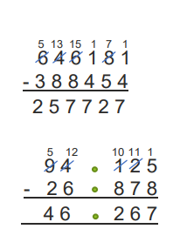  5 13 15 1 7 1  6 4 6 1 8 1  - 3 8 8 4 5 4  2 5 7 7 2 7  5 12 10 11 1  9 4 1 2 5  - 2 6 8 7 8  4 6 2 6 7 | - - on the left.  - Lined up according to place value. When subtracting decimal arrange numbers around decimal points.  - When ‘borrowing’ cross the original number out and write the new number above.  - When subtracting whole numbers start from the ones. As the bottom number is larger borrow from the 8 tens leaving 7 tens and place 1 above the 1.  - 11 - 4 = 7. Remember you can borrow from the number on the left.
x Multiplication | 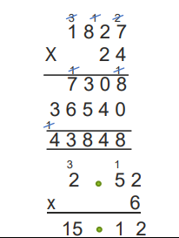  3 1 2  1 8 2 7  X 2 4  1 1  7 3 0 8  3 6 5 4 0  1  4 3 8 4 8  3 1  2 5 2  x 6  15 1 2 | - X on the left.  - Multiply the ones of the bottom number by the ones, tens, hundreds and thousands.  - Carry above the top number and  cross out when added.  - Before multiplying by the tens add a 0 on the right of the second row. This is because we want to multiply by 20 (2 tens.)  - Multiply 2 tens by the ones, tens,  hundreds and thousands.  - When carrying place on the line,  don’t forget to cross out when added.  - Add the two rows of answers and  carry above the answers.

÷ Division  Decimal short division.  Short division with a fraction remainder  Short division with decimal remainders  Long division | 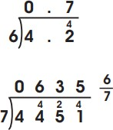  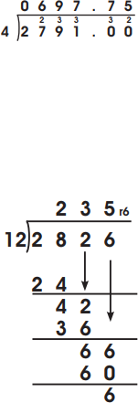 | Short division with fraction remainders  - 4 ÷ 7 = 0 remainder 4. Put the 0 above the line and the 4 next the 4. 44 ÷ 7 = 6 remainder 2. Place the 6 above the line and the 2 next to the 5.  - 25 ÷ 7 = 3 remainder 4. Place the 3 on top of the line and 4 next to the 1.  - 41 ÷ 7 = 5 remainder 6. Place the 5 on the line and write the remainder as a fraction.  E.g.:  6 Top number (numerator) is  7 the remainder.  The bottom number (denominator) of the fraction needs to be the number you were dividing by.  Short division with decimal remainder.  - 2 ÷ 4 = 0 remainder 2. Place the 0  on the line and 2 next to the 7.  - 27 ÷ 4 = 9 remainder 3. Place the 6 on the line and the 3 next to the 9.  - 39 ÷ 4 = 9 remainder 3. Place the  9 on the line and the 3 next to the 1.  - 31 ÷ 4 = 7 remainder 3.  - Add a decimal point and a 0 after the point. Place the remainder 3 next to the 0.  - 30 ÷ 4 = 7 remainder 2. Place a decimal point on the answer line and put 7 after it.  - Place another 0 with a 2 beside it.  Long Division  - Set out the calculation. Start by  looking at the  first two digits of 2,826.  - Divide 28 by 12 to find how many times 12 goes into 28. Write 2 above the line in the answer and place as is shown. Find the remainder: 4. Bring down the digit 2.  - Divide 42 by 12 to find how many  times 12 goes into 42.  - Write 3 above the line in the answer space and record 36 (12x3) below 42.  - Subtract 36 from 42 to find the remainder, 6.  - Bring down the digit 6 and continue  by dividing 66 by 12.  - 66 ÷ 12 = 5r6

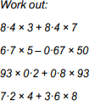
Examples of deeper understanding
Multiplication and
Division


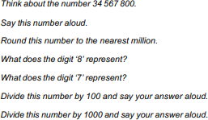
Place
Value

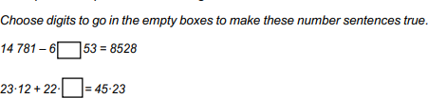

Addition and Subtraction

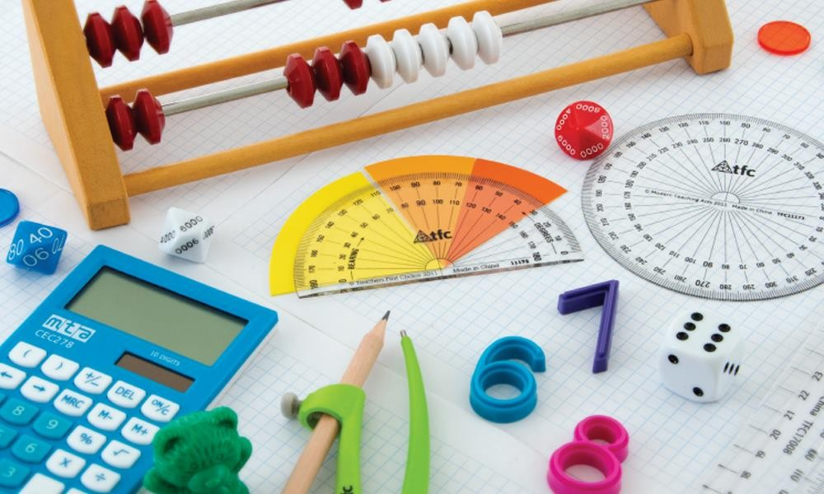

Maths vocabulary for parents

The aim of this section is to explain some of the maths vocabulary and terms that we use when teaching maths so you can confidently support your child at home.

If there are any further words or phrases you are unsure of then please do not hesitate to ask your child’s class teacher, the maths subject leader (Mr Savage) or look here: http://www.mathsisfun.com/definitions/index.html

The definitions have been spilt into the different areas of maths.

Number and Place Value
Place value - where the number is in the number system or the value of the digit.
Digit means a numerical symbol (1 2 3 4 5 6 7 8 9 0) A number is made up of digits. A digit is not a number, they are different.
Partition means split the number into the values of each digit e.g 125 is 100 and 20 and 5.
Consecutive means next door numbers without gaps e.g. 14, 15 and 16 are consecutive.
Ascending means ordering a set of numbers from smallest to biggest.
Descending means ordering a set of numbers from biggest to smallest
Estimate means make a sensible guess.
Mixed number has a whole number and a fraction, e’g. 6 ½ =
six and a half.

Number Facts and Calculations
Calculate means work it out. Calculation means using an operation to work out an answer.
Difference means subtract.
Equation a maths statement where 2 sides are equal e.g. 2 + 2 = 4 or 2 + 2 = 3 + 1
Number sentence is a calculation involving numbers or an equation e.g. 4 + 6 = 10 or 17 - 3 = 14
Operation means add, subtract, multiply or divide. These are the 4 main operations in maths.
Sum means add and only add. 4 x 6 is not a sum, it is a calculation or a multiplication.

Multiple means a number in a particular times table e.g. 50 is a multiple of 10 as it is in your 10 x table.
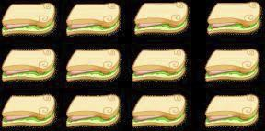
Array is when objects or numbers are arranged in rows and columns.

3 x 4 =12
4 x 3 = 12

Inverse means the opposite. For example, + is the opposite operation to -, x is the opposite of ÷
Remainder means the number that is left over if a number does not divide exactly by another eg. 23 ÷ 5 = 4 r3 (4 remainder 3).
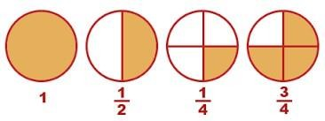
Fraction is part of a number group or objects split into equal parts, e.g half (1/2) of 4 is 2, 3 quarters (3/4) of 8 is 6.

Shape
Fraction means part of a whole, ½, ¼, ¾ etc. If a whole is split into sixths then the whole will now consist of 6 equally sized pieces.
Line of symmetry means the line you would fold down so that the 2 sides would match exactly.
Vertex, more commonly known as a corner, means a point where 2 sides or 2 edges meet, (used for 2D and 3D shapes).
Vertices - plural of vertex.
Polygon means a 2D shape with 3 or more sides. Quadrilateral means a 4-sided shape.
Measurement
Analogue clock shows the 12-hour clock face with a clock face using hands.
Digital clock is a clock which doesn’t have hands, it
shows the time in digits.
Capacity means the amount something can hold, usually measured in ml or l.

Handling data
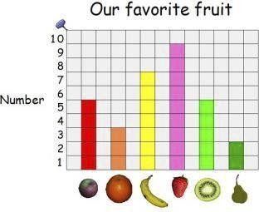
Block graph means a simple bar graph made from blocks.

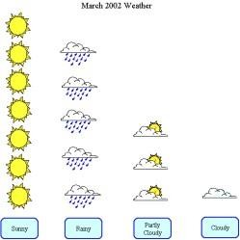
Pictogram means a graph where picture represent the data. For example, if recording eye colour, you could draw coloured eyes to pile up to make a graph. You can also extend the task by one car on the graph representing 2 cars in real life, so half a car on the graph would equal one real car.

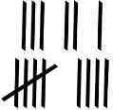
Tally means count using a bar and gate.

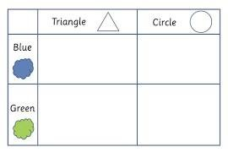
Carroll Diagrams sort data using a yes/no system.

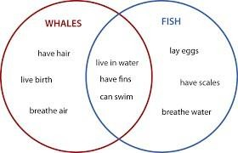
Venn Diagrams sort data using relationships between the set of data being sorted.

Maths symbols

+ | Add Addition Altogether Plus  Sum Total
- | Subtract  Subtraction Minus Difference Take away  How many less/left?
x | Multiply Multiplication Times  Times tables Sets of  Groups of
÷ | Divide Division  Share/shared by
= | Equals Equal to
< | Less than
> | Greater than

Our Lady of Lourdes Catholic Primary School
Fleming Field
Shotton Colliery
Durham
DH6 2JQ

Enquiries should be addressed to:
Mrs Ashton (Executive Headteacher) or
Ms Wetherell (Maths Lead)

PHONE:
0191 526 1531

E-MAIL ADDRESSES:
For general queries:
office@ourladylourdesdurham.org
(Mrs Armstrong)

For Special Educational Needs and/or Disabilities queries:
gwright@ourladylourdesdurham.net
(Mrs Wright, Special Educational Needs and/or Disabilities Coordinator)

