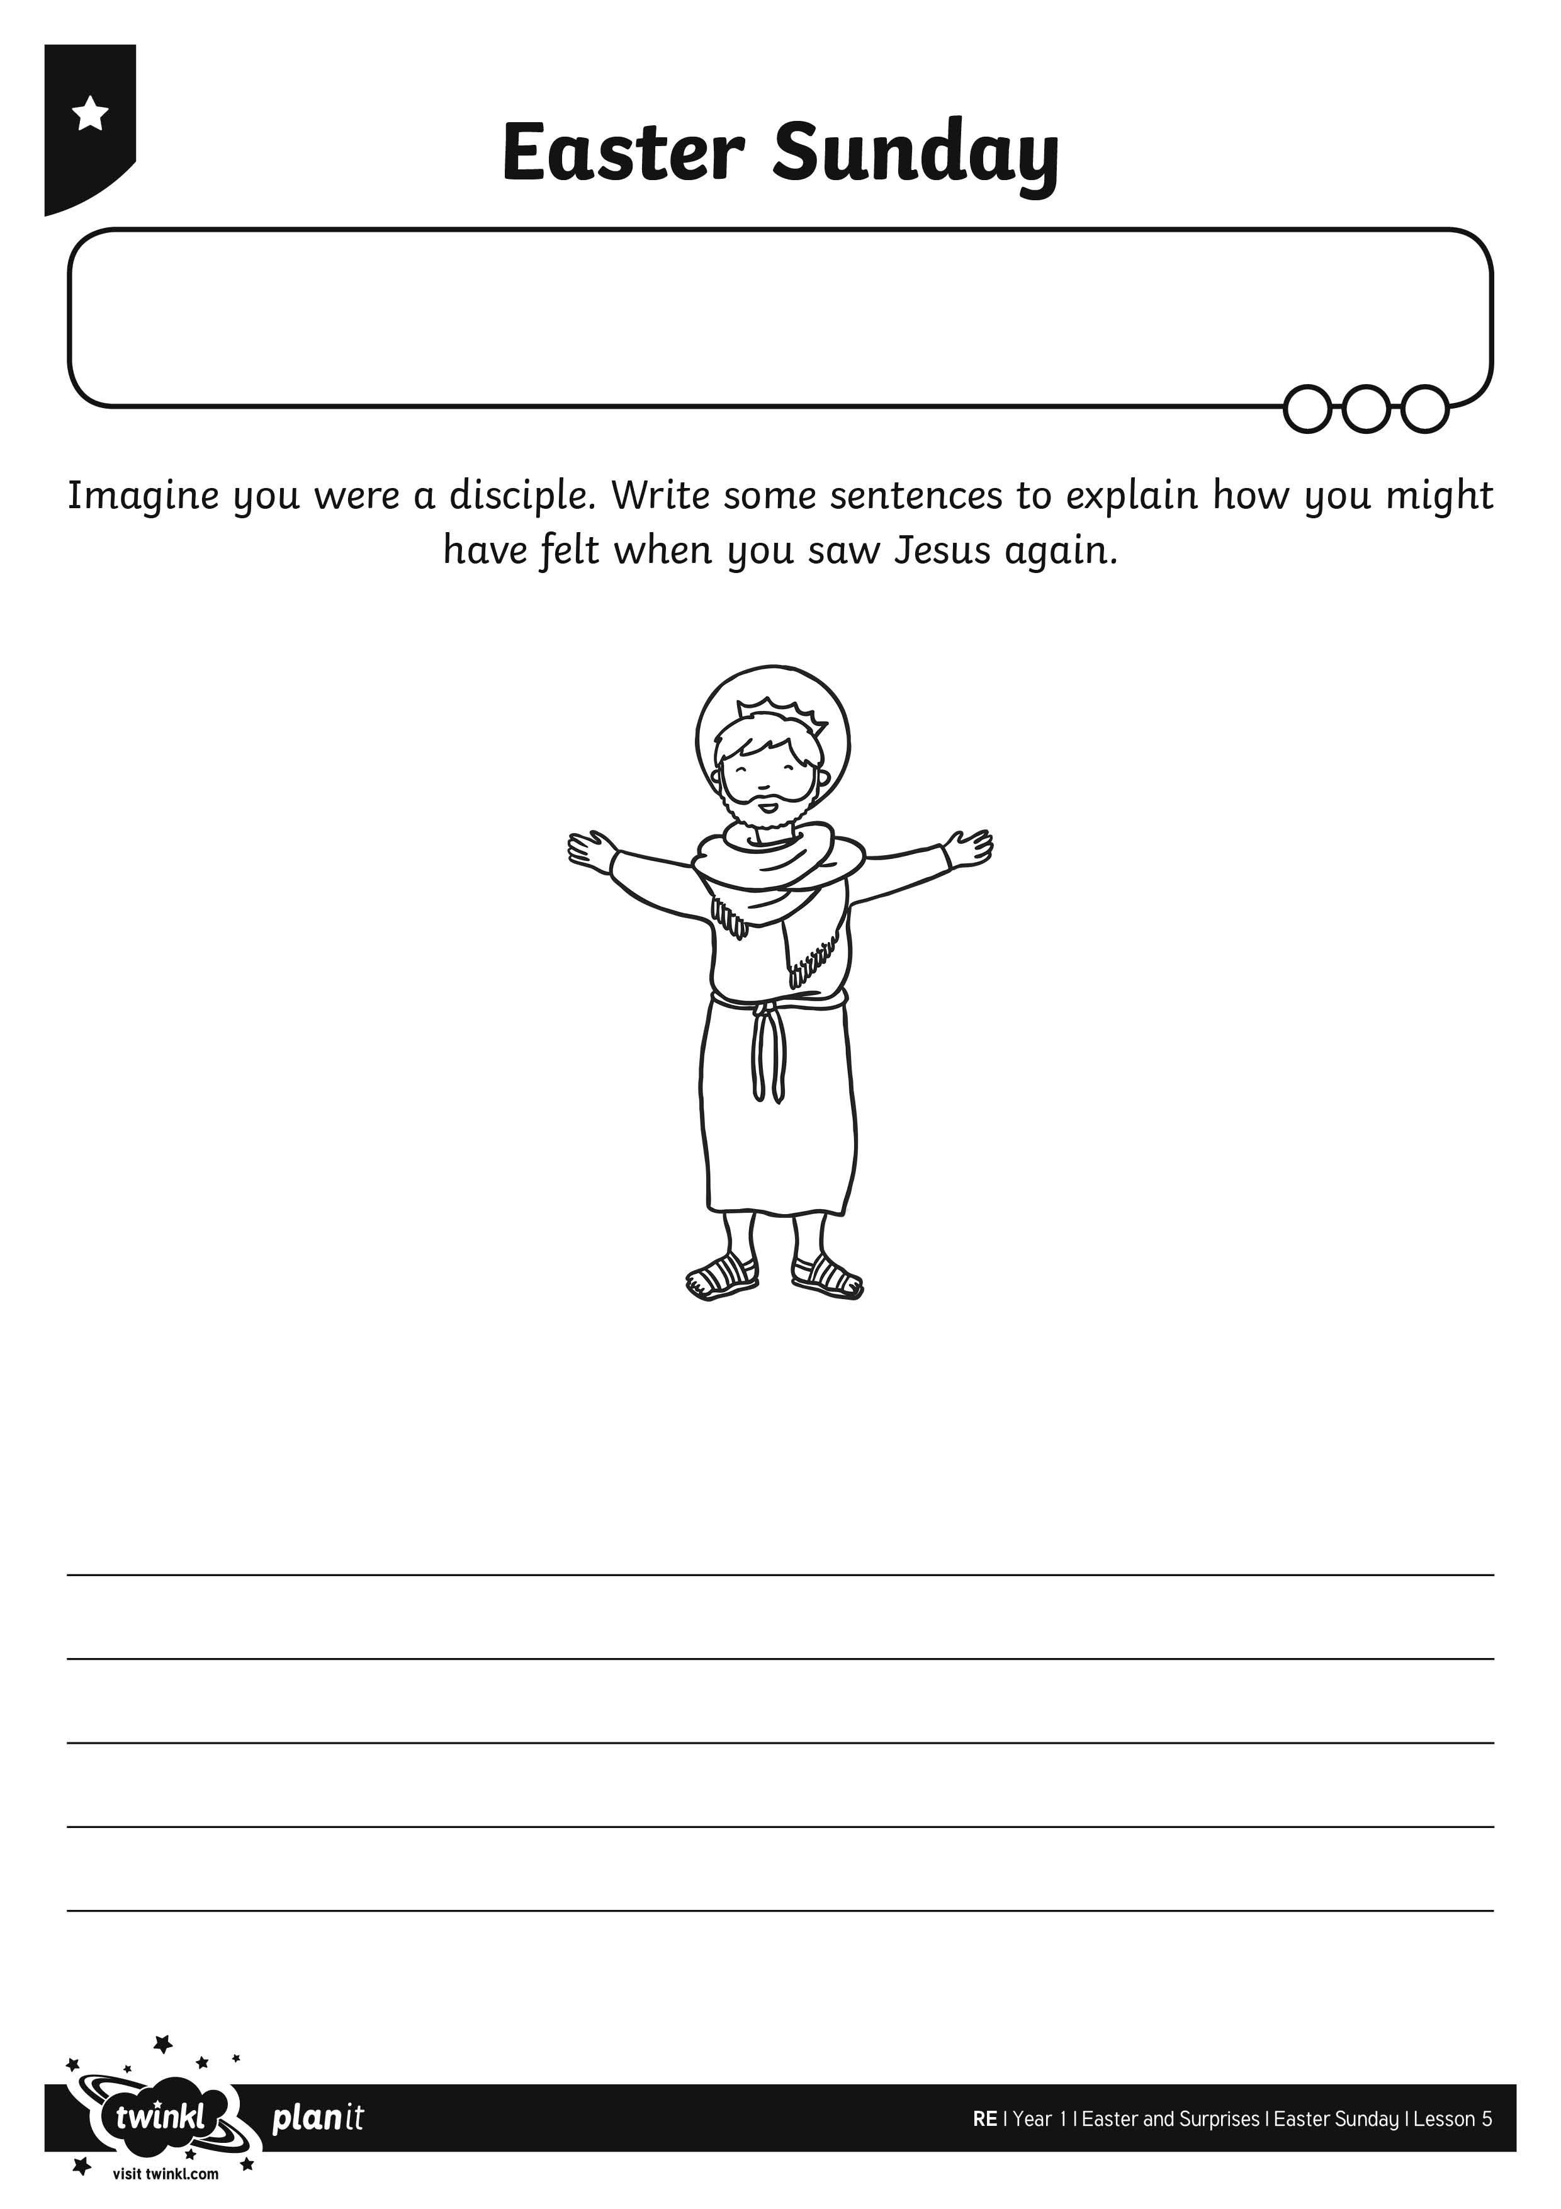
I can explain how the disciples felt on Easter Sunday.
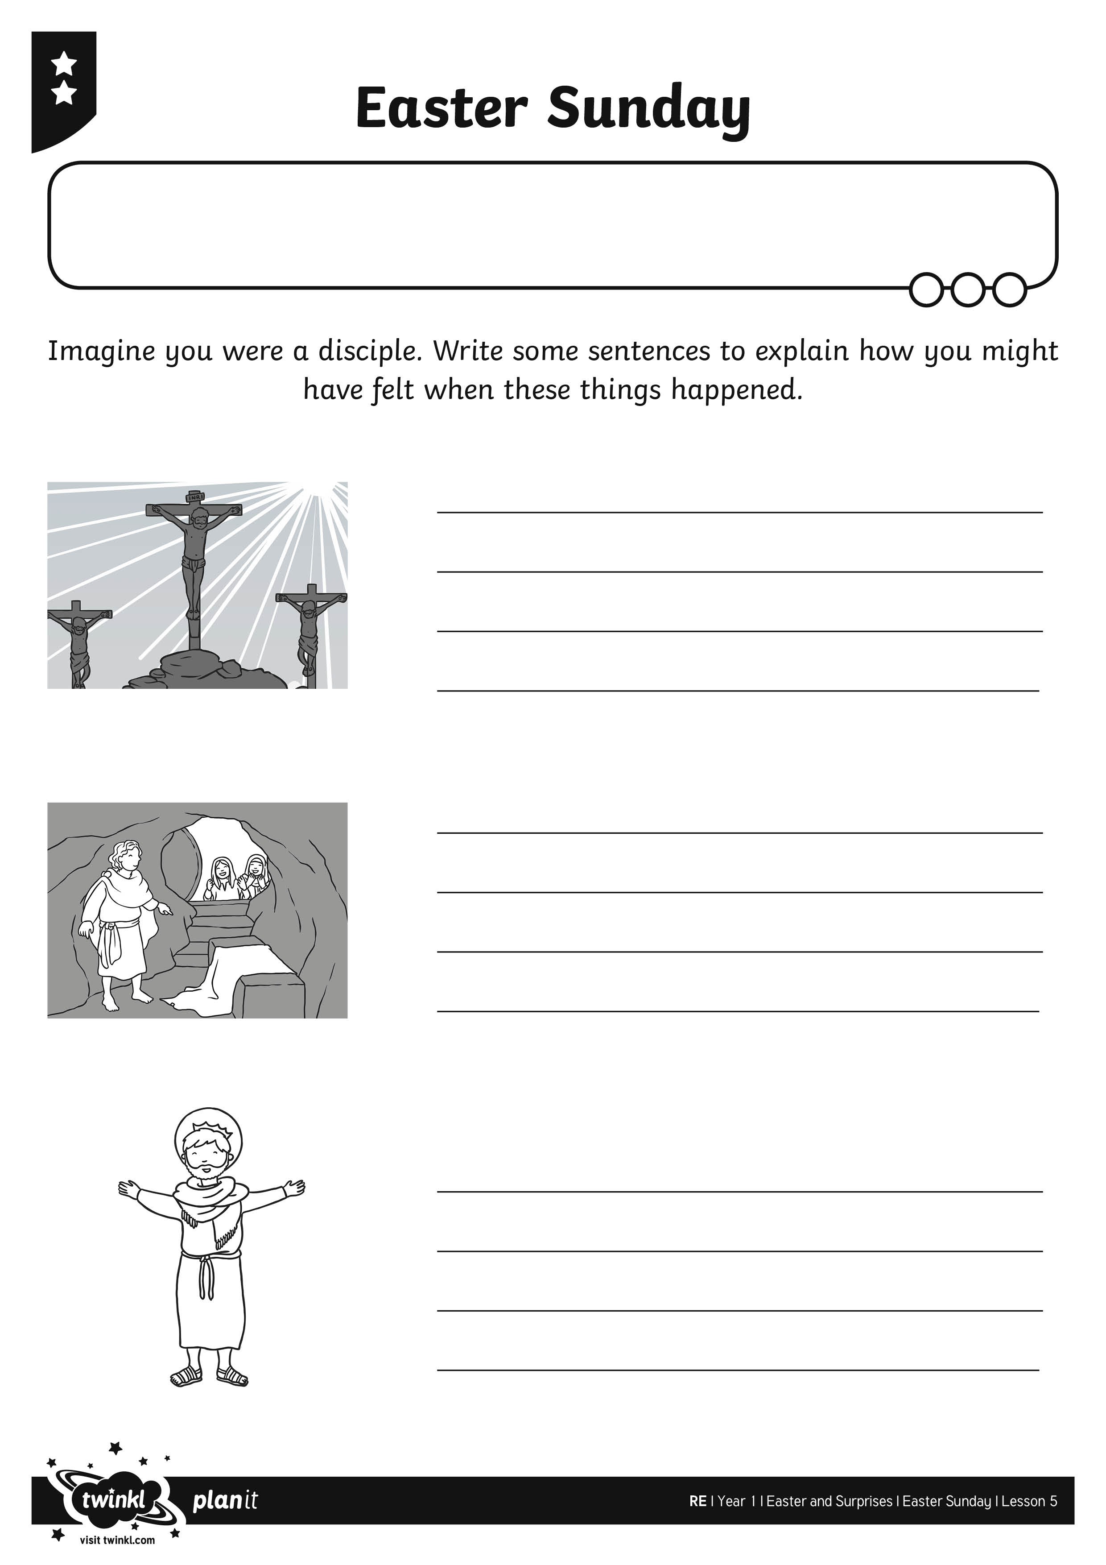
I can explain how the disciples felt on Easter Sunday.
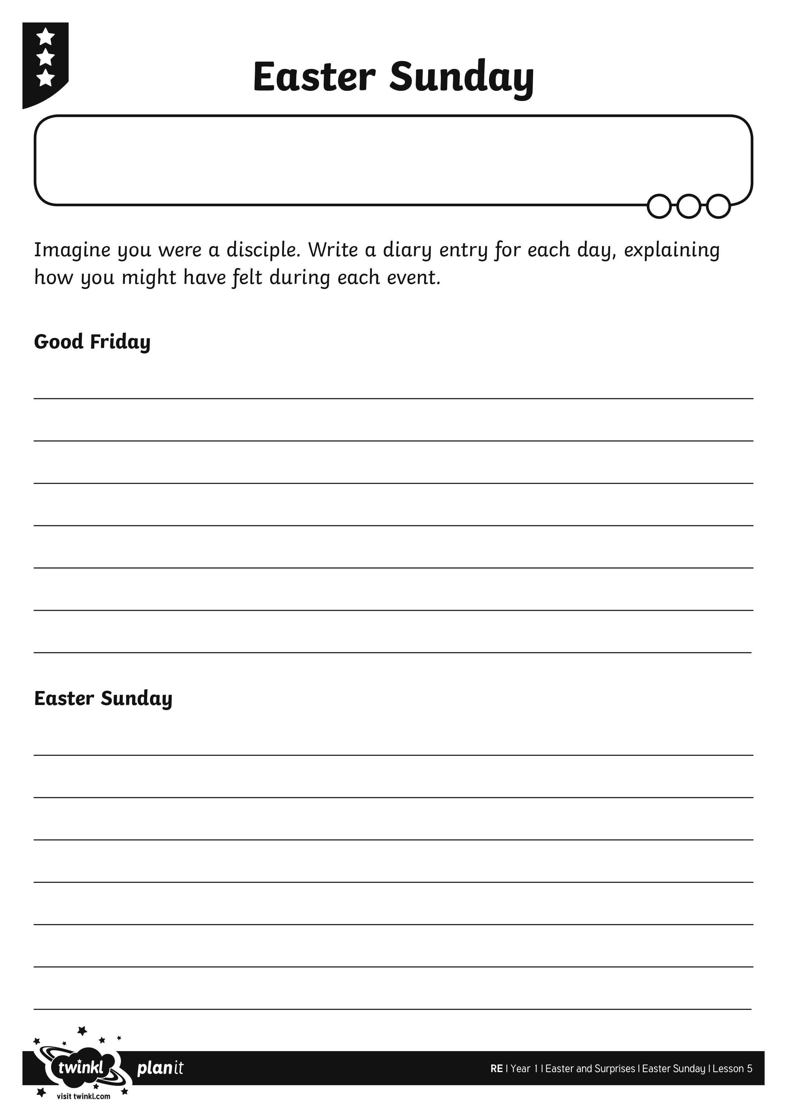
I can explain how the disciples felt on Easter Sunday.

