Can I describe how the disciples felt when they saw Jesus again?

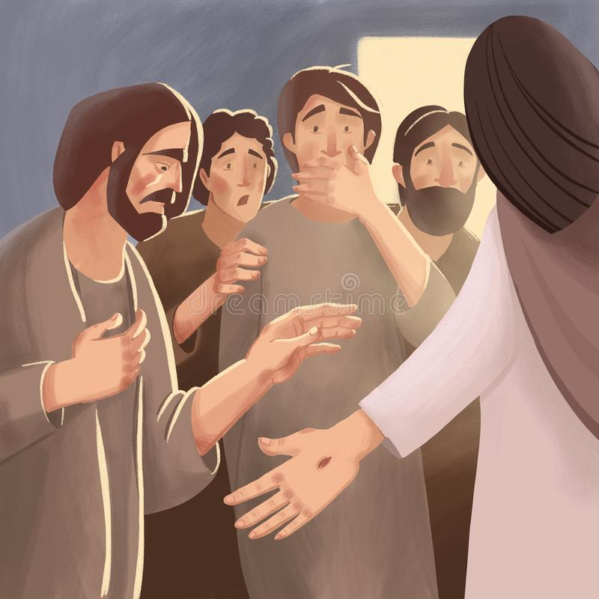

Word Bank

scared frightened shocked worried disappointed emotional happy joyful surprised