Can I retell the story of Jesus and the miraculous catch of fish?

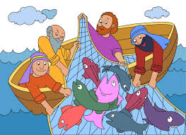

**Word bank – Jesus Peter fishermen boat catch follow me**

Phrase to use - ‘I will make you a fisher of men.’

____________________________________________________________________________________________________________________________________________________________________________________________________________________________________________________________________________________________________________________________________________________________________________________________________________________________________________________________________________________