Can I write questions about the Ascension of Jesus?

Imagine you witnessed Jesus going back to Heaven to be with His Father. What questions would you have?

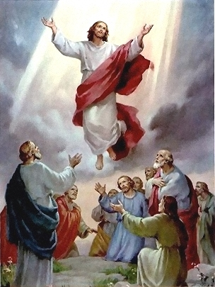

As a disciple of Jesus, how would you have felt when you witnessed Jesus going back to be with His Father?

_______________________________________________________________________________________________________________________________________________________________________________________________________________________________________________________________________________________________________________________________________________________________