Can I identify landmarks and human and physical features in my local area? 20.10.20

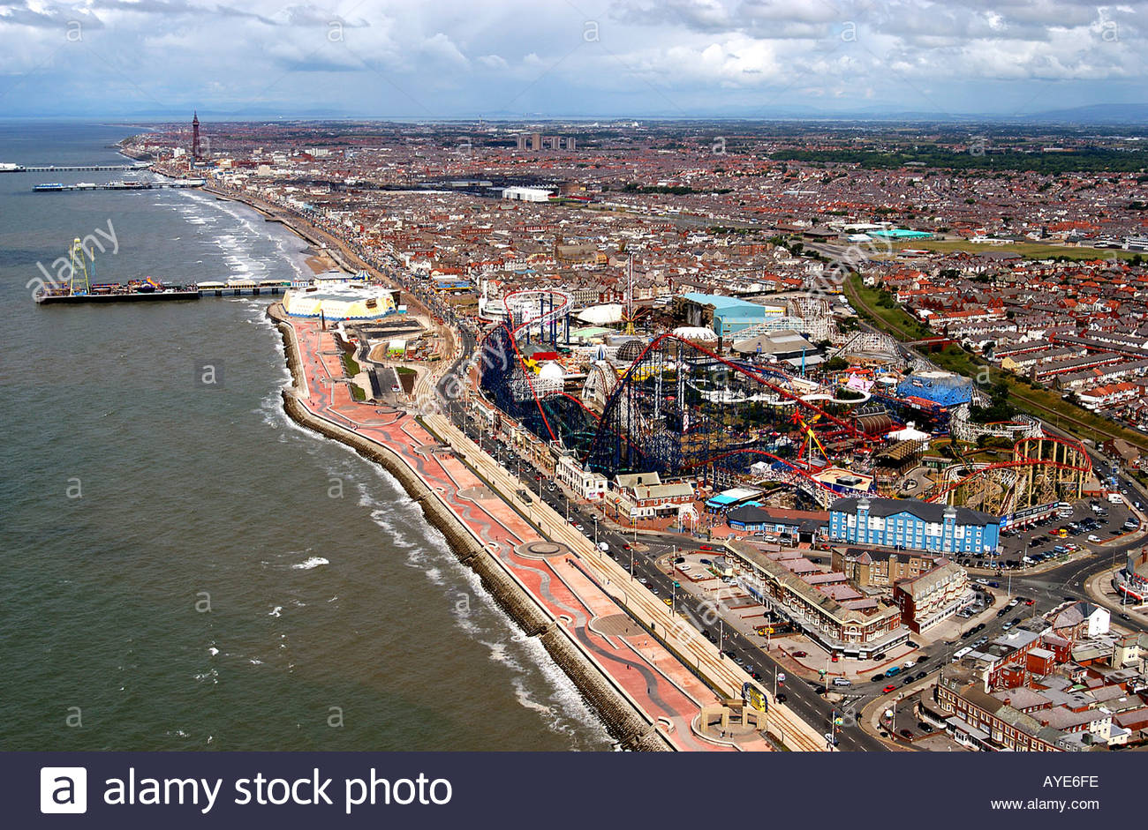

Photo from google pictures.

|  |  |  |
| --- | --- | --- |
| Landmarks | Human features | Physical features |
|  |  |  |
|  |  |  |
|  |  |  |