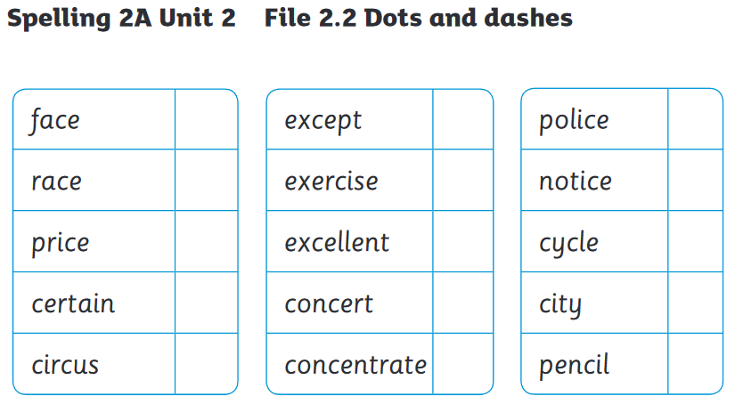

Word Changers
Root Word | + suffix |  | Root Wood | + suffix
city | cities |  |  | exercises
 | races |  |  | pencils
 | priced |  |  | cycled
 | noticed |  |  | concentrated
 | offices |  |  | certainly
Choose The Right Word.
race raced racing cycle cycling cycles

1. The angry dog ________________ after the scared cat.
2. I was told off for ___________________ around my house .
3. Dad __________________ to work.
4. I like ___________________ through the park.
5. We learned about the life ____________ of a butterfly.

