**Early Years**

**Key Vocabulary:** multiplication, multiply, multiplied by, multiple, grouping, doubling, array

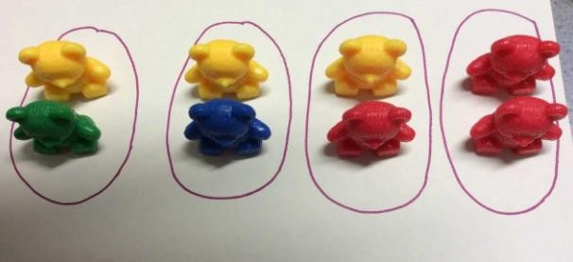**Times Tables:** To count in steps of 2s and 10s and begin to count in 5s.

|  |  |  |  |
| --- | --- | --- | --- |
| **Objective & Strategy** | **Concrete** | **Pictorial** | **Abstract** |
| To count in steps of 2s and 10s and begin to count in steps of 5. | Children will count in steps of 2s and 10s. They will begin to count in 5s. | Children will verbally say their number sequence aloud to demonstrate their understanding. | 2, 4, 6, 8…  10, 20, 30, 40…  5, 10, 15, 20, 25, 30… |
| To be able to double numbers. | Using practical activities using manipulative including uni-fix cubes to demonstrate doubling. | Children will begin to draw pictures to demonstrate doubling.  Double 1 equals 2.  + = | 1 + 1 = 2  **Stem Sentence:**  Double **1** equals **2** |
| To experience equal groups of objects. | Children will experience equal groups of objects. Children will be encouraged to count the groups, then count how many objects are in a group.  E.g. 2 x 4= | Children will have images of equal groups to solve multiplication sentences by counting how many are in each equal group. | 2 x 4 = 8  **Stem Sentence:** I know there are **2** groups with **4** in each group. |

**Year 1**

**Key Vocabulary:** multiplication, multiply, multiplied by multiple, grouping, doubling, array

**Times Tables:** Children in Year 1 need to count in steps of 2, 5 and 10.

|  |  |  |  |
| --- | --- | --- | --- |
| Objective &  Strategy | Concrete | Pictorial | Abstract |
| To count in steps of 2, 5 and 10s. | Children will be able to use concrete resources to count in steps of 2, 5 and 10. | Children will verbally say their number sequence aloud to demonstrate their understanding.  Children would begin to count aloud and write numbers to match the sequence. E.g. 0, 5, 10, 15, 20… | Children will be able to count aloud in sequences, starting at different points.  Children will be able to write sequences with multiples of numbers 2, 4, 6, 8…  10, 20, 30, 40…  5, 10, 15, 20, 25, 30… |
| To double numbers up to 20. | Children will demonstrate knowledge of doubling through concrete resources, including uni-fix cubes.    Double 20 equals 40. Double 16 equals 32  When beginning to double more complex numbers, children will need to explore partitioning the whole number into tens and ones, using base 10, and double the tens and then the ones, before recombinging to find the total. | Children will be able to use jottings and picture representations to show demonstration of doubling. | Children will learn to partition a number and then double each part before recombining it back together.    **Stem Sentence:**  Double **1** equals **2** |

|  |  |  |  |
| --- | --- | --- | --- |
| To make equal groups and count the total. | Children will use concrete resources to make equal groups.    **Stem Sentence:** I know there are **2** groups with **6** in each group. | Children will draw jottings and have pictorial representations to demonstrate knowledge of equal groups.  **2 x 6 = 12** | 2 x 6 = 12  **Stem Sentence:** I know there are **2**  groups with **6** in each group. |
| To understand multiplicatio n as repeated addition. | Children will be able to use a range of concrete resources to add equal groups. | **Children will use pictorial representations, including the use of a number line to solve problems.**  **There are 3 sweets in 1 bag. How many sweets are in 5 bags altogether?**    **3 + 3 + 3 + 3 + 3 = 15** | Children will be able to write addition number sentences to describe pictures or objects.  3 + 3 + 3 + 3 + 3 = 15 |
| To understand multiplicatio n as arrays. | Children will create arrays using concrete objects, which they then can describe what it represents  e.g. 2 lots of 5, 3 lots of 10. | Children will draw their own pictorial representations and will have the visually provided to show understanding of arrays.  .  2 lots of 5 3 lots of 2. | 3 x 2 = 6  2 x 5 = 10 |

**Year 2**

**Key Vocabulary:** multiplication, multiply, multiplied by, multiple, grouping, doubling, array, row, column, groups of, times once, twice, three times … ten times, repeated addition, one each, two each, three each … ten each, equal groups of, multiplication table, multiplication fact.

**Times Tables:** children in Year 2 need to count in steps of 2, 3, 5 and 10s.

|  |  |  |  |
| --- | --- | --- | --- |
| **Objective &**  **Strategy** | **Concrete** | **Pictorial** | **Abstract** |
| To double numbers up to 100. | Model using base 10 to partition a number and then double the ones and the tens.  **Double 26 is 52** | Draw pictures and representations to show how to double numbers.  **Double 26 is 52** | Partition a number and then double each part before recombining back together. |
| To count in multiples of 2s, 3s, 5s and 10s (repeated addition). | Count the groups as children are skip counting, children may use their fingers as they are skip counting.  Use bar models. | Number lines, counting sticks and bar models should be used to show representation of counting in multiples. | Count in multiples of a number aloud.  Write sequences with multiples of numbers. 0, 2, 4, 6, 8, 10  0, 3, 6, 9, 12, 15  0, 5, 10, 15, 20, 25 , 30  4 x 3 = |

|  |  |  |  |
| --- | --- | --- | --- |
| To show that multiplication is commutative. | Children will create arrays using a variety of concrete resources, including cubes and counters.    Pupils should understand that an array can represent different equations and that, as multiplication is commutative, the order of the multiplication does not affect the answer    4 x 3 = 12 3 x 4 = 12 | Children will use a range of pictures to represent arrays to show different calulations and show commuatativity.  4 x 3 =12  3 x 4 = 12 | Children will write the different multiplication sentences to show the commutative law.  12 = 3 x 4  12 = 4 x 3  Children will also be able to use an array to write multiplication number sentences and reinforce repeated addition.    3 + 3 + 3 + 3 + 3= 15 5 x 3 = 15  5 + 5 + 5 = 15 3 x 5 = 15 |
| To use related multiplication and division facts using the inverse for the 2, 3, 5 and 10 times table.  This will be taught alongside division to show how the numbers relate and build fluency. | Children will use concrete resources, including cubes to represent arrays. These will then form part of the learning process to explain number related facts and begin to write these in number form.  2 x 4 =8 4 x 2 = 8 8 ÷ 2 = 4 8 ÷ 4 = 2 | Children will use pictorial representations to solve missing number facts that demonstrate related facts. | Children will show all 8 related number sentences to demonstrate related facts.  2 x 4 = 8  4 x 2 = 8  8 ÷ 2 = 4  8 ÷ 4 = 2  8 = 2 x 4  8 = 4 x 2  2 = 8 ÷ 4  4 = 8 ÷ 2 |
| To begin to use the grid method to solve multiplication problems | Children will be introduced to the grid method by using arrays to demonstrate the links.  12 x 5 = 60  **Step 1:** Partition the number into tens and ones, e.g. 12 = 10 and 2 and place the multiplier to the side.  **Step 2:** times the multiplicand by the multiplier. E.g. 10 x 5 and 2 x 5 and record the answers in base 10 in the boxes.  **Step 3:** Add both answers to find the total for multiplication sentence. E.g. 50 + 10 = 60 | Children can represent their work with place value counters or base 10 in a way that they understand. They can draw the counters (using colours to show different amounts or just use the circles in the different columns) or base 10 like shown below. | Start with multiplying by one digit numbers and showing the clear addition alongside the grid. |

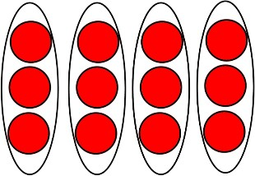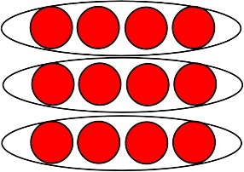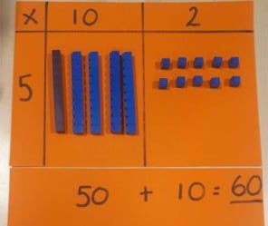

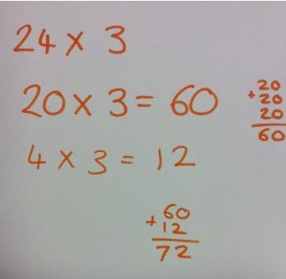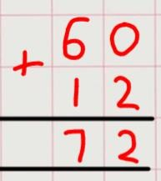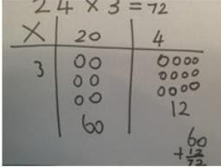one each, two each, three each … ten each, equal groups of, multiplication table, multiplication fact.

|  |  |  |
| --- | --- | --- |
| **X** | **20** | **4** |
| **3** | 60 | 12 |

# **Times tables**- Children in Year 3 need to be able to confidently count in steps of 2, 3, 4, 5, 8, 10, 50 and 100.

|  |  |  |  |
| --- | --- | --- | --- |
| **Objective & Strategy** | **Concrete** | **Pictorial** | **Abstract** |
| To use related multiplication and division facts using the inverse for the 2, 3, 4,  5, 8 and 10 times table. | Children understand the link between multiplication and division and use physical objects to find related facts.  3 x 6= 18 18 ÷ 3 = 6 6 x 3 = 18 18 ÷ 6 = 3 | Children represent an array pictorially then find the associated multiplication and division facts by sorting into equal groups. | Children apply their understanding of inverse relationships to write related multiplication and division statements.  3 x 6 = 18 18 = 3 x 6  6 x 3 = 18 18 = 6 x 3  18 ÷ 3 = 6 6= 18 ÷ 3  18 ÷ 6 = 3 3= 18 ÷ 6  They use associated vocabulary correctly and know what each number represents in the calculation. |
| To use a formal written method of multiplication (grid method).  2-digit x 1 digit number | Children use partitioning to multiply numbers using the grid method. They partition the multiplicand and multiply each part by the multiplier. Children use base ten and place value counters to represent arrays of the partitioned number.  **24 x 3 = 72**  Use of unit cubes use of base 10    Use of place value counters finding the total | Children show their understanding by represent the calculation in the grid using their own pictorial representation.  **24 x 3 =72**  Children use jottings to partition the multiplicand and multiply each part by the multiplier. | **Formal Method**  The children use the grid method for larger numbers. They multiply numbers by first partitioning the multiplicand and then multiplying each part by the multiplier. In year 3 children are expected to multiply 2-digit by a 1 digit number.  **24 x 3 = 72**  Children apply their knowledge of multiplication to word problems.  *There are 5 balloons in a packet. There are 18 packets in a box. How many balloons are there altogether in a box?* |

**Year 4**

**Key Vocabulary:** multiplication, multiply, multiplied by, multiple, factor, product, grouping, doubling, array, row, column, groups of, times once, twice, three times … ten times, repeated addition, one each, two each, three each…ten each, equal groups of, multiplication table, multiplication fact, inverse, square, squared, cube, cubed, distributive law.

# **Times tables**- Children in Year 4 need to be able to confidently count in steps of 2, 3, 4, 5, 6, 7, 8, 9, 10, 11 and 12.

|  |  |  |  |
| --- | --- | --- | --- |
| **Objective & Strategy** | **Concrete** | **Pictorial** | **Abstract** |
| To recall multiplication and division facts for multiplication tables up to 12x 12. | Children continue to deepen their understanding of the link between multiplication and division and use physical objects to find related facts.  3 x 6= 18 18 ÷ 3 = 6 6 x 3 = 18 18 ÷ 6 = 3 | Children represent an array pictorially then find the associated multiplication and division facts by sorting into equal groups. | Children apply their understanding of inverse relationships to write related multiplication and division statements.  3 x 6 = 18 18 = 3 x 6  6 x 3 = 18 18 = 6 x 3  18 ÷ 3 = 6 6= 18 ÷ 3  18 ÷ 6 = 3 3= 18 ÷ 6  They use associated vocabulary correctly and know what each number represents in the calculation. |
| To multiply and divide mentally, including: multiplying by 0 and 1 and multiplying together 3 numbers. | Children multiply and divide numbers by zero and one. They understand the meaning of the calculation and the need of equal sized groups.    Children use objects to calculate totals when three numbers are multiplied together.  **2 x 4 x 5 = 40** | Children show their understanding of multiplying by 0 and 1 by drawing representations.    Children use objects to calculate totals when three numbers are multiplied together.  **2 x 4 x 5 = 40**    Or they may decide to represent it as 2 x (4 x 5) 2 x (20) = 40 | Children understand how to multiply by 1 and 0 and apply to word problems.  1 x 83 = 76 x 1 =  4567 x 0= 0 x 23 =  *Jack earns £12 a week on his paper round. He did not work for one week whilst he was on holiday. How much did he earn?*  Children solve number puzzles using the knowledge of multiplying 3 single digit numbers. |

|  |  |  |  |
| --- | --- | --- | --- |
| To use a formal written method of multiplication (grid method).  3-digit x 1 digit number | Children recap the grid method introduced in Year 3 and represent calculations using the place value counters and base ten equipment. They first partition the multiplicand then multiply each part by the multiplier.  **327 x 4 = 1308**    1200 + 80 + 28 = 1308  1200 + 80 + 28 = 1308 | Children show their understanding by represent the calculation in the grid using their own pictorial representation.  **327 x 4 = 1308** | **Formal Method**  The children continue to use the grid method using partitioning to multiply each part.  In year 4 children are expected to multiply 3-digit by a 1 digit number.  **327 x 4 = 1308**  **X 300 20 7**  **4** 1200 80 28  1200 + 80 + 28 = 1308 |
|  | Children use jottings to partition the multiplicand and multiply each part by the multiplier. | Children apply their knowledge of multiplication to worded problems. |
| To use a formal written method of multiplication (short multiplication).  3-digit x 1 digit number | Children represent calculations using the place value counters and base ten equipment and move towards using a columnar method. They begin by multiplying the ones, then the tens then the hundreds before finding the total.  **327 x 4= 1308**  7 x 4= 28  20 x 4= 80  300 x 4 = 1200 | Children represent the calculation by drawing pictorial representations. They partition the multiplicandthen multiply each part by the multiplier.  **327 x 4 = 1308**  Children understand the place value and can exchange between columns which leads to the formal condensed method.  **327 x 4 = 1308** | **Formal Method**  In year 4 children are expected to multiply a 3-digit by a 1 digit number.  Children apply their knowledge of the grid method begin to record in a columnar form. At this stage they still partition the multiplicand and multiply each part by the multiplier.  Children then move on to using the condensed method of short multiplication. They carry below the line. |

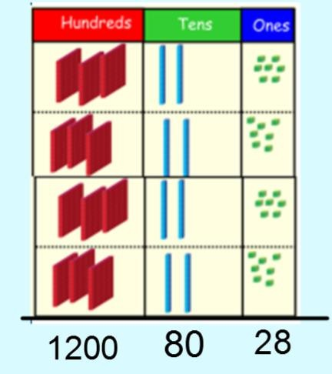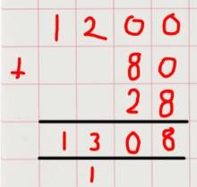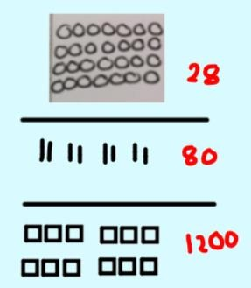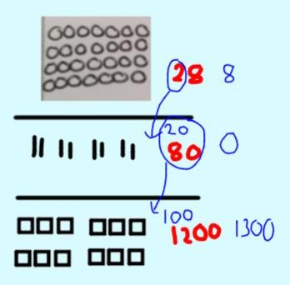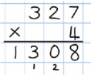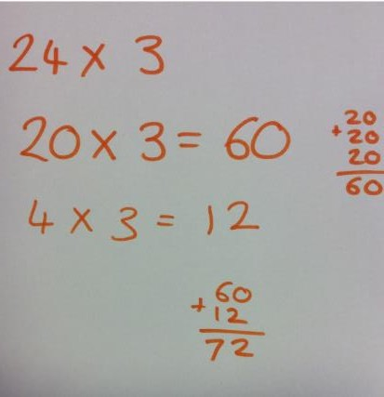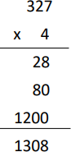

|  |  |  |  |
| --- | --- | --- | --- |
|  |  |  |  |
|  |  |  |  |

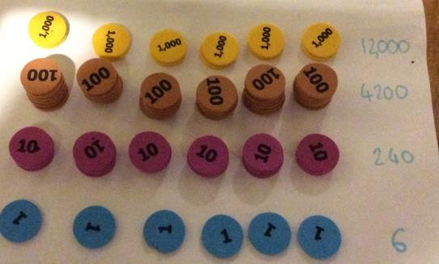**Year 5**

**Key Vocabulary:** multiplication, multiply, multiplied by, multiple, factor, product, grouping, doubling, array, row, column, groups of, times once, twice, three times … ten times, repeated addition, one each, two each, three each … ten each, equal groups of, multiplication table, multiplication fact, inverse, square, squared, cube, cubed, distributive law.

# **Times tables**- Children in Year 5 need to be able to confidently count in steps of 2, 3, 4, 5, 6, 7, 8, 9, 10, 11 and 12.

|  |  |  |  |
| --- | --- | --- | --- |
| **Objective &**  **Strategy** | **Concrete** | **Pictorial** | **Abstract** |
| To recall multiplication and division facts for multiplication tables up to 12x 12. | Children continue to deepen their understanding of the link between multiplication and division and use physical objects to find related facts.  3 x 6= 18 18 ÷ 3 = 6 6 x 3 = 18 18 ÷ 6 =3 | Children represent an array pictorially then find the associated multiplication and division facts by sorting into equal groups. | Children apply their understanding of the inverse relationships to write related multiplication and division statements.  3 x 6 = 18 18 = 3 x 6  6 x 3 = 18 18 = 6 x 3  18 ÷ 3 = 6 6= 18 ÷ 3  18 ÷ 6 = 3 3= 18 ÷ 6  They use associated vocabulary correctly and know what each number represents in the calculation. |
| To use a formal written method of multiplication (short multiplication).  Up to 4-digit x 1 digit number | Children represent calculations using the place value counters and base ten equipment. They solve in a columnar form and begin by multiplying the ones, then the tens then the hundreds then the thousands before finding the total.  **2741 x 6 = 16,446**  1 x 6= 6  40 x 6= 240  700 x 6= 4,200  2000 x 6= 12,000 | Children represent the calculation by drawing pictorial representations. They partition the multiplicandthen multiply each part by the multiplier They understand the place value and can confidently exchange between columns. This leads to the condensed method. | **Formal Method**  In year 5 children are expected to multiply numbers up to a 4-digit by a 1 digit number.  The children continue to use the condensed method of short multiplication but with larger numbers. The number is carried underneath between columns. |

|  |  |  |  |
| --- | --- | --- | --- |
| To recognise and use square numbers and cube numbers. | Children use resources to explore squared and cubed numbers.  **Square numbers**    **4 9 16**  **Cubed numbers**    **8 27** | Children represent squared and cubed numbers pictorially. They use the correct notation for squared (²) and cubed (³).  Image result for pictorial square and cubed numbers | Children can find and recognise squared and cubed numbers and use the correct notation for squared (²) and cubed (³). |
| To multiply whole numbers and those involving decimals by 10, 100 and  1,000 | Children use resources to understand what 10, 100 and 1000 times bigger looks like. | Children use place value grids to multiply numbers by 10, 100 and 1000s. They understand the movement of the digits on the place value grid.      They apply this knowledge to decimal numbers. | Children apply their knowledge of place value to multiply numbers by 10, 100 and 1000, including decimal numbers.  34 x 100= 3400  1234x 1000= 1234000  5.6 x 10 = 56  12.367 x 100 = 1236.7  They apply their knowledge to word and number puzzles.    *Breen Airways charges £1600 for a return flight to Australia. King Airlines is ten times cheaper. How much do King Airlines charge?* |

|  |  |  |  |
| --- | --- | --- | --- |
|  | Children represent calculations using the place value | Children will first use their knowledge of place value to partition the multiplicand and multiplier. They then show their understand pictorially in a grid method.  **18 x 13 = 234**    Children then move towards the columnar method by representing each stage with jottings.  Children are encouraged to multiply the ones first.  **18 x 13 = 234** | Children will first secure their understanding using the grid method.  18 x 13 = 234  **X 10 8**  **10** 100 80  **3** 30 24  They will then move on to a more condensed method of long multiplication.  **18 x 13= 234 124 x 26 = 3224** |
|  | counters using the grid method. |
|  | **18 x 13 = 234** |
| To use a formal written method of multiplication (long multiplication). |  |
| Up to 4-digit x 2 |  |
| digit number | **18 x 13 = 234** |
|  | Children then solve in a |
|  | columnar form. They begin |
|  | by multiplying the ones, |
|  | then the tens, the |
|  | hundreds then the |
|  | thousands before finding |
|  | the total. |
| To use a formal written method of multiplication to multiply number up to 2 decimal places (grid method). | Children represent calculations using the place value counters and base ten equipment. They partition the decimal number and multiply by the multiplier. They then find the total.  **4.9 x 3 = 14.7** | Children continue to multiply decimal numbers by partitioning the decimal number. They draw pictorial representations and use jottings to find the total.  **4.9 x 3 = 14.7** | Using the grid method, children will be able to multiply decimals with one decimal place by a single digit number. They should know that the decimal points line up under each other and place holders are added.  **4.9 x 3= 14.7** |
| Decimal numbers x 1 digit number |  |  | **X 4 0.9**  **3** 12 2.7 |

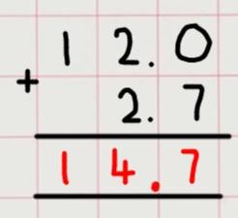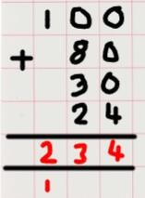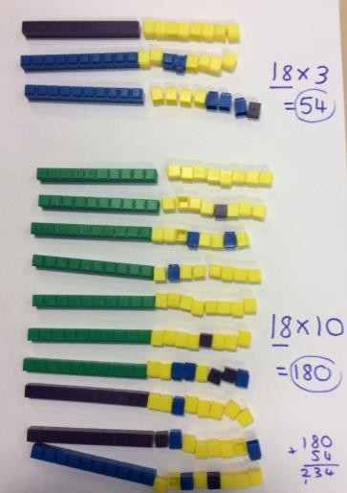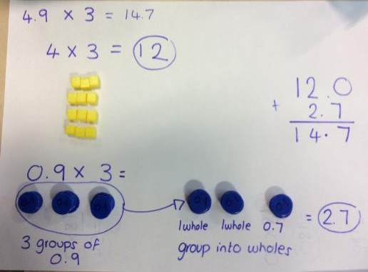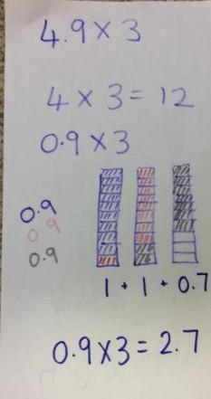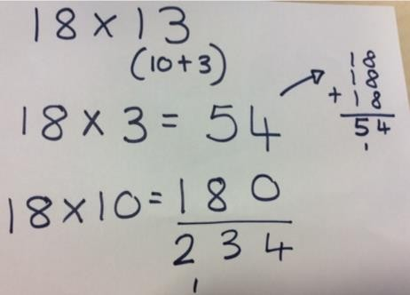

|  |  |  |
| --- | --- | --- |
|  |  |  |
|  |  |  |
|  |  |  |

|  |  |  |
| --- | --- | --- |
|  |  |  |
|  |  |  |

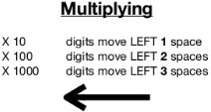**Year 6**

**Key Vocabulary:** multiplication, multiply, multiplied by, multiple, factor, product, grouping, doubling, array, row, column, groups of, times once, twice, three times … ten times, repeated addition, one each, two each, three each … ten each, equal groups of, multiplication table, multiplication fact, inverse, square, squared, cube, cubed.

# **Times tables**-children in Year 4 needs to be able to confidently count in steps of 2, 3, 4, 5, 6, 7, 8, 9, 10, 11 and 12.

|  |  |  |  |
| --- | --- | --- | --- |
| **Objective &**  **Strategy** | **Concrete** | **Pictorial** | **Abstract** |
| To recall multiplication and division facts for multiplication tables up to 12x 12. | Children continue to deepen their understanding of the link between multiplication and division and use physical objects to find related facts.  3 x 6= 18 18 ÷ 3 = 6 6 x 3 = 18 18 ÷ 6 =3 | Children represent an array pictorially then find the associated multiplication and division facts by sorting into equal groups. | Children apply their understanding of inverse relationships to write related multiplication and division statements.  3 x 6 = 18 18 = 3 x 6  6 x 3 = 18 18 = 6 x 3  18 ÷ 3 = 6 6= 18 ÷ 3  18 ÷ 6 = 3 3= 18 ÷ 6  They use associated vocabulary correctly and know what each number represents in the calculation. |
| To multiply whole numbers and those involving decimals by 10,  100 and 1,000 | Children use resources to understand what 10, 100 and 1000 times bigger looks like. | Children use place value grids to multiply numbers by 10, 100 and 1000s.  They understand the movement of the digits left on the place value grid.    They apply this knowledge to decimal numbers. | Children apply their knowledge of place value to multiply numbers by 10, 100 and 1000, including decimal numbers.  34 x 100= 3400  1234x 1000= 1234000  5.6 x 10 = 56  12.367 x 100 = 1236.7  They apply their knowledge to word and number puzzles. |

|  |  |  |  |
| --- | --- | --- | --- |
| To use a formal written method of multiplication to multiply number up to 2 decimal places (grid method).  Decimal numbers x 1 digit number | Children represent calculations using the place value counters and base ten equipment. They partition the decimal number and multiply by the multiplier. They then find the total.  **4.92 x 3 = 14.76** | Children continue to multiply decimal numbers by partitioning the decimal number. They draw pictorial  representations and use  jottings to find the total.  **4.92 x 3 = 14.76** | **Formal method**  Using the grid method, children will be able to multiply decimals with up to two decimal places by a single digit number. They should know that the decimal points line up under each other and zeros are added at place holders.  **4.92 x 3**  **X 4 0.9 0.02**  **3** 12 2.7 0.06  Children will move onto using the condensed method. |
| To use a formal written method of multiplication (short multiplication). | Children represent calculations using the place value counters and base ten equipment. They solve in a columnar form and begin by multiplying the ones, then the tens then the hundreds then the thousands before finding the total.  **2741 x 6 = 16,446** | Children represent the calculation by drawing pictorial representations. They partition the multiplicandthen multiply each part by the multiplier They understand the place value and can confidently exchange between columns. This leads to the condensed method. | **Formal Method**  In year 6 children are expected to multiply multi digit numbers by a 1 digit number.  The children continue to use the condensed method of short multiplication. The number is carried underneath. |
| Multi-digit numbers x 1 digit number | 1 x 6= 6  40 x 6= 240  700 x 6= 4,200  2000 x 6= 12,000 |  |  |

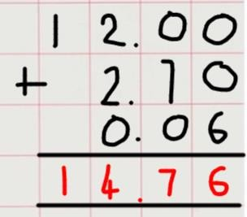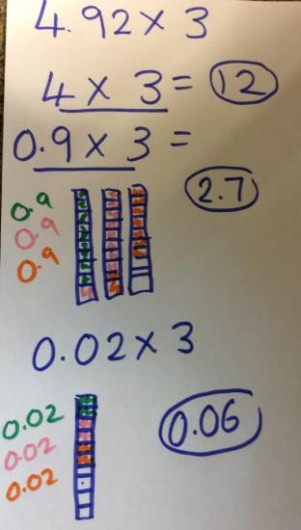

|  |  |  |  |
| --- | --- | --- | --- |
|  |  |  |  |
|  |  |  |  |

|  |  |  |  |
| --- | --- | --- | --- |
| To use a formal written method of multiplication (long multiplication).  Multi-digit x 2 digit number | Children represent calculations using the place value counters using the grid method.  **124 x 26 = 3224**    They then solve calculations in a columnar form and begin by multiplying the ones, the tens then the hundreds then the thousands before finding the total.  **124 x 26 = 3224** | Children will first use their knowledge of place value to partition the multiplicand and multiplier. They then show their understand pictorially in a grid method.  **124 x 26 = 3224**    **124 x 26 = 3224**  Children then move towards the columnar method by representing each stage with jottings. Children are encouraged to multiply the ones first. | **Formal Method**  In year 6 children are expected to multiply multi digit numbers by a 2 digit number. The children are introduced to long multiplication. The number is carried underneath.  **124 x 26 = 3224**  **Step 1:** Multiply the multiplier by the multiplicand. Start with the ones, multiply 6 by 4 (24). Write the 4 in the ones column and carry the 20 below the line.  **Step 2:** Multiply the 6 by 20 (120) and add the 2 (122). Cross off the carried 20. Write the 4 in the tens column and carry the 100 below the line.  **Step 3:** Multiply the 6 by 100 (600) and add the  100 (700). Cross off the carried 100. Write the 7 in the hundreds.  **Step 4:** Move to the tens column on the multiplier and start a new line. Multiply the 20 by 4 (80) and record.  **Step 5:** Multiply the 20 by 20 (400) and record. Then multiply the 20 by the 100 (200) and record.  **Step 6:** Total the numbers.  **4 digit x 2 digit**  **1234 x 16 = 19,744** |

