
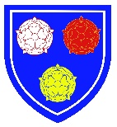
Our Lady of the Most Holy Rosary Catholic Academy
Maths Curriculum

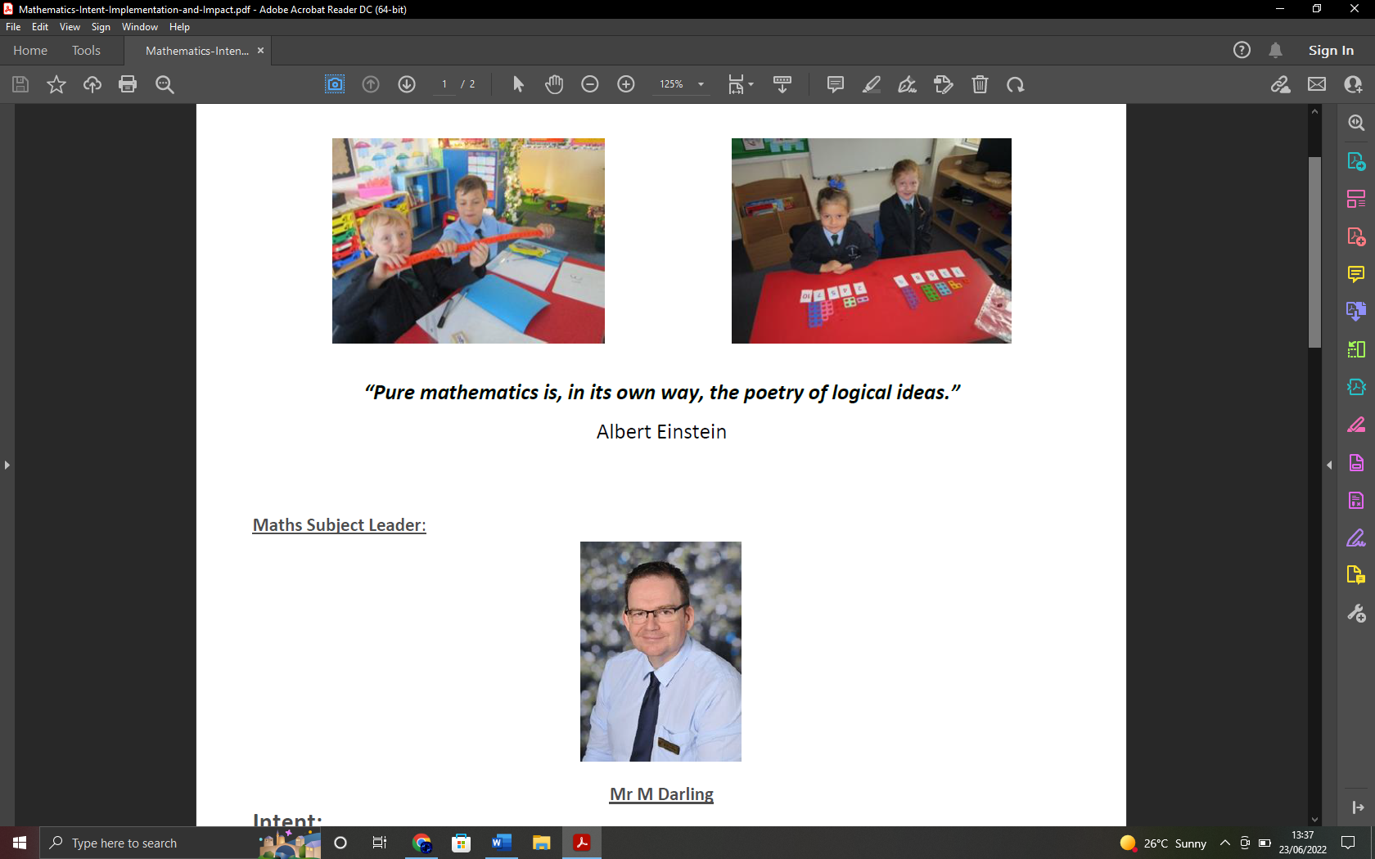
Intent
At Holy Rosary, we have designed a broad and balanced curriculum. We intend our children to understand the world, have the ability to reason mathematically and develop a sense of enjoyment and curiosity.

Our mathematics curriculum is underpinned by our Trust virtues and aims to ensure that children:
- become confident and fluent in the fundamentals of mathematics, including through varied and frequent practice with increasingly complex problems over time, so that pupils develop conceptual understanding and the ability to recall and apply knowledge rapidly and accurately.
- are challenged and make meaningful, purposeful links with other subjects.
- develop curiosity and resilience by reasoning mathematically and following a line of enquiry, conjecturing relationships and generalisations, and developing an argument, justification or proof using mathematical language
- Share their mathematical reasoning in a respectful and friendly environment where children are prepared to take risks and secure a deep understanding.
- can solve problems by applying their mathematics to a variety of routine and non-routine problems with increasing sophistication, including breaking down problems into a series of simpler steps and persevering in seeking solutions
- take on the responsibility of developing and mastering lifelong learning skills that can be applied to a 21st century Britain.
- have self-belief believing they can do it!
Implementation
At Holy Rosary children have a discreet mathematics lesson every day.
Our teaching in maths is supported by the White Rose Maths scheme of work. Our policies and progression documents provide a high level over view of our systematic approach to maths across our school. In order to aid children develop their mathematical understanding, make connections and deepen their understanding a broad and balanced curriculum has been developed where children build upon prior knowledge and develop new concepts. Our calculation policy supports a Concrete, Pictorial, and abstract approach (CPA).

We place a strong emphasis upon these concrete and pictorial elements of maths since these are the building blocks needed to enable children to fully understand the abstract methods.

As a member of the ‘Maths Hub’, Holy Rosary uses the mastery teaching model. This model is built around a child- centred lesson design that models and embeds a growth mindset approach to mathematics. It is structured around a whole- class teaching model that focuses on helping all children to build a deep understanding of mathematical concepts.

Lesson Design
All lessons at Holy Rosary use the teaching for mastery approach developed around the five big ideas (Coherence, variation, fluency, mathematical thinking and representation and structure.) At the beginning of a lesson children are given opportunities to develop their arithmetic skills using a programme called Tough Ten; within this short focused session children solve written calculations or develop fluency in number bonds or times tables.

A review of previous learning is then undertaken to ‘link’ previous and new learning.

Mathematical vocabulary is introduced or revisited. The modelling by teachers the use of mathematical vocabulary is an embedded feature of our lessons at Holy Rosary.

Following this, children are then introduced to a new concept that builds upon previous learning. They develop their mathematical reasoning and competence when solving problems. This structure provides children with the opportunity to develop why? and why not? questions.

Throughout the lesson, children are given opportunities to discuss their mathematical thinking with their partner and use a range of different representations such as tens frames, part- whole models and bar models.

Children move from the concrete (use of physical apparatus) and pictorial (drawing a picture representation) to using abstract symbols. We call this the CPA approach. This allows children to make secure mathematical connections and move between different contexts and representations.
At the end of the lesson children have the opportunity to reason mathematically and further develop their mathematical vocabulary.

At Holy Rosary we see the ability to reason as the glue that bonds pupils’ mathematical skills together; it is an important skill which bridges the gap between fluency and problem solving, allowing pupils to use their fluency to accurately carry out problem solving.

Impact
We measure the impact of our maths curriculum through our assessment procedures. There are a number of ways in which teachers can assess what children have learnt. Formal testing is one aspect but teachers constantly question throughout lessons to assess what children know.

A mathematical concept or skill has been mastered when a child can show it in multiple ways, using the mathematical language to explain their ideas, and can independently apply the concept to new problems in unfamiliar situations.

Children demonstrate quick recall of facts and procedures. This includes the recollection of the times tables.
The flexibility and fluidity to move between different contexts and representations of mathematics.
The ability to recognise relationships and make connections in mathematics.
Children show a high level of pride in the presentation or their work and can explain their learning.

