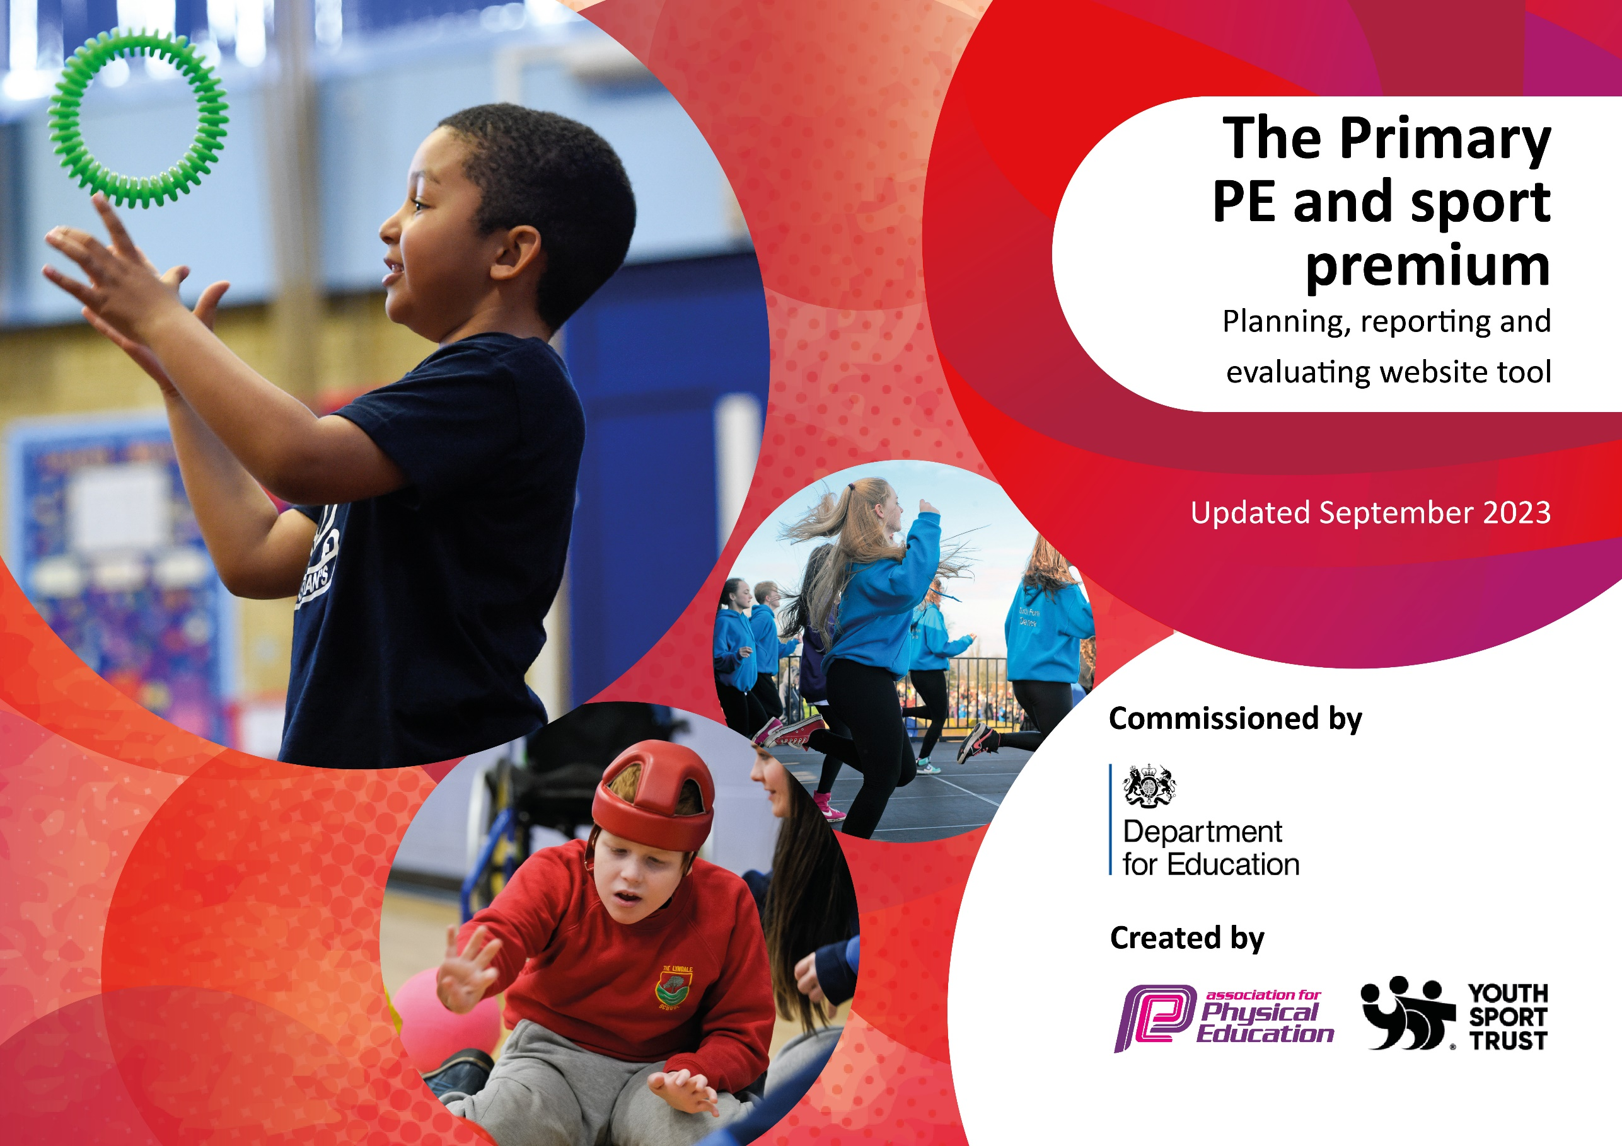

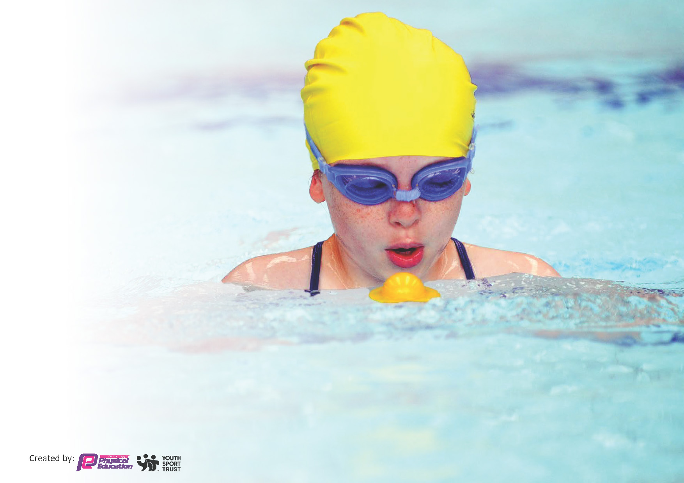
This template can be used for multiple purposes:
by:
- It enables schools to effectively plan their use of the Primary PE and sport premium
- It helps schools to meet the requirements (as set out in guidance) to publish information on their Primary PE and sport premium
- It will be an effective document to support Ofsted inspections enabling schools to evidence progress in Physical Education (PE) and evidence swimming attainment, which forms part of the PE National Curriculum. We would recommend schools consider
the Intent, Implementation and Impact of any spend, as examined within the Education Inspection Framework.

It is important that your grant is used effectively and based on school need.

Schools must use the funding to make additional and sustainable
improvements to the quality of the PE, School Sport and Physical Activity (PESSPA)
they offer. This means that you should use the Primary PE and sport premium to:

- Build capacity and capability within the school to ensure that improvements made now will benefit pupils joining the school in future years
- Develop or add to the PESSPA activities that your school already offers.

The Primary PE and sport premium should not be used to fund capital spend projects; the school’s core budget should fund these. Further detail on capital expenditure can be found in the updated Primary PE and sport premium guidance.

The Primary PE and sport premium guidance, outlines 5 key priorities that funding should be used towards. It is not

necessary that spending has to meet all the key priorities, you should select the priorities that you aim to use any funding towards.

Although completing this template is not a requirement for schools, schools are required to publish details of how they spend this funding. Schools must also outline what the impact this funding has had on pupils’ PE and sport participation and attainment and how any spending will be sustainable in the future. All funding must be spent by 31st July 2024.

The Department for Education has worked closely with the Association for Physical Education (afPE) and the Youth Sport Trust (YST) to develop this template and encourages schools to use it. This template is an effective way of meeting the reporting requirements of the Primary PE and sport premium.
Review of last year’s spend and key achievements (2022/2023)

We recommend you start by reflecting on the impact of current provision and reviewing your previous spend.

Activity/Action | Impact | Comments
Drumba workshop  Yard Shooter | We experienced a high intensity Drumba workshop day which inspired both staff and pupils. This then allowed us to put in a plan to add Drumba to our curriculum offer, which has had a huge impact on the children in 23/24.  Yard shooters have been placed in both yards to promote ball skills. Children use them frequently and basketball skills have increased dramatically as a result.

Key priorities and Planning
This planning template will allow schools to accurately plan their spending.

Action – what are you planning to do | Who does this action impact? | Key indicator to meet | Impacts and how sustainability will be achieved? | Cost linked to the action
Ensure range of equipment available  Assigned roles for UKS2 pupils as playground leaders  Encourage all pupils to be involved in PESSPA  Boost and promote 30 mins extra activity to aid fitness and mental health | Children  Lunchtime supervisors  Children, teaching staff  Children, teaching staff  Lunchtime supervisors, children, teaching staff | Key indicator 3: The Profile of PE and Sport is raised across the school as a tool for whole school improvement.  Key indicator 2 -The engagement of all pupils in regular physical activity – the Chief Medical Officer guidelines recommend that all children and young people aged 5 to 18 engage in at least 60 minutes of physical activity per day, of which 30 minutes should be in school. | Children become more confident on the playground and engage in games suitable for their age and skill levels.  Children are active when they need to be and can experience new things.  Leaders will become more confident and prouder their new roles.  Pupil engagement boosted for after school clubs. This will allow us to keep track of children who are achieving the extra 30 mins activity outside of school. | £ 5000  £300  £5000  £3000

Ensure staff are trained to be able to provide top quality PE.  Provide equal opportunities for all pupils following a skills based approach to PE lessons  Provide new opportunities for activities to be tried in school  Provide transport to events  Enable children to take part in competitive activities | Teaching staff  Teaching staff, children  Teaching staff, children  Children  Children | Key Indicator 1: Increased confidence, knowledge, and skills of all staff in teaching PE and sport.  Key indicator 4: Broader experience of a range of sports and activities offered to all pupils.  Key indicator 5: Increased participation in competitive sport. | Provide a more structured PE plan based on skills. Boost staff CPD to allow teachers to provide high quality teaching.  Look actively for opportunities for children to have taster sessions in different activities.  Children to be able to attend all events throughout the year | £ 5000  £3000  £5000  £1000  £1000

Key achievements 2023-2024
This template will be completed at the end of the academic year and will showcase the key achievements schools have made with their Primary PE and sport premium spending.

Activity/Action | Impact | Comments
Ensure staff are trained to be able to provide top quality PE.  Provide equal opportunities for all pupils following a skills-based approach to PE lessons  Enable children to take part in competitive activities | Staff are fully trained in Drumba and REAL PE which has allowed children to work on a skills-based approach to learning. This has allowed them to be part of their own learning and choose to adapt their needs themselves when accessing lessons. Children are more active within lessons and teachers are confident.  Children have attended a variety of sports throughout the year and this has boosted their confidence and skills.

Swimming Data
Meeting National Curriculum requirements for swimming and water safety.
Priority should always be given to ensuring that pupils can perform safe self-rescue even if they do not fully meet the first two requirements of the National Curriculum programme of study

Question | Stats: | Further context  Relative to local challenges
What percentage of your current Year 6 cohort can swim competently, confidently and proficiently over a distance of at least 25 metres? | 79% | Due to demand at our local pool, children only have the opportunity to attend one slot per year. Children lack opportunity outside of school to attend swimming to further cement knowledge before the next years swimming.
What percentage of your current Year 6 cohort can use a range of strokes effectively [for example, front crawl, backstroke, and breaststroke]? | 46% | Due to demand at our local pool, children only have the opportunity to attend one slot per year. Children lack opportunity outside of school to attend swimming to further cement ranges of strokes before the next years swimming.

What percentage of your current Year 6 cohort are able to perform safe self-rescue in different water-based situations? | 82% | Children completed safe self-rescues in Y5, due to timetabling for the local pool, Y6 did not repeat this task again.
If your schools swimming data is below national expectation, you can choose to use the Primary PE and sport premium to provide additional top-up sessions for those pupils that did not meet National Curriculum  requirements after the completion of core lessons. Have you done this? | No
Have you provided CPD to improve the knowledge and confidence of staff to be able to teach swimming and water safety? | No

Signed off by:

Head Teacher: | Lucy Flaherty
Subject Leader or the individual responsible for the Primary PE and sport premium: | Sarah Desborough, Mathew Bradley
Governor:
Date:

