SEND Information Report
Approved on:
July 2023
Next review:
June-July 2024
Our Lady Of The Most Holy Rosary Catholic Academy

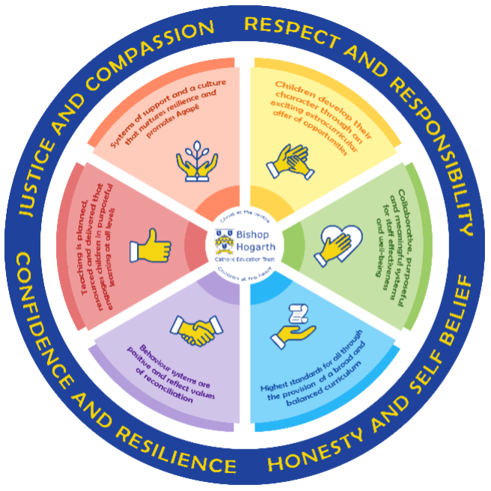
As part of the family of Bishop Hogarth Catholic Education Trust, our school has at its core, the virtues, and values of:
Respect for others and themselves, recognising that we are all created in the image of God and therefore must be compassionate towards others, especially the vulnerable. ​
Confidence in their own abilities, knowing that their talents are gifts from God and resilience to persevere when things become difficult. ​
Honesty in regard to the world around them and themselves and the ability to take responsibility for the times we may fall short of the mark. ​
Gratitude for all the amazing gifts from God and willingness to share their gifts both personal and material. ​

As an inclusive school, all teachers are teachers of pupils with Special Educational Needs & Disabilities. We deliver a curriculum and create an environment that meets the needs of every pupil within our school. We ensure that every pupil with Special Educational Needs and / or disabilities makes the best progress possible. We foster and promote effective working partnerships with parents / carers, pupils, and outside agencies. We consider the ‘whole’ child and strive to ensure that all our SEND pupils are prepared for adulthood.​

Our school’s approach to supporting pupils with SEND

At Holy Rosary we aim for every child to reach their full potential and we want all our children to access the same high quality curriculum regardless of their ability.
We always strive to provide the type of education that supports each child individually, including those with SEND. We have set up all our classrooms to be ASD friendly and include visual timetables to help your child organise their day and know what is coming next. We apply what is termed Adaptive Learning in which learning is scaffolded in different ways to provide the help your child needs to learn the same things as the rest of the class.
In addition to these strategies that help all children learn together, your child may need additional support on things that they particularly need to work on—how this will be achieved will be discussed with you and written up on their APDR tracker. This lists what your child’s needs are, the targets that we want them to work on, the strategies we will use to help them in class and a space to review progress.

Some children learn to overcome their barriers and can come off the register (though we will always have a mind to what their issues used to be in this case) and some children stay on longer or throughout their time with us because their need is not something that can be permanently overcome. There is no problem with either situation—all our children are individuals and will receive the help that is right for them.
APDRs are reviewed termly, or more often if needed and you will have a chance to meet with your child’s teacher to discuss what needs to happen and how the targets may change. Pupil and parent voice is important throughout this process.

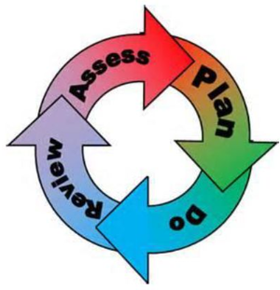
How will the school staff support my child?
The graduated response-Identifying, planning for and supporting pupils with SEND
Where a pupil is identified as having a special educational need, School will follow a graduated approach which takes the form of cycles of ‘Assess, Plan, Do, Review’. ​
• Assess a child’s special educational need. ​
• Plan the provision to meet your child’s aspirations and agreed outcomes. ​
• Do put the provision in place to meet those outcomes. ​
• Review the support and progress.

How does the school know if children need extra help and what do I do if I think my child has special educational needs?

- Assess
At Holy Rosary a child will be identified as having SEND when their learning difficulty or disability calls for special educational provision that is different or additional to other children of the same age. Assessment is a whole-school approach that can quickly identify where a child is not making progress. This may include observations and assessments by the class teacher, meetings with the leadership team when looking at pupil progress or a concern from a parent or carer.

- Plan
The curriculum at our school is delivered through quality first teaching by their class teacher. This teaching is planned for all children so that they all work towards the same learning goal. Staff will plan to use a range of different strategies that will support a child with SEND to make progress in each lesson. They will review this and adapt teaching so that all children can succeed. Where specific interventions are needed, these will be arranged by the class teacher in conjunction with the SENDCo, Headteacher and other agencies who can support.

- Do
Our teachers are skilled at adapting teaching and learning to meet the diverse needs in each class. ​
Daily planning considers individual children’s needs and requirements and is annotated and adapted according to need. Explicit reference is made in the teacher’s planning to the needs of those children identified with SEND. ​
Adaptive teaching is approached in a range of ways to support access to the curriculum and ensure that all children can experience success and challenge in their learning. ​
Grouping arrangements consider the different skills and abilities of each child. This ensures that learning is maximised. ​

Additional adults support groups and individual children with the long-term goal of developing independent learning skills. The class teacher monitors this support to avoid students becoming over reliant on this. ​
We fully encourage parental support and offer opportunities for individual meetings with parents/carers to provide clarity and recommendations on how they can support their child at home.

- Review
Review meetings are held termly with parents, class teacher and other professionals as necessary. These meetings will review how well the child is progressing, how well their needs are being met and what can be done to support further if needed. The review process might also bring up areas where more advice is needed; in this case school will work with parents to decide a strategy for doing this and then deciding how the specialist findings feed into the day-to-day work in class. In some cases further support might be sought through the Local Authority Higher Needs Funding or by requesting an Education, Health and Care Plan (EHCP)

How will the curriculum at our school be matched to my child’s needs?
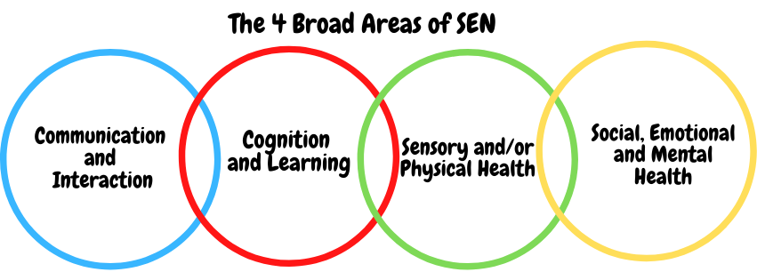SEN needs are classified under four broad areas of need. Below are the strategies, in class support and interventions that school may put in place to support your child.

Communication and Interaction
Strategies to support children with these needs include:
· Access to small group and/or individualised interventions to develop skills in communication, interaction, emotional awareness, self-care, flexible thinking · Enhanced access to visual approaches e.g. PECS (Picture Exchange Communication System) · Access to low stimulus area if required · Access to a lunchtime Nurture Club · Access technology · Explicit teaching of generalising skills from one context to another · Careful planning of transitions · Mentoring and/or buddy systems · Social stories

Cognition and Learning
Strategies to support children with these needs include:
· Regular, individually focused intervention e.g Daily Reading/phonics · Increased access to small group support · Practical aids for learning e.g. table squares, time/number lines, pictures, photos, accessible reading material suited to age · Increased access to ICT · Adaptations to assessments to enable access e.g. readers, scribe, ICT · Curriculum adapted to meet the learning needs of the child/young person - Use of Individual Learning Plans · School will refer to the Specialist Learning Team in Stockton for further strategies if all school based interventions have been explored.

Sensory/Physical
Strategies to support children with these needs include:
· We support those who need physical aids to support access e.g. wheelchair, mechanical lifts, walking frame, hearing aids, ear defenders, large print materials if required · Access to a specialist teacher/LSA for the hearing/visual impaired · Concrete apparatus available to support learning · Support for personal care from our school nurse · Therapy programmes delivered in school, designed by specialists e.g. Occupational Therapists, Physiotherapists · Adapted curriculum to enable full access e.g. alternative recording devices, modified PE curriculum

Social, Emotional and Mental Health
Strategies to support children with these needs include:
· Access to our lunchtime Nurture Group · Access to time out/quiet time · Child led reward systems which are individually adapted · Access to counselling services – Alliance · Increased access to additional adults in the classroom through funded support · Increased access to the outdoor environment

What training is provided for staff supporting children with SEND?
All staff working with children in school have training in SEND, and this is a focus for staff training every year. APDR Trackers are shared with Teaching Assistants and additional support and training provided as needed to help them work effectively with the children in their classes. Where a child needs very specific support, specialist training is sources to enable staff to deal with this specialist issue.

How do we support transition in our school?

Transition within classes/key stages: ​
We work closely as a team to make sure class teachers have adequate chance to discuss their new class before moving up in September. Where a child joins or leaves in–year we will talk to their previous or next school to make sure information is passed on well.

Transition to Secondary settings: ​
When children leave us in Y6 for secondary school we meet with the new school’s SEND team for a detailed handover and can also arrange enhanced transition with secondaries to make transition as smooth as possible. This might take the form of additional visits, hall passes, toilet passes, a named contact at school or many other provisions tailor made for the child’s needs.

Where can I get further information about services for my child?

The Local Offer
Stockton on Tees Local Offer details services available in Stockton on Tees:
https://www.stockton.gov.uk/article/5826/Children-with-special-educational-needs-and-disabilities-SEND

What key school documents refer to support and provision for pupils with SEND?

- SEND Policy​
- Admissions Policy​
- Supporting Pupils with Medical Needs Policy​
- Accessibility Plan​

Accessibility​
We have wheelchair access and lifts to the different levels of the school. Other access issues can be supported – contact the school office to discuss.

Activities Outside of School​
We make sure that all children can access all areas of school life, including extra-curricular clubs and activities, school visits and visitors and the school residential visits. If you have any questions regarding this, contact your child’s teacher or our SENDCo, Mr Darling

What to do if you have a complaint, a compliment, or a query.
In the first place, speak to your child’s class teacher as they know your child best. If you want to ask for more specific advice, they can arrange a meeting between yourself and our SEND Coordinator, Mr M Darling.

​
Name of school SEND governor.
Mrs Julia Douglass is our SEND governor

