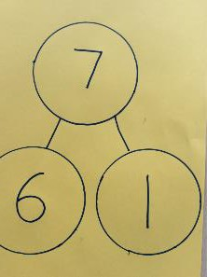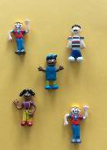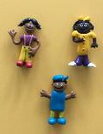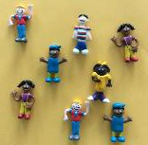**Early Years**



**Key Vocabulary:** add, more, sum, make, total, How much more is…? one more, altogether

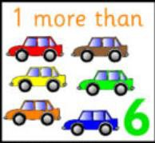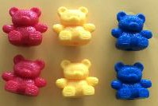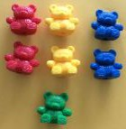**Counting fluency:** To count forwards and backwards in steps of 1s, 2s, 5s and 10s.

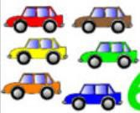

|  |  |  |  |
| --- | --- | --- | --- |
| Objective & Strategy | Concrete | Pictorial | Abstract |
| To find one more than a given number up to 20. | Use physical objects to add one object to find the whole.  **One more than 6 is 7**  +  =  Modelled using counters for the Part Whole Method. | Use pictorial representations to add one object to find the whole.  **One more than 6 is 7**  + =  Modelled using Part- Whole with numbers recorded. | Record as a written calculation.  **6 + 1 = 7**  **1 + 6 = 7**  **7 = 6 + 1**  **7 = 1 + 6** |
| To use objects to add two single-digit numbers. | Use physical objects to add two single objects to find the whole.  **5 + 3 = 8**  **+ =**  Modelled using counters for the Part Whole Method.    Modelled using a Bead String | Use pictorial representations to add two single digits to find the whole.  Modelled using the Part Whole Method with numbers    Modelled using a Number Line | Record as a written calculation.  **5 + 3 = 8**  **3 + 5 = 8**  **8 = 5 + 3**  **8 = 3 + 5** |

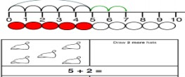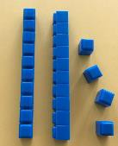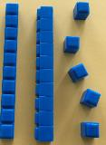**Year 1**

**Key Vocabulary:** addition, add, more, and, makes, sum, total, altogether, count on, one more, two more…ten more…., how many more to make? How many more is…than…? How much more is…?

**Counting fluency:** To count forwards and backwards in steps of 2s, 5s and 10s.

|  |  |  |  |
| --- | --- | --- | --- |
| **Objective & Strategy** | **Concrete** | **Pictorial** | **Abstract** |
| To find one more than a given number up to 100.  To find 10 more than a given number up to 100. | Use physical objects to find one or ten more than a given number.  **1 more than 25 is 26**  Modelled Using Base 10  **+**  =  **10 more than 25 is 35**  Modelled using Base 10 | Use pictorial representations to add.  **1 more than 25 is 26**  Modelled using the Part-Whole method with Base 10 then numbers    **10 more than 25 is 35**  Modelled using the Part-Whole method with Base 10 then numbers | Record as a written calculation  **24 + 1 = 25**  **1 + 24 = 25**  **25 = 24 + 1**  **25 = 1 + 24**  Record as a written calculation  **25 + 10 = 35**  **10 + 25 = 35**  **35 = 25 + 10**  **35 = 10 + 25** |
| To represent & use number bonds and related subtraction facts within 20. | Use physical objects to find related number facts. Number beads  **2 more than 5**  **5+2=7** | Use pictorial representations to show related number facts  **2 more than 5**  **5+2=7** |  |

|  |  |  |  |
| --- | --- | --- | --- |
| To add two single-digit numbers. | Use physical objects to add two single objects to find the whole.  **5 + 3 = 8**  **+ =**  Modelled using counters for the Part Whole Method.  **5+3 = 8**  Modelled using a Bead String  **5+3 = 8** | Use pictorial representations to add two single digits to find the whole.  Modelled using the Part Whole Method with numbers  **5+3 = 8**  Modelled using a Number Line | Record as a written calculation.  **5 + 3 = 8**  **3 + 5 = 8**  **8 = 5 + 3**  **8 = 3 + 5** |
| To add a one digit and two-digit number to 20, including zero. | Use physical objects to add one-digit and two-digit numbers to find a whole.  **5 + 13 = 18**  **+ =**  **15 + 0 = 15** | Use pictorial representations to add one-digit and two-digit numbers to find the whole.  Modelled using the Bar Model Children will represent the problem in a bar model. They will then use their knowledge of addition to help solve the problem.  Part-Whole method with counters  **15 + 0 = 15** | Record as a written calculation  **13 + 5 = 18**  **5 + 13 = 18**  **18 = 5 + 13**  **18 = 13 + 5**  Record as a written calculation  **15 + 0 = 15**  **0 + 15 = 15**  **15 = 0 + 15**  **15 = 15 + 0** |

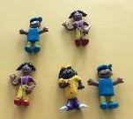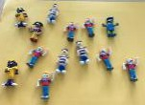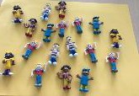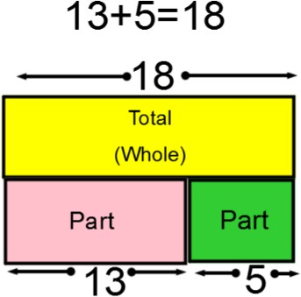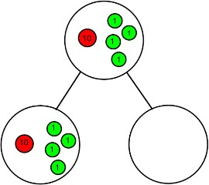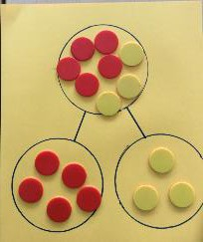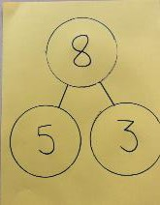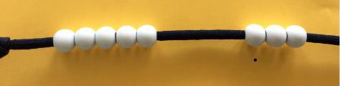

|  |  |  |  |
| --- | --- | --- | --- |
| To solve one step problems that include addition. | Use physical objects to solve one step problems. Modelled using Part Whole with Base 10  **7 = ? + 4** | Use pictorial representations to solve one step problems.  Modelled using Part-Whole with numbers  **7 = ? + 4**  Modelled using the Bar Model.  Children would then go on to solve it using their knowledge of addition. | Record as a written calculation  **7 = + 4** |
| To start at the bigger number and count on. | Use physical objects to count on from a number.  **12+5= 17**  Modelled using a bead string | Use pictorial representations, begin to count on from a given number. Modelled using a number line | Record as a written calculation  **12 + 5 = 17**  **5 + 12 = 17**  Put the larger number in your head and count on the smaller number to find your answer. |
| To regroup to make 10.  *This is an essential skill for column addition in Year 2.* | Use physical objects to regroup to make 10. | Use pictorial representations, begin to count on from a given number. | Record as a written calculation.  **7 + 4 = 11**  ***If I am at seven, how many more do I need to make 10?***  ***How many more do I need now to make it to 11?*** |

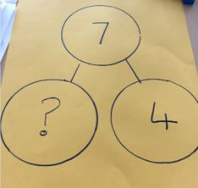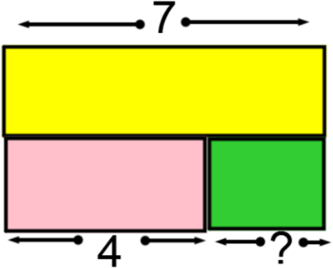

|  |  |  |  |
| --- | --- | --- | --- |
| To add near doubles. | Modelled using concrete resources  **6 + 7**  Step 1- Make the calculation.  Step 2- Adjust the 6 to a 7 by adding 1.  Step 3- Add them to find the total.  Step 4- Subtract the 1, which was previously added, from the total to find the final answer. | Modelled using pictorial representations  **6 + 7 =**  Adjust 6 by adding 1 to make it 7.  Find the answer to double 7 = 14  Remember to subtract the 1 that was added to find the final answer, 14-1= 13 | Record as a written calculation.  **6 + 7 = 13**  **7 + 6 = 13**  **13 = 7 + 6**  **13 = 6 + 7** |

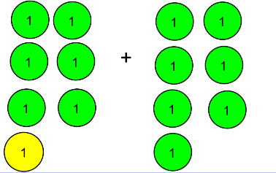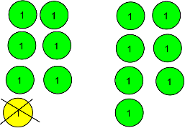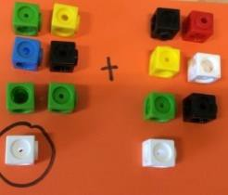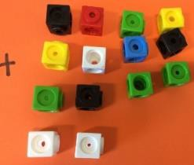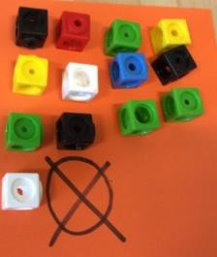

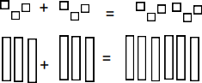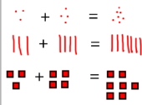**Year 2**

**Key Vocabulary:** addition, add, more, and, makes, sum, total, altogether, double, count on, one more, two more…ten more…., one hundred more, how many more to make? How many more is…than…? How much more is…?

**Counting fluency:** To count forwards and backwards in steps of 2s, 3s, 4s, 5s and 10s.

**Mental strategies**

|  |  |
| --- | --- |
| **Skill** | **Strategy** |
| To add 9 to a 2-digit number by adjusting. | **34+9 M**ake the number with base ten equipment, then add 10. You then need to subtract 1 because 10 is actually one more than 9. Children will begin to do this mentally without equipment. For 34+9 you would first add 10 34+10 = 44 then subtract 1, 44-1=43 so 34+9=43. |
| To add near doubles | **13+14** When numbers are very close in value, adjust one of numbers to make it the same then use knowledge of portioning to double then subtract 1  For 13+14 = Make 13 into 14 by adding 1, double 14 by doubling 10 (20) and doubling 4 (8) and recombine (28). Then subtract the one that you added at the beginning (28-7) sp  13+14= 27. |

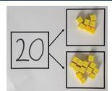**Year 2 Calculation Methods**

|  |  |  |  |
| --- | --- | --- | --- |
| **Objective** | **Concrete** | **Pictorial** | **Abstract** |
| To recall and use addition facts to 20 fluently. | Use physical objects to represent each part of calculation. Then use this to show related addition facts.  Modelled using part whole method. Children explore ways of making number bonds by moving the concrete objects around.  **20 = 7+ 13** | Use pictorial representatives to explore addition facts to 20.  Children begin to showing their understanding by representing using numbers.  Modelled using the part whole method with structured number sentences to show relation facts. | Record as a written calculation  **? + 1 = 20**  **1 + ? = 20**  **20 – 1 = ?**  **20 - ? = 1** |
| To derive and use related facts up to 100. | Use physical objects to show mathematical facts up to 100.  Modelled using Base 10  e.g.  **3 + 3 =6**  so…  **30 + 30 = 60** | Use pictorial representations to show mathematical related facts.  Children show their thinking using jottings to record their mathematical  calculations.  **3 + 3 =6**  **30 + 30 = 60**  **300+300 = 600** | Record as a written calculation  **3 + 4 = 7**  **leads to…**  **30 + 40 = 70**  **leads to… 300 + 400 = 700** |

|  |  |  |  |
| --- | --- | --- | --- |
| To add three 1 digit numbers to 100. | Use physical objects to add three single digit numbers to 100.  Children to use concrete resources to add three 1 digit numbers.  **7 + 2 + 3** | Use pictorial representations to add three single digit number to 100.  Modelled using images  Children find the numbers that make 10 to aid the adding skills. |  |
| To add a two digit number and ones up to 100. | Use physical objects to add two-digit number and ones.  Children would use equipment for example, Base 10 to help them show their mathematical thinking.  **45 + 4 = 49**  **+ =** | Use pictorial representatives to add two-digit number and ones to 100.  Use the Bar Model method to show number correspondence in order to find the whole.  **Using the Bar Model to add 45+4=?** |  |
| To add multiples of 10. | Use physical objects to add multiples of 10. Using place value counters to add  Children use concrete apparatus to show number sentences. Children  then combine to find their answer.  **20 + 40 = 60** | Use pictorial representatives to add multiples of 10. Using a Hundred Square  Children circle the smallest number on the 100 square. They then add the larger multiple of 10 by jumping down in steps of 10.  **20+40=60** |  |

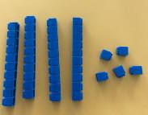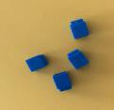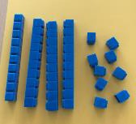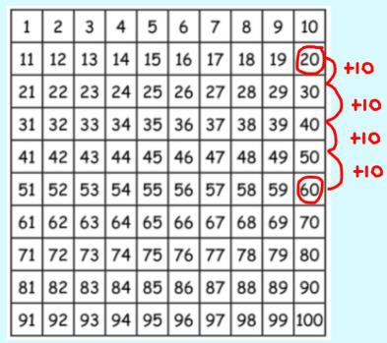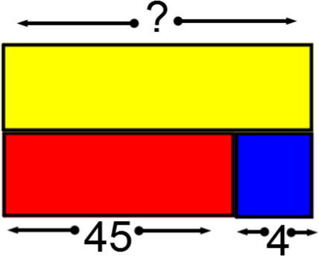

|  |  |  |  |
| --- | --- | --- | --- |
| To add a two digit number and tens to 100. | Use physical objects to add two-digit number and tens.  Children represent the calculation using base 10 or place value grids and counters. When finding totals, they add the ones first, then the tens to find the whole.  Modelled using Base 10  **27 + 30 = 57** | Use pictorial representations to add two-digit number and tens.  **Using a 100 Square**  Children circle the non-multiple of 10 then add the multiples of 10 by jumping down the hundred square.  Modelled using a number line Start with the non-multiple of 10 and jump in tens.  **27 + 30 = 57** | Record as a written calculation, including missing box questions.  **27 + 10 = 37**  **27 + 20 = 47**  **27 + ? = 57** |
| To add two 2 digit numbers to 100 (including bridging through 10) | Children will continue to organise calculations using concrete resources to make sense of the problem.  Modelled using Base 10  **45+34=79**  **+ =**  **25 + 47 = 72**    When children bridge through 10, they will need to exchange 10 ones for 1 ten. | Use pictorial representations to add two 2-digit number to 100.  **45+34=79**  Modelled using a number line  Start with the largest number and partition the second. Add the tens first then the ones. It is important that the children record their workings underneath. To find the answer, children count the numbers inside each jump. | Record as a written calculation.  **45**  **+ 34**  **9 (5+4)**  **70 (40+30)**  **79**  Begin to use more condensed method of column addition.  2 5  + 4 7  7 2  1 |

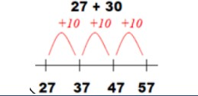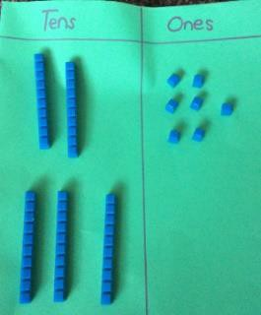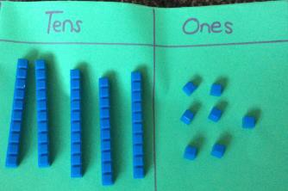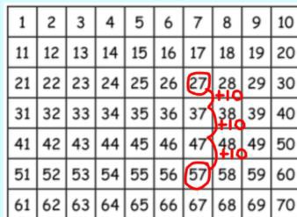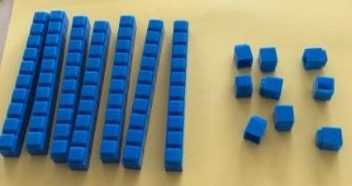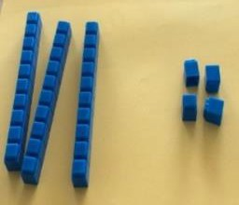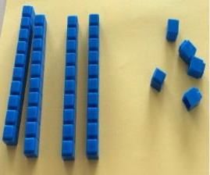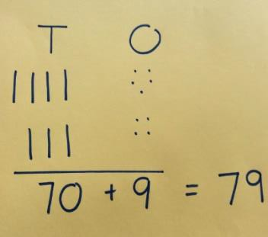

**Year 3**

**Key Vocabulary:** addition, columnar addition. add, more, and, makes, sum, total (of), count on, altogether, increased by, double, near double, one more, two more…ten more…., one hundred more, inverse, commutative law, how many more to make? How many more is…than…? How much more is…?

**Counting fluency:** To count forwards and backwards in steps of 2s, 3s, 4s, 5s, 6s, 8s, 10s and 100s from any given number.

**Mental strategies**

|  |  |
| --- | --- |
| **Skill** | **Strategy** |
| * Add three small numbers. | **6+ 14 + 5** Look for any number bonds e.g 14+6=20 then add 5  Add two number, find the total then add the final number. |
| *add a 3-digit number and ones, including crossing boundaries. | **432+ 6** If the ones do not cross into the tens column then add the ones only 432 + 6 = 438  **654+ 8** If the ones cross into the tens column then use knowledge of number bond to solve. For 654 + 8 you would partition 8 into 6 and 2 then 654 + 6 = 660 + 2 = 662. |
| *add a 3- digit number and tens including crossing boundaries | **534+40** If the tens do not cross into the hundreds column then add the tens only 534+40= 574  **543+70** If the tens cross into the hundreds column then use knowledge of number bonds to solve. For 543+70 you would partition 70 into 60 and 10 and then 543 + 60 = 603 + 10 = 613 |
| *Add a 3-digit number and hundreds including crossing boundaries. | **524+300** If the hundreds do not cross into the thousands column then add the hundreds only 524+300= 824.  **654+500** If the hundreds cross into the thousands column then use knowledge of number bonds to solve. For 654+500 you would partition 500 into 400 and 100 then do 654+ 400 = 1054 +100 = 1154 |
| * Add a 2-digit number to a 3-digit tens number including crossing boundaries. | **540+34** If the tens do not cross into the hundreds column then add the tens only 540+ 34= 574.  **620+92** If the tens cross into the hundreds column then use knowledge of number bonds. For 620+92 you would partition 92 into 80, 10 and 2.  Then do 620+ 80=700 +10 +2= 712 |
| Add pairs of 2-digit numbers including crossing boundaries. | **33+65** If the tens do not cross into the hundreds column then add the tens and ones separately. For 33 + 65 first add the tens 30+60=90 then add the ones 90+3+2= 95  **28+63** If the ones cross into the tens column add the tens then the ones and recombine. For 28 + 63 add the tens 20+60= 80 then the ones 8+3 = 11 then recombine 80+11= 91 |
| *Add to any 3-digit number to make the next ten or hundred. | **254+?= 260** Look for any number bonds e.g. 4 + 6 = 10 so 254+6=260  **543+ ?=600** Look for the nearest multiple of 10 using knowledge of number bonds 543+7= 550. Then add on in steps of 10 until you reach the multiple of 100. 550+50 = 600.  The solution to 243+57=600 |
| *Add near doubles. | **18+16** Adjust one number so they are the same e.g. 16 to make it 18 by adding 2. They then use their doubling facts to double 18 then subtract 2. 18 + 18 = 36 -2=34  **60+70** Adjust one number so they are the same e.g. 60 to make it 70 by adding 10. They then use using their doubling facts to double 70 and then subtract 10.  70 + 70 = 140 -10= 130 |
| *Add near multiples of 10 and 100 and adjust. | **34+9** When adding 9 you would add 10 then subtract 1 because 10 is actually one more than 9. For 34+9 you would do 34+10=44 – 1 =43.  **543+ 99** When adding 99 you would add 100 then subtract 1 because 100 is actually one more than 99. For 543+99 you would do 543+100=643 – 1 =642. |

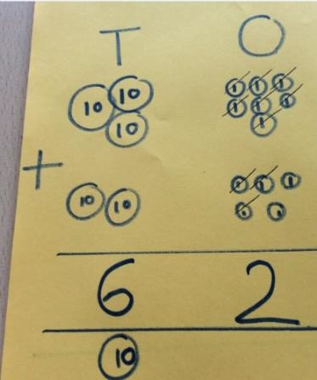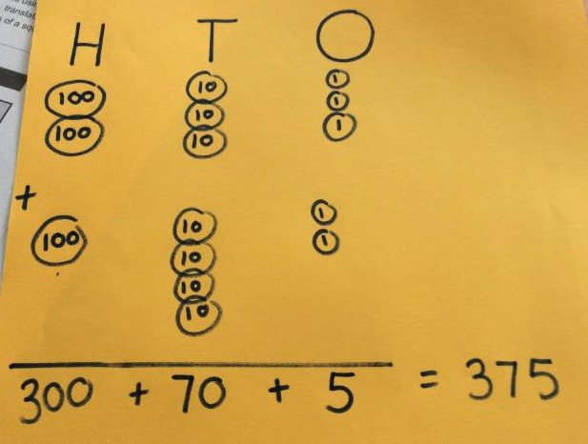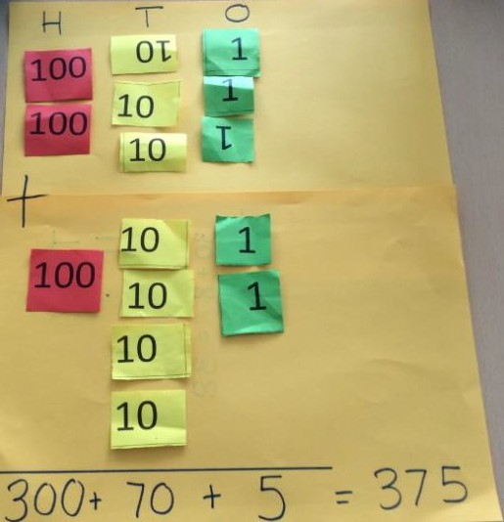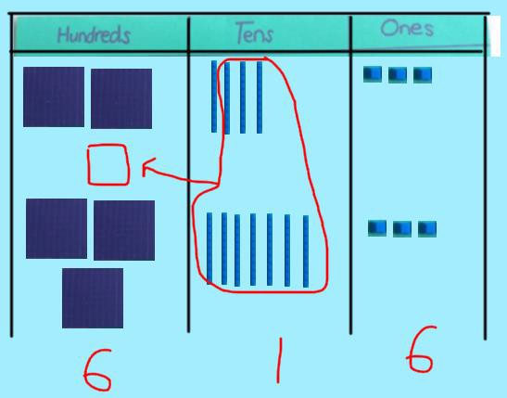**Year 3 Calculation Methods**

|  |  |  |  |
| --- | --- | --- | --- |
| **Objective** | **Concrete** | **Pictorial** | **Abstract** |
| To add numbers up to 3 digits, using formal written methods- no regrouping. | Use physical objects to add numbers up to 3 digits using a formal method.  Modelled using Base 10 and place value counters-  Add the ones first then the tens*.*  **233+142=375** | Use pictorial representations e.g. jottings.  **233+142=375** | Written method (expanded form)  **233**  **+142**  **5 (3+2)**  **70 (30+40)**  **300 (200+100)**  **375**  Condensed columnar addition  **233**  **+ 142**  **375** |
| To add numbers up to 3 digits, using formal written methods, with regrouping. | Use physical objects to add numbers up to 3 digits.  Modelled using Base 10 and place value counters- Add the ones together first then the tens.  **37+25=62**  +  =  **Modelled using Base 10**  Children to understand that the highest amount in each column is 9 so sometimes exchange into the next column is necessary.  Children know to exchange ten 1s for a ten and ten 10s for a hundred.  **243+ 373 = 616** | Use pictorial representations to add numbers up to 3 digits.  **37+25**  **243 +373= 616** | Continue to use the expanded method until secure in understanding.  Condensed columnar addition Carry below the line when bridging.  **37**  **+25**  **62**  **1**  **2 4 3**  **+ 3 7 3**  **6 1 6**  **1** |

|  |  |  |  |
| --- | --- | --- | --- |
| To solve addition problems, including missing numbers. | Use physical objects to solve addition problems, including missing numbers.  Children will need to solve problems that are incomplete using their knowledge of inverse operations.  **33= ? + 11**  **11+ ? = 33**  **? + 11 =33**  The missing number can be presented in multiple places.  **Modelled using the Part Whole Method** | Use pictorial representations to solve addition problems, including missing numbers.  **Modelled using the Bar Model**  Use the bar model, children will make sense of the problem before solving it.  **Modelled using the Part Whole method**  Children use their knowledge of inverse operations to solve missing number problems effectively. | Record as a written calculation  37+??=62 |

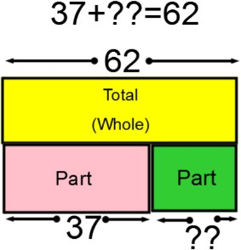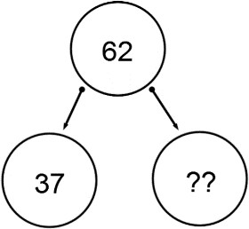

**Year 4**

**Key Vocabulary:** addition, columnar addition. add, more, and, makes, sum, total (of), count on, altogether, extra, in all, combined, increased by, double, near double, one more, two more…ten more…., inverse, commutative law, one hundred more, how many more to make? How many more is…than…? How much more is…?

**Counting Fluency:** To count backwards and forwards in steps of 2s, 3s, 4s, 5s, 6s, 7s, 8s, 9s, 10s, 11s, 12s, 100s and 1000s from any given starting number.

**Mental Strategies**

|  |  |
| --- | --- |
| **Skill** | **Strategy** |
| *add a 4-digit number to ones including crossing boundaries. | **5432 + 6** If the ones do not cross into the tens column then add the ones only 5432 + 6 = 5438  **7654 + 8** If the ones cross into the tens column then use knowledge of number bonds to solve. For 7654 + 8 you would partition 8 into 6 and 2 then 7654 + 6 = 7660 + 2 = 7662. |
| *add a 4-digit number to tens including crossing boundaries. | **6527+30** If the tens do not cross into the hundreds column then add the tens only 6527+30= 6557.  **4256 +90** If the tens cross into the hundreds column then use knowledge of number bonds to solve. For 4256 +90 you would partition 90 into 50 and 40 and then 4256 + 50 = 4306 + 40 = 4346. |
| *add a 4-digit number to hundreds including crossing boundaries. | **2378+400** If the hundreds do not cross into the thousands column then add the hundreds only 2378+400= 2778.  **6527+700** If the hundreds cross into the thousands column then use knowledge of number bonds to solve. For 6527+700 you would partition 700 into 500 and 200 then 6527 + 500 = 7027+200 = 7227. |
| *add a 4-digit number to thousands including crossing boundaries. | **5267 + 3000** If the thousands do not cross into the ten thousand column then add the thousands only 5267 + 3000= 8267.  **5267 + 7000** If the thousands cross into the ten thousand column then use knowledge of number bonds to solve. For 5267 + 7000 you would partition 7000 into 5000 and 2000 then 5267 + 5000 = 10,267+2000 = 12,267. |
| *Add any pair of 3-digit multiples of ten including crossing boundaries. | **430+520** If the numbers do not cross into others columns then use partitioning to add 430+520 = 950.  **650+270** If the tens cross into the hundreds column then use knowledge of number bonds to solve . For 650+270 you partition 270 into 200 and 50 and 20. Then you would do 650+200= 850 then 850 + 50 = 900 to make the next multiple of 100 then add 20 900+20-= 920. |
| *add near multiples of 10, 100 or 1000 then adjust. | **2335+59** Add the nearest multiple of 10 (60) then subtract 1 because 60 is actually 1 more than 59. 2335+60= 2395-1= 2394.  **2345+199** Add the nearest multiple of 100 (200) then subtract 1 because 200 is actually 1 more than 199. 2345+200= 2545-1= 2544.  **5423+2999** Add the nearest multiple of 1000 (3000) then subtract 1 because 3000 is actually 1 more than 2999 . 5423+3000= 8423-1= 8422. |
| *add near doubles of 2 or 3- digit numbers. | **38+37** If the numbers are near doubles, adjust so that they are the same number. Then use the portioning method for doubling and adjust.  For 38+37, double 38 then take away 1 to make 75. |
| *Add to a decimal fraction with units and tenths to make the next whole  number. | **0.4+ 0.6** Use knowledge of number bonds to solve. For 0.4 + ? = 1, you would use your knowledge of 4+6 = 10 so you would know 0.4 + 0.6 = 1.0. |

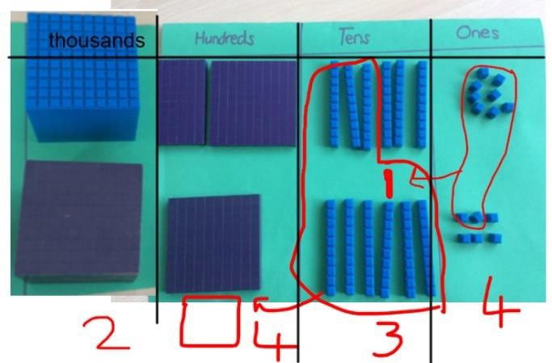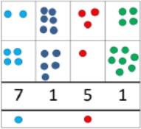**Year 4 Calculation Methods**

|  |  |  |  |
| --- | --- | --- | --- |
| **Objective &**  **Strategy** | **Concrete** | **Pictorial** | **Abstract** |
| To add numbers with up to 4 digits. | **Modelled using Base 10**  Children to understand that the highest amount in each column is 9 so sometimes exchange into the next column is necessary. Children understand that they can exchange ten 1s for a ten and ten 10s for a hundred and ten 100s for a thousand.  Children begin to understand multi exchange where exchange is needed in more than one column.  **1268+ 1166 =**  **2434** | Use pictorial representations to add numbers up to 4 digits.  Children will use images to represent the place value. If exchanging is needed, this will be shown below the line. This leads to greater understanding when using the formal written method as the children know what the digit below the line represents.  **2634 + 4517 = 7151**  The blue dot represents 1000 and the red dot represents 100. | Record as a written calculation  Condensed columnar addition Carry below the line  **3517 + 396 = 3913** |
| To solve simple measure and money problems up to two decimal places. | Use physical objects to solve simple measure and money problems.  Children will gather then organise the amount required. Using the place value chart, children will then solve the calculation.  **£1.55 + £3.18=£4.73** | Use pictorial representations to solve simple measure and money problems.  Using pictorial representations of money, children to solve up additions involving numbers with up to two decimal places.  **£1.31 + £2.43= £3.74** | Record as a written calculation  Condensed columnar addition Children should line the decimals  correctly under one another, considering place value. |

**Year 5**

**Key Vocabulary:** addition, columnar addition. add, more, and, makes, sum, total (of), count on, altogether, extra, in all, combined, increased by, double, near double, one more, two more…ten more…., one hundred more, inverse, commutative lawhow many more to make? How many more is…than…? How much more is…?

**Counting Fluency:** To count backwards and forwards in steps of 2s, 3s, 4s, 5s, 6s, 7s, 8s, 9s, 10s, 11s, 12s, 100s and 1000s from any given starting number.

**Mental Strategies**

|  |  |
| --- | --- |
| **Skill** | **Strategy** |
| * Add any pairs of 4-digit multiples of 100. | **4500 + 3200** If the hundreds and thousands column do not cross into other columns then partition to add 4500 + 3200 = 7700.  **5400 + 7900** If the hundreds and thousands column cross then use knowledge of number bonds to solve. For 5400 + 7900 you add 5000+7000=12,000 and 900+400=1300 and recombine 12,000+ 1300 = 13,300. |
| *add near multiples of 10, 100, 1000, 10,000 then adjust, including crossing boundaries. | **2335+58** Add the nearest multiple of 10 (60) then subtract 2 because 60 is two more than 58 2335+60= 2395-2= 2393.  **2345+297** Add the nearest multiple of 100 (300) then subtract 3 because 300 is three more than 297 2345+300= 2645-3= 2642.  **5438 +3995** Add the nearest multiple of 1000 (4000) then subtract 5 because 4000 is five more than 3995 5438+4000= 9438-5= 9433. |
| *Add tenths to a 1-digit whole number and tenths. | **4.3+0.4** If the tenths do not cross into ones column then add the tenths and ones separately 4.3 +0.4= 4.7  **2.4 + 0.8** If the tenths cross into the ones column then use your knowledge of number bonds to partition. For 2.4 + 0.8, use your knowledge that 4+6= 10 to partition the 0.8 into 0.6 and 0.2 so 2.4 + 0.6 = 3 +0.2 = 3.2 |
| *Add two 1-digit whole numbers and tenths. | **4.3+3.4** If the tenths do not cross into ones then add the tenths and ones separately e.g. 4.3+3.4= 7.7  **6.7 + 1.5** If the tenths cross into the ones column then use your knowledge of place value to solve. Make both numbers ten times bigger then calculate 67+15= 82. To adjust make your answer 10 times smaller 82 ÷ 10 = 8.2 so 6.7+1.5= 8.2 |
| *Add 2-digit numbers with tenths and hundredths. | **0.46+0.21** If the tenths and hundredths do not cross into ones then use partitioning to solve e.g. 0.46+0.21= 0.67  **0.36 + 0.84** If the tenths and/or hundredths cross into another column then use your knowledge of place value to solve. Make both numbers 100 times bigger then calculate 36 + 84 = 120. To adjust make your answer 100 times smaller 120 ÷ 10 = 1.2 so 0.36+0.84 = 1.20 |
| *Add to a decimal fraction with units and tenths to make the next whole  number. | **4.4 + ? = 5** Use knowledge of number bonds to solve. For 4.4 + ? = 5, you would use your knowledge of 4+6 = 10 so know 0.4 + 0.6 = 1.0 so 4.4 + 0.6 =5. |
| *Add near doubles of decimals. | **3.8+3.7** If numbers are near doubles adjust to make them the same number. Then use the portioning method for doubling and adjust.  For 3.8+3.7, double 3.8 by doubling 3 (6), doubling 0.8 (1.6) then combine to make 7.6 then take away 0.1 to make 7.5. |

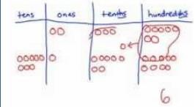**Year 5 Calculation Methods**

|  |  |  |  |
| --- | --- | --- | --- |
| **Objective**  **& Strategy** | **Concrete** | **Pictorial** | **Abstract** |
| To add numbers with more than 4 digits. | **Modelled using place value counters**  Children to understand that the highest amount in each column is 9 so sometimes exchange into the next column is necessary. Children understand that they can exchange ten 1s for a ten, ten 10s for a hundred, ten 100s for a thousand, ten 1000s for a ten thousand.  Children understand multi exchange where exchange is needed in more than one column.  **52,546 + 34,375 = 86,921** | Using different pictorial representations for the values, the children show exchanges and understand the place value. This leads to greater understanding when using the formal written method as the children know what the digit below the line represents.  **52,546 + 34,375 = 86,921** | Record as a written calculation  Condensed columnar addition Carry below the line.  Children to solve calculation involving multiple exchanges. |
| To add numbers with up to two decimal places. | Use physical objects to add numbers with up to two decimal places.  Modelled using place value charts and counters  **2.37 + 91.79 = 94.16** | Use pictorial representations to add numbers with up to two decimal places.  Children will use jottings to help them represent the calculation. They add each column starting first from the furthest column to the right and carry below the line when needed.  **2.37 + 81.79 =**  **84.16** | Record as a written calculation Condensed columnar addition  Children should line decimals up correctly,  including examples when there are different number of decimal places. |

**Year 6**

**Key Vocabulary:** addition, columnar addition. add, more, and, makes, sum, total (of), count on, altogether, extra, in all, combined, increased by, double, near double, one more, two more…ten more…., one hundred more, inverse, commutative law, how many more to make? How many more is…than…? How much more is…?

**Counting Fluency:** To consolidate counting backwards and forwards in steps of 2s, 3s, 4s, 5s, 6s, 7s, 8s, 9s, 10s, 11s, 12s, 100s, 1000s and 10,000s from any starting number.

**Mental Strategies**

|  |  |  |
| --- | --- | --- |
| **Skill** | **Strategy** | |
| Reconsolidate all strategies from Y4 and 5. | | |
| *Add a 4-digit multiple of 100 to a 4-digit number. | **6365 + 3400**  **5432+1800** | If the hundreds do not cross into the thousands column then add the hundreds only 6365 + 3400 = 9765.  If the hundreds cross into the thousands column then use knowledge of place value to partition. For 5432+1800 you partition 1800 into 1000 and 600 and 200. Then you would do 5432+1000= 6432 then 6432 +600 = 7032 + 200 = 7232. |
| *Add large numbers. | **455,000 + 324,000** If the hundreds and thousands do not cross into the thousands column then use partitioning to solve 455,000 + 324,000 = 879,000  **543,000 + 387,000** If the hundreds, thousands or ten thousands cross into another column then use knowledge of place value to partition.  For 543,000 + 387,000 you would do 500,000+300,000= 800,000 then 40,000+80,000= 120,000 and 3,000 +7,000 =10,000  and recombine 800,000 + 120,000+ 10,000 = 930,000 | |
| *add near multiples of 0.01, 0.1, 10, 100, 1000 then adjust, including crossing boundaries. | **3.9 + 4.4**  **2.56 + 4.98** | Add the nearest whole number (4) then subtract 0.1 because 4 is actually 0.1 more than 3.9 so 4.4 +4= 8.4 – 0.1 = 8.3  Add the nearest whole number (5) then subtract 0.02 because 5 is actually 0.02 more than 4.98 so 2.56 +5 = 7.56 – 0.02= 7.54 |
| *Add several 1-digit whole numbers and tenth. | **3.4 + 2.8 + 3.5** | Use knowledge of place value and partitioning to solve. Make each decimal fractions 10 times bigger and do 34 + 28 + 35 = 97 Then adjust to make your answer 10 times smaller 97÷ 10 = 9.7 so 3.4 + 2.8 + 3.5 = 9.7 |
| *Add decimals with different numbers of places. | **0.45 + 2.3** | Add by partitioning using your knowledge of place value. First add the ones 0 + 2 = 2, then the tenths 0.4 + 0.3 = 0.7 then the hundredths 0.05 + 0 = 0.05 and recombine 2+ 0.7 + 0.05= 2.75 |
| *Add to any number with two decimal places to make the next tenth or whole number. | **2.34 + ? = 2.4**  **6.35 + ? = 7** | Use knowledge of number bonds to 10. 34+6=40 so 2.34+ 0.6 = 2.4  Use knowledge of number bonds to 100. 35+65=100 so 6.35+ 0.65= 7 |
| *Add to any number with three decimal places to make the next tenth or whole. | **4.245 + ? = 5**  **3.256 + ? = 3.3** | Use knowledge of place value to help 245+ 755= 1000 so 4.245+ 0.755= 5  Use knowledge of place value 256 + 44= 300 so 3.256+ 0.044 = 3.3 |

**Year 6 Calculation Methods**

|  |  |  |  |
| --- | --- | --- | --- |
| **Objective** | **Concrete** | **Pictorial** | **Abstract** |
| To add several numbers of increasing complexity. | **Modelled using Base 10**  Children to understand that the highest amount in each column is 9 so sometimes exchange into the next column is necessary. Children understand that they can exchange ten 1s for a ten, ten 10s for a hundred, ten 100s for a thousand, ten 1000s for a ten thousand.  Children understand multi exchange where exchange is needed in more than one column.  **52,546 + 34,375 = 86,921** | Using different pictorial representations for the values, the children show exchanges and understand the place value. This leads to greater understanding when using the formal written method as the children know what the digit below the line represents.  **52,546 + 34,375 = 86,921** | Record as a written calculation Condensed columnar addition  Children to solve calculation involving multiple  exchanges and numbers with different numbers of digits. |
| To add numbers with increasing complexity, including adding money, measure. | Use physical objects to add numbers with increasing complexity, including adding money, measure  Using counters and a place value chart  **1.30 + 80.79 = 82.09** | Use pictorial representations to add numbers with increasing complexity, including adding money, measure  Using jottings and place value chart.  Children will use jottings to help them represent the calculation. They add each column starting first from the furthest column to the right and carry below the line when needed.  **2.37 + 81.79 =84.16** | Children add several decimals with different numbers of decimal places by lining up digits and inserting zeros as place holders. |