

Geography
Curriculum Overview
Curriculum Coverage
Upper KS2 | Y6 | 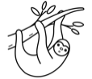 | Biomes (8 lessons) |  | North America (8 lessons)
Upper KS2 | Y5 | 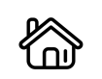 | Settlements and Land Use (8 lessons) |  | Natural Resources (8 lessons)
Lower KS2 | Y4 | 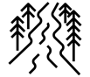 | Journey of the River (8 lessons) | 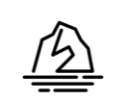 | Coasts (8 lessons)
Lower KS2 | Y3 | 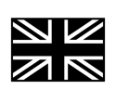 | My Place in the World: The United Kingdom (8 lessons) | 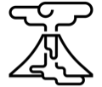 | Volcanoes and Earthquakes (8 lessons)
KS1 | Y2 | 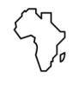 | Handa’s Africa Adventure (7 lessons) |  | Planet Earth (7 lessons)
KS1 | Y1 |  | Where I live (7 lessons) |  | Wonderful weather (7 lessons)
Intent
This geography curriculum will inspire in, all pupils, a curiosity and fascination about the world and its people. It will equip pupils with knowledge about diverse places, people, resources and natural and human environments, together with a deep understanding of the Earth’s key physical and human processes. This includes:
- Locational knowledge of globally significant places;
- Have opportunities to experience physical geography and human geography throughout the learning journey;
- Have opportunities to experience geography outside the classroom, where pupils will have the geographical skills. to be competent in:
  - fieldwork to observe, measure record and present the human and physical features in the local area;
  - using a range of sources of geographical information, including maps, diagrams, globes, aerial photographs and Geographical Information Systems (GIS);
  - communicate geographical information in a variety of ways, including through maps, numerical skills and writing at length.

Implementation

The key threshold concepts across the Geography curriculum are taught throughout the units to develop geographically knowledge and skills from EYFS to Y6 and beyond. The curriculum is designed for progression and built around the overarching threshold concepts with content structured as a narrative over time, ensuring essential knowledge is learned, applied and accessible for all pupils. The curriculum narrative is led by the four threshold concepts:
- Location and place knowledge;
- Geographical skills and communication;
- Physical processes and landscapes;
- Human interaction with the environment.

Impact
- Pupils can talk enthusiastically about geography;
- Pupils can use subject specific vocabulary effectively in both written and verbal work;
- Pupils understand their place in the world and are aware of contemporary issues such as deforestation and sustainability.
“The study of geography is about more than just memorizing places on a map. It’s about understanding the complexity of our world, appreciating the diversity of cultures that exists across continents.” President Barack Obama

