SEND Information Report
Approved on:
July 2023
Next review:
June 2024
Our Lady and St Bede Catholic Academy

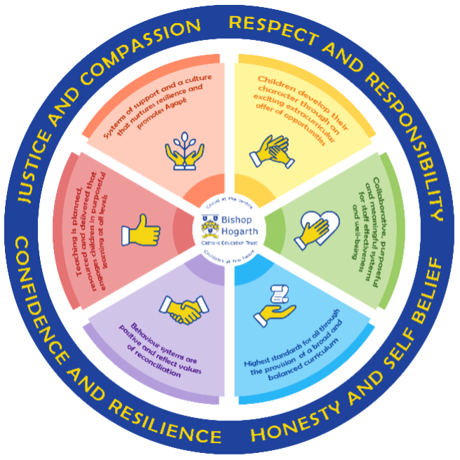
As part of the family of Bishop Hogarth Catholic Education Trust, our school has at its core, the virtues and values of:
Respect for others and themselves, recognising that we are all created in the image of God and therefore must be compassionate towards others, especially the vulnerable. ​
Confidence in their own abilities, knowing that their talents are gifts from God and resilience to persevere when things become difficult. ​
Honesty in regards to the world around them and themselves and the ability to take responsibility for the times we may fall short of the mark. ​
Gratitude for all of the amazing gifts from God and willingness to share their gifts both personal and material. ​

As an inclusive school, all teachers are teachers of pupils with Special Educational Needs & Disabilities. We deliver a curriculum and create an environment that meets the needs of every pupil within our school. We ensure that every pupil with Special Educational Needs and / or disabilities makes the best progress possible. We foster and promote effective working partnerships with parents / carers, pupils and outside agencies. We consider the ‘whole’ child and strive to ensure that all our SEND pupils are prepared for adulthood.​

Our school’s approach to supporting pupils with SEND

Teachers are responsible for the progress of all pupils in their class. High-quality teaching is personalised to individual needs, making good use of high-quality resources to improve pupil progress. This is the first step in supporting pupils who may have a SEND need. All pupils are challenged to do their very best and make the most progress that they can.
All of our pupils are known well by at least one member of staff, usually their Form Tutor, with further support from their Head of Year and Teaching Assistants.
Form tutors enjoy developing strong relationships with the pupils they work with every day. Good behaviour and organisation are rewarded. Sanctions exist to support consistently high standards of behaviour and decorum.
A very small number of pupils with a specific SEND need may be monitored in our support room, with various amounts of integration into their main form group weekly. This provides the pastoral care that all pupils need, but with more focus on support for those pupils with particular needs and requirements. This support is provided by the Special Educational Needs Coordinator (SENDCO), Enhanced Mainstream School (EMS) Manager and Teaching Assistants (TAs).
We manage medical needs by working closely with parents and healthcare professionals and use the information and advice to develop and review pupils’ Individual Health Care Plans (IHCP). We also listen to and act on their advice, providing staff training when needed. Please see the ‘Supporting Children with Medical Needs Guidance’ policy for further information.
We run a range of extracurricular clubs. The Enhanced mainstream base is an inclusive space, available for any pupil who may need temporary additional support.

How will the school staff support my child?
The graduated response-Identifying, planning for and supporting pupils with SEND
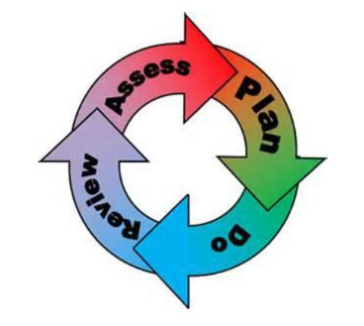
Where a pupil is identified as having a special educational need, School will follow a graduated approach which takes the form of cycles of ‘Assess, Plan, Do, Review’. ​
• Assess a child’s special educational need. ​
• Plan the provision to meet your child’s aspirations and agreed outcomes. ​
• Do put the provision in place to meet those outcomes. ​
• Review the support and progress.

How does the school know if children need extra help and what do I do if I think my child has special educational needs?

Assess

Pupils are identified in several ways including communication with parents, primary schools, Year 6-7 transition work and analysis of current and prior attainment data. The steps taken are a graduated approach as set out in the 0-25 Special Educational Need and Disability Code of Practice 2014. A copy of this can be found on the school website under SEND.
Where a pupil has received support in primary school, discussions with parents/carers, the pupil, and the class teacher/SENDCo will help to inform provision.
If you are concerned that your child might have SEND, please contact our SENDCO.
As you know your child best, we would appreciate sharing relevant information at the earliest opportunity, this includes any paperwork that will help us support your child's needs. We would include your child in this process, so they are fully involved from the outset.
Some children might need special arrangements to enable them to access assessments and exams. The SENDCO manages this work in line with the Assistant Head in charge of Data, Exams officer and recommendations from ‘The Joint Council for Qualifications’
We follow the graduated response model, “Assess, Plan, Do, Review” and your input will be invited at each stage.
In some cases, pupils may develop so that they no longer require specific SEND support. If this happens then the SENDCo will carry out observations and, in discussions with staff and parents/carers, look to remove the pupil from the SEND register.
For further support, you can contact the SEND Information, Advice and Support Officer on 01642 527158 or SENDIASS@stockton.gov.uk
For additional information, please see details of Stockton’s full Local Offer of SEND support at Stockton LA SEND Local Offer.

Plan

All teachers are teachers of students with SEND. All teachers and support staff will be made aware of the pupil’s needs, the support provided and any strategies needed. This information will be recorded on the school’s SEND information system Edukey and shared with staff, highlighting when any changes may occur throughout the academic year. This information provides our staff with suitable strategies and approaches to help them to meet a wide range of learning needs. Our team of Teaching Assistants (TAs) are deployed where they can best serve pupils’ needs in close collaboration with teachers. The SENDCo oversees this deployment of staff.
Our procedures are in line with the SEND Code of Practice (2014).
Where it is decided to provide a pupil with SEND support, parents and the pupil will be informed. The pupil will have a SEN support plan put in place, with clear strategies and support based on their individual needs.
Where a pupil fails to make adequate progress, despite additional intervention, we seek advice from relevant outside professionals. These include, but are not exclusive of Educational Psychologist, Hearing/Visual Impaired Team, Occupational Therapy, Child and Adolescent Mental Health Service (CAMHS), Early Help and LA outreach services provided via the Local Authority’s SEND team. These professionals may need to carry out their own assessments and observations. This is done will full consent from parents/carers.
Information about a pupil’s SEND is securely shared with staff via Edukey, SIMS, Share Point and the Microsoft Teams, with which all staff are familiar.
We try to discuss specific concerns with pupils and parents to provide support tailored to individual needs and requirements. We modify teaching and learning approaches and the environment to facilitate access for all pupils. We happily comply with expectations set within equality and disability law. For more information please refer to the Equality Act 2010.
Year 9 reviews have a focus on options for Key stage 4 and these are also the focus for Year 11 pupils when considering post-16 choices and we work closely with Opportunities and local colleges to ensure full participation post-16.

Do

Our teachers are skilled at adapting teaching and learning to meet the diverse needs in each class. ​
Daily planning considers individual children’s needs and requirements and is annotated and adapted according to need. Explicit reference is made in the teacher’s planning to the needs of those children identified with SEND. ​
Adaptive teaching is approached in a range of ways to support access to the curriculum and ensure that all children can experience success and challenge in their learning. ​
Grouping arrangements consider the different skills and abilities of each child. This ensures that learning is maximised. ​
Additional adults are used to help groups and individual children with the long term goal of developing independent learning skills. The class teacher monitors this support to avoid students becoming over reliant on this. ​
We fully encourage parental support and offer opportunities for individual meetings with parents/carers to provide clarity and recommendations on how they can support their child at home.

Review

The impact of the support on the pupil’s progress will be reviewed termly. The impact of this support along with the views of the pupil and his/her parents will be used to decide on any changes to the support in light of the pupil’s progress.
The pupil will always be at the heart of the review process at Our Lady and St Bede Catholic Academy. Every effort will be made to ensure that pupil welfare, wellbeing and academic progress is of the highest quality. The school will inform and involve the family at every stage and work with them to provide the support that the pupil requires to progress as expected.
Your child’s teachers will manage/guide any relevant interventions, which will be reflected in lesson planning. Data is closely monitored and reviewed by Heads of Department, class teachers and Heads of Year to ensure that your child’s provision is having a positive impact on outcomes. It is also sometimes appropriate for a member of our SEN Department to work with your child in lessons or within a time-limited intervention. This can provide the opportunity for close individual monitoring of engagement and progress and you will be kept advised of any significant successes or concerns.
Where a pupil continues to make little or no progress, the school will consider, with parental consent, the involvement of external specialists. The SENDCo, subject teacher and specialists will consider what is required to support the pupil’s progress – appropriate equipment, strategies, etc. Following this, we set a date to review the support. Support may be adapted or replaced, depending on how effective it has been in achieving expected outcomes.
‘Additional’ or ‘different’ provision is delivered in a range of ways, including through the provision of additional specialist resources, the support of an additional member of staff, the use of the enhanced mainstream base etc. Where necessary, and with your full consent, we will approach outside services for advice to strengthen the provision offered to your child We encourage you to get involved in your child’s additional provision as we believe that best outcomes are achieved when there is a consistent home/school approach being taken, wherever possible.
If good progress is still not being made, despite all steps taken, we move to the next step of the graduated approach put forward within the 0-25 Special Educational Needs and Disability Code of Practice.
If a pupil has an Educational Health Care Plan (EHCP), parents will be invited to an annual review of this working document.

How will the curriculum at our school be matched to my child’s needs?
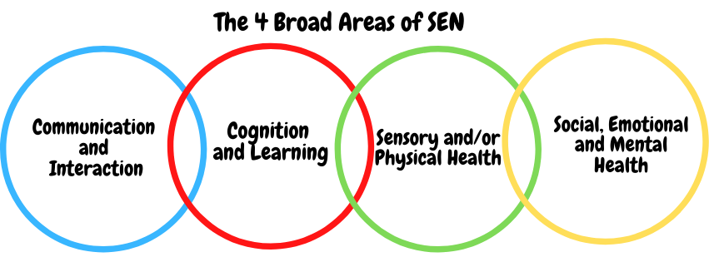SEN needs are classified under four broad areas of need. Below are the strategies, in class support and interventions that school may put in place to support your child.
Communication and Interaction (school to populate this section)
Strategies to support children with these needs include:
- Access to small group and/or individualised interventions.
- TA support.
- Access to interventions on social and emotional stories.
- Interventions such as Incredible 5 point scale.
- Access to low stimulus area/safe space.
- Flexible approaches to timetable.
- Modifications to lunch and break times.
- Enhanced access to additional aids, such as sensory tools, visual timetables, ear defenders and work stations.
- Access to technology-Laptops, software.
- Social and emotional stories, feelings cards.
- Careful planning of transitions.
- Access to Speech and Language Therapist.
- Access to Educational Psychologist.
- Access to Daisy Chain service.
- Access to Future Steps.
- Access to communication aids, such as books and strips.

Cognition and Learning (school to populate this section)
Strategies to support children with these needs include:
- Quality first teaching Training for staff.
- Needs of pupils identified to staff using Edukey
- SEN Support Plans for those identified as SEN with targets and strategies for support.
- Scaffolding, Modelling and Chunking.
- Range of metacognitive and cognitive strategies to support learning.
- Practical aids for learning, working memory boards, task cards, overlays etc.
- Increased adult support if needed.
- Adaptations to assessments to enable access e.g. computer readers, word processor, additional time.
- Support from outside agencies e.g. Educational Psychologist.
- Small group or individual intervention.
- Rest breaks
- Phonic/reading development programmes- e.g. RWI Fresh Start, Lexia and Accelerated Reading
- Increased access to ICT- e.g. laptops and Zoomtext.
- Curriculum will be adapted to meet the learning needs of the child.
- Pre and post teaching of vocabulary and new concepts.
- Frequent repetition and reinforcement – retrieval practice.

Social, Emotional and Mental Health (school to populate this section)
Strategies to support children with these needs include:
- Use of key worker to suit the needs of the individual.
- Monitoring of behaviour via ClassCharts.
- Whole school behaviour management system.
- Reward system to promote behaviour for learning.
- Working with outside agencies via Early Help to promote safe behaviours e.g. Opportunities etc.
- Key worker Mentoring with key adult from the Pope Francis Provision Team.
- Meet and Greets.
- Individual rewards system.
- Behaviour Support Plans.
- Increased access to additional adults in the classroom.
- Alternative curriculum opportunities including reduced timetables.
- Visual timetables.
- Incredible 5 point scale.
- Social and emotional stories.
- Transition programmes in place.
- Access to CAMHS and Educational Psychologist.
- Outreach to support SEMH needs.
- Emotional resilience nurse.
- Access to the Early Help Team (LA).
- Access to Stockton Family hubs and well-being interventions.
- Managed moves/Respite.

Sensory/Physical (school to populate this section)
Strategies to support children with these needs include:
- School meets statutory requirements of DDA.
- Radio aids, Roger Pen, Pebble devices.
- Access to Sensory Support services for advice on planning for pupils with a visual or hearing impairment.
- Flexible teaching arrangements will enable pupils to move seats to access lessons.
- Teachers will be made aware of the implications of physical and sensory impairments.
- Use of alternative coloured background on white boards.
- Liaison with outside agencies for specific equipment to aid access to the curriculum.
- Provision of specialist ICT equipment.
- Occupational Therapist/ Physiotherapist targeted programmes.
- Highly personalised access arrangements to facilitate the needs of all pupils with disabilities.
- Key staff who are named Hearing Impaired Champion / Visually impaired Champion.
- Access to Speech and Language.
- Access to a specialist teacher/LSA for the hearing/visual impaired.
- Concrete apparatus available to support learning.
- Therapy programmes delivered in school, designed by specialists e.g. Occupational Therapists, Physiotherapists etc.
- Adapted curriculum to enable full access e.g. alternative recording devices, modified PE curriculum.

What training is provided for staff supporting children with SEND?
Our Lady and St Bede is committed to ensuring that staff training is monitored and kept up-to-date in order that this support is of maximum benefit to pupils. The school’s SENDCO is a qualified teacher and holds the National Award for SEND co-ordination (NASENCo).
We fully comply with the requirements outlined in the Special Educational Needs Code of Practice (2014). We also make reasonable adjustments to our practices to comply with the Equality Act (2010). Staff have been trained to cater for learners who may have difficulties with:
• Cognition and Learning
• Communication and Interaction
• Sensory and/or Physical Needs
• Social, Emotional and Mental Health
Where new needs are identified for which the school is unprepared to offer provision, staff are selected and training is arranged. Where necessary, the school draws on the services of outside agencies and specialists.
We have a number of teaching and support staff that are experienced / have received training in the following areas:
Read Write Inc Fresh Start, First Aid, Sensory Processing Disorder, NEAS-Sensory versus Behaviour, Theraplay and Understanding and Supporting Autism in the classroom, ACES and understanding trauma.

How do we support transition in our school?

Transition within classes/key stages: ​

Information is passed to the new class teachers through department meetings and Edukey. Individual targets/strategies for all SEND pupils will be discussed with new teachers.
Children who require additional support to ensure a smooth transition to their new classes, will also receive the required support from the pastoral and/or SEND team. Opportunities for enhanced transition for SEND pupils is available.

Transition to a new school
If a pupil moves to a new school within or at the end of an academic year, we will contact the school SENDCo to ensure he/she knows about any special arrangements or support that needs to be made for the pupil. If necessary or possible, a meeting will be arranged with other professionals. The school will also transfer all records held for the pupil to the new school as soon as possible.

Enhanced transition
Pupils will be identified by primary schools of any pupils they feel require additional support with transition. The enhanced transition package consists of an after hours small group tour with a range of key staff, several opportunities for visits during school time with support from their primary school staff, 1:1 visits for EHCP pupils and their family’s with the SEND department.

Transition to Post-16 Education
The transition process will begin in Year 10, particularly for some of our more vulnerable pupils. We work closely with all of the major post-16 education establishments in the area. Meetings are held for the transfer of essential information relating to EHCPs, Child and Family Services and pastoral matters. The pastoral/welfare team will also support pupils who require additional support during their transition period.
We can also support you in organising meetings with college staff if you wish to speak to them personally, this also includes referrals to opportunities who provide expert support for pupils who require focussed transitional support into post-16 education.

Where can I get further information about services for my child?

The Local Offer

The Stockton-on-Tees Local Offer

At Our Lady and St Bede’s we involve other bodies including; health and social care, Local Authority support services, charitable and voluntary sector organisations in meeting the children’s SEND and supporting their families. These may act in an advisory capacity, extend expertise to staff, provide additional assessment, support a child directly or consult with all parties involved with the child. ​
- Educational Psychologist ​
- Physiotherapists ​
- Occupational therapists ​
- Speech and Language therapists ​
- Visually/Hearing Impaired Service ​
- CAMHs – Child and Adolescent Mental Health Service ​
- 0-19 Service​
- School Support advisors (Early Help)​
- Emotional resilience nurse​
- Specialist SEN teachers​

All the information of what services and support is available in Stockton-on-Tees can be found on the Local Offer. Please click the link below for more details.

Link to: Stockton Local Authority Offer https://www.stockton.gov.uk/children-and-young-people/children-with-special-educational-needs-sen/

What are the Key Policies and Accessibility for pupils with SEND?

School documentation relevant to SEND:​
SEND policy​
Admissions policy​
Supporting Pupils with Medical Needs Policy​
Accessibility Plan​

Accessibility
With due regard to our Admission Policy, parental choice and accessibility of the school building, all pupils with special educational needs and/or disabilities who apply will be accepted by the school. The ground floor is fully wheelchair accessible.
- Disabled toilet facilities are located on the ground floor in each building: St Mary’s Building, Saint John Paul II Building and St Bede Building, as well as within our Sports Hall changing facilities.
Activities Outside of School
- Our Lady and St Bede Catholic Academy is an inclusive school and we will put in place appropriate support, whenever possible, to enable pupils to be educated alongside their peers. This may include extra staffing and/or equipment.
- Staff who are arranging an offsite trip will discuss with parents and the SENDCo any requirements needed and the suitability of any trip which the school is taking part in.
- We will not stop pupils from going on a trip due to their special educational need and/or disability if the trip is suitable for the pupil, and their safety and the safety of others is not compromised. Please refer to our school Equality Act policy.
- There is a designated Assistant Headteacher who oversees all trips to ensure pupils are safe and included where possible, along with the Headteacher.

What to do if you have a complaint, a compliment or a query

Our Lady and St Bede welcomes compliments and feedback on our provision for SEN pupils as we seek to improve on the quality of education provided for children with SEN and we like to hear from parents/carers about their child’s experiences. ​
Compliments, complaints and feedback can be sent the school email address enquiries@olsb.bhcet.org.uk and the email will be passed to the relevant staff member.​
Alternatively, parents/carers can speak to the form tutor, class teacher and Head of Year or ask to make an appointment with the SENDCo.​
If matters are unresolved, parents/carers can seek further advice from SENDIASS on 01642 527158 or sendiass@stockton.gov.uk ​
If the concern is directly related to decisions around and EHC Assessment or EHCP, this will be managed directly by the Stockton SEN team. Parents/carers will be contacted directly by the team to receive information about mediation and other services.

The school details and relevant contacts
Headteacher Mrs M Wilkinson
SENDCo Mrs A Glover
Transition Lead Mrs A Stephenson
SEND Governor Jennifer Robbins
Our Lady and St Bede Catholic Academy, Stockton-on-Tees, TS19 0QH
Tel: 01642 704970
Website: www.olsb.bhcet.org.uk
Academy Email: enquiries@olsb.bhcet.org.uk
Bishop Hogarth Trust:
www.bhcet.org.uk
For further information
- SEND Code of Practice: https://www.gov.uk/government/consultations/revision-of-the-send-code-ofpractice-0-to-25-years
- Local Authority’s Local Offer: Special Educational Needs and Disabilities 0-25 | Stockton Information Directory

​

