OUR LADY & ST THOMAS CATHOLIC PRIMARY SCHOOL

**MATHEMATICS POLICY Updated September 2024**

“We are unique, talented and loved by God”

**This policy should be read in conjunction with the equality, diversity, disability, racial, gender, safeguarding, marking, SEND, assessment and calculation policies.**

**Mission Statement**

Our Lady and St. Thomas Catholic Primary School recognises the uniqueness of each individual child and member of staff in its care and aims to provide a balanced, relevant school experience within the context of a Christian Catholic environment, dedicated to promoting gospel values. By communicating these values, we endeavour to enable our children to achieve their full potential and become literate, numerate and caring adults with life enhancing skills and attitudes.

As a school that respects children’s rights we uphold the articles from the United Nations Convention on the Rights of the Child. These articles underpin our Mathematics policy:

Article 3 (best interests of the child) The best interests of the child must be a top priority in all things that affect children.

Article 28 (right to education) Every child has the right to an education. Primary education must be free and different forms of secondary education must be available to every child. Discipline in schools must respect children’s dignity and their rights. Richer countries must help poorer countries achieve this.

Article 29 (goals of education) Education must develop every child’s personality, talents and abilities to the full. It must encourage the child’s respect for human rights, as well as respect for their parents, their own and other cultures, and the environment.

## Aims and objectives

Mathematics teaches children how to make sense of the world around them through developing their ability to calculate, reason and solve problems. It enables children to understand relationships and patterns in both number and space in their everyday lives.

Our objectives in the teaching of mathematics are:

* to use a mastery approach to deliver maths in line with the National Curriculum.
* to develop good mental strategies.
* to promote enjoyment of maths through practical activities, exploration, discussion and cross curricular opportunities.
* to promote confidence and competence with numbers and the number system.
* to develop the ability to solve problems and reason in a range of contexts and using a wide range of mathematical vocabulary.
* to develop a practical understanding of the ways in which information is gathered and presented.
* to help children understand the importance of mathematics in everyday life.
* to develop the children’s curiosity about maths so that they are able to challenge themselves and take risks in their learning.
* to support each child to make progress at their own pace, ensuring that they are secure in their understanding and are able to move on confidently.

## Teaching and learning

At Our Lady and St Thomas RC Primary School children have 5 maths lessons per week as well as additional arithmetic sessions and Flashback 4 sessions. We use White Rose Maths for our Medium Term/small steps planning and we also use their calculations policies as they are in line with mastery strategies. Other resources we use include NCETM and Nrich maths.

At Our Lady and St Thomas RC Primary School we have been embedding our **mastery** approach to the teaching and learning of mathematics which involves teaching small steps ensuring deep understanding of each concept taught. Each step is taught via a Concrete – Pictorial - Abstract approach. We are currently involved in the NCETM/Maths Hub Programme. As members of this programme we are part of a teacher research group and therefore have support from a lead teacher and colleagues from other schools.

In EYFS ad KS1 we also teach the Mastering Number Programme.

The rationale behind changing our approach to teaching mathematics lay within the NCETM Maths Hub Programme as well as the 2014 National Curriculum, which states:

* The expectation is that most pupils will move through the programmes of study at broadly the same pace.
* Pupils who grasp concepts rapidly should be challenged through being offered rich and sophisticated problems before any acceleration through new content.
* Those who are not sufficiently fluent with earlier material should consolidate their understanding, including through additional practice, before moving on.

**What is Teaching for Mastery?** (Taken from the NCETM/Maths Hub Specialist Programme)

Teaching is underpinned by the 5 big ideas:

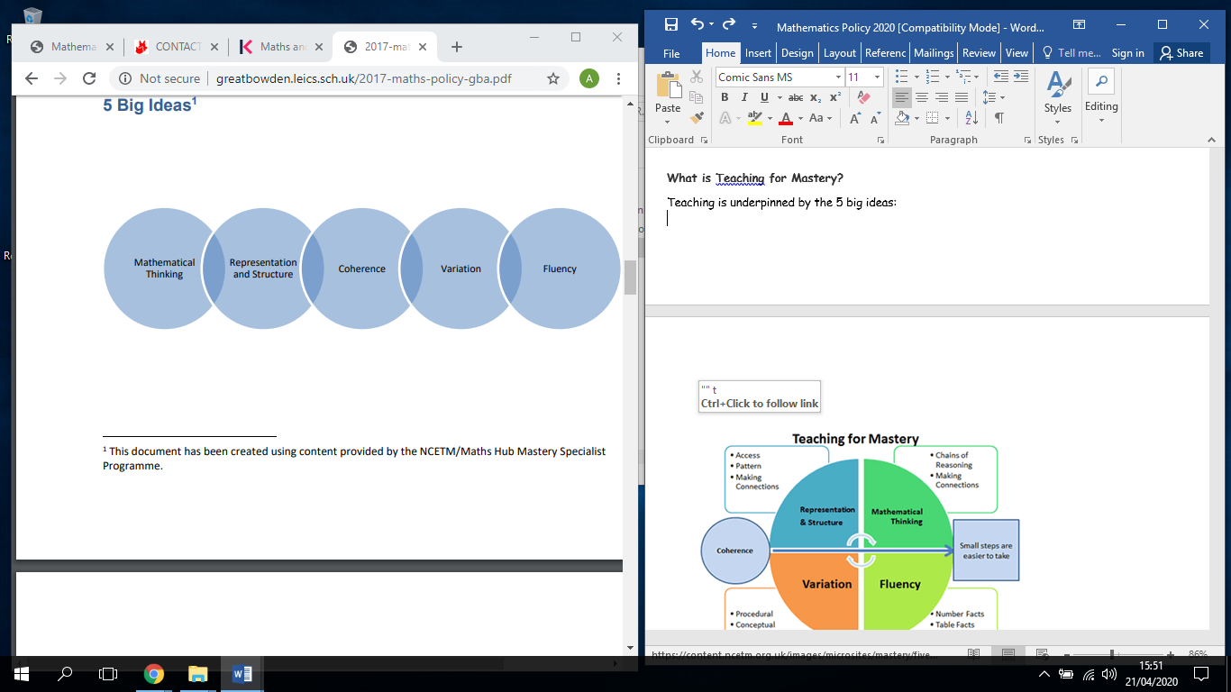

**[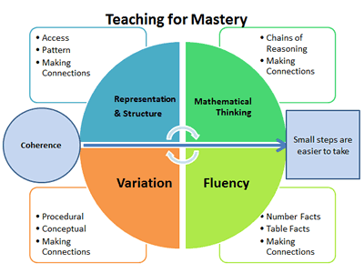](https://content.ncetm.org.uk/images/microsites/mastery/five_big_ideas_diagram_large.gif)**

**Fluency** is the quick and efficient recall of facts and procedures and the flexibility to move between different contexts and representations of mathematics.

**Mathematical Thinking** provides opportunities for children to make chains of reasoning connected with the other areas of their mathematics. They make connections and look for patterns and relationships.

**Representation and Structure** ensures concepts are explored using concrete, pictorial and abstract representations, the children actively look for patterns and generalise whilst problem solving.

**Coherence** is achieved through the planning of small, connected steps to link every question and lesson within a topic.

**Procedural Variation** is where examples used within the lesson are changed, drawing attention to different features.

**Conceptual Variation** is when a concept is presented in different ways within a lesson. Fluency with a relentless focus on number and times table facts.

**Teaching Principles** (Taken from the NCETM/Maths Hub Specialist Programme)

1. Teachers believe in the importance of mathematics and that the vast majority of children can succeed in learning mathematics in line with national expectations.

2. The whole class is taught mathematics together, with no differentiation by acceleration to new content. We do not group children by ability. The learning needs of individuals are addressed through careful scaffolding, questioning and appropriate rapid intervention where necessary, to provide the appropriate support and challenge.

3. The reasoning behind mathematical processes is emphasized. Teacher/pupil interaction explores how answers were obtained as well as why the method worked and what might be the most efficient strategy.

4. Precise mathematical language, often couched in full sentences, is used by teachers so that mathematical ideas are conveyed with clarity and precision. We value ‘mathematical talk’ and children get lots of opportunity to talk about and evaluate their mathematics during lessons.

5. Conceptual variation and procedural variation are used extensively throughout teaching. This helps to present the mathematics in ways that promote deep, sustainable learning.

a. Conceptual variation is where the concept is varied and there is intelligent practice. Positive variation is showing what the concept is, and negative variation is showing what the concept isn’t. This clears away misconceptions at the very start. Within positive variation, both standard and non-standard representations are shown.

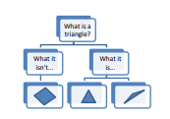

b. Procedural variation is where different procedures and/or representations are used to bring about understanding. For example, teachers may collect several solutions for a problem (some right, some wrong) before guiding the class towards the most efficient method. It also involves highlighting the essential features of a concept or idea through varying the non-essential features. Variation is not the same as variety – careful attention needs to be paid to what aspects are being varied (and what is not being varied) and for what purpose.

6. Sufficient time is spent on key concepts to ensure learning is well developed and deeply embedded before moving on.

**Features of Lesson Design**

1. Lessons are short but intense; teacher input usually lasts around 30 minutes giving ample time for independent practice whilst the teacher delivers rapid intervention should somebody require it. Independent practice includes reasoning, problem solving and higher-order thinking activities.

2. Lessons are sharply focused with one new objective introduced at a time.

3. Difficult points and potential misconceptions ae identified in advance and strategies to address them planned. Key questions are planned, to challenge thinking and develop learning for all pupils.

4. The use of high quality materials and tasks (NRICH, NCETM Mastery Assessment materials) to support learning and provide access to the mathematics is integrated into lessons.

5. There is regular interchange between concrete/contextual ideas and their abstract/symbolic representation.

6. Making comparisons is an important form of developing deep knowledge. The questions “What’s the same, what’s different?” are often used to draw attention to essential features of concepts. What is a triangle? What it isn't... What it is... 6

7. Teacher-led discussion is interspersed with short tasks involving pupil to pupil discussion and completion of short activities. Formative assessment is carried out throughout the lesson; the teacher regularly checks pupils’ knowledge and understanding and adjusts the lesson accordingly. This forms part of the mastery learning instructional process.

## Mathematics Curriculum Planning

Mathematics is a core subject in the National Curriculum, and we use a range of resources including White Rose, NCETM and Nrich as the basis for implementing the statutory requirements of the programme of study for mathematics.

We carry out the curriculum planning in mathematics in three phases (long-term, medium-term and short-term). The National Curriculum Programmes of Study gives a detailed outline of what we teach in the long term, while our Medium Term Planning identifies the key objectives we teach to in each year.

Our medium term mathematics plans are taken from White Rose and give details of the main teaching objectives for each term. These plans are kept electronically and reviewed by the subject leader.

It is the class teacher who completes the weekly plans for the teaching of mathematics. These weekly plans identify the specific learning intentions for each lesson. The class teacher keeps these individual plans, and the class teacher and subject leader often discuss them on an informal basis.

## EYFS

We teach mathematics in our Reception/Nursery class and follow White Rose Medium Term planning as well as using Mastering Number, Number Blocks and Nrich problem solving activities. These resources used for planning ensure that the children cover all aspects of maths necessary to meet the Early Learning Goals. We give all the children ample opportunity, through lessons and continuous provision, to develop their number sense, their understanding of number, measurement, pattern, shape and space, through varied activities that allow them to enjoy, explore, practise and talk confidently about mathematics.

## Maths links to other curriculum areas

English

The teaching of mathematics contributes significantly to children's understanding of English in our school by actively promoting the skills of reading, writing, speaking and listening. For example, in mathematics lessons, we expect children to read and interpret problems, in order to identify the mathematics involved. They are also improving their command of English when they explain and present their work to others when reasoning and problem solving. In English lessons, too, maths can contribute: younger children enjoy stories and rhyme that rely on counting and sequencing, while older children encounter mathematical vocabulary, graphs and charts when reading non-fiction texts.

Personal, social and health education (PSHE) and citizenship

Mathematics contributes to the teaching of PSHE and citizenship. The work that children do outside their normal lessons encourages independent study and helps them to become increasingly responsible for their own learning. The planned activities that children do within the classroom encourage them to work together and respect each other's views. We present older children with real-life situations in their mathematics work related to the spending of money.

**Spiritual, moral, social and cultural development**

The teaching of mathematics supports the social development of our children through the way we expect them to work in pairs or as part of a group within lessons. Children are given opportunities to work together and discuss their ideas and results therefore encouraging confidence.

## Mathematics and ICT

Information and communication technology enhances the teaching of mathematics significantly, because ICT is particularly useful for mathematical tasks. It also offers ways of impacting on learning which are not possible with conventional methods. Teachers can use software to present information visually, dynamically and interactively, so that children understand concepts more quickly. Younger children use ICT to communicate results with appropriate mathematical symbols. Older children use it to produce graphs and tables when explaining their results, or when creating repeating patterns, such as tessellations. When working on control, children can use both standard and non-standard measures for distance and angle. They can also use simulations to identify patterns and relationships.

## Mathematics and Inclusion

At our school, we teach mathematics to all children, whatever their ability and individual needs. Mathematics forms part of the school curriculum policy to provide a broad and balanced education to all children. Through our mathematics teaching, we provide learning opportunities that enable all pupils to make good progress. We strive hard to meet the needs of those pupils with special educational needs, those with disabilities, those with special gifts and talents and those learning English as an additional language, and we take all reasonable steps to achieve this. For further details, see separate policies: Special Educational Needs; Disability Discrimination; Gifted and Talented Children; English as an Additional Language (EAL).

When progress falls significantly outside the expected range, the child may have special educational needs. Our assessment process looks at a range of factors – classroom organisation, teaching materials, teaching style, differentiation – so that we can take some additional or different action to enable the child to learn more effectively. Assessment against the National Curriculum allows us to consider each child's attainment and progress against expected levels. This ensures that our teaching is matched to the child's needs.

Intervention will lead to the creation of an Individual Support Plan for children with special educational needs. The Support Plan may include, as appropriate, specific targets relating to mathematics.

We enable all pupils to have access to the full range of activities involved in learning mathematics. Where children are to participate in activities outside the classroom (a 'maths trail', for example), we carry out a risk assessment prior to the activity, to ensure that the activity is safe and appropriate for all pupils.

## Assessment for learning

Teachers will assess children's work in mathematics from three aspects (long-term, medium-term and short-term). We use short-term assessments to support our daily planning. These short-term assessments are closely matched to the learning intent.

We assess termly to measure progress against National Curriculum expectations. We assess against our progression document.

We assess at the end of the academic year and use this data to assess progress against school and national targets. We can then set targets for the next term and make a summary of each child's progress before discussing it with parents. We pass this information on to the next teacher at the end of the year, so that they can plan for the new school year.

## Monitoring and review

The coordination and planning of the mathematics curriculum are the responsibility of the subject leader, who also:

* Supports colleagues in their teaching, by keeping informed about current developments in mathematics, and by providing a strategic lead and direction for this subject;
* Evaluates medium Term and weekly planning, identifying strengths and areas to be improved.
* Observes lessons across the school and identifies strengths and areas to be improved.
* Scrutinises maths books and conducting interviews with children about their books/lessons and understanding.

The mathematics governor will meet regularly with the subject leader to review progress.

This policy will be reviewed every year.

**Role of the Subject Leader**

* Keep staff informed and updated about current initiatives.
* Provide training and target updates relating to the NCETM Maths Hub Teaching for Mastery Programme
* Attend training and county Network meetings.
* Monitor teaching and learning of maths (planning, support, lesson observations, work scrutiny, monitoring data)
* With headteacher, analyse data from SATS and termly tests.
* Audit resources.
* Work with governors to keep them informed about maths developments in school.
* Support teaching assistants in school.
* Organise and monitor maths interventions.
* Organise and monitor extra-curricular maths activities. (Y2/Y6 booster classes, times table club, eggs on legs club)
* Ensure homework is given where appropriate to all children in school.
* Monitor use of resources ie White Rose, Nrich, Mastery documents, Classroom Secrets.

**Parental Involvement**

At Our Lady & St Thomas RC Primary we encourage all parents to be involved in maths by:

* Inviting them into school twice per year to discuss progress.
* Providing interim reports each term and an end of year report stating the child’s achievements.
* Sending homework activities to be completed with their child.