SEND Information Report
Approved on:
July 2023
Next review:
June-July 2024
Our Lady and St Thomas Catholic Primary

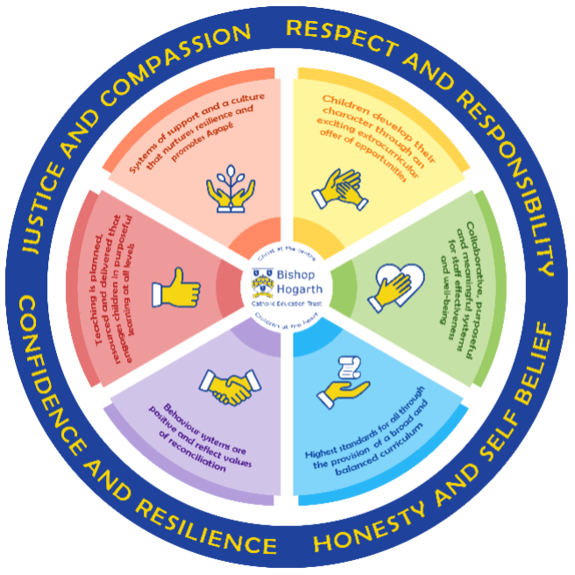
As part of the family of Bishop Hogarth Catholic Education Trust, our school has at its core, the virtues, and values of:
Respect for others and themselves, recognising that we are all created in the image of God and therefore must be compassionate towards others, especially the vulnerable. ​
Confidence in their own abilities, knowing that their talents are gifts from God and resilience to persevere when things become difficult. ​
Honesty in regard to the world around them and themselves and the ability to take responsibility for the times we may fall short of the mark. ​
Gratitude for all the amazing gifts from God and willingness to share their gifts both personal and material. ​

As an inclusive school, all teachers are teachers of pupils with Special Educational Needs & Disabilities. We deliver a curriculum and create an environment that meets the needs of every pupil within our school. We ensure that every pupil with Special Educational Needs and / or disabilities makes the best progress possible. We foster and promote effective working partnerships with parents / carers, pupils, and outside agencies. We consider the ‘whole’ child and strive to ensure that all our SEND pupils are prepared for adulthood. ​

Our school’s approach to supporting pupils with SEND
- Our Lady and St Thomas Catholic Primary aims to offer children an educational experience where staff will strive to identify and remove barriers to learning and create an environment in which every child is encouraged to reach their potential and ensure no child is left behind.

- Our Lady and St Thomas Catholic Primary School strives to be an inclusive school. Inclusion is central in the Catholic ethos and values of the school – a philosophy, which covers every child's rights and entitlement to the very best experiences education can offer.

- The school is committed to constantly reviewing and evaluating its practices, systems and curriculum provision.

- Teachers are responsible for the progress of ALL pupils in their class. High quality teaching is personalised to meet every child’s need. This is the first step in supporting pupils who may have SEND (Special Educational Needs and Disabilities). All children are challenged to do their very best. This is enough for most pupils to make progress.

- All children will be taught a broad and balanced curriculum; differentiated to the needs of each individual. Where children require extra support, specialist resources or extension materials, these will be provided wherever possible.

- All children are known well by their class teacher, who develops strong relationships with them. Good behaviour and work is rewarded.

- Children can express their views in several ways, including via class feelings board, worry boxes, class council meetings, school council representatives or directly to staff. We encourage all pupils to have a voice in school.

- We manage medical needs by working closely with parents and healthcare professionals. We listen to and act on their advice, providing staff training when needed.

- There is also an SEND governor who has particular involvement with SEND policy and provision. Our Offer OLST has a wealth of expertise from its staff. Where needed, we liaise with Specialist Services and outside agencies to ensure the best education for every child in our care.

If you are concerned about your child’s progress or that your child may have SEND and/or a disability, please contact school on 01388 746336

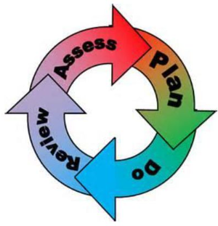
How will the school staff support my child?
The graduated response-Identifying, planning for and supporting pupils with SEND
Where a pupil is identified as having a special educational need, School will follow a graduated approach which takes the form of cycles of ‘Assess, Plan, Do, Review’. ​
• Assess a child’s special educational need. ​
• Plan the provision to meet your child’s aspirations and agreed outcomes. ​
• Do put the provision in place to meet those outcomes. ​
• Review the support and progress.

How does the school know if children need extra help and what do I do if I think my child has special educational needs?

- Assess
- Identification – Your child will be identified as having SEND and/or a disability if they have significantly greater difficulty in learning than the majority of children of the same age or if they have a disability preventing or hindering the use of educational facilities provided for children of the same age within the Local Education Authority.
- First steps - if from our rigorous tracking and monitoring of your child’s progress, it becomes apparent that he/she is not making expected progress then you will be invited to a meeting with their teacher and the SENDCo. Where appropriate your child will be involved in this meeting. At the meeting we will begin to explore the possible barriers to learning and you will be asked how we can best support your child.
- Observations and assessments will then be carried out and, if required, input from specialist services may be sought with your permission.
- Where appropriate your child may be placed on a Short Note or the SEND Support Register and a Support Plan will be devised by the class teacher that will set achievable targets. These will be reviewed and updated at least half-termly.
- EHCPs (Education, Health and Care Plans) will be used when a child’s needs are deemed more complex and require the input from a range of outside agencies. An EHCP helps to determine the level of educational, social and health support the child needs.

- Plan
- Our procedures are in line with the SEND Code of Practice (2014).
- The first point of contact is the class teacher, who has overall responsibility for the welfare of your child. Additional provision is planned carefully and overseen by the SENDCo (Special Educational Needs and Disabilities Co-ordinator).
- It is implemented by a skilled team of teachers and supported by experienced teaching assistants. SEND Resources
- At OLST we have an extensive range of different SEND resources and interventions available. These are closely matched to the needs of our children and their progress is monitored by the class teacher, the SENDCo and staff with specific curriculum responsibilities.
- Where provision does not result in adequate progress, as outlined in the SEND Code of Practice, the SENDCo should be consulted for advice.
- Do

- Our teachers are skilled at adapting teaching and learning to meet the diverse needs in each class. ​
- Daily planning considers individual children’s needs and requirements and is annotated and adapted according to need. Explicit reference is made in the teacher’s planning to the needs of those children identified with SEND. ​
- Adaptive teaching is approached in a range of ways to support access to the curriculum and ensure that all children can experience success and challenge in their learning. ​
- Grouping arrangements consider the different skills and abilities of each child. This ensures that learning is maximised. ​
- Additional adults support groups and individual children with the long-term goal of developing independent learning skills. The class teacher monitors this support to avoid students becoming over reliant on this. ​
- We fully encourage parental support and offer opportunities for individual meetings with parents/carers to provide clarity and recommendations on how they can support their child at home.

- Review
- For every child who is in the care of the Local Authority, (a looked after child - LAC), a Personal Education Plan (PEP) will be devised.

- This Plan will establish clear targets and actions to respond effectively to each child’s needs and provide a continuous record of their achievements.
- If your child has an EHCP plan, you will be invited to an annual review of this plan.

- Homework is given regularly and your child may have the opportunity to access computer programmes to support their learning at home through the school website. You are encouraged to support your child’s learning at home.

How will the curriculum at our school be matched to my child’s needs?
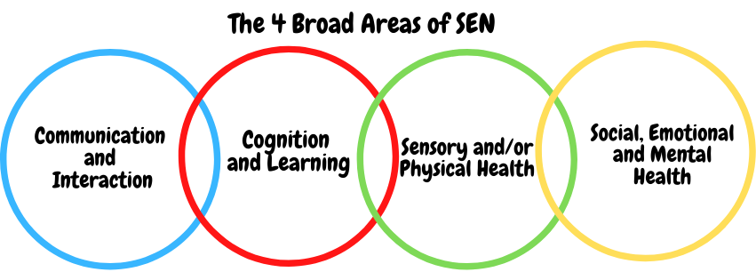SEN needs are classified under four broad areas of need. Below are the strategies, in class support and interventions that school may put in place to support your child.
Communication and Interaction
Strategies to support children with these needs include:
- Access to small group and/or individualised interventions to develop skills in communication and interaction with others, e.g. Time to Talk,
- Visual timetables used when appropriate
- Flexible approaches to timetabling
- Modifications to lunch and/or break times, e.g. duties, time change
- Access to additional aids/technology
- Explicit teaching of generalising skills from one context to another
- Careful planning of transitions, e.g. advance notice, familiar resources
- Mentoring and/or buddy systems
Cognition and Learning
Strategies to support children with these needs include:
- Regular, individually focused interventions, e.g. reading, additional phonics (RWI) and Maths support
- Increased access to small group support in class
- Practical aids for learning, e.g. table squares, time/number lines, pictures, photos, accessible reading material suited to age, individualised success criteria
- Increased access to ICT programmes and Apps
- Flexible groupings
- Access to technical aids e.g. spell checker, ICT software and/or hardware
- Adaptations to assessments to enable access e.g. readers, scribe, ICT
- Curriculum/delivery adaptations to meet the learning needs of individuals
- Frequent repetition and reinforcement

Sensory/Physical
Strategies to support children with these needs include:
- Occupational Therapy interventions developed by Treetops and delivered by Mrs Hauxwell with regular refresher training from Occupational Therapists for individual children
- Concrete apparatus available to support learning
- Adapted curriculum to enable full access
- Sensory resources available e.g. wobble board, headphones/ear guards
- Access to support for personal care, e.g. school nurse service

Social, Emotional and Mental Health
Strategies to support children with these needs include:
- Access to time out/individual work area – Chill out area, busy boxes, sensory boxes, calming activities, mindfulness colouring
- Zones of regulation support
- Mentoring/Buddy system
- Individualised rewards system
- Access to counselling services, e.g. CAMHS, MHST, EWEL, Piece of Mind
- Increased access to additional adults in and out of the classroom
- Supported transition programme with chosen secondary school
- Play therapy/ Lego therapy style support
- Opportunities to develop Social and Emotional aspects of learning through small group work
- Trained specialist in Loss and Bereavement

What training is provided for staff supporting children with SEND?
- All teachers have Qualified Teacher Status and our teaching assistants have a minimum of a level 2 qualification.
- OLST values staff training and organises courses/training programmes to ensure teachers and teaching assistants stay up to date with current research into teaching and learning.

Staff training in respect of SEND and disabilities includes:
- Child Protection training/ Prevent and any other safeguarding updates.
- Precision Teaching / Literacy difficulties training
- MABLE Speech and Language Training
- SEND updates/ Positive Handling
- Refresher Occupational Therapy training and individual physio programmes
- Attachment Disorder and ASD Training
- Managing Autism in the classroom
- Zones of Regulation
- Durham Resilience Project training
- Lego/drawing therapy
- Loss and Bereavement

How do we support transition in our school?

Transition within classes/key stages: ​
- Enhanced transition for at least 1 half term prior to a move into a new classroom/year group. This involves a supported weekly transition visit to join a lesson each week and get to know the new classroom, routines and teacher.
- Transition books created with our expert teaching assistants where your child will be fully involved in the creation. This can then be used over the Summer and shared so your child gets used to the changes to come and it is not overwhelming for them in any way.

Transition to Secondary settings: ​
- We work closely with all secondary schools in the area. There is an enhanced transition process in Y6 for those children who require this.
- Transition meetings are held between the Y6 teacher/SENDCo and transition staff from secondary to share essential information relating to Support plans, EHCPs, Child and Family Services and pastoral matters.
- We can also support you in organising meetings with secondary school staff if you wish to speak to them personally.
- When reviewing an EHCP for children in Y6, staff from the secondary school will always be invited to the review meetings.
- During the last term, staff from secondary schools come to meet our Y6 children and in addition to this, our Y6 children attend their chosen secondary school for transition days and events.

Where can I get further information about services for my child?
T The Local Offer
- https://www.durham.gov.uk/localoffer
A dedicated service called SENDIASS for parent and carer additional support.
- https://durhamsendiass.info/durhams-local-offer/

What key school documents refer to support and provision for pupils with SEND?

- SEND Policy​
- Admissions Policy​
- Supporting Pupils with Medical Needs Policy​
- Accessibility Plan​

Accessibility​
- With due regard to our admission policy, parental choice and accessibility of the school building all children with special educational needs who apply will be accepted by the school.
- Wherever possible our school is wheelchair accessible.
- OLST has shower facilities.
- Disabled toilet facilities are located near the school entrance.
- Communication with parents whose first language is not English is supported by advice from the Local Authorities EAL (English as an additional language) team and interpreters sought when needed.

Activities Outside of School​
- OLST is an inclusive school which enables your child to be educated alongside their peers.
- This may include extra staffing and/or equipment.
- Staff who are arranging an offsite visit will discuss with parents and the SENDCo any requirements needed and the suitability of any trip which the school is taking part in.

What to do if you have a complaint, a compliment, or a query.

The school details and relevant contacts
Please email office@olst.bhcet.or.uk or telephone school on 01388 746336
​
Name of school SEND governor.
Mrs Joanne Norman – an appointment can be made to speak with her by contacting the school office.

