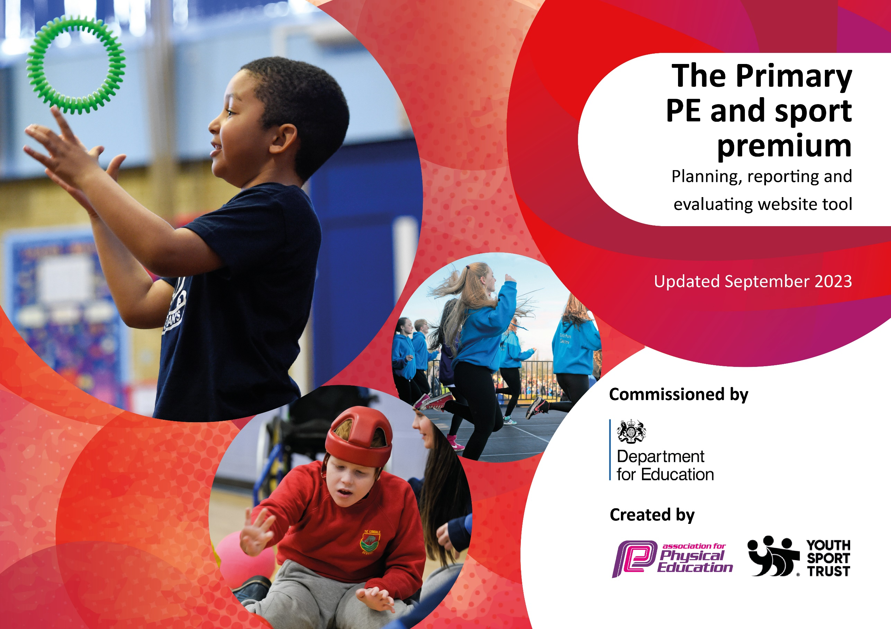

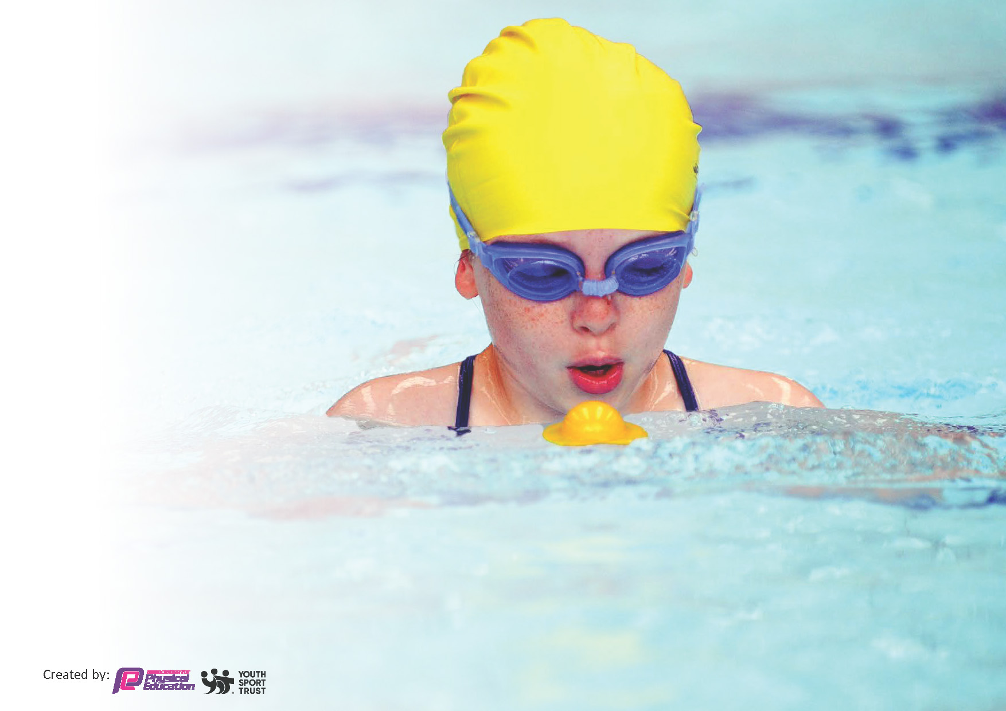
This template can be used for multiple purposes:
by:
- It enables schools to effectively plan their use of the Primary PE and sport premium
- It helps schools to meet the requirements (as set out in guidance) to publish information on their Primary PE and sport premium
- It will be an effective document to support Ofsted inspections enabling schools to evidence progress in Physical Education (PE) and evidence swimming attainment, which forms part of the PE National Curriculum. We would recommend schools consider
the Intent, Implementation and Impact of any spend, as examined within the Education Inspection Framework.

It is important that your grant is used effectively and based on school need.

Schools must use the funding to make additional and sustainable
improvements to the quality of the PE, School Sport and Physical Activity (PESSPA)
they offer. This means that you should use the Primary PE and sport premium to:

- Build capacity and capability within the school to ensure that improvements made now will benefit pupils joining the school in future years
- Develop or add to the PESSPA activities that your school already offers.

The Primary PE and sport premium should not be used to fund capital spend projects; the school’s core budget should fund these. Further detail on capital expenditure can be found in the updated Primary PE and sport premium guidance.

The Primary PE and sport premium guidance, outlines 5 key priorities that funding should be used towards. It is not

necessary that spending has to meet all the key priorities, you should select the priorities that you aim to use any funding towards.

Although completing this template is not a requirement for schools, schools are required to publish details of how they spend this funding. Schools must also outline what the impact this funding has had on pupils’ PE and sport participation and attainment and how any spending will be sustainable in the future. All funding must be spent by 31st July 2024.

The Department for Education has worked closely with the Association for Physical Education (afPE) and the Youth Sport Trust (YST) to develop this template and encourages schools to use it. This template is an effective way of meeting the reporting requirements of the Primary PE and sport premium.
Review of last year’s spend and key achievements (2023/2024) £17,300

We recommend you start by reflecting on the impact of current provision and reviewing your previous spend.

Activity/Action | Impact | Comments
- Key indicator 1: The engagement of all pupils in regular physical activity.  - Pupils know the benefits of physical activity and sport on their health and wellbeing.  - All pupils to complete the daily mile each day. Class teacher to baseline this Autumn, Spring, Summer times for each child.  - Pupils enjoy and learn while engaging in outdoor activities through our Forest School provision. | - Improved fitness levels and levels of attainment as demonstrated in half termly assessments.  - Pupils to see the progression in their stamina and speed across the academic year.  - Greater understanding of the natural world and the physical and mental health benefits of working outdoors.
- Key indicator 2: The profile of PESSPA being raised across the school as a tool for whole school improvement.
- Target Year 6 pupils for those not reaching National Curriculum standard in swimming (Spring/Summer)
- Entering and participating in sporting events Lewis Marr/ Parkside Cluster Football Team
- Appoint Sports Leaders and representatives to act as Sporting Ambassadors. Chosen by teaching staff for demonstrating sportsmanship
- Additional swimming sessions for Y6 to increase our proportions of children meeting the expected stand | Increased pupil outcomes in swimming:  - 58% to 65% to be able to swim confidently 25m with a range of strokes.  - 41% to 58% of children able to perform safe self-rescue in different water-based situations. | - The cost of transport has risen astronomically. It costs nearly £4000 to take pupils swimming weekly which has to date been a cost to school. School to review swimming SLA and look at cheaper alternatives.

Key priorities and Planning
This planning template will allow schools to accurately plan their spending.

Key indicator 1: The engagement of all pupils in regular physical activity | Key indicator 2: The profile of PESSPA being raised across the school as a tool for whole school improvement | Key indicator 3: Increased confidence, knowledge and skills of all staff in teaching PE and sport | Key indicator 4: Broader experience of a range of sports and activities offered to all pupils | Key indicator 5: Increased participation in competitive sport
Action – what are you planning to do | Who does this action impact? | Key indicator to meet | Impacts and how sustainability will be achieved? | Cost linked to the action
Opportunities for pupils to explore the benefits of physical activity and healthy lifestyles through PE sessions. | Teaching staff and coaches - to facilitate activities  Pupils - to take part | Key indicator 1: The engagement of all pupils in regular physical activity  Key indicator 2: The profile of PESSPA being raised across the school as a tool for whole school improvement  Key indicator 5: Increased participation in competitive sport | Improved fitness levels and levels of attainment as demonstrated in half termly assessments | TBC  PE specialist coach.
All pupils to complete the daily mile each day.  Class teacher to record baseline times at the beginning of each term. | Class teacher – to monitor and track timings  Pupils - to take part  PE Coordinator – to track attainment of pupil’s scores | Key indicator 1: The engagement of all pupils in regular physical activity  Key indicator 2: The profile of PESSPA being raised across the school as a tool for whole school improvement | Pupils to see the progression in their stamina and speed across the academic year.  Improved activity within pupils  Staff awareness of pupil activity and PE attainment. | £1000  Maintenance of daily mile track.
Pupils to engage, learn and partake in outdoor activities. | Outdoor learning school specialist – to facilitate  Pupils – to take part. | Key indicator 2: The profile of PESSPA being raised across the school as a tool for whole school improvement  Key indicator 4: Broader experience of a range of sports and activities offered to all pupils | Greater understanding of the natural world and the physical and mental health benefits of working outdoors  Increased attainment in outdoor adventure skills.  Inspiring families | £2000  Forest school specialist.  Maintenance of school garden.
Monitoring attainment, provision and assessment of PESSPA throughout the school. | PE Coordinator – to track attainment of pupils across the school  Headteacher – to ensure targets are met with all children | Key indicator 2: The profile of PESSPA being raised across the school as a tool for whole school improvement  Key indicator 3: Increased confidence, knowledge and skills of all staff in teaching PE and sport | Maintain high standards, recognising the importance of PESSPA.  Staff awareness of pupil activity and PE attainment. | £500  Cover of PE coordinator during monitoring sessions.
Acquisition of PE Specialist to provide provision of fundamental skills to EYFS and KS1 pupils | PE specialist – to facilitate sessions and assess half-termly.  Class teacher – to work with PE specialist for CPD | Key indicator 1: The engagement of all pupils in regular physical activity  Key indicator 2: The profile of PESSPA being raised across the school as a tool for whole school improvement  Key indicator 3: Increased confidence, knowledge and skills of all staff in teaching PE and sport | Improved fitness levels and levels of attainment as demonstrated in half termly assessments  Improved teacher confidence to work alongside PE specialist. | £4000  PE specialist teacher.
Target Year 6 pupils not reaching National Curriculum expectations in swimming (Spring/Summer) | Year 6 students working below expectations – to be targeted with intervention/small-group sessions  Swimming coach/in school swimming specialist teachers – to facilitate | Key indicator 2: The profile of PESSPA being raised across the school as a tool for whole school improvement | Improved swimming outcomes and higher averages. | £1000  Up-to-date training of swimming specialists in school.  Payment of swimming facilitators.  Return transport to swimming sessions.
Entering and participating in a variety of competitive (cross country, netball, sportshall athletics, football, badminton, Tri-golf) and non-competitive (dance, Thai boxing) within our cluster, school teams and local competitions | Lewis Marr – cluster facilitator and organizer of local events  PE Coordinator – to oversee pupil engagement and activity within a variety of provided opportunities  Pupils – to take part | Key indicator 1: The engagement of all pupils in regular physical activity  Key indicator 2: The profile of PESSPA being raised across the school as a tool for whole school improvement  Key indicator 4: Broader experience of a range of sports and activities offered to all pupils  Key indicator 5: Increased participation in competitive sport | Improved outcomes as pupils complete in a cluster environment.  Pupil engagement and awareness of competitive and non-competitive sports.  Improved team work skills.  Pupils to progress to county finals of netball tournament and/or cross country final.  Increased interest of outer-school sport engagement. | £1000  Subscription to Wear Dale & Teesdale PESSPA cluster activities.  Return transport to event locations.
Appoint Sports Leaders and representatives to act as sporting ambassadors and facilitators to engage pupils during breaks and lunchtimes. | Sports Ambassadors – chosen by staff/other pupils who have a talent and/or passion for sport  PE Coordinator – to meet with sports ambassadors to discuss ideas on pupil voice and ideas to raise sport’s profile within the school.  PE Specialist coach – to facilitate training sessions specifically for sports ambassadors | Key indicator 1: The engagement of all pupils in regular physical activity  Key indicator 2: The profile of PESSPA being raised across the school as a tool for whole school improvement | Increased pupil voice, with relation to sport, throughout the school.  Raised confidence and developed leadership skills within the pupil body. | £300  Badges and trophies for sports ambassadors.  Specialisted training sessions with PE coach.
Wider curricular activities and themed days/weeks, including Sports Day. | PE coordinator/school staff – plan and delivery of Sports Day, Healthy Lifestyle week, Healthy Eating Day & Football Fun Day.  Outer-school facilitators (Thai boxing specialist, Cricket coach, Quidditch coach, Hoopstars coach) – to facilitate whole-class sessions.  Pupils – to take part. | Key indicator 1: The engagement of all pupils in regular physical activity  Key indicator 4: Broader experience of a range of sports and activities offered to all pupils  Key indicator 5: Increased participation in competitive sport | Opportunities to try new adventurous activities, develop teamwork and leadership skills. | £1200  Staffing organizing and facilitating for Sports Day.  Medals/trophies for children participating in events.  Specialised coaches and outer-school facilitators.
Implementation of new Primary PE Planning and Commando Joe’s curriculum | PE specialists, Coaches and Class teachers – to use assessment and curriculum tools within PE lessons  School staff – to attend and engage in Commando Joe’s training | Key indicator 1: The engagement of all pupils in regular physical activity  Key indicator 3: Increased confidence, knowledge and skills of all staff in teaching PE and sport  Key indicator 4: Broader experience of a range of sports and activities offered to all pupils  Key indicator 5: Increased participation in competitive sport | Greater confidence and quality of PE sessions delivered by non-specialist staff.  Rigid assessment tools to monitor and progress pupil attainment and progress from EYFS to Year 6.  Engagement of pupils in a high-quality curriculum with high-quality resources.  Development of teamwork skills within different sport/activities.  Application of problem solving and trust values within Commando Joe’s sessions | £2700  Cost of Primary PE Subscription.  £3000  Subscription to Commando Joe’s resources and curriculum.
PE coordinator to meet with local, cluster PE leads and school games organizer, once a half term | PE Coordinator – to meet with other PE leads/events organisers in the local area | Key indicator 3: Increased confidence, knowledge and skills of all staff in teaching PE and sport | Greater awareness of current and relevant sporting issues, news and events. | £100  Cover of PE coordinator during monitoring sessions.
Subsidise afterschool clubs (Thai boxing, multi-skills, football club, forest school) and year 5/6 residential | PE Coordinator/headteacher – to allocate financial aid to specified children and subsidise transport costs for all pupils.  PE Coach – to run afterschool clubs to run throughout the school year.  Forest school specialist – to facilitate afterschool sessions throughout the school year. | Key indicator 1: The engagement of all pupils in regular physical activity  Key indicator 4: Broader experience of a range of sports and activities offered to all pupils  Key indicator 5: Increased participation in competitive sport | Increased experiences in adventurous activities and a range of sporting opportunities.  Engagement of physical activity and interest outside of school. | £1200  Cost of PE coach, Thai-Boxing coach and forest school specialist for afterschool clubs.  Cost of transport for Y5/6 Residential.

Key achievements 2024-2025
This template will be completed at the end of the academic year and will showcase the key achievements schools have made with their Primary PE and sport premium spending.

Activity/Action | Impact | Comments

Swimming Data 2023-24
Meeting National Curriculum requirements for swimming and water safety.
Priority should always be given to ensuring that pupils can perform safe self-rescue even if they do not fully meet the first two requirements of the National Curriculum programme of study

Question | Stats: | Further context  Relative to local challenges
What percentage of your current Year 6 cohort can swim competently, confidently and proficiently over a distance of at least 25 metres? | 65% (11)  42% national (22) | We start the children experiencing the water when they move into KS2. 24-25 sees a change to our swimming SLA due to the high costs associated with transport.  Each cohort will have a half term swimming.  Autumn 1 – Y3/4  Autumn 2 – Y6  Spring 1 – Y5 (with Y6 who cannot swim 25m)  We will review for Spring 2 and use any additional monies from budget to concentrate on Y6.
What percentage of your current Year 6 cohort can use a range of strokes effectively [for example, front crawl, backstroke, and breaststroke]? | 65% | The above plan will allow for those who cannot do this in Y6 to receive an additional 7 weeks of swimming lessons.

What percentage of your current Year 6 cohort are able to perform safe self-rescue in different water-based situations? | 58% | This will be given higher priority given our village is close to the river as part of our safeguarding.
If your schools swimming data is below national expectation, you can choose to use the Primary PE and sport premium to provide additional top-up sessions for those pupils that did not meet National Curriculum  requirements after the completion of core lessons. Have you done this? | Yes
Have you provided CPD to improve the knowledge and confidence of staff to be able to teach swimming and water safety? | Yes | We have two members of staff trained to teach swimming so that lessons can be taught in smaller differentiated groups and more focus can be given on developing individual skills.

Signed off by:

Head Teacher: | Ruth Veitch
Subject Leader or the individual responsible for the Primary PE and sport premium: | Grace Egginton – PE Coordinator and Class Teacher
Governor: | Laura Minto
Date: | 10.09.24

