

Oxford Gardens Primary School
Phonics and Reading Policy

Aims
At Oxford Gardens we aim to:
- Ensure progression of reading skills across the school.
- Inspire pupils to read through exciting, shared experiences.
- Develop a clear understanding of the structure and language features associated with different text types.
- Teach pupils to decode letter-sound correspondences quickly and effortlessly, using their phonic knowledge and skills.
- Teach pupils to read ‘tricky’ words on sight.
- Teach pupils to understand what they read.
- Teach pupils to read aloud with fluency and expression.
- Teach pupils to spell phonetically and easily by segmenting the sounds in words.
- To teach pupils reading for pleasure

Teaching and Learning
- High quality texts are used to challenge, enthuse and engage children.
- There is a clear progression in the teaching of reading which includes the familiarisation of different text types, the identification of structure and language features, modelled reading, guided reading and independent reading.
- Progression of teaching reading includes giving children opportunities to work on fluency and expression within their reading.
- Reading opportunities are linked to IPC themes in order to provide pupils with a wide selection of books.
- Technology is used to enhance the children’s engagement and understanding of reading through a range of mixed media.

Provision
i) Foundation Stage in the Incredible Years Provision

As a school, we follow Read, Write Inc.
In Reception, the pupils rapidly learn sounds and the letter or groups of letters they need to represent them. Simple mnemonics help them to grasp this quickly. This is especially useful for pupils at risk of making slower progress. This learning is consolidated daily. Pupils have frequent practice in reading high frequency words with irregular spellings – ‘tricky red words’.
We make sure that pupils read books that are closely matched to their increasing knowledge of phonics and the ‘tricky red words’. This is so that, early on, they experience success and gain confidence in their reading abilities. Re-reading and discussing these books with the teacher supports their increasingly fluent decoding.
Alongside this, the teachers read a wide range of stories, poems and non-fiction to pupils. They are then soon able to read these texts for themselves.
Reception have a daily Phonics lesson which can include learning a sound, reading a book and completing a comprehension task. Each group has a set of Ruth Miskin resources.

ii) Key Stage 1
All Key Stage 1 classes have a 30-minute Phonics/Guided Reading lesson each day which can include learning a sound, reading a book and completing a comprehension activity. Teachers follow a structured Read Write Inc plan which outlines the daily speed sound and comprehension activities. Each group has a set of Ruth Miskin resources and the children are grouped by Phonic ability. When children are ready to progress, they move onto Guided Reading lessons, which follow a similar format to the KS2 lessons outlined below.

iii) Key Stage 2
All Key Stage 2 classes have a 30-minute Guided Reading lesson each day. Pupils are grouped by reading ability. The teacher works with each group in a 4-day rotation during the week, with 1 day held as a whole class focus; it is up to the teacher’s discretion as to whether this takes place at the beginning or the end of the week. Each task is carefully selected to provide an appropriate level of challenge and will focus on a particular aspect of the reading strand chosen. Teachers choose a target for each group to work on based on an assessment of their individual needs.

Planning
Both Reception and Key Stage 1 use Read Write Inc. to plan each Phonics and Reading lesson. They use the interactive flipcharts, sound cards and books to plan interesting and engaging lessons.

Key Stage 2 use the objectives and units flexibly to plan engaging and challenging learning that provides meaningful opportunities to read and understand what they have read.

The Guided Reading lessons are differentiated to different targeted levels and teachers are required to indicate on their planning if the children are working independently or as part of a focus group. Teachers use the reading strands from the National Curriculum and the Guided Reading books to target learning at each level and ensure high expectations are set for children’s progression.

Teachers are required to plan extension activities to ensure children are being stretched. The extension should provide a learning experience that builds on learning and targets progress to the next level. Planning should show where each adult is placed within the class.
Every lesson has at least 1 assessment focus; these are either shared with the pupils or created with the pupils depending on age and ability. There should be up to 3 pieces of independent comprehension work in each child’s book by the end of each week.

At home, you might hear your children talking about the ‘Reading Dogs’ that they have learnt about at school. These ‘Reading Dogs’ are used to help the children understand the different skills in their reading. In KS1 there are 5 dogs and in KS2 there are 7 dogs.

i) Key Stage 1 Reading Dogs:
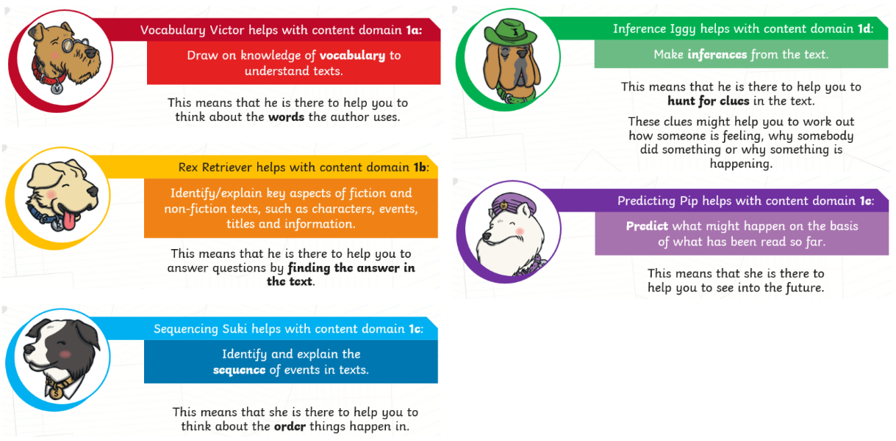
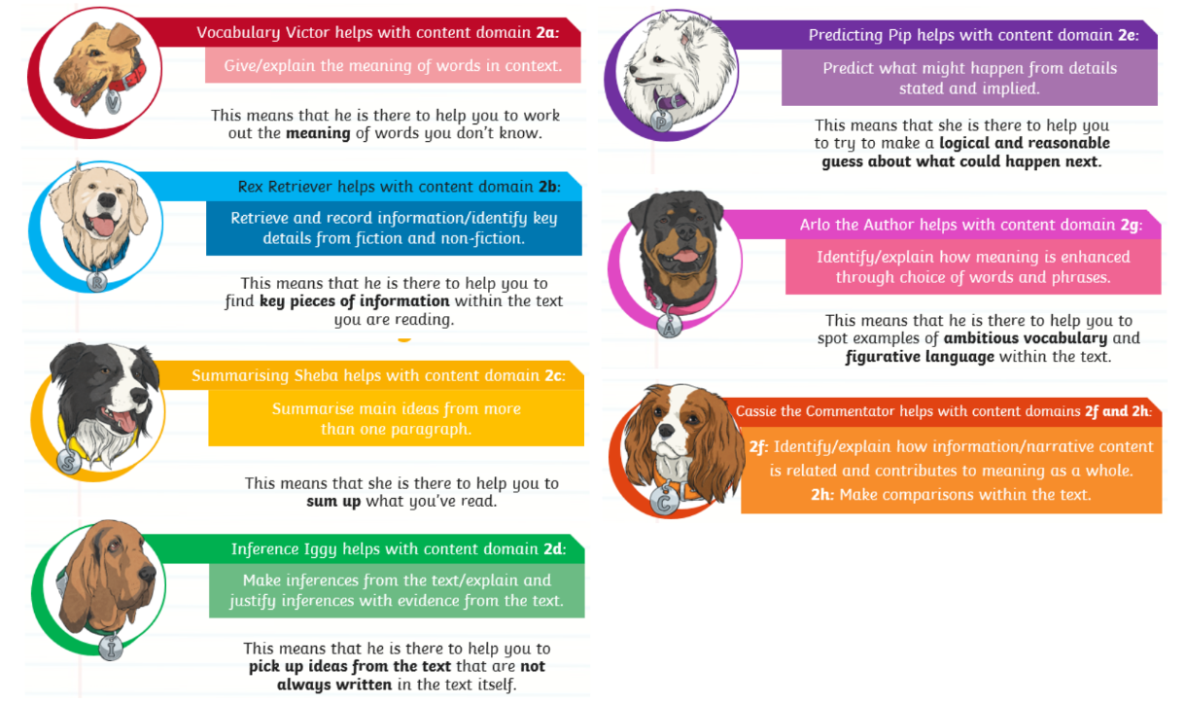
ii) Key Stage 2 Reading Dogs:

Assessment, Monitoring and Moderation
In Key Stage 1 and Key Stage 2, the grades for each child are put on SIMS at the end of each term and teachers report to SLT the reading level of every child in the class. Children from Year 1 to 6 are assessed against the curriculum objectives for each year group. Teachers are expected to update excel sheets for their year groups termly, stating if the child has achieved an objective in Autumn, Spring or Summer. These will then indicate if a child is emerging, developing, secure or mastering. These are then used to input data on SIMS.

Termly progress meetings identify strategies addressing any concerns. On a weekly basis, teachers evaluate the progress of PPG children in order to track their progress and highlight any concerns.

Teachers are expected to use AFL strategies that are agreed and reviewed on a yearly basis, in all guided reading lessons.

Assessment is a critical element of our programme. The teachers assess:
- pupils’ phonic knowledge
- the speed at which pupils are able to read the text
- their understanding of the texts they read.

In Reception and Year 1, we use and record the results from the Read Write Inc Ruth Miskin Phonics Assessments which take place every term. This data allows us to track progress, identify gaps in learning and inform subsequent planning and teaching. It also allows us to quickly move pupils to another group if they are progressing faster than their peers. Similarly, the children in Year 2 and Year 6 do termly SATS papers and the children in Years 3-5 do termly NFER tests. These assessments are used alongside 3BM to assess pupil progress, monitor attainment and inform planning.

Strategic leaders and SLT monitor reading on a fortnightly basis, ensuring the whole school is monitored across a half term. Moderation for the following half term responds to the school needs identified at the end of the previous half term.

Resources
Guided Reading resources for Year 2 and Key Stage 2 are stored on the Staff Drive or in the appropriate classroom. The Guided Reading books are kept in the Year 4 spare classroom. Ruth Miskin Phonics resources are also stored in the Year 4 spare classroom.

Use of ICT
ICT is used to support and enhance children’s learning. Classes are all equipped with Chromebooks and these are used to provide opportunities for children to read online books and news articles. In Key Stage 1, children use iPads and Chromebooks to practise their phonics and Key Stage 2 use the Chromebooks to access a range of mixed media texts. Staff have been trained to effectively use a variety of programs on the computer in order to support their teaching and modelling and to enhance the children’s learning.

Home Reading
Children in Reception and Key Stage 1 take home a levelled reading book at least twice a week. Each child from Reception to Year 6 will take home a reading diary which should be signed by their parent/carer every day. KS1 children will be given Phonics spelling homework in a spelling homework book once a week. KS2 children will take home spellings and take part in one reading homework activity per week, which will be displayed on seesaw.

Policy Review Date: Summer 2026

